ArvindKumar Rajanth Yadav

Email-id:yarvind740@gmail.com
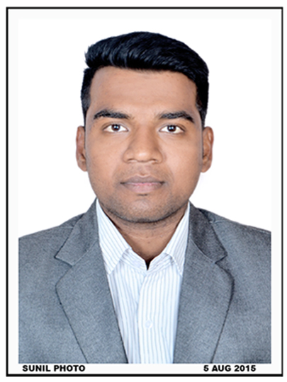
Mobile no.:+91 9765291399/
+91 8623995770
CAREER OBJECTIVE:
Aim to work in an environment where I can utilize my knowledge in technical skills, towards the development and implementation of the new ideas that contributes to growth of the organization.
ACADEMIC QUALIFICATIONS:

Course | Institute | University/Board | Year | Aggregate
MCA | MET’s BKC Institute of Engineering, Nasik | Savitribai Phule Pune University | Pursuing | 63%
BCA | B.Y.K College of Commerce, Nasik | Savitribai Phule Pune University | April 2014 | 60.54%
HSC | Bhonsala Military College,Nashik | Savitribai Phule Pune University | February 2011 | 63.33%
SSC | Don Bosco High School,Nashik | Maharashtra State Board | March 2009 | 64.46%

TECHNICAL SKILLS:
- Programming Languages: C, C++, Core Java (Intermediate), VB6.0, VB.NET, C#.Net (Intermediate) and SQL.
- Web Technologies : HTML, PHP (Beginner), ASP.Net (Beginner).
- Development Tools : Turbo C, Eclipse, sqldeveloper.
- Databases : Oracle SQL, PL/SQL, MS Access.
- Operating Systems : Windows, Ubuntu.
- Other Tools : MS-Office.

ACADEMIC PROJECTS:
During academic year 2013-2014, I developed two projects as a part of my academics. Details are as follows:
BCA(Final Year)
Project: Blood Bank Management System Duration: Two Months
Technology used: VB6.0 Team size: One(Individual)
Project Description: Blood bank management system is a software application used to maintain day to day transactions in a blood bank. This software help to register all the donors details, Blood collection details, Blood issued details etc. This project is aimed to developing an online Blood Donation Information.

BCA(Final Year)
Project: Medical Shop Management System Duration: Two Months
Technology used: Visual studio 2008 Team size: One(Individual)
Project Description: Medical Shop Management software is so designed as to ease the work load of medical shop professionals. The main feature includes invoicing, inventory and stock control, accounting, client and vendor management.

MCA(Sem-5)
Project: Documentation for Admission Process Duration: Two Months
Technology used: PHP Team size: Group(4 members)
Project Description: Documentation for Admission Process is website where all documents and various certificates details is provided. So that students can get detail information about the documents.

PERSONAL DETAILS:
- Permanent Address: Plot on.1, Yadav Niwas, Someshwar Colony, Behind A.B.B Company, Satpur, Nashik-422007.
- Date of Birth: 14 June 1993.
- Languages Known: English, Marathi, Hindi and Bhojpuri.
- Mobile:+91 9765291399/ +91 8623995770
- Email-id:yarvind740@gmail.com

EXTRA CURRICULAR ACTIVITIES:
- Done NCC in Naval wing and got gold medal for “Semaphore Competition”.
- Worked in organizing committees during EUREKA Event held in B.Y.K College.
- Developed MET-SPARX application using Mozilla Web maker in that Appmaker was been used.
- Worked in Campaigning, Databases, Gaming committees during MET_SPARX Event arranged every year by MCA MET Students.
- Participated in Many Events under MET-SPARX like Blind-coding, Technical Quiz.
- Consistent participation in the departmental activities held during entire academic year.
- Actively volunteered two events in MET-SPARX 2014.
HOBBIES:
- Doing Workout.
- Listening Songs.
- Playing Football and Volleyball.
- Tracking.

DECLARATION:
I do hereby declare that the particulars of information and facts stated herein above are true, correct and complete to the best of my knowledge and belief.

(ArvindKumar Rajnath Yadav)

