Name : Avinash v. kale

Career Objective:

To put my abilities and learning skills to best use and make my effective contribution to an organization for a bright and rewarding career

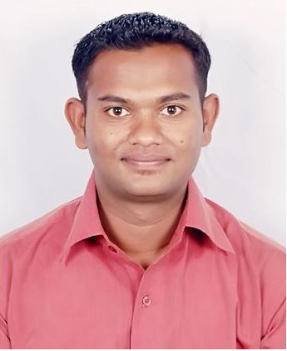
Personal Details

Gender: Male Marital Status: Single

D.O.B.: 28 - 12 - 1988 Language Proficiency: English, Hindi,marathi.

Permanent Address: “raj gruh” kale chowk ward no.1 devlali camp nasik.422401

E-mail: avinashkale.6@gmail.com Phone: +919175758122.

Specialization (Major) : Marketing

Education Qualification:
Course | Institute/College/School | University/Board | Percentage | Month / Year of Passing
Master of Business Administration. | Sinhgad Academy Of Engineering, Pune | University of Pune | 58.25% | july2013
BSC (COMPUTERS) | R.N.C college nasik road nasik. | University of Pune | 52.89% | April- 2011
Std XII |  | University of Pune | 53.17% | March 2007
  SVKT college devlali camp
Std X | St.patricks convent high school. | University of Pune | 66.80% | March 2005

Technical Skills:

- Networking and CCNA course from SEED infotech ,nasik.
- Hardware
- C,C++,JAVA , languages
- Working Knowledge of M.S.OFFICE
- Smooth Hand in internet
- Assembling of computers
- Installation of O.S and software.

Post-graduation project

Name of Company : STERLING MOTORS (authorized dealer for TATA MOTORS) Nasik.
Project Title : A STUDY ON CONSUMER BUYING BEHAVIOUR ON TATA NANO
WITH REFERENCE TO NASIK CITY.
Location : Nasik.
Tenure : 2 Month
Project Description : working with sales dept. of sterling motors
To Study the consumer buying Behaviour to Tata Nano in
Nasik city.

Graduation Project

Name of Company/Institute : R.N.C college Nasik road.
Project Title : LIBRARY MANAGEMENT SYSTEM
Project Description : front end-java, back end – MS access.
System manages the book transaction for student and teacher, it also
Automatically calculate fine for students and generate report accordingly
It also generates daily and monthly report for books.

Extra-Curricular Activities: (Hobbies)

- Participated in Various sports Competitions at School & College level
- Organized the management event ‘FUNANZA 2K12’ in college
- Organized blood donation campaign in college level .

(AVINASH .V. KALE)

