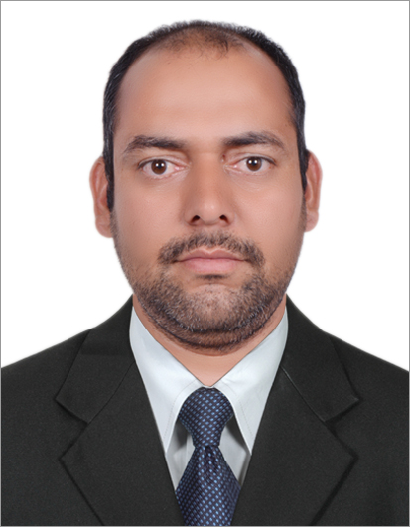
`

Curriculum Vitae

Avinesh Kumar S/o Late Sh. Ramesh Sharma

Vill: Abada Brana P/o, Dis, teh: una (H.P)

State: himachal PRADESH Pin: 174303

Contact No. +971589283187 & WhatsApp: +917807126170. kumaravinesh918@gmail.com

Career Objective

Seeking a place as a Plumbing, Drainage & Fire Fighting Draughtsman within a reputed, progressive organization in order to utilize my skills, expertise and extensive knowledge to the benefit of the organization and for my career development.

Educational Qualification

Graduation Passed from H.P. University of Shimla Section (April2004) Arts.

Post-Graduation passed from H.P. University of Shimla section (April2006) HINDI.

Post-Graduation passed from H.P. University of Shimla section (April2009) SANSKRIT.

Ncc Certificate ‘B’ & ‘C’ other sport certificate cross country.

Technical Qualification

Provisional National Trades Certificate of Punjab State Board of Technical Education & Industrial Training

(I.T.I) Under the Trade Draftsman Mechanical from July 2000.

Dip in Mech. Engineering from National Institute of Management Solution New Delhi -046 Sections Dec, 2008.

Professional Qualification
- Expert in Auto Cad & Revit 2017 & 2018, Catia V5r16 a Mechanical 3d & Typing in English.
- Making Design 2d & 3d, Sheet Metal & Modeling Products, Builders Work Layout & Shop Drawing. (MEP)

Experience (Past) From Dec 2008 To April 2014 –

M/S Omega Consultants (P) Ltd. (New Delhi) Mechanical draughtsman (HVAC & Plumbing)

Job Profile
- As per site build & Plumbing and Drainage layouts.
- Sectional Layout & Typical Details layout & shop drawings and details layout
- Draw a Design on First Angle & Third Angle View & Project. (N.T.P.C) General Arrangement Drawing.
- Making Design of All Type Mechanical Compacts Product & Civil, & Mech, Drawing Project. (M.E.P)
- Supervising the entire construction site & meeting plan for safeties with labors.
- Market and competitors study and Display merchandising and part in purchase department.
- Erection Work & Shifting the Material Crane Other Launching of Steel Girder Bridge with Metrology.
- Making Dwg. of Object Made of Sheet Metal & Automobiles Parts & Maintaining Register for Work Order
- Erection & launching of crane & winch machine Scheme & Methodology drawing.

Experience UAE DUBAI & DOHA, QATAR (Past) From MAY 2014 to MAY 2017: -

M/S Pantech Engineering Co. W.L.L. Mechanical draughtsman (Plumbing)

Job Profile
- Plumbing layouts. & builders work layout & Drainage layout
- shop drawings and Section details layout
- Coordination for MEP layout

Experience DUBAI UAE (PRESENTLY) From AUGUST 2017 to TILL DATE: -
Presently Working in Capstone company As a PLUMBING coordination Draftsman in (Target engineering,
Al Shafer engineering and now presently in Al Habtoor specon the royal Atlantis hotel in palm
Jumeirah from 01 SEPTEMBER 2017 to till now)

Job Profile
- HVAC layout drawing, Plumbing & Fire fighting and site engineer
- 2D & 3D Drawing layout & Builders work layout & Shop drawing. (MEP)
- Coordination for MEP layout

Strengths & Hobbies
My strength self-Motivated, my parents, hard work, Honesty & Helping nature.
Im, Sincere Quick Learner, Positive Approach, Amiable Nature, Listening to Music,
Reading Technical & Religious Books. & making new friends.

I easily adopt any environment my Carrier and my life

Passport Details

Passport No : - S9782868

Place of Issue : - Dubai

Date of Issue : - 24-10-2018

Date of Expiry : - 23-10-2028

Personal Profile

Names. : Avinesh Kumar

Father Names. : Late Sh Ramesh Sharma

Date of Birth. : 16 September 1981.

Sex. : Male

Religion. : Hindu

Marital Status. : Married

Nationality. : Indian

Passport. : I Have A Passport, No: - S9782868

Capability. : To Face Any Problem

Languages Known. : Hindi, English & Punjabi

Permanents Address. : Avinesh Kumar S/O Late Sh Ramesh Sharma

Vill:-Abada Braña P/O, Dis, Teh: una (WhatsApp:+971589283187) State: - Himachal Pradesh Pin Code: 174303

Email: - happy.sharma95@Yahoo.Com

Declaration:

I Consider Myself Familiar with Industrial Production Engineering Aspects. I Am Also Confident of My Ability to Work in A Team. I Hereby Declare That the Information Furnished Above Is True to The Best of My Knowledge.

Thanking You Anticipation of Your Favorable Reply.

Date.20-03-2019 Avinesh Kumar

Place: Dubai UAE

