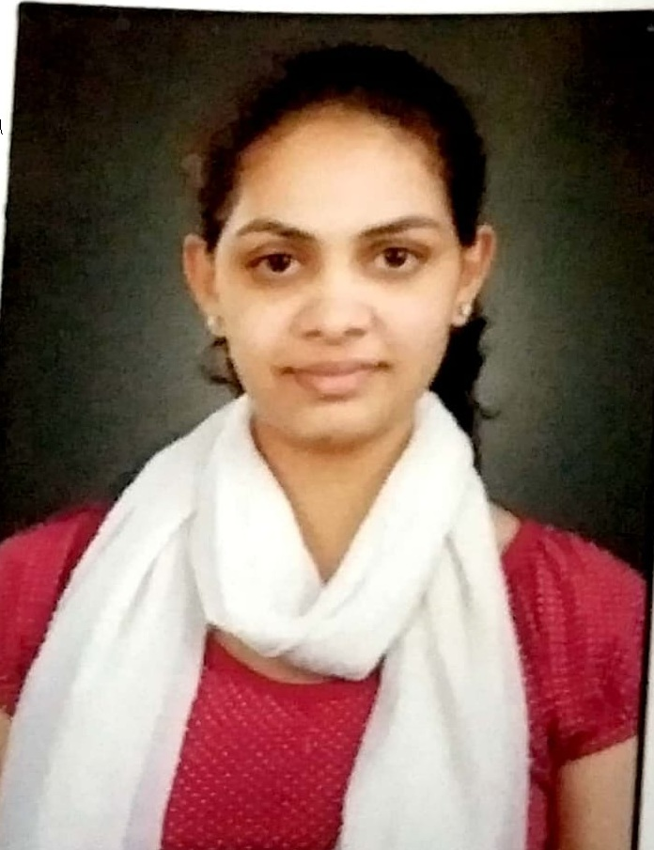

Miss Jayshree Arjun Saykhede
B.com, M.com

Cellular: 9657845056
Email: saykhedej14@gmail.com
Nationality: Indian

Address:
Krushan pooja row house no. 6,Lakshmi kedar nagari ,Dasak ,Jail Road ,Nashik Road , Nashik ,422101

Objectives
Seeking a position to utilize my skills and abilities in a dynamic organization, which in turn will help me to attain my goals and further develop my skills for the future challenges.

Work Experience

I worked in SKVM AND Co. (CA Akshay V. Ladha firm) From August 2014 to September 2017.

Responsibilities Handled
- Income tax Return filing, Income Tax Assessment and Appeal work.
- Accounting (Data Entry ) and Balance sheet Finalization.
- Working VAT, TDS, Service Tax and Return filing.
- Audit work.

COURSE

Certificate Course on Computer Concepts

From: 2009

Institute: An autonomous scientific society of department of information technology, ministry of communication and information technology, government of India.

Certificate Course in Government Commercial Certificate Examination

From: 2009

Institute: Adarsh Commercial Institute.

Certificate Course in Information Technology Training Course

From: 2013

Institute: The Institute of chartered accountant of india

Academic Qualifications

M.com (Advance Accounting ,Taxation and auditing)
Year: 2016
School: External
University: Savitribai Phule,Pune University,Pune,Maharashtra, India
Grade : 50 %

B.com (Business Administration)
Year: 2013
School: Gokhale Education and NSC Science College, Nashik Road.
University: Pune University,Pune,Maharashtra, India
Grade : 59.17%

H. S. C.
Year:- 2010
School: Gokhale Education Society’s Arts, Commerce and Science Junior College Nashik Road.
Board: Maharashtra State Board
Grade : 50.17%

S. S. C.
Year:-2008
School: Kendriya Vidyalay ISP,Nehru Nagar, Nashik Road, Nashik ,Maharashtra, India
Board: CBSE
Grade : 57%

Information Technology Skills

- Certificate Course on Computer Concepts
- Tally ERP 9

Project Work

- Audit work and Finalisation balance sheet of Nashik Sport Marathon 2017.

Guide Name : CA Akshay Vinod Laddha

Extracurricular
- Participated and won Second price in Games and Sport Meet.
- Participated in Help age India (Social Service).
- Participated in The National Association for the blind.
- Participated and Won second price in sport meet organised by KVS Mumbai region in the 2008.

INTERESET AND HOBBIES
- Dancing
- Painting

PERSONAL PROFILE
Father’s name : Arjun Saykhede

Mother’s name : Rekha Saykhede

Date of Birth : 14TH January 1993

Marital Status : Unmarried

Sex : Female

Nationality : Indian

Languages known : English, Marathi and Hindi

DECLARATION
I hereby declare that the above details furnished by me are true to the best of my knowledge.

Date:- 28th June 2018 Jayshree A. Saykhede
Place:- Nashik

