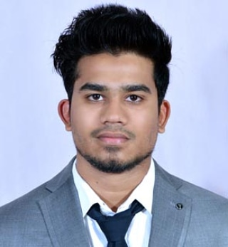
Present Address: Pingale Galli, Shahaji Chowk, Makhmalabad, Nashik, 422003.
Maniyar Moij Javed
B.E, Mechanical
Contact No. : - 8087935286, 9028308098
E-mail:- maniyarmoij@gmail.com

CAREER OBJECTIVE

To work in an organization with a professional work driven environment where I can utilize and apply my knowledge, skills while fulfilling organizational goals.

WORK EXPERIENCE

PAM System's Pvt Ltd.

Mechanical Design Engineer, Design & Development Department. Feb.2018 - Present

Solidworks 2017 -
I'm responsible for 3D modeling, assembly, drafting of product,drawing conversion & process design of small components, machines & Responsible for providing technical advice.

JOB RESPONSIBILITY :
- Responsible for solid modeling, assembly including detail Drawings applying GD&T, bill of material of LPG bottling machines, Chain Conveyor with checking of 3D models & 2D Drawings.
- Improving the design of existing machines and system as per customers requirement with maximum working flexibility.
- Monitoring detailed drawings of structures & preparing models of the projects.
- Checking & detailing of fabrication and erection drawing for various structures,
- Involved in Designing and development of Camera vision system, Automatic Diverter Unit which is used in LPG cylinders handling and inspecting system in the plant.
- Researching & developing ideas for new equipment's & system's.

AutoCAD -
Involved in the design of LPG plants.

JOB RESPONSIBILITY :
- Prepared Plant Layout, GA Drawings & P & ID.
- Modify & check out the 2D Drawings.
- Involved in Designing and development of LPG Bottling Plant.

PROFESSIONAL QUALIFICATIONS

- Bachelor of Engineering with specialization in Mechanical from Savitribai Phule Pune University,Guru Gobind Singh College of Engineering & Research centre,Nashik in the year 2017 with First Class.
- Diploma in Mechanical Engineering from N.D.M.V.P.S. Rajshree Shahu Maharaj Polytechnic, Nashik in the year 2014 with 72 %
- S.S.C. Examination from Mumbai Divisional Board, K.B.P. Highschool Mokhada, Dist. Palghar in the year 2011 with 84 %

IT PROFICIENCY

Solidworks 2017
Auto CAD
Draftsight
CREO
CATIA V6
NX 9
Microsoft Office - Excel, Word, Power Point

PROJECTS REPORT

- Air Cooling Effect through Vehicle Suspension System
- Seminar on “Study of the Smart Materials”
- Pedal Operated Wood Cutter Mechanism

ACHIEVEMENTS

- Research Paper on Air Cooling Effect through Vehicle Suspension System
- Participate in Indian Engineering Olympiad [3rd year Engg.]
- Maharashtra Junior Science Olympiad (NET) Level 2 (8th std.)

INTERPERSONAL SKILL

- Eager to learn new technologies and methodologies.
- Patience, Positive and Honest.
- Flexibility, able to adapt the different situations.
- Self-motivated, able to perform role with minimum supervision.

PERSONAL DETAILS

- Father’s Name : Javed Jafar Maniyar
- Permanent Address : 666C, Beside Jama Masjid, Madina Chowk, Main Road Mokhada, Palghar, 401604, Maharashtra, India.
- Date of Birth : 25th March 1996
- Language Known : English, Hindi, Marathi
- Marital Status : Single
- Nationality/Religion : Indian / Muslim
- Passport Details : S0627404 Valid Up to : 29-Feb-2028

DECLARATION

I hereby declare that the above information is true to the best of my knowledge & belief.

