RESUME

MAYUR JAIN

Career Objective:-

To make optimum utilization of my knowledge and skills, utilize opportunities effectively for professional growth and to contribute in the best possible way for the betterment of the organization and self.
Personal Profile :-

Name: - Mayur Dilip Jain
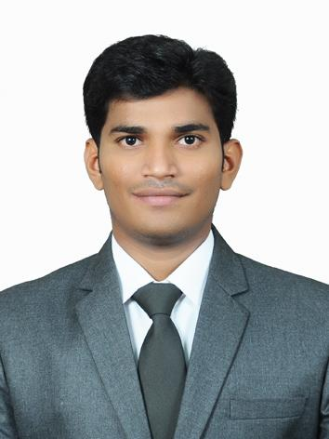
Gender :- Male
Marital Status: - Single
Date of Birth : - 10/10/1994
Language Proficiency: - English, Marathi, Hindi, Gujrathi, Ahirani
Permanent Address: - 31, Nateshwar Society Wakharkar Nagar, Dhule.
Mob. No: - 8888255131
Mail Id: - mayurdjain1010@gmail.com

Education Qualification :-

- Post Graduation Completed In Master Of Business Administration. ( MBA Marketing)
- Graduation Completed In, Bachelor Business Management

Education Qualification:
Course | Institute/College/School, Location | University/Board | % | Year of Passing
MBA | Sinhgad Institute of Management and Computer Application (SIMCA), Narhe, Pune | Pune University | 63% | 2017
BBM | M.D.Palesha Commerce College Dhule. | North Maharashtra University Jalgoan. | 67.5% | 2015
HSC | J.R.City Junior College Dhule. | Nasik Board | 73% | 2012
SSC | New City High School Dhule. | Nasik Board | 58.5% | 2010

Past Experience :- | Computer Skills

- Name of Company :- Livguard Energy Technologies Pvt. Ltd
- Product Name :- Livfast By Luminous
- Area Cover: - Aurangabad, Jalna, Beed, Parbhani, Nanded.
- Working From : 1st March 2017
- Responsibilities Undertaken :-
- Secondary and Primary Sales
- Customer Relationship Management
- Service Management
- Branding n Promotional Activity
- Market Research Activity
- Working As Per PJP (Pre Journey Plan)
- Organizing Dealer/Technician Meet to Increase Business Volume.
- Handling 4 Territories At Once. Regular Follow Up, And Close The Deals.

- Current Experience :-

Name of Company :- Okaya Power Pvt. Ltd.
- Product Name :- Okaya, Mtek(Microtek), Digi Power
- (Inverter Battery, Automotive Bty, SMF Bty, Solar Bty)
- Cover: - Nasik(Base), Dhule, Nandurbar
Working From : 13 Feb 2018 To Till
- Responsibilities Undertaken :-
  - Secondary and Primary Sales
  - Customer Relationship Management
  - Service Management
  - Branding n Promotional Activity
  - Market Research Activity
  - Working As Per PJP (Pre Journey Plan)
  - Organizing Dealer/Technician Meet to Increase Business Volume.
  - Handling 3 Territories At Once. Regular Follow Up, And Close The Deals.

Summer Internship Project :- | Computer Skills

- Name of Company: - Hindustan Coca-Cola Beverages Pvt. Ltd.
- Project Name:-"Study of sales & distribution of coca-cola in comparison with Pepsi at Dhule."
- Location:- Dhule
- Duration : 60 Day
- Responsibilities Undertaken :-
- Marketing Research
- Customer Relationship
- Display Management
- Promotion Activity
- Sales and Purchase system
Computer Skill :- | Computer Skills

- Computer Proficiency: Ms Office, Ms Excel, Ms Power Point
- Programming Language: C++, VB.Net and JAVA.
- Tally ERP.9
- English Typing 30 WPM

Skills:

Teamwork, Problem Solving And Analytical Skills, Initiative, Adaptability To Change, interpersonal And Communication Skills, Strategic Thinking And Planning Abilities, Time Management And Project Management Skills

Other Activities :-
Extra Curricular Activities:-
- Participation in Spectrum ‘Brand Maniac’
- Attended Netiquettes & Be a good cyber citizen workshop

Hobbies :-
- Travelling
- Playing Cricket

Key Skills & Attributes :-
- Communication Skills
- Positive Attitude
- Self Confidence
- Good Interpersonal Skill

Acknowledgement :-

hereby confirm that the information given above is best of my knowledge.

Date. :-
Place :-

