Sub: Application for the post of MEP BIM Modeler

With reference to the subject mentioned above, I hereby submit my CV for your kind perusal and further consideration.
I introduce myself as a qualified REVIT Modeler. A total 8 month of experience in MEP Designing and worked on individual projects of BIM Modeling (Version 2014 to 2017). Worked for different services Like Mechanical, Plumbing. Excellent 3D designing skills summed up with splendid knowledge in the areas of Revit MEP and Auto CAD. I worked in single Revit MEP environment, covering commercial and residential projects like hospitals , high rise buildings & school.

I am confident to Draft & understand designing concepts to collaborate the MEP works for commercial & Industrial Projects.

I believe that my qualifications and experience will add value to organization and its clients if given opportunity, will take it as a challenge to prove myself to be an asset for the organization.
Thank you & Best regards;

Yours truly,

MOHAMMAD ZIA UR RAHMAN

C U R R I C U L U M V I T A E
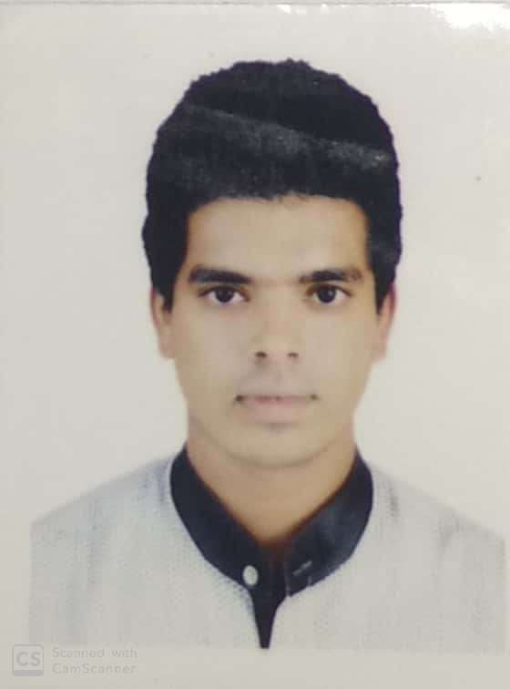
MOHAMMAD ZIA UR RAHMAN
Mechanical Engineer (B.E.)
MEP ( P.G.D ).
Achalpur-444806(M.S),INDIA.
Phone – 0091-8600320098
E-mail: ziya1412@gmail.com

- CAREER OBJECTIVE:-
Looking for a challenging and demanding position for MEP BIM Modeler in a growth oriented HVAC / Electro - Mechanical consulting/contracting/ construction organizations where there is ample scope for individual and organizational growth.

- PROFESSIONAL EXPERIENCE:-
- Company : ABK Consultants & Engineers.
Position : MEP Design Engineer
Duration : Aug’2018 – Till Date
Job Responsibility :
- HVAC:
- Survey of building by surveying location of the building, orientation of building, direction and dimensions of the House/Room and inside volume which has to be conditioned and note down the points for Heat Calculations.
- Calculating Heat Load using CARRIER and ASHRAE standards latest HVAC-Hourly Analysis Programming (H.A.P) software.
- Designing of Air Distribution System by Velocity Method, Equal Friction and Static Regain Methods.
- Calculating ESP.
- Designing of Residential, Commercial and Kitchen Ventilation systems.
- Selection of machines like FCU’s, AHU’s, Chillers, Pumps, Blowers.
- Calculating the Pipe Sizing for the chilled water system according to the GPM.
- Preparation of Bill of Quantity of Materials for Ducts.
- Carry out Pump Head Calculation for the selection of Pumps.
- PLUMBING & DRAINAGE:
- Hot and Cold water capacity calculations.
- Sizing & Selection of Pumps,Water Storage Tanks.
- Pipe sizing for water services.
- Water Demand & Load Unit Calculations.
- Design & preparation of Schematic diagrams (Autocad).
- Design & preparation of Cold & Hot Water Layout drawings (Autocad).
- FIRE FIGHTING DESIGN:
- Design of Sprinkler System.
- Calculating Water Storage Capacity.
- Calculating Pump Size.
- Design & preparation of Schematic drawings. (Autocad).
- Design & preparation of Sprinkler/Hydrant/Water Spray Layout drawings (Autocad).

- REVIT-MEP:
- Modeling of Mechanical, Electrical & Plumbing services based on design standards.
- Working on Project Setup in REVIT by using worksets, views, Filters & by linking Architectural, Structural & design standards.
- Working and editing REVIT families.
- Creating HVAC systems.

- TRAINING EXPERIENCE:-
- P.G. Diploma in MEP(HVAC, Plumbing & Drainage, Fire Fighting Systems ) Designing, Drafting, Erection and Commissioning .
- REVIT-MEP.

      - PROJECTS HANDLED:-
SR.NO | PROJECT DETAILS | NAME
1. | Complete HVAC, Plumbing, Fire Fighting Design. | Sanap Hospital.
2. | HVAC Design for VRV/VRF System of 50HP(40TR). | Bunglaw.
3. | HVAC & Fire Fighting Design System Calculations. | Hayaat Hospital.
4. | HVAC Design for Ductable Packaged System of 50TR. | Amanora Mall.
5. | Complete HVAC, Plumbing, Fire Fighting Design Layouts. | 14-Floor High Rise Building.
6. | Complete Fire Fighting Design Layouts. | 17-Floor High Rise Building.

- EDUCATIONAL QUALIFICATION:-
Course Name | Institution | University / Board
B.E(Mechanical) | ANJUMAN COLLEGE OF ENGINEERING & TECHNOLOGY,NAGPUR. | RTMN University
H.S.C. | RAHMANIYA JUNIOR COLLEGE,ACHALPUR. | PUNE BOARD
S.S.C. | RAHMANIYA HIGH SCHOOL,ACHALPUR. | PUNE BOARD

- COMPUTER LITERACY :
- Software :-
- REVIT-MEP..
- AUTOCAD. (Received Autodesk Professional Certification from Autodesk-USA for AutoCAD
2016).
- HAVAC Software :
- HAP ( Hourly Analysis Programme ).
- McQUAY Duct Sizer.
- McQUAY Pipe Sizer
- Office Suit :-M.S Office all versions (Excel ,Word ,Power Point ).

- CRITICAL SKILLS:
- Reliable Team Player and ability to work under pressure.
- Excellent Communication Skills
- Ability to manage time,meet deadlines and willingness to learn.

- PERSONAL PROFILE:-
- D.O.B - 11JULY1997
- Gender - Male
- Passport - Available- R9792566 ( Validity : 25-07-2028 )
- Linguistic Proficiency - English, Hindi.
- Hobbies - Cricket, Swimming , Workout, Traveling.

Declaration,
I hereby declare that all the furnished information made here are true and correct to the best of my knowledge and belief.


Signature
( MOHAMMAD ZIA UR RAHMAN )

