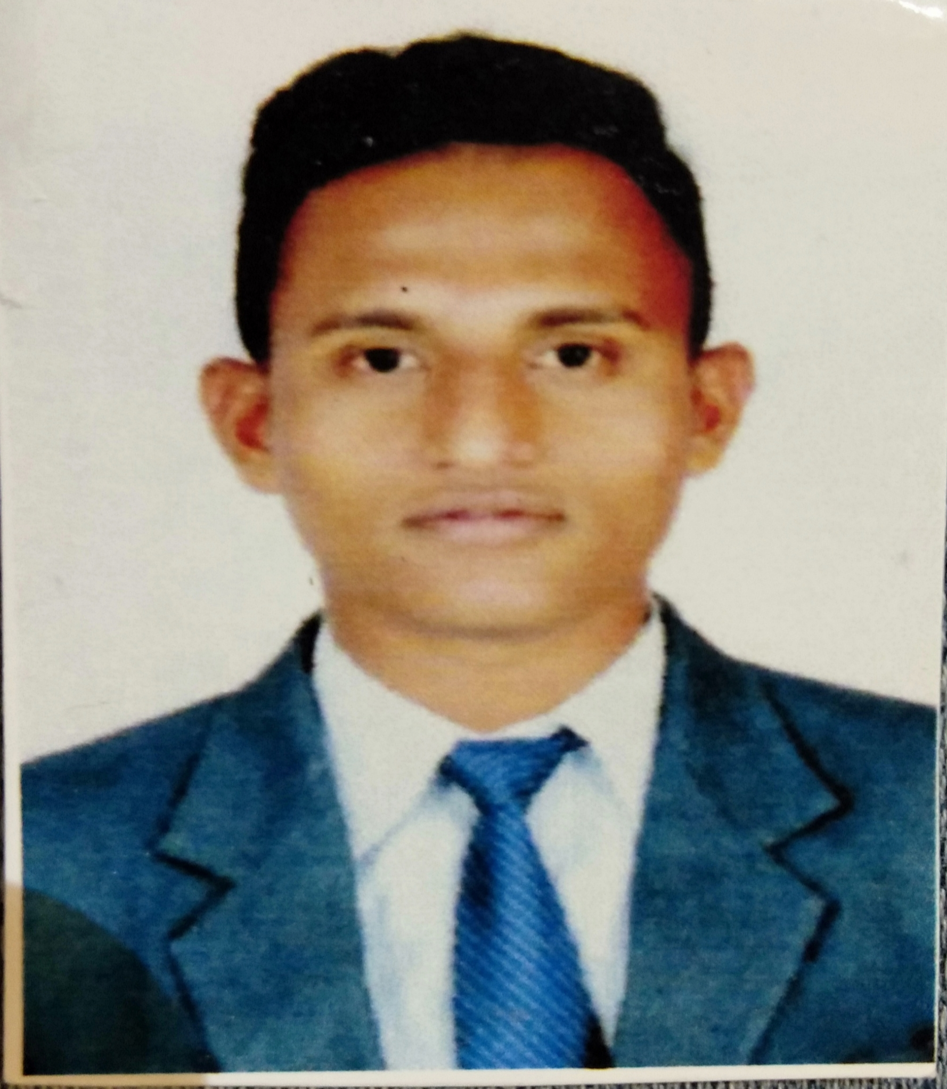
Ahmednagar, India
+918999623254
nazimshaikh9767@gmail.com
Nazim Shaikh
Photo

EDUCATION
EXPERIENCE
- Good people management and communication skills. Team player.
- Able to work under high pressure and time limitation.
- Be elegant and with nice personality.
- With good managerial skills and organizational capabilities.

University of PUNE.
- B.s.c (computer science)
- Completed 12 Science from Pemraj sarda college
- Completed Training of Boxing Coach.

Associate Optimize Retailing and Customer Service Crossword. 07/01/2019
- Received intensive training, including quantitative and quality training in Retailing and In customer service.
- 1.5 year experience in capital one process in wipro pvt.
Data Analyst Intern Cyber Securities 3/6/2015 - 5/6/2018
- Helped to develop strategies for marketing and market education
- Made business plan and PowerPoint for financing
- 1 year experience in Wipro.

ACTIVITIES

- Sports, National gold medalist in boxing
- 3D game designing.
- Typist.

SKILLS

- Languages: English and Hindi in business proficiency
- Activities: English Typist, 3D game designing,Sports.
- Interests: Reading, Listening Music , traveling, communicating with Peoples , swimming, Sports.

EVALUATION

