RESUME
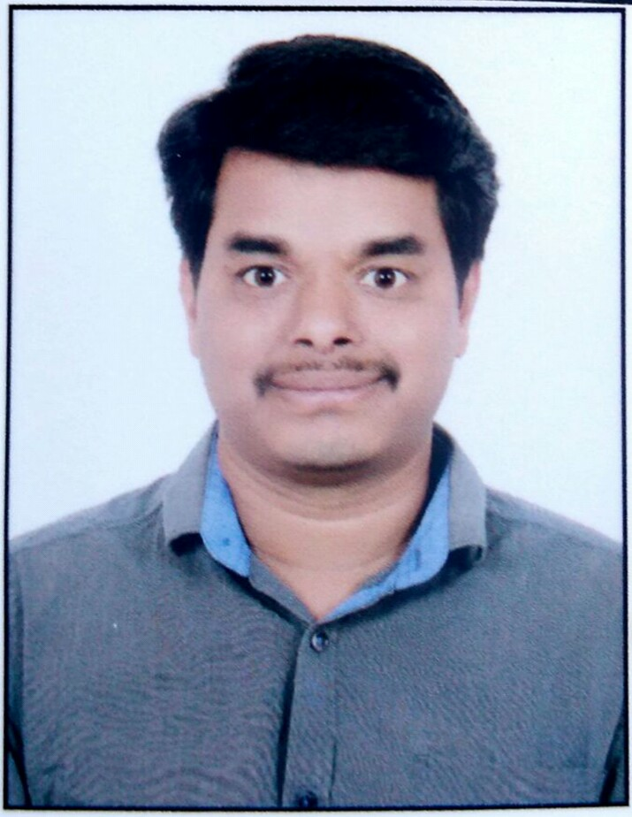
Raj Kumar Uppuniti
Mobile: +91 95333 51511
Email: rajkumar88880@gmail.com

Career Objective:
To be part of globally competitive environment that gives an opportunity to handle challenging assignments where I can utilize my proven skills to the development of organization with active interest in the field of IT Infrastructure Operations that involves Technology Management, High Level Design, Project Planning, Implementation, People Management and Development of Procedures and Processes.
Professional Summary:
As an Infrastructure operations analyst with overall 5+ yrs. of experience in IT industry with vast experience in dealing with Incident, problem, Change and vendor Management activities. Worked for various global customers like Microsoft Corporation, Unilever & Netgear. Expertise in handling Enterprise level Server infrastructure & perform several infrastructural operations as part of environmental readiness required by business and per committed Service Level Agreements. Hands on experience in investigating the critical Incidents and problem tasks and providing the Root Cause Analysis. Gained immense knowledge in handling IT management tools like BMC Remedy, Service Now and other internally developed and maintained tools.

Education:
- Bachelor of Technology [B.TECH -ECE] – 2011. JNTU Hyderabad.

Certifications:
- Microsoft Certified solution Associate (MCSA-410).
- Certified Windows Azure Specialist (70-533).
- Mahindra Satyam Certified Infrastructure Professional (MSCIP).
- Trained on ITIL V3 foundation.
Technical Knowledge
Microsoft servers : Windows Server 2003, 2008, 2008 R2, 2012 and 2012 R2.

Virtualization : Microsoft Hyper-V & System Center Virtual Machine Manager 2012.

Tools : Microsoft ITSM, Service Now, BMC Remedy & Sales force.

Cloud Solutions : Microsoft Azure (IAAS) & Amazon Web services (IAAS).
Work Experience:

Current Employer: Zensar Technologies India Pvt. Ltd [Since Nov 2016]
Project Details:
Title : CTS Wintel Administration
Client : Network Devices MFG Company.
Designation : Sr. Software Engineer.
Role : Microsoft Hyper-V Administrator.

Amazon Web Services (IAAS) Related Responsibilities:
- Build, Deploy, Manage & Maintain AWS EC2 instances for multiple AWS Accounts and Regions.
- Troubleshoot AWS EC2 instance connectivity issues using EC2Rescue, SSM Run Command, SSM State Manager and Automations.
- Create and Manage AWS Load Balancers (ELB, ALB & NLB) based on the requirement for various Web applications.
- Troubleshoot instance unhealthy issues on the Load Balancers and prepare KB documentation.
- Upload Custom certificates for the Web Applications into AWS Certificate Manager, which can be used to attach Load Balancers and Cloudfront Distributions.
- Create and Deploy WAF & Shield for Various web applications based on the requirement.
- Create and Manage Cloudfront Distributions for various Web Applications & troubleshoot issues related to Cloudfront with the help of AWS support.
- Create and Monitor Alarms for EC2 instances resource utilization through AWS Cloud Watch.
- Analyze Load Balancer & Cloudfront logs stored in S3 using Athena to check the cause of the issue.
- Prepare basic Scripts using AWC CLI commands to automate AMIs, Volume snapshots for EC2 instances
And scheduling the same.

Microsoft Azure (IAAS) Responsibilities.
- Proving the cost effective, Resilient and reliable solutions to the customers and building the infrastructure.
- Creation of Virtual servers, Storage Accounts, Configuring Virtual networks for VMs.
- Creating Resource groups and Availability sets for the Virtual Servers as required.
- Create Internal and External Load Balancers.
- Create server Images as part of Microsoft Azure Backup.
- Migration of Virtual servers from Amazon AWS/On premise servers to Microsoft Azure cloud.
- Creation of Application Gateways for Web Applications and enable WAF for the same.
- Troubleshoot issues related to Load Balancers and Application Gateways.
- Create and Manage CDN and troubleshoot basic issues.
- Analyze the infrastructure and create Virtual Networks, Network Security groups based on the requirement.
- Provide Role based Access to the users based on the requirement.

Previous Employer: Accenture India Pvt. Ltd [Since Mar 2015 to Oct 2016]
Project Details:
Title : Unilever Partner Services
Client : Unilever UK Limited.
Designation : Software Engineering Analyst.

Windows and Microsoft Hyper-V and SCVMM Related Responsibilities:
- Providing end to end support for all the IT infrastructure operations like Incident, Problem, Change and Vendor management Activities.
- Install and configure and manage Hyper-V hosts and Hyper-V clusters.
- Upgrade the Hyper-V hosts OS and Hyper-V Clusters in the environment.
- Quick and live migration of VMs within the Hyper-V host cluster.
- Live Storage migration of VMs from one volume to other Volume.
- Creating snapshots of VMs and reverting VMs to a given particular point of time.
- Performing Physical to virtual Migrations and vice versa as per the requirement.
- Migrating the servers from VMWare environment to Hyper-V environment.
- Addition and removal of ESX and Xen Servers to/from SCVMM console.
- Troubleshooting the Cluster Shared Volume and Server Message Block related issues.
- Installation, configuration and management of ESX and Virtual Center servers in DMZ.
- Hands on experience on HP and DELL Servers and managing the physical and blade servers remotely.
- Investigating on HP and DELL hardware incidents, problem tasks and coordinating with hardware vendors to replace the faulty part.
- Monitoring the server performance based on CPU, RAM and system drive space utilization.
- Performance monitoring and performance tuning of the servers.
- Creating the DFS shares and providing the new DFS links.
- Troubleshooting the DFS replication issues between the replication partner and replication group.
- Providing the access to the users for the DFS shares and revoking the access from the DFS shares.
- Creating/deleting users and Service accounts in the Active Directory and providing the access.
- Troubleshooting DNS related issues and Creating/modifying or deleting DNS records.
- Reservation of IP/ deletion of a reservation from the DHCP server.
- Investigating on the server down cases and analyzing the system event logs.
- Responsible for monthly patching compliance and troubleshooting missed client machines.
- Troubleshooting on MacAfee update failures on the servers and keeping the servers compliant.
- Configuring the print servers and troubleshooting the print queue related issues.
- Creating and managing disk quota and troubleshooting disk quota related issues.

Previous Employer: Tech Mahindra Pvt. Ltd System Engineer [Since Aug 2012 to Mar 2015]
Project Details:
Title : Microsoft Global Change Operations.
Client : Microsoft Corporation.
Designation : System Engineer.
Key Responsibilities:
- Based on the client requirement, Building the Microsoft infrastructure with respect to the configuration.
- Responsible for Second-level (L2) support for all server related issues.
- Administered change management related to server upgrades and software installation.
- Basic administration on active directory and Domain Name Service.
- Installation, Configuration, Administration and Trouble shooting of Virtual Machines, Physical and Blade servers and Rehoming/Moving the servers across the domains.
- Basic administration on active directory and Domain Name Service.
- Creating managing and administering Microsoft windows Clusters.
- Installation, Configuration, Administration of Hyper-v and SCVMM 2008 R2 and 2012.
- Configuring HP ILO and Managing physical and blade servers using HP ILO.
- Provisioning the storage to the virtual machines using SCVMM/Hyper-V management console.
- Having knowledge on Configuring and Maintaining Windows Deployment Server (WDS) and adding Install & Boot Images to the existing WDS server.
- Scheduling and pushing the OS or its related patches on to the servers using SCCM.
- Creating and Managing Virtualization Environment using Hyper-V and SCVMM 2012.
- Decommission of the physical, blade and Virtual machines as per the procedure.

Personal Details

Father’s name : Deva Raju

DOB : 10th July 1990

Marital Status : Married

Languages Known : English, Hindi and Telugu

Present Address : SR. No: 34/1, Shejwal park lane 5,
Raskar Creations Lane,
Near Old Sai Baba Temple, Chandan Nagar,
Kharadi, Pune,
Maharashtra, Pin: 411014.
Declaration

I hereby declare that the above written particulars are true to the best of my knowledge and belief.

Rajkumar U

