CURRICULUM VITAE
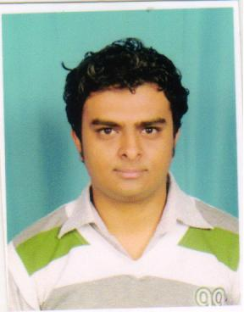
SHRINIVAS V SARDESHMUKH
P-448/5, Pratap Nagar,
I.N.S. Shivaji
Lonavla-410402
Mob: 9623149959
Email: Shrirocks@hotmail.com
AREA OF INTEREST

SPECIALISATION: Marketing/Advertising/B2B Marketing/Online Marketing

CAREER OBJECTIVES

To be a part of an Organization where the management recognizes and rewards Loyalty, Honesty, Hard- work of the employee by providing growth opportunities in the field of marketing.
TIONAL BACKGROUND
EDUCATIONAL BACKGROUND
EDUCATIONAL BACKGROUND

Sr. no. | Educational Qualification | Year of Passing | School/ University | Percentage
1. | MBA (Marketing) | 2012 | University of Pune | 53.38%
2. | B com | 2010 | University of Pune | 56%
3. | Higher Secondary Certificate | 2007 | Maharashtra Board | 67%
4. | Secondary School Certificate | 2005 | CBSE | 43%
EXPERIENCE & SUMMER INTERNSHIP for Management

1. Name of the company : S.D. Fabrication, Pune
Project : To study the customers and dealer’s satisfaction survey for
fabrication.
2. Name of Company : Super fabrication Pvt. Ltd.
Position : Business Development Executive/Team Leader for 2 years
3. Name of Company : Tulip Advertisers Pvt. Ltd.
Position : Team Leader for 1 year

TECHINICAL PROFICIENCIES

- Operating Platform : Windows 98, Windows XP, Windows 2003, Windows 7 Fedora 9
- Expertise in Computer Software:
MS Office Excel/ Word/ PowerPoint
Internet: Basic operations
E-mail: Necessary Operating

ACHIEVEMENTS

Secured 1st position in Swimming

EXTRACURRICULAR ACTIVITIES

Participated in Football Tournament in College

Participated in Cricket tournament in college
Participated in swimming competition
PERSONAL DETAILS

- Permanent address : P-448/5 Pratap Nagar, I.N.S. Shivaji, Lonavla-410402
- Date of Birth : 13/07/1990
- Hobbies : Playing cricket, Football, Swimming
- Languages Known : English, Hindi, Marathi
- Marital Status : Unmarried
- Strength : Believe in Teamwork, Helping nature,
Positive attitude, Hardworking,
DECLERATION
I hereby declare that all the above information given by me is completely true at the best of my knowledge.
Thanks & Regards

Shrinivas. V. Sardeshmukh Place: Pune

