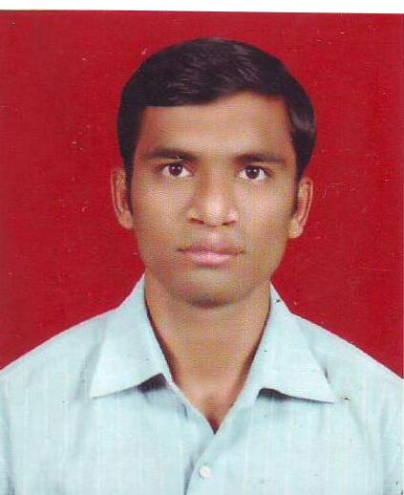
CURRICULUM VITAE

Santosh Deshmane
Flat No.7 Swami Datt Apt, S No.65/2B Dhruv Nagar, Gangapur Shiwar Nashik - 422005
Email : deshmanesantosh09@gmail.com
Mobile : +91 8600207666/8999161547

CAREER OBJECTIVE:
To be able to achieve respect at the workplace by attaining all goals with the best and optimum utilization of resources as well as team spirit and working with unyielding integrity and company values to provide the best results.
PROFESSIONAL SUMMARY:
- With 2 years 10 months of rich BPO experience in Shipping & Logistics process (Bill of Lading)
- Strong knowledge in Final Bill of Lading
- Knowledge in Off-Page optimization (SEO)
- Knowledge in Google Webmaster Tool
- Knowledge in Google Analytical Tool
- Knowledge in Google AdWords
- Have good knowledge of Excel
Achievements & Awards:
- Participated in UGC Sponsored National Level Seminar On Internal Security Challenges To India In 21st Century
- Volunteered for sarpamitra Samelen in 2009 organize by State government
- Awarded by Best Performance of the Year
- Appreciation for achieve highest levels of Customer Satisfaction
- Awarded by Maharashtra State Government Forest Department And Maharashtra Andhashradha
Nirmulan Samiti for 2nd Maharashtra Sarpamitra Samelen Feb 2009
Employers:
- Working as Quality Checker and Process Final Bill of Lading in WNS Global Services from
- June - Present
- Worked as Seo Executive in Sprint Soft Services from 2012 Sept – 2014 May
EDUCATIONAL QUALIFICATION:
- Bachelor of Arts (B.A.) Pune University (2009)

TECHNICAL SKILLS:

Operating System | Windows XP, Windows 7, Internet

AREAS OF STRENGTH:
- Matched with the ability to manage stress, time and people effectively.
- Ability to learn any tool quickly.
- Ability to work in Team.

PERSONAL DETAILS:

Address | Flat No.7 Swami Datt Apt, S No.65/2B Dhruv Nagar, Gangapur Shiwar Nashik - 422005
Alternate Contact No. | Mobile: 8600207666 / 7057028043
Alternate Email | deshmanesantosh09@gmail.com
Date of Birth | 14th Aug 1986
Hobbies | Travelling & Exploring new places, Listening Music, Cricket, Football
Languages | English, Marathi, Hindi
Marital Status | Married
Nationality | Indian.

DECLARATION:
I hereby declare that the information submitted above is true and correct to the best of my knowledge and belief and I have knowingly not omitted/ misrepresented any information.
Date:
Place: Nashik Santosh Deshmane

