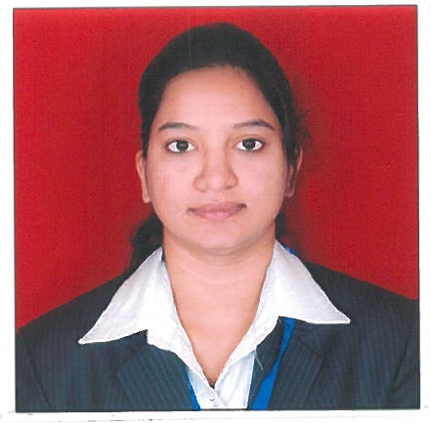

ULKA BEJALWAR
Contact no. 9766359305
Email id: bejalwarulka@gmail.com

OBJECTIVE
To build my own identity with best of knowledge & skills I have & to serve the organisation with the my managerial skills and set to achieve higher goals in life which in turn will satisfy firm’s as well as my goals of professionalism.

WORK EXPERIENCE
Company: Ashirwad Foundation
Position: Business Head
Duration : Jan 2016- Present
Job description:
- Recruitment
- Training the team.
- Administration work
- Generating the business.
- Promotional activities
- Joining formalities
- Brand building Strategies
- Identification & segregation of potential Market segments
- Revenue generation.
- Team handling
- Responsible for achieving the target.
- Monitoring & evaluating the performance.

Company: Neeyamo Enterprises PVT. Ltd, Pune.
Position: Payroll Executive
Duration: Feb 2014- May 2015
Job Description:
- End to end processing for clients.
- Maintenance of payroll system, tracking and maintaining employee’s monthly attendance.
- Updating and maintaining payroll records, preparation of pay slip and managing special situation like maternity or sickness pay.
- Payroll administration, preparation of salary statements to F&A.
- Conducting induction & On boarding programe.
- Assisting in Administration part,.
- Maintaining and updating the database of all the employees.
- Arranging the technical interview and coordinating with the concerned person.
- Preparation and reconciliation of payment summaries.
- Ensuring prompt maintenance of staff records at all times including archiving and filing.

EDUCATION
COURSE | YEAR | COLLEGE/SCHOOL | UNIVERSITY/  BOARD | PERCENTAGE
P.G.P  Gen.(HR) | 2013 | MIT College Of Management | Autonomous | 60%
MBA  (RETAIL) | 2013 | MIT College Of Management | Punjab Technical University | 59%
BBA | 2011 | Centre point college ,Nagpur | RTMN University | 72%
HSC | 2008 | Hislop college | State board | 59%
SSC | 2006 | Bishop cotton school | State board | 62%

STRENGTH
- Positive approach.
- Hard Working.
- Sincere
- Determined

INTEREST
- Business activity
- Social work.

PROJECT
Organization : MINDA Pvt Ltd, Chakan, Pune
Duration : 3rd May to 19th June
Title : Talent management process adopted by MINDA Pvt. Ltd
Work Done : Did a survey on feel good factors i.e. to know what are the motivating &
demotivating factors of the employees which in return helped the organisation.

Organization : Future Group, Big Bazaar, Pune
Duration : 5 days on 11th to 15 August 2011
Title : Food bazaar
Work Done : Worked with the HR team & assisted them in their activities & also helped the
customer in solving their problems in the CSD (customer service desk
department)

Co-CURRICULAR ACTIVITIES
- I was the team leader for various activities undertaken in collage.
- I was appointed as a volunteer in various competition & programs.
- I was also appreciated for a good team player in my organization.

PERSONAL INFORMATION

Date of Birth : 9th December 1989.
Sex : Female

Nationality : Indian
Hobbies : Listening Music, Travelling, cooking.
Permanent Address : 94 FF Sadiquabad Colony, Mankapur, Nagpur. Pin code: 440030
Present Address : 94 FF Sadiquabad Colony, Mankapur, Nagpur. Pin code: 440030

PLACE: Nagpur ULKA BEJALWAR

