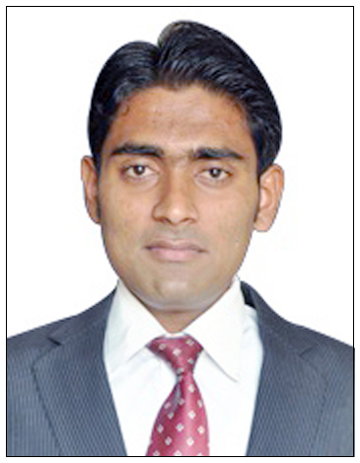
Uttam Kangane
S/O J Kanagne
F.07, Mangaljyot Apartment,
Bhagwati Chowk, Rane Nagar,
Nashik (Maharashtra)-422101
Email: uttamkangane@ymail.com
Mob-No: 9765559799 / 9405556664

Career Objectives

To succeed in an environment of growth and excellence and earn a job which provides me job Satisfaction and self development and help me achieve personal as well as organization goal

TOTAL PROFESSIONAL WORK EXPERIENCE: - 3+ Yrs
Currently working with CMS Info Systems Pvt Ltd (on site The Gateway Hotel, Ambad Nashik) as FMS Engineer. Mar 2014 – 3 Feb 2016.

Work as part of a proactive team of support staff responsible for delivering a high quality, customer-focused professional service. Facilitating highest level of technical support and customer service.
Duties
- Responsible for the day to day IT requirements of the company such as user management, trouble shooting, help and advice.
- Maintenance & management of the Critical Windows based Server Environment.
- Servers Monitoring.
- Symantec Antivirus Clients server Managements.
- Windows Update patches updating and installation.
- Fidelio (PMS), Point of Sale (Shawman), Citrix (Delphi), Application Installation and configuration and troubleshooting.
- SQL Server Installation and configuration
- Server installation, configuration and Troubleshooting
- MS Outlook Installation, Configuration and troubleshooting
- Working on Active Directory accounts, configuration.
- Virtualization (VMware) installation and configuration.
- Installation and Configurations of Switches, Routers, Modems, firewall, access points.
- CCTV installation and configuration.
- Managing and monitoring of backups in multiple locations.
- Providing maintenance support to Desktop, Laptop, Servers, Printers and break-fix solutions.
- Follow documented processes i.e. implementing change control procedures.
- Producing reports for senior managers. Troubleshooting technical problems and implementing solutions.
- Purchasing of IT Equipment and software in line within agreed budgets.
- Responsible for the fast and accurate troubleshooting of reported faults.
- Providing technical support via helpdesk systems for a wide range of internal & external applications TCS Ticketing Tool.

KEY SKILLS AND COMPETENCIES
- Highly organised and disciplined with a passion for Information Technology.
- A positive, high energy team player.
- Knowledge of Active Directory, DNS, DHCP, SQL Server, Linux
- Databases (SQL, Oracle)
- Knowledge of windows Server 2003,2008,2012
- Having a passion for providing excellent customer service.
- Customer focused and keen on exceeding expectations.

Minitek Systems (I) Pvt. Ltd. (Provide Service on Site to ThyssenKrupp Electrical Steel India Pvt.Ltd
Hardware & Network Support Engineer. Nov 2010 – Nov 2012
Duties
- Install the all software, Hardware, Networking Device (Router, Switch).
- Provide Technical Support about Lotus Note Mail, printer, SAP Software, Windows Operating Systems.
- Install all printers; find out printer problem & Repair printer.
- Leading Team of more than 5 Engineers, who are responsible for providing IT support in more than 10 branches of TKES Group Company.
- Providing additional technical support in Rothe Erde India Pvt Ltd. and ThyssenKrupp Engine Components India Pvt Ltd.
- Security Management for VPN and Wireless Users.
- Documentation, training and updating team members with client requirements.
- Ensure all the assets are tracked and maintained, asset records are updated as and when changes happening.
- Training and updating team members with client requirements.
- Ensure the timely reports and required data are sent.
- Mail Server Using Lotus Note 7.2. , 8.01, 8.5.3
- Providing technical support for VPN connectivity in all ThyssenKrupp branches.
- Closing all issues within given time
- Giving training to new engineers & guiding them
- Making reports in TMS (Ticket Management System)

AREAS OF EXPERTISE

Microsoft operating systems
Computer networks and TCP/IP
Network cabling
Antivirus Server and Client
Patch Management
Supporting desktop systems
Microsoft SQL Server

ACADEMIC QUALIFICATIONS

- MCM (Master of Computer Management)
Networking Specialization from Institute of Management, Research and Technology Nashik in Apr 2014 with 1St Class
- Bachelor of Arts
Passed from K.V.N.Naik College Nashik. In March 2012 from University
Of Pune with Higher 2nd Class
- Diploma in Computer Hardware & Networking
Hi Tech information Technology Nashik in July 2010
- Higher secondary certificate
Maharashtra state board of secondary & higher secondary education.
Passed from Mar. 2007 Pune University.

- Secondary school certificate
Maharashtra state board of secondary & higher secondary education
Passed from Mar. 2005 Pune University.

PROFESSIONAL

(MCP) Microsoft Certified Professional: Microsoft Windows XP Profesional,
Microsoft Windows Server 2003
PROJECT

MCM SEM IV Project
Topic Network Re-Engineering
Organisation Suyojit Infrastructure Pvt Ltd
Duration 2 Month.
Description Reconstructing the existing design and introducing alterations in the system allows us to accommodate changes. The reengineering concept focuses on how the organization can be modified to have the optimal utilization of the data and have an increased productivity.
PERSONAL DETAILS

Date of Birth : 25th Apr 1990
Marital Status : Single
Languages : English, Hindi, Marathi
Hobbies : Surfing Net, Travelling, Music, making new Friends

I hereby declare that the information furnished above is true to the best of my knowledge.

(Kangane Uttam J)

