RESUME

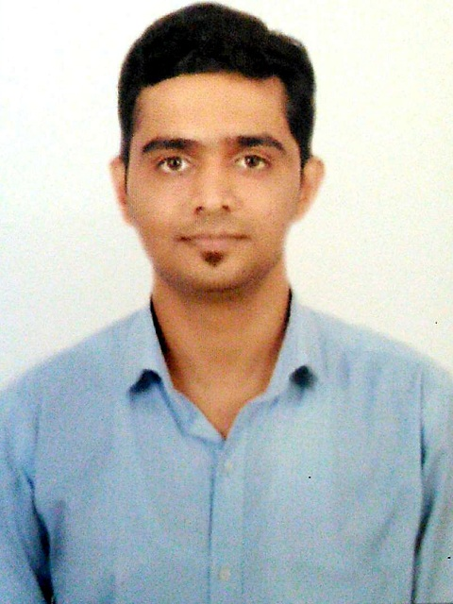
HARSHAL B. PATIL
M.E. Infrastructure Engineering & Management
D.O.B.: 12-Dec-1992
Nationality: India
Location: Amalner, Jalgaon (MH) India
Mobile: +91 8830115865 / 9881181198
Email: hbpatilonline@gmail.com
Indian Passport no: S8317340

OBJECTIVE

To secure a challenging position in a reputable organization to expand my learnings, knowledge and skills.

PROFESSIONAL EXPERIENCE

- Working as Digital Marketing Executive, Admission Counselor and Assistant Professor at G.H.Raisoni Institute of Engineering and Management, Jalgaon from September 2016
- Famous Website Owner – www.emotionalhaunt.com
www.onlinemsbte.home.blog
www.jeestudy.home.blog
- Involving in brain storming sessions for admissions, revenue generation and best practices
- NAAC files preparation for criteria IV and VII
- Autonomy files Preparation
- Search Engine Optimization, Social Media Marketing, Google Analytics
- Effective and meaningful communication made with all types of stakeholders and future admission target with help of digital marketing
- Worked as departments AIMS coordinator (Academic Institutional Monitoring Software)
- Worked as Officer In Charge in MSBTE examination
- Effective use of software and apps for teaching learning process

EDUCATION

Year | Degree | Institute | Class
2018 | Masters of Engineering  Infrastructure Engineering and Management | SSVPS’s B.S. Deore College of Engineering, Deopur, Dhule (M.H) | First Class
2015 | Bachelor of Engineering  Civil Engineering | R.C.Patel Institute of Technology, Shirpur, Dhule (M.H) | First Class with Distinction
2012 | Diploma  Civil Engineering | Smt.S.S.Patil Institute of Technology, Chopda, Jalgaon (M.H) | First Class
2009 | Secondary School Certificate | G.S.Highschool, Amalner, Jalgaon (M.H) | First Class

TRAININGS FROM IIT BOMBAY
- Pandit Madan Mohan Malaviya National Mission on Teachers and Teaching, Twenty days Induction Training Program organized at IIT Bombay for top 120 teachers from all over India.
- Faculty development program (FDP 101X) Foundation Program in ICT for Education by IIT Bombay T10KT project
- Effective and Efficient Online Teaching in the Age of Corona, A Hands On Workshop on 23 May 2020 organized by IIT Bombay

Digital Marketing Certifications for Google Digital Garage, Udemy and E Marketing Institute

PUBLICATIONS
- Implementation of an Ideal Irrigation System to Cover Deficit of Crop Water Need for Khandesh Region Published in International Journal of Civil Engineering and Technology (IJCIET) Volume 8, Issue 2, February 2017, pp. 631–641 Article ID: IJCIET_08_02_065
- Design Considerations for Flexible Pavements in Water Logged Area Published in International Journal Of Engineering Sciences & Research Technology June 2017
- Design Consideration for Flexible Pavement in Waterlogged Area (Nimzari Naka to Nimzari, Shirpur, Maharashtra) Published in IJSRD International Journal for Scientific Research & Development| Vol. 5, Issue 05, 2017 ISSN (online): 2321-0613

Declaration
I do hereby declare that the above mentioned statement and information are true, complete and concise to the best of my knowledge and belief.

Place:-

Date-

HARSHAL B.PATIL

Please scan qr code to see all documents

