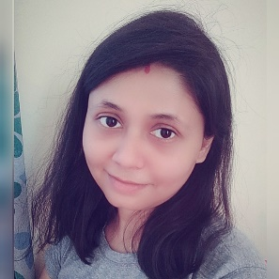

Aditi Ghosh

Contact No: 8655096668 / 7767040328

ghoshmumaditi87@gmail.com

**Teacher :** Creative and passionate teacher, good in involving and motivating students of all ability levels. Like to utilize my skills as well as my interest to teach and educate the young minds effectively and efficiently. Organized and amicable towards the students, seeking for permanent teaching scope.

### 

### Experience

* Two months of experience in teaching during teacher’s training.
* Prior work history in tutoring and guiding students has provided ample preparation for teaching and developed a diverse range of skills.

### Education Qualification

* 2013 : **Bachelor of Education (B.Ed)** with 70.06% from The University of Burdwan
* 2011 : **Masters in English (M.A.)** with 54.25% from IGNOU
* 2009 : **Honours in English (B.A.)** with 53.25% from The University of Burdwan
* 2006 : **Higher Secondary Examination (H.S.)** with 79.50% from West Bengal Council of Higher secondary Education (WBCHSE)
* 2004 : **Secondary Examination (Madhyamik)** with 83% from West Bengal Board of Secondary Education (WBBSE)
* 2012 : **Training in Information Technology Application** with A+

### Highlights

* Creative
* Communicative
* Enthusiastic
* Rational
* Optimist
* Active Listener
* Punctual
* Leadership
* Inter-personal Skill

### Hobbies

* Reading books & articles.
* Singing.
* Watching sci-fi movies.
* Learning different languages.
* Gathering knowledge about unknown and mysterious things.

Language known

* English, Bengali, Hindi