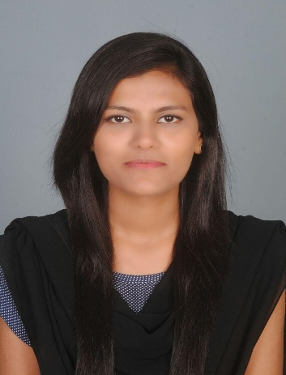

**AMBREEN IFTIKHAR**

**Contact No:** +91 7982949570 **Nationality:** Indian

**Email:** [ambreenali13@gmail.com](mailto:ambreenali13@gmail.com) **Marital Status:** Unmarried

**Date of Birth:** 27 November 1993 **Languages Known:** English, Hindi & Urdu.

**Current Location:** Delhi, India

#### PERSONAL PROFILE

*I see myself as a self-motivated, creative & dedicated, having an analytical frame of mind and an aptitude for problem solving. I value the importance of teamwork and have good communication skills as well.*

***KEY SKILLS:***

*Ability to meet quality standards within the confines and deadlines.*

*Ability to work in fact paced changing environment.*

*Motivated and committed to excellence*

*Proficiency in English.*

***CAREER OBJECTIVE:***

*To utilize my skills towards a challenging career in an organization that will provide continuing opportunities to learn and grow. I intend to be an asset to the organization and serve it in the best possible manner.*

***WORK EXPERIENCE:***

* *Successfully completed three months Internship at Human Resource Shared Service, Al Futtaim International Holding Group, Jeddah, KSA from 3rd June 2016 to 3rd August 2016.*

1. *Working on SAP system.*
2. *HR Planning.*
3. *Customer Relation Management*
4. *On boarding*
5. *Off boarding*
6. *Workforce management*

***ACADEMIC QUALIFICATION:***

* *PhD in Human Resources Mangement from Lovely Professional University, Punjab (Pursuing)*
* *Masters of Commerce(M.com) From IGNOU( pursuing) 2018-2020*
* *Diploma In International Business from IGNOU 2019.*
* *MBA from FMSR, Department of Business Administration, AMU, Aligarh, U.P. INDIA.*
* *B. Com from Women College, AMU, Aligarh, U.P. India in 2015.*
* *12th from C.B.S.E. (IIS Riyadh, KSA) in 2012*
* *10th from C.B.S.E. (IIS Riyadh, KSA) in 2010*

#### SOFTWARE PROFICIENCY:

* *Diploma in Tally : Aligarh Muslim University, Aligarh, U.P. India in 2013*
* *Diploma in MS Office : Aligarh Muslim University, Aligarh, U.P. India in 2014*
* *Operating Systems : MS-Windows-98, Windows-2000, Windows-XP.*

*Windows 2000 Server, Windows NT4*

* *Packages : MS-Word, Excel, Power Point, Ms-Outlook.*

*Adobe Photoshop, Adobe Acrobat,*

*Tally.*

***EXTRA CURRICULAR ACTIVITIES:***

* *Earned appreciation by participating in “Co-curricular Activities” held in connection with “Jamie Campus Across the Sea" on 3rd April 2008.*
* *Has been a Member of Marketing & Hospitality at “Recrufest' 16’, The Mega-Job Expo" organized by Internal Quality Assurance Cell and Training & Placement Office (General), held at Aligarh Muslim University, Aligarh on 2-3 April 2016.*
* *Has been Captain of Chess Team for the years at Sr. Secondary Level.*
* *Has been Captain of Basket Ball at Sr. Secondary Level.*
* *Has been Captain of Table Tennis at Sr. Secondary Level.*
* *Has been an active member of the College Student Union*
* *Debate winner at College.*
* *Hosted various important College and Society’s Functions and Events.*

***Declaration:***

***I do hereby declare that the facts stated above are true and correct to the best of my knowledge*.**

**PLACE: Delhi. India**

**DATE: 22February 2020. (AMBREEN IFTIKHAR)**