**CURRICULUM VITAE**

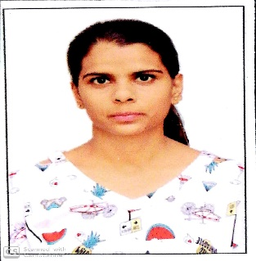

**Name -** ARCHANA MEENA

**Date of birth-** 06-Nov-1997

**Place of birth-** Sawai Madhopur , Rajasthan

**Address-** Archana Meena D/o Mr. Ram Khiladi Meena

Plot no. 30, Raj Vihar Colony, Sawai Madhopur - 322001

**College-**  Govt Women Engineering College, Ajmer

**Contact No-** 9785110268

**Email-** archanameena67gmail.com

**Education-**

|  |  |  |  |
| --- | --- | --- | --- |
| **Program** | **Instituition** | **Percentage** | **Completion year** |
| Bachelor of technology | Govt.women engineering college ,Ajmer | 65% | 2019 |
| 12th | Kendriya Vidyalaya no.1 Kota | 76% | 2015 |
| 10th | Kendriya Vidyalaya no. 1 Kota | 83.6% | 2013 |

**Training project –**

**Title -**Telecommunication

**Duration-** May2018-July2018

**Company name –** Arden telecom private limited, Jaipur

**Description –** BTS, GSM installation ,4G network .

**Academics project –**

**Minor project –** propeller clock with Arduino nano

**Major project** – advance propeller clock with Bluetooth

**Leadership and teamwork-**

Volunteer in TAKSH 2k15

Sub head in DJ & sound in epistemico 2k17

Sub head of Refreshments committee in freshers 2k16

**Achievements**

Secured first position in kabaddi (spardha 2k16) at IIT BHU

Secured first position in kabaddi (spardha 2k17) at JK LAKSHMIPAT UNIVERSITY

**Extra-curricular**

Active member of Scouts and Guide

Participate in” ENTERPRENEURSHIP AWARENESS CAMP”

Participate in COMET 16

**Skills**

C, C++, html(basic), MS-office