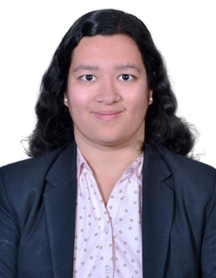

|  |
| --- |
| **Jaee Jogalekar** |

***MBA – Human Resource***

***Career Objective:***  To gain experience for acquiring skills and knowledge in Human Resource Department.

|  |  |  |  |  |  |  |  |  |  |  |  |
| --- | --- | --- | --- | --- | --- | --- | --- | --- | --- | --- | --- |
| 9527297435  himajogalekar7@gmail.com  https://www.linkedin.com/in/jaee-jogalekar-b768421a0  **SKILLS**  Communication skills  Leadership skills  Innovation skills  Presentation skills  **INTERESTS**  Cookery  Literature.  Arts  Psychology  Diving  **LANGUAGE**  English  Hindi  Marathi | **ACADEMIC PROFILE**   |  |  |  | | --- | --- | --- | | MBA | Pursuing | 7.4 SGPA | | Bachelor in Hotel Management | 2019 | 73 % | | HSC (VOC) | 2015 | 73% |   **WORK EXPERIENCE**   |  | | --- | | Vivanta by Taj, Blue Diamond, Pune(6 Months)  Intern (Department of HR & Operations)  Magna Global Pvt Ltd. ( Two Months)  Internship in HR (Recruitment).  The Catalyst  Role of Junior HR executive. (September – November 2020) |   **CERTIFICATIONS**  1.Award Winning Certification of (PUMBA)Druv 2020 for Marketing Wizard.  2.Second Runner up in Personality Contest, (IMRT), Nashik.  3.Excellence Certification of Taj Blue Diamond.  4.Online Certification of Leadership and management program, Elearning.  5. Poona Girls Sports Certificate.  6. Personality development Course, Bhonsala Military.  **EXTRA CURRICULAR**  1 **Publication:** International Research Paper ; VUA Conference, Hungary.  2 Shayari and Poetry writing.  3 Welfare Catering.  4 Active Participation in HR Summit, SPPU, Nashik.  - Role of Industrial Relations (Company relations, Internal relations)  - Hosted Hospitality Department  - Role in Guest Handling & Guest escorting. |