**Resume**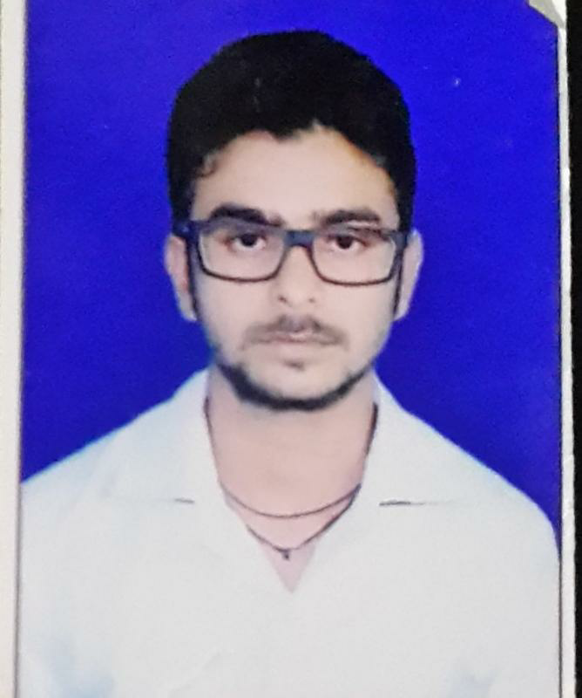

**Karan Raj Sinha**

**Address :**

Street:137,BD:-70, Flat A2,

Narkel Bagan, Newtown, Kolkata -700156

**Mobile No:** 91-7979732450

**Email-id:** karansinha854@gmail.com

**CURRENT JOB:**  **Full Stack Developer at Tata Consultancy Services, Kolkata-156, India (**2017-Present**).**

## **OBJECTIVE**

To become an efficient Software Professional in a highly competitive technological world where performance is rewarded with new challenging responsibilities and to serve a reputed growth oriented industry in the field of Design, Development and Maintenance.

## **PROFESSIONAL SUMMARY**

* 3 + solid work experience in Java Technologies in the areas of Analysis, Development and Maintenance.
* Web development skills using Java,J2EE, Spring Boot, Servlets, JSP..
* Having hands-on experience in UI technologies like Angular 8, JSP,Bootstrap, HTML.
* Having hands on experience in writing JUnit test cases, Content deployment (ICMS), Knowledge transfers and Business analysis.
* Good working knowledge on Application development and maintenance life cycle process.

## **PROJECT SUMMARY**

**Project Name:** **Digital Enhancement and Development**  
**Client:** US Based Client  
**Role:** Application Developer   
**Technology Used:** Java, J2ee, JSP, Spring  
**IDE and Tool used:** Eclipse, STS, Putty, WinSCP ,JIRA.  
**Duration:** Dec 2017- till Date

**Description:**

We have enhanced, maintained and migrated an old Online Net Banking System of our client to the latest technology (Angular with Spring boot). In this system customers will do all types of online transaction, viewing statement and many other functionalities. Mostly we worked on an offer project, In which specific customers will get specific offers depending upon the type of transaction.

**Responsibilities:**

* Participating in client calls and involved in the requirement gathering from the clients.
* Requirement Analysis, Design and Development.
* Responsible for Coding Action and POJO Classes, Implementing Business logic.
* Writing JUnit Test Case, Code Deployment and Bug Fixing.
* Responsible for Managing Content Using ICMS Tool.

## **TECHNICAL PROFILE**

* **Java Technology:** Spring Boot,Rest services, Servlet
* **FrameWorks:** Spring.
* **Languages:** JAVA, JAVA8, C .
* **Web Technology**: HTML, Angular 8
* **Operating Systems:** Windows Family.
* **IDE:** Eclipse, STS, and NetBeans.
* **Tools:** Putty, WinSCP, JIRA, Nexus, and ICMS,Postman, ServiceNow

## **EDUCATIONAL PROFILE**

|  |  |  |  |  |
| --- | --- | --- | --- | --- |
| **QUALIFICATION** | **SCHOOL/COLLEGE** | **BOARD/UNIVERSITY** | **YEAR OF PASSING** | **PERCENTAGE** |
| MCA | Ignou University | Ignou University | 2020 | 68.1%(till 5th sem) |
| BCA | St. Xavier’s College,  Ranchi | RANCHI UNIVERSITY | 2016 | 77.84% |
| 12th | St. Xavier’s College,  Ranchi | RANCHI UNIVERSITY | 2013 | 75% |
| 10th | Rotary School | CBSE | 2011 | 9.4(CGPA) |

## **COLLEGE/ILP PROJECT**

* **OFFICE PROJECT :**  “ I have been awarded by my client for making 2 Process improvement applications which solves the roadblock facing in every release”..
* **PROJECT-ILP (2017): “**Kolam Designing using python**” .**
* **INC REPORT TOOL : “** This application generates reports for all the modules in my project.”
* **PROJECT-COLLEGE (2013-2016):**“Banking Application/ Online Tutor Communication.”

## **SKILLS/INTEREST**

* Result oriented developer
* Coding
* Agile
* Dedicated and highly ambitious
* Website Designing and Editing

## **PERSONAL PROFILE**

**Name**: Karan Raj Sinha

**Date of Birth**: 17-08-1995

**Relationship Status**: Unmarried

**Nationality**: Indian

**Languages Known**: Hindi and English.

**Mobile No**: 91-7979732450

**DECLARATION**

I hereby declare that the above written particulars are true to the best of my knowledge and belief.

Date: 17-05-2020

Place: Kolkata Signature: Karan Raj Sinha