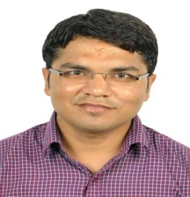

**LAXMINARAYAN CHARAN**

Mobile: +91 - 7710012751

E-Mail: Ln.charan28@gmail.com

**SOFTWARE DEVELOPMENT ENGINEER**

Offering 2.5 years experience in Software Development using Microsoft Technologies such as ASP.Net C#, WCF and MS SQL Server

**PROFILE SUMMARY**

* Expertise in development & implementation of Web based Applications using Microsoft.NET (3.0, 3.5 & 4.0) and Microsoft SQL Server 2005, 2008 & 2008 R2.
* Proficient in Microsoft SOA such as WCF.
* Proficient in Software Development Life Cycle, with accountability of Requirements of Gathering, Programming, Production Support, Debugging, Troubleshooting, & Maintenance.
* Excellent track record of handling high profile client located across 100+ countries across the globe.
* Sincere & self-confident team player with excellent analytical, logical reasoning, communication & troubleshooting skills and strong work ethics.
* **Two years+** of experience in **working in a team**, helping the team members to overcome the technical challenges and making efforts to learn from them also**.**

**TECHNICAL SKILLS**

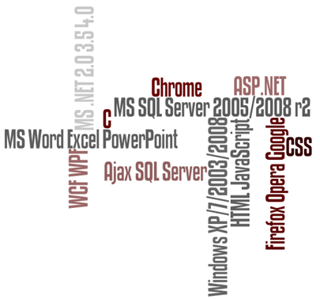

**Languages**: C#, ASP.NET, WCF, Ajax, HTML, JavaScript

**Technologies**: Microsoft .NET 2.0, 3.5, 4.0, CSS

**Databases**: MS SQL Server 2005/2008/2008 R2

**Tools**: Visual Studio 2010, Team Foundation Services **Operating Systems**: Windows XP, Windows 7, Windows 2003/2008 Server

**Office Applications**: Microsoft Office (Word, Excel and PowerPoint)

**Browsers**: Internet Explorer, Firefox, Opera, Google Chrome

**WORK EXPERIENCE**



**Since DEC’12 with Tata Consultancy Services, Mumbai as Software Developer**

**PROJECT EXPERIENCE**

**Visa Facilitation Services (VFS) Global Role - Developer**

**Client:** VFS Global (Visa Facilitation Services)

**Period: 2+** years

**Team Size:** 15

**Platform:** ASP.NET c# 3.0/3.5/4.0 (Visual Studio 2010/2008/2005), WCF

**Database:** SQL Server 2005/2008/R2

**Client Profile:** VFS Global is a global Outsourcing and Technology Services Specialist catering to diplomatic missions & governments worldwide. The company provides Visa Issuance related administrative and non-judgmental services, standing as a middle-man between the visa applicant and embassies (decision maker and issuer). VFS serves 50 diplomatic missions in 100 countries worldwide, handling over 10 million users every year.

**Project Scope**: The project involves designed & development of the following modules

Create Appointment

Submit Documents and Fill Form at VFS Application Centers

Scan Documents & Transfer Details from VFS Application Center to VFS Operation Center and from VFS Operation Center to Embassy

Track Appointment by User

**My Role**:

Analyzing and modifying existing codes to incorporate changes in the application / user requirements.

Writing new codes as required.

Identifying the bugs and resolving the same.

Solving the performance related issue by optimizing query etc.

Developing SQL Procedures, Functions, Views, Triggers, Indexes, Jobs etc.

Providing post deployment support to the client.

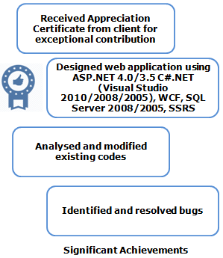**Accomplishments**:

* Received Appreciation Certificate(TCS GEMS) for outstanding contribution to current project “VFS Global”
* Participated in daily defect meetings with the Project Manager and Development Team; identified gaps and suggested relevant solutions
* Analyzed and modified existing codes to incorporate changes in the application / user requirements, wrote new codes as required

**E-Recruitment Role - Developer**

**Tools/Technologies**: ASP. Net with C#, Visual Studio 2010, SQL Server 2008,TFS

**Duration**: 3 months

**Team Size**: 6

**Description**:

This is a web application designed using Verification and Validation model (commonly known as V&V) for company employees to raise vacancy requests and recruitment requests and edit details of placement consultants. The application was designed for the automation and faster processing in the recruitment process of any organization.

**Responsibilities**:

Six tier architecture and Unit testing of modules of the application using .Net Framework, Visual Studio, SQL.

Defect tracking& fixing in TFS.

**EDUCATION**

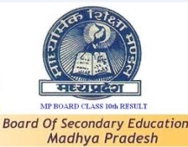

* Bachelor of Engineering (Computer Science) from RGPV, Bhopal with 70% marks in 2012
* 12th from Excellence School, Neemuch, MP with 80% marks in 2007
* 10th from Excellence School, Neemuch, MP with 79% marks in 2005

**ACADEMIC PROJECTS**

**Title:** Online National Polling

**Period: 1** Year

**Role:** Software Developer

**Platform** ASP.NET c# 3.5 (Visual Studio 2008), SQL Server 2005

**Scope:** The goal of this system is to make Complete Election process online. This is accomplished from voter id generation, candidate nomination, verifying candidate and General user details, casting vote and declaring result.

**EXTRACURRICULAR ACHIEVEMENTS**

* Attended training session and certified on IBM DB 2 tool and RAD tool for web sphere software.
* Attended the Workshop of Certified Ethical Hacking(Level-1).
* Received TCS GEMS for outstanding contribution.
* Member of Scouts and Guides group in school.

**PERSONAL DETAILS**

Date of Birth: 12th Aug 1989

Address: Flat no 726, B-wing, Omkar C.H.S, MIDC road no 19, Behind Suncity hotel, Andheri (East) Mumbai-400093.

Passport No: K5658486

Languages Known: English and Hindi