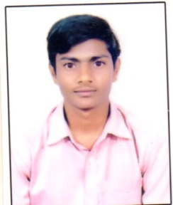 **MALLA VENKATA CHELLARAO**

[Malla.venkatachellarao1997@gmail.com](mailto:Malla.venkatachellarao1997@gmail.com)

Ph.no:8297393693

**EDUCATION**

**Bachelor of Technology, Mechanical Engineering Completed, May 2018**

Avanthi Institute of Engineering and Technology, JNTUK Marks 67%

Narsipatnam, Visakhapatnam, Andhrapradesh

**Intermediate, M.P.C Completed, April 2014**

Sri Sai Junior College, Board of Intermediate(B.O.I) Marks 81%

Kotananduru, Tuni, Andhrapradesh

**High school, S.S.C Completed, April 2012**

Z.P.H.School, State Board Marks 77%

Boddavaram, Kotananduru, Tuni, Andhrapradesh

**EXPERIENCE**

Quality Assurance Enginner at Srinivasa Engineers Pvt Ltd,Hyderabad(July 2018 to January 2020 worked on here)

**SKILLS**

Work Dedication

Time Management

Self Motivation

Good Computer Skills

AutoCAD

**LANGUAGES**

Telugu

English

Hindi

**PERSONAL DETAILS**

Father’s Name: Mr.Peda jogeswararao Marital Status: Single

Birthday: June 10,1997 Nationality: Indian

Gender: Male

**ADDRESS DETAILS**

D.No:1-209, Boddavaram Village and Post, Kotananduru Mandalam, Tuni, Rural

East Godavari District, Andhrapradesh-533401

**PROJECTS**

**1.Mini Project Title: Design and Fabrication of Shock Absorber Springs**

**2.Project Title: Davis 90 degrees Steering Gear Mechanism for Parallel Parking of Battery Car**

**3.NCL,DCL,TENOVA,TATA,ADCL and Thyssenkrupp projects are like chutes,structures,shoring boxes, supporting coils,corner angles,columns and floor beams are fabrication should be done as per on the drawing with good quality of these projects**

**DECLARATION**

I, MALLA VENKATA CHELLARAO, hereby declare that the information contained herein is true and correct to the best of my knowledge and belief.

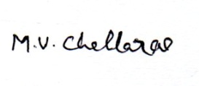

Place:

Date:

**MALLA VENKATA CHELLARAO**