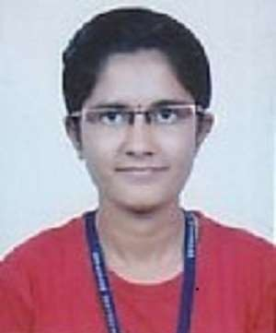

BHATT MANSHRIBEN B.

ADDRESS:C-693,street no 7,opp.varahi book store, kaliyabid,ramnagar,Bhavnagar,364001, GUJARAT, INDIA.

CONTACT: Mobile: **+ 91 9374781083/9374119393**

* E-Mail id : b [ileshkumarbhatt@gmail.com](mailto:ileshkumarbhatt@gmail.com)

m [anashribhatt@gmail.com](mailto:anashribhatt@gmail.com)

## C areer Objective:

To Work In A Challenging Environment, Demanding All My Skills And Efforts To Explore And Adapt Myself In Different Fields And Realize My Potential Where I Get The Opportunity For Continuous Learning.

## A cademic Profile:

|  |  |  |  |  |  |
| --- | --- | --- | --- | --- | --- |
| **Qualification** | **College** | **UNIVERSITY/BOARD** | **STREAM** | **YEAR OF PASSING** | **RESULT** |
| M.E | Santilal Shah Government Engineering college, Bhavnagar. | Gujarat Technological University | Electronics & Communication | 2020 | SPI  (Up to 3rd sem)  9.67/10 |
| B.E | Government Engineering college, Bhavnagar. | Gujarat Technological  University | Electronics &  Communication | 2018 | CGPA  8.75/10 |
| 12th | Swaminarayan Gurukul High School, Bhavnagar. | G.H.S.E.B | Science | 2014 | 69.00% |
| 10th | Swaminarayan Gurukul School, Bhavnagar | G.S.E.B | - | 2012 | 79.00% |

**E ducational Experience:**

**Organization**: Government Engineering College, Bhavnagar.

**Project Title**:

1. **Automatic Fire Alarm (BE 5th sem)**
2. **Touch Screen Based Ordering System (BE 7th & 8th Sem)**

**Organization**: Santilal Shah Engineering College, Bhavnagar.

**Project Title**:

**1. Design and Simulation Of Band Pass Filter For S and C band(ME 4th running)**

**Technical Skills:**

|  |  |
| --- | --- |
| Programming  Languages | C, Embedded C, Assembly Language, HTML. |
| Software  Knowledge | MS-Office, HFSS,ADS,CST. |
| Operating System | Windows, Linux. |

**Area of Interest:**

* Networking
* Web designing
* Communication

# Hobbies:

* Reading.
* Travelling.
* Social Activity

# Personal Details:

* Date of Birth : 28rd August 1997
* Father`s Name : Bileshkumar V Bhatt
* Mother’s Name : Chintanben B Bhatt
* Languages known : Gujarati, English, Hindi.
* Nationality : Indian.
* Mobile No : 9374781083