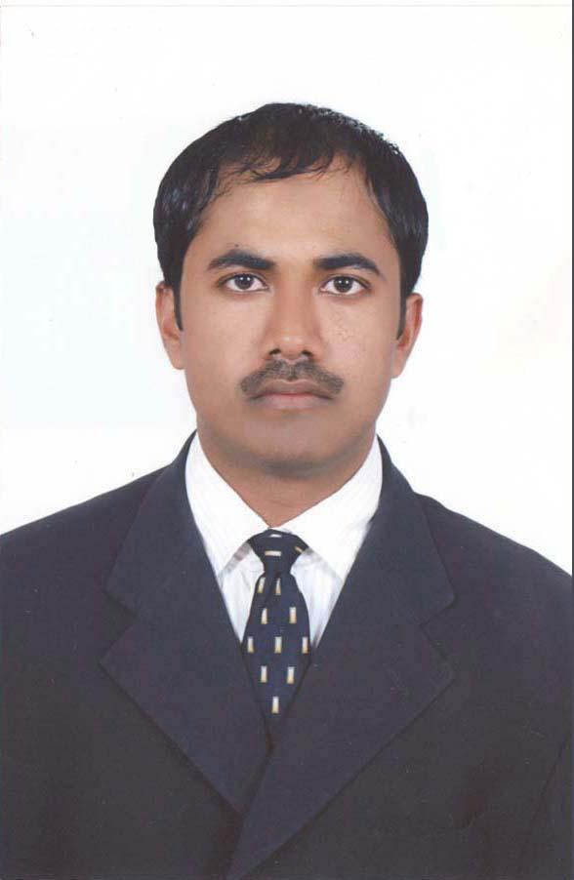

Dear Sir/Madam

I wish to offer my humble candidature with the aim of seeking the required position in your prestigious and highly esteemed establishment.

It is highly imperative on my part to brief you about my professional background and myself. I seek pleasure in introducing myself as **Masroor Husain, 3 Years Diploma in Civil Engineer** from Delhi Institute of Engineering Studies, Delhi. and thus posses the requisite academic and professional profile to serve any organization.

Enclosed, please find my Curriculum Vitae, for your kind personal and favorable consideration. In case, my profile suits your job requirement, I will be happy to follow the procedure of appointment.

I assure you that you will find me person who can go beyond the usual and ordinary to achieve the targets and goals with an understanding of its implementation in future.

Waiting for a suitable response and hoping your best regards.

 Thanking you in anticipation,

Yours Faithfully,

                .   Masroor Husain

**CURRICULUM VITAE**

**Masroor Husain ADDRESS:-**

Street – Vijay Vihar, Phase-1

Mob: - +917417682586, +919528006272 Rohini, Sector – 5

E-mail:- husainalarrab@rediffmail.com City - Delhi

[husainsbg@gmail.com](mailto:husainsbg@gmail.com), husainsbg2@gmail.com

[husainalarrab@yahoo.com](mailto:husainalarrab@yahoo.com), husainbaigintl@yahoo.com

# *PROFILE*

● I am a committed person who believes in hard work, dedication,

loyalty towards work, flexible & a team man.

● Proficient with the use of Windows, MS Office and the Internet.

# *OBJECTIVE*

● Seeking challenging position in **field** with growing

Organization that can enable to me apply my knowledge, skill

and experience in the best interests of organization to further

my personal and organization goals.

# *EDUCATIONAL QUALIFICATION*

**Degree**  **College**  **Result**

● **B.A M.J.P.R (University) Pass**

**● 10+2 U.P Board Pass**

**● Matriculation U.P Board Pass**

# *PROFESSIONAL QUALIFICATION*

● 3 Years Diploma in Civil Engineer from Delhi Institute of Engineering Studies

Delhi.

● Diploma in Computer Auto Cad From CAD DESIGN Institute at Dehradun.

● Diploma in Computer Revit Architecture From CADD CENTRE Institute at Delhi.

● Diploma in Computer 3ds Max From CADD CENTRE Institute at Delhi.

● Diploma in Computer Software MS Office & Desktop Publishing from CTRI

Computer Institute at Chandpur.

● Expert in Data entry.

● Expert in M S Office, Corel Draw, Page Maker 5.0,Page Maker 6.5. Page

Maker 7.0, Photoshop.

● Expert in Auto Cad Civil, Architectural, Structural & Electromechanical.

● Knowledge of Coordination with Mechanical & Structural Drawing.

● Knowledge of Read and Work on Architectural Drawing.

● Knowledge of Read and Work on Structural Drawing.

● Knowledge of Read and Work on Mechanical Drawing.

● Knowledge of Read and Work in (QC) Qantity Control Department.

● Knowledge of Serveyor Work in Building Field.

● Knowledge of Design Drawing & Shop Drawing.

● Expert in Typing Hindi, English, Urdu.

# *WORK EXPERIENCE*

**●** 4 Years Experience AutoCAD Draftsman (Structural Department) From 09-03-2012 to 29-02-2016 in Saudi Binladin Group Company in Saudi Arabia (Project - Haram Expantion Makkah).

**●** 3 Years Experience in AutoCAD Draftsman (Architectural Department) from 11-06-2008 to 20-06-2011 Al- Arrab Trading And Contracting Company in Doha Qatar (Project - The Pearl Qatar).

● 15 Months Experience Auto Cad (Civil) from 01-03-2016 to 31-05-2017 CAD DESIGN STUDIO Dehradun.

● 1 Years Experience Auto Cad (Module Design) from 01-06-2018 to 1-06-2019 Kroma Digital Service Pvt. Ltd. Delhi.

**●** 1 Year Experience Site Engineer Baig International Company Riyadh Metro Project Saudi Arabia (Project – Riyadh Metro).

**●** 1 Year Experience Civil Engineer Abdullah E. Al Jaidah & Sons Company Doha Qatar.

● 18 Months Experience Auto Cad (Civil) from CAD DESIGN STUDIO Dehradun.

● 6 Months Experience Auto Cad (Electro Mechanical) from RANIKESH HI TECH EQUIPMENTS PVT LTD Gurgaun (Haryana).

● 3 years Experience in Desktop Publishing from CTRI Computer institute at Chandpur.

● 6 Months Experience as a computer operator in Denik Jagran News Paper Chandpur.

# *COMPUTER SKILL*

**● Operating System :**  Microsoft Windows 98/ 2000 Server and professional

/XP/Vista Windows 7

**● Application :** MS-Office 2000, XP, 2000 and 2007. Microsoft Office

Outlook 2003. Outlook Express

# *LINGUISTIC SKILL*

**Language Read Write Speak**

**English**  Yes Yes Yes

**Hindi**  Yes Yes  Yes

**Urdu** Yes Yes Yes

**Arabic** Yes Yes Yes

# *PASSPORT DETAILS*

**● Passport No :** M 5748983

**● Date of Issue :** 03-06-2015

**● Date of Expiry :** 02-06-2025

**● Place of Issue :** Jeddah

# *PERSONAL DETAILS*

**Father’s Name --** Mr. Marghoob Husain

**Date of Birth --** 25/July/1984

**Gender --** Male

**Marital Status -- M**arried

**Nationality --** Indian

**Religion --** Islam

# *HOBBIES*

● Playing Cricket & Listen to Music.

● Playing with computer and working on it.

I hereby declare that all the information’s furnished above are correct and true to the best of my Knowledge and belief

**Date ……….**

**Place ……… (Masroor Husain)**