

**iFieldSmart Technologies.**

**Get onboard today with iFieldSmart Technologies**

**----**

Use your field hours better with advanced **construction management software.**

**A simple and intuitive construction**

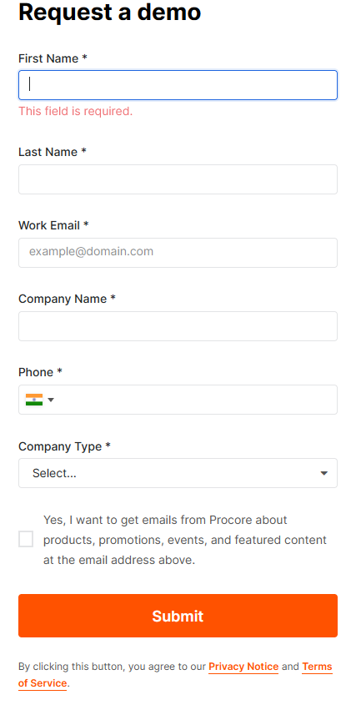

**management dashboard built for the field.**

The adaptability of the iFieldSmart Technologies platform

supports multiple solutions and products with updated data

streaming to connect projects and people across global corners.

**Take complete control of your onsite activities.**

Empower your drawings with proactive sheet management, take

task management to another level, drive improved RFI and Submittal

management, leverage construction coordination at its best, and much

more – do it all on an easy-to-use dashboard.

**Powerful integrations to simplify your workflows.**

Enrich your construction management processes with integrations

to reinforce your field outcomes. Leverage dynamic integrations like

Procore, BIM360, Zapier, Revit, Navisworks, and Outlook on a single view

Screen.

**Tailor-made for demanding construction projects by**

**construction experts.**

With more than a decade of AEC experience, we’ve worked with numerous

clients to focus our efforts on **resolving field challenges -** driven by simplicity

and value. We listen to industry experts to expand our **construction management**

**software** – Deploy our app in a matter of minutes & stay organized on your laptop,

mobile, or tablet.

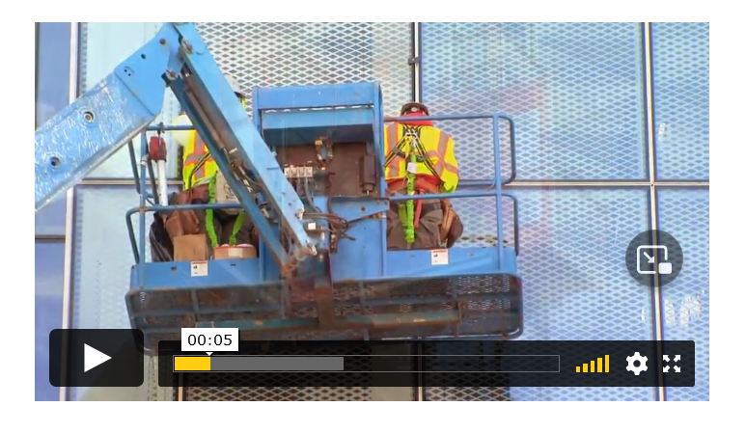

**[**Add video frame here

If you have iFieldSmart

Intro vid.**]**

**We’re here to schedule a demo – Let’s make your onboarding quick and hassle-free.**

**__**

Discover why iFieldSmart Technologies needs to be your construction management app.

**Schedule your demo here.**

[Add button]