**RESUME** 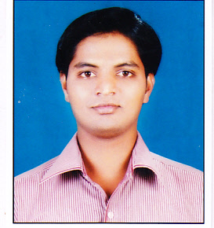

**SAMADHAN BHAGIRATH SABALE** E-mail ID - sameer7194 @rediffmail.com

13, Chinar Ho. So. Icchamani Nagar, Shivaji Mobile No. - 9890705665

Nagar. Jail Road, Nashik Road, Nashik- 422101 8983113017

# OBJECTIVE

Acquire a Human Resources Management position in an organiztion which will require me to apply my business education and HR skills to assist the company in the achievement of its goals.

# Education Qualification

|  |  |  |  |
| --- | --- | --- | --- |
| Education | Institute | University | Percentage |
| **MBA(HR)** | Vishwasattya College of MBA, Ozar, Nashik. | PUNE | 2nd year Appearing |
| **B.COM**  **(Cost & Work Accounting)** | K.K. Wagh College, Nashik. | PUNE | 48 % |
| **HSC** | Aarambha college, Nashik Road | PUNE | 46.83 % |
| **SSC** | V.V.M. High School, Nashik Road | PUNE | 47.20 % |

# SUMMER PROJECT

* **Title : “ABESENTEEISM”** Causes, Effect & Control
* **Organization Name : Liberty Oil Mills**, Shinde Gaon, Nashik.
* **Department :** HR
* **Designation :** Management Trainee
* **Period :** May 2012 – July 2012
* **Duties / Responsibilities :**  **1.** To assist and report the HR Executive,

**2.** To communicate with the employees,

**3.** To suggest the strategies for the organisation

# SOFT SKILLS

* MS CIT : 91 %
* Tally : A+
* Typing (English-30) : 60 %

# STRENGTHS

* Dedication towards work.
* Flexible
* Good team player
* Good communication skill with positive approach.
* Punctuality and time management

# personal particulars

* **Date of Birth** : 23th July, 1989
* **Nationality**  : Indian
* **Gender** : Male
* **Marital Status** : Unmarried
* **Languages Known** : English, Hindi and Marathi
* **Hobbies** : Fond of Travelling

Watching Television.

# EXTRA CURRICULAR ACTIVITIES

* Member of Cricket winning team in inter college competition.
* Member of Inter College Vollyball team.

# Date : K:\SAMEER SIGN.jpg

# Place : Nashik (Samadhan B. Sabale)