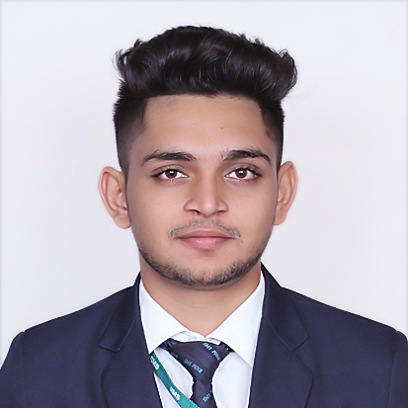

SHUBHAM MAHESH KAISARE

Contact Details:

Current Address: Personal Data:

Flat No. D2-12, Popular Nagar Gender: - Male

Warje Malwadi, Opp. Mai Mangeshkar DOB: -13th Nov. 1996 Hospital, Pune – 411058. E-mail:-shubham.kaisare82@gmail.com

Mobile No: +91-9834322079

Career Objective: -

Opportunity to explore new skills in the field of **Human Resource** enabling me to make positive contribution towards growth of organization.

Professional Qualification:-

**PGDM -** Post Graduate Diploma in Management (AICTE Approved), from International Institute of Management Studies (IIMS Pune) Batch 2017-2019.

**Major ---** Human Resources **Minor ---** Marketing

|  |  |  |  |  |
| --- | --- | --- | --- | --- |
| **Semester** | **1st** | **2nd** | **3rd** | **4th** |
| **Marks (%)** | 67.63% | Pursuing | Pursuing | Will Pursue |

Academic Records:

|  |  |  |  |
| --- | --- | --- | --- |
| **Education** | **University/College Name** | **Year of Passing** | **Result %** |
| Hotel Management | SCHMTT | 2018 | 64 % |
| H.S.C. | SP College/ Pune University | 2014 | 66 % |
| S.S.C. | Rosary High School/ Pune University | 2012 | 78 % |

Professional Experience:-

Company Name: Rubicon Skill Development Limited, Pune.

Designation: Team Lead Sourcing

During: 2nd March’20 till present.

Job Responsibility:

* In the Talent Acquisition department for the first few months, job responsibility included looking at the internal hiring and specific and lateral hiring.
* Later in my 3rd month, I was promoted to Team Lead sourcing where I handled the team of 7 and there I was responsible for managing targets and hiring for the clients.
* Most experience included, people handling, specific hiring, and client management.

Summer Internship Project:-

**Company Name:** Huntsmen & Barons Private Ltd, Pune

**Project Title:** Human Resources Recruitment Research.

**Duration:** 22nd April’ 2019 – 22nd June’ 2019 (2 Months)

**Project Profile:** Recruitment Intern (BFSI Sector)

* Worked for the recruitment department for the firm in core Banking, Finance and Insurance sector.
* Looking and finding suitable candidates fpr the particular required profile.
* Handling the core clients of the firm in the recruitment sector.
* Gain proper knowledge required to the recruitment sector.

Winter Internship Project:-

**Company Name:** Oyo Private Ltd. , Goa

**Project Title:** Working and getting to know the core Human Resources Department.

**Duration:** 12th Nov’ 2018 - 27th Dec’ 2018 (1.5 Months)

**Project Profile:** HR Administration Intern

* Worked for understanding the core functions of the HR Dept.
* Maintaining proper records regarding the employees.
* Understanding the employees.

.

Seminars/Workshops/Conferences:-

* Attended ‘National Start-up and Human Resources Conclave 2K18.
* Attended the workshop named “Finishing School” hosted by Mr. Anand Munshi

Computer Proficiency:

* **Languages:**  Microsoft.NET.
* **Operating Systems:** Windows (XP, 7,8,10)

Hobbies:

* Cricket
* Table Tennis
* Bike Riding

Declaration:-

I hereby declare that the information provided by me is true to the best of my knowledge and belief.

**Date:**

**Place**: Pune ( Shubham Kaisare)