**Solution Analyst**



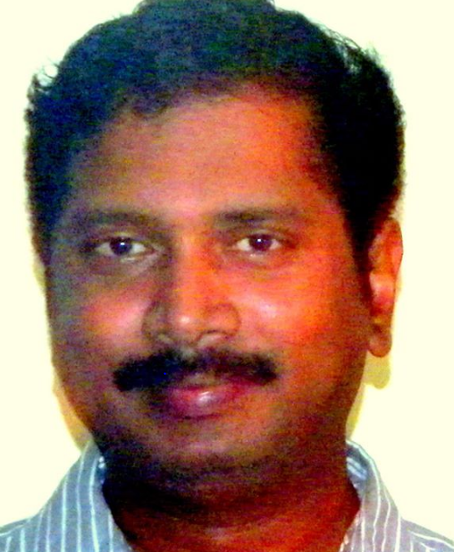

Cell: +91 9945715553

E-Mail: [vasuscm@gmail.com](mailto:vasuscm@gmail.com)

|  |  |
| --- | --- |
| **Name** | **Srinivas Sasikanth** |
| **Residing in** | Bengaluru |
| **Availability** | Immediate |

**Experience Summary**:

|  |  |
| --- | --- |
| SAP Consulting | **11 Years** / 08 Months |
| Production planning & Execution (Indian ordnance factory services) | 09 Years / 05 Months |

**SAP Projects summary**:

|  |  |  |
| --- | --- | --- |
| Type of project | Industry | Number projects =11 |
| Implementation | Process Industry | 02 |
| Implementation | Discreet Manufacturing | 02 |
| Development | Discreet Manufacturing | 02 |
| Development | Process Industry | 02 |
| Global support | Process industry | 02 |
| Global Roll out | Process Industry | 01 |

**SAP modules:**

|  |  |
| --- | --- |
| SAP Module | K-level (K1 to K8) |
| PP | K6: Project implementation manager / Implementation specialist |
| QM | K5: Senior consultant / Management Consultant |
| LE | K4: Consultant 3 |
| PP/DS & EWM | K3: Consultant 2 |
| PM & PS | K2: Consultant 1 |

|  |
| --- |
| Critical Skills |

MRP

Safety stock Planning

Logistics Execution

Back order processing

Batch Management

PI sheet configuration

SAP smart factory

Material Staging

QM sample Management

QM-IDI interface

AGILE methodology

ASAP methodology

GAP analysis Green Field Implementation

WRICEF objects development Solution Architect experience

**Employment Summary**:

|  |  |  |
| --- | --- | --- |
| Employer | Designation / Role | Location |
| Indian ordnance factory | Production Engineer | Nagpur |
| VST- IT projects Wing | SAP Consultant | Hyderabad |
| Zensar Technologies | SAP Consultant | Hyderabad |
| Tech Mahindra | Module Lead | Bengaluru |
| Sigma- Aldrich | Senior Functional Analyst | St. Louis (US) & Bengaluru |
| Cater Pillar | Senior IT analyst | Bengaluru |
| Wipro Technologies | Lead Consultant | Bengaluru |
| Umgeni water | Senior Functional Consultant | Pietermaritzburg (South Africa) |
| Kennametal | Solution Architect | Latrobe (USA) & Bengaluru |
| Merc Pharma | Solution Architect | Bengaluru |

**Project details & Critical deliverables**

|  |  |
| --- | --- |
| **Project # 11** | Global Roll Out & Development |
| **Client** | Merc Pharma (<https://www.merck.com/index.html>) |
| **Employer** | VRD Net Work |
| **Employment period** | 18/09/2019 to 22/05/2020 |
| **Designation & Module** | Solution Analyst – PP, LE, QM, EWM |
| **Role** | Solution Architect |
| **Project duration** | 08 months |
| **Location** | Bangalore |
| **Employment type** | Fixed term Contract |
| Internal Manufacturing with 3PL logistics | |

|  |  |  |
| --- | --- | --- |
| **Project # 10** | Development | |
| **Client & Employer** | Kenna metal (<https://www.kennametal.com/us/en/home.html>) | |
| **Employment period** | 04/02/2019 to 26/07/2019 | |
| **Designation & Module** | Tech. Lead Apps Delivery | |
| **Role** | Solution Architect | |
| **Project duration** | 06 months | |
| **Location** | Latrobe – USA & Bangalore | |
| **Employment type** | Fixed term – Project specific hire | |
| SAP smart factory | | |
| **Project # 0 9** | Development | |
| **Client & Employer** | Umgeni Water (<http://www.umgeni.co.za/>) | |
| **Employment period** | 07/06/ 2017 - 24/12/2018 | |
| **Designation & Module** | SAP Senior Consultant (PP/QM/PM) | |
| **Project duration** | 18Months | |
| **Location** | Durban, South Africa | |
| **Employment type** | Fixed Term Contract | |
| QM-IDI interface | | |
| **Project # 08** | Development | |
| **Name of Employer** | Wipro Technologies (<https://www.wipro.com/>) | |
| **Employment period** | 18 Months (28/09/ 2015 to 03/ 04/ 2017) | |
| **Client** | Schneider Electric (<https://www.se.com/za/en/>) | |
| **Designation & Module** | Lead Consultant (SAP PP/QM) | |
| **Project duration** | 06 Months | |
| **Location** | Bangalore, India | |
| **Reason for Leaving** | Migration to South Africa | |
| Shop floor Control: Order Management | | |
| **Project # 07** | Implementation | |
| **Name of Employer** | Wipro Technologies( <https://www.wipro.com/>) | |
| **Employment period** | 18 Months ( 28/09/ 2015 to 03/ 04/ 2017) | |
| **Client** | Apple. Inc. (<https://www.apple.com/sitemap/>) | |
| **Designation & Module** | Lead Consultant (SAP PP & APO (PP/DS) ) | |
| **Project duration** | 12 Months | |
| **Location** | Bangalore, India | |
| **Employment type** | Permanent | |
| MRP heuristics development & Capacity Planning | | |
| **Project # 06** | Development | |
| **Client & Employer** | Cater pillar (<https://www.caterpillar.com/>) | |
| **Project duration** | 06 Months (23/ 03/ 2015 to 21 / 09/ 2015) | |
| **Designation & Module** | Sr. IT. Analyst – PP& QM | |
| **Location** | Bangalore, India | |
| **Reason for Leaving** | ODC closure | |
| Product labeling: Truck Division | | |
| **Project # 05** | Implementation | |
| **Client & Employer** | Sigma –Aldrich (<https://www.sigmaaldrich.com/canada-english.html>) | |
| **Project duration** | 08 Months (16 /07/ 2014 to 17 /03/ 2015) | |
| **Designation & Module** | Sr. Functional Analyst (PP-PI /QM) | |
| **Project Location** | St. Louis (US) & Bangalore (India ) | |
| **Reason for Leaving** | Fixed term – Project specific hire | |
| “Master recipe” transformation using BODS  PI- Sheet Development | | |
| **Project # 4** | Global Support | |
| **Name of Employer** | Tech Mahindra(<https://www.techmahindra.com/DAVID.html>) | |
| **Employment period** | **2 Years 10 Months** ( 30 / 08/ 2011 to 07/ 07/ 2014 ) | |
| **Designation & Module** | Module lead (PP & APO (PP/DS) & QM) | |
| **Client** | Nestle (<https://www.nestle.com/>) | |
| **Project Location** | Bangalore, India | |
| **Period of Employment** | 2011 – 2014 | |
| **Reason for Leaving** | Seeking new Challenge | |
| Global Support sustenance  Change request management | | |
| **Project # 3** | | Implementation |
| **Name of Employer** | | Zensar Technologies (<https://www.zensar.com/>) |
| **Client** | | ACG- Worldwide (<http://www.acg-world.com/home>) |
| **Designation & Module** | | SAP Consultant (PP/QM) |
| **Project Duration** | | 10 Months |
| **Project Location** | | Mumbai (India) |
| **Reason for Leaving** | | Migration to Bangalore |
| Project MRP & Assemble to order Implementation | | |
| **Project # 2** | | Implementation |
| **Name of Employer** | | Zensar Technologies (<https://www.zensar.com/>) |
| **Employment period** | | 22 Months (24 /09/ 2009 to 16 /08/ 2011) |
| **Employment type** | | Permanent |
| **Client** | | Hyderabad Chemical Limited (<https://www.nichinoindia.com/>) |
| **Designation & Module** | | SAP Consultant (PP/QM) |
| **Project Duration** | | 12 Months |
| **Project Location** | | Hyderabad (India) |
| Batch costing & Batch specific production unit | | |
| **Project # 1** | | Global Support |
| **Client & Employer** | | VST Industries – IT projects wing (<http://www.vsthyd.com/>) |
| **Employment period** | | 18 Months (17 / 09/ 2007 to 31/03/ 2009) |
| **Employment type** | | Permanent |
| **Designation & Module** | | SAP Consultant (PP/QM) |
| **Reason for Leaving** | | Seeking new challenge |
| Global support sustenance | | |
| **Functional experience:** | | |
| **Employer** | | Indian Ordnance Factory (<http://ofbindia.gov.in/>) |
| **Employment period** | | 29/03/1998 to 08/09/2007 (09 years 05 Months) |
| **Employment type** | | Permanent |
| **Location** | | Nagpur |
| **Designation** | | Production and Planning Engineer |
| **Reason for Leaving** | | SAP Consultancy |

**Education**

|  |  |
| --- | --- |
| Degree / Diploma / Certification | Board |
| Degree in Mechanical Engineering | Institute of Mechanical Engineers (India) |
| Diploma in Mechanical Engineering | Board of Technical Education (Karnataka) |
| SCM Solution Consultant – Manufacturing & Planning | SAP -AG |

|  |  |
| --- | --- |
| Indian Passport | Validity: 09/2028 |
| US B1/B1 visa | Validity: 09/2024 |
| South Africa PR | Validity: 12/2023 |