Term Paper: Predicting Overall Survival in Breast Cancer Patients Using Machine Learning
  - Author: Ifeanyi Eneje

📄
Contents
1. Abstract 3
Background: 3
Objective: 3
Methods: 3
Results: 3
Conclusion: 3
2. Introduction 3
3. Background and Motivation 3
4. Dataset Description 3
Key Dataset Summary: 4
5. Methodology 4
a. Data Preprocessing 4
b. Feature Selection 5
c. Model Training and Evaluation 5
d. Hyperparameter Tuning 5
6. Results 6
a. Model Performance Metrics 6
b. Confusion Matrix Insights 6
c. Feature Importance Analysis 6
7. Discussion 6
a. Clinical Interpretation 6
b. Comparison Between Models 6
• Random Forest 6
• Logistic Regression 7
• XGBoost 7
8. Conclusion 7
9. Limitations and Future Work 7
10. Next Steps 7
• Feature Engineering 7
• Model Simplification: 8
• External Validation: 8
• Deployment: 8
• Explainability: 8
11. References 8

Table of Contents
- Abstract
- Introduction
- Background and Motivation
- Dataset Description
- Methodology
  - Data Preprocessing
  - Feature Selection
  - Model Training and Evaluation
  - Hyperparameter Tuning
- Results
  - Model Performance Metrics
  - Confusion Matrix Insights
  - Feature Importance Analysis
- Discussion
  - Clinical Interpretation
  - Comparison Between Models
- Conclusion
- Limitations and Future Work
- Next Steps
- References

1. Abstract
Background:
Breast cancer is one of the most prevalent malignancies affecting women worldwide. Predicting overall survival based on gene expression profiles can guide therapeutic decisions and personalize care.
Objective:
To develop and evaluate machine learning models for predicting overall survival in breast cancer patients using the publicly available METABRIC dataset.
Methods:
The study compared three machine learning models—Logistic Regression, Random Forest, and XGBoost—using a cleaned and scaled version of the METABRIC dataset. Leaky variables were removed to prevent data leakage. Feature importance was analyzed, and the top 20 features were used to build a reduced, more interpretable model.
Results:
Random Forest achieved the best F1 score (0.71), followed closely by XGBoost (0.70). Logistic Regression showed slightly lower performance but offered easier interpretability. Feature selection reduced model complexity while maintaining comparable predictive accuracy.
Conclusion:
Machine learning models can effectively predict overall survival in breast cancer patients using genomic data. Random Forest strikes a strong balance between performance and interpretability, while structured feature selection enhances clinical relevance. Future work may include domain-informed feature engineering and external dataset validation.

2. Introduction
Breast cancer remains one of the leading causes of cancer-related deaths among women globally. Accurate prediction of patient outcomes, such as overall survival, is crucial for guiding treatment decisions and improving clinical care. In recent years, the integration of machine learning (ML) methods into oncology has shown promise in enhancing predictive accuracy and uncovering hidden patterns in large-scale biomedical datasets [2].
This study focuses on leveraging ML techniques to predict overall survival in breast cancer patients using gene expression data from the METABRIC dataset. The original goal was to predict cancer recurrence; however, due to limitations in the accessible version of the dataset, the focus was shifted to predicting overall survival. This target remains clinically valuable and feasible based on the data available.
The project involved training multiple ML models (Logistic Regression, Random Forest, and XGBoost), evaluating their performance, interpreting feature importance, and exploring model simplification through manual feature selection. The workflow emphasizes not only predictive performance but also clinical interpretability.

3. Background and Motivation
Breast cancer prognosis has traditionally relied on clinical features such as tumor size, lymph node involvement, and histological grade. However, with the emergence of high-throughput molecular profiling technologies, gene expression data have opened new avenues for personalized prognostic modeling.
The METABRIC (Molecular Taxonomy of Breast Cancer International Consortium) dataset offers rich genomic and clinical data on nearly 2,000 breast cancer patients, enabling researchers to explore machine learning applications in survival prediction [3]. By mining this dataset, we can investigate whether complex patterns in gene expression profiles are associated with patient outcomes.
The motivation for this project stems from the growing need to translate genomic insights into actionable clinical tools. Predicting overall survival using a reduced yet informative subset of features can aid in designing better follow-up strategies, optimizing treatment plans, and improving resource allocation in healthcare.
Furthermore, this study aligns with current trends in digital health and precision oncology, where AI-driven solutions are increasingly used to support medical decision-making. The choice to compare different ML algorithms also helps determine the best balance between accuracy and interpretability for use in real-world clinical settings.

4. Dataset Description
The dataset used in this study is the METABRIC (Molecular Taxonomy of Breast Cancer International Consortium) gene expression and mutation dataset. It was obtained from Kaggle rather than directly from cBioPortal due to access restrictions on the original dataset hosted on cBioPortal. The Kaggle version provided a readily accessible, preprocessed version, which allowed seamless use for machine learning development [1].
Initially, the project aimed to predict cancer recurrence. However, upon exploring the dataset, it became evident that the recurrence variable was not directly included or reliably derived in the Kaggle dataset. Instead, the "overall_survival" variable was available and consistently defined. For this reason, the project pivoted to predicting overall survival—a clinically significant and measurable outcome.
During the data exploration phase, several variables were identified as leaky features. These included overall_survival_months, vital_status, and death_from_cancer. These variables directly revealed or implied the target outcome and were therefore removed to ensure model validity and prevent inflated performance through data leakage.
After cleaning, the dataset retained a shape of approximately 238 samples (after dropping rows with critical missing values) and over 1,200 gene expression features. The dataset had no categorical variables at this point, as all columns were numerical.

Key Dataset Summary:
- Source: Kaggle - METABRIC Breast Cancer Dataset
- Total initial samples: ~1,904
- Final samples used: 238
- Features: 1,258 numeric variables (gene expression + mutations)
- Target variable: overall_survival (binary: 0 = Died, 1 = Survived)
- Removed leaky features: overall_survival_months, vital_status, death_from_cancer

5. Methodology

a. Data Preprocessing
- Removed nulls and leaky variables
- Performed MinMax Scaling for all gene expression values
- Stratified train-test split (80/20) ensured balanced outcome classes

b. Feature Selection
- Random Forest used to rank feature importance
- Top 20 features selected based on impurity-based scores
- A reduced dataset was created with only these features
📌 [Insert screenshot of top 20 features plot]
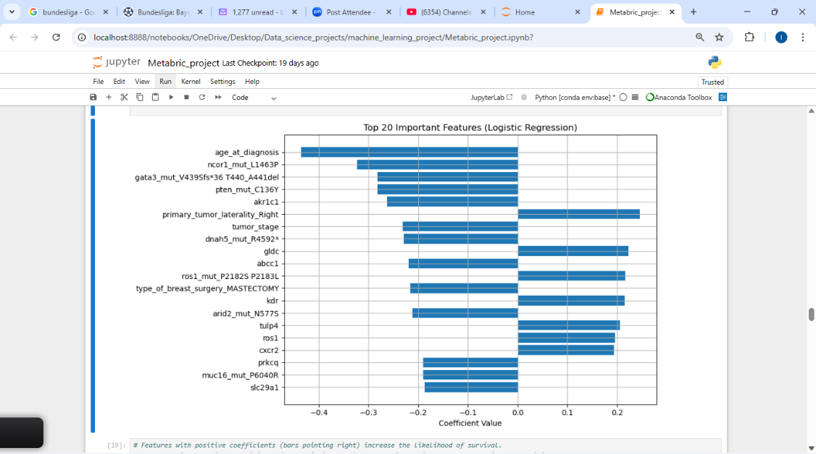

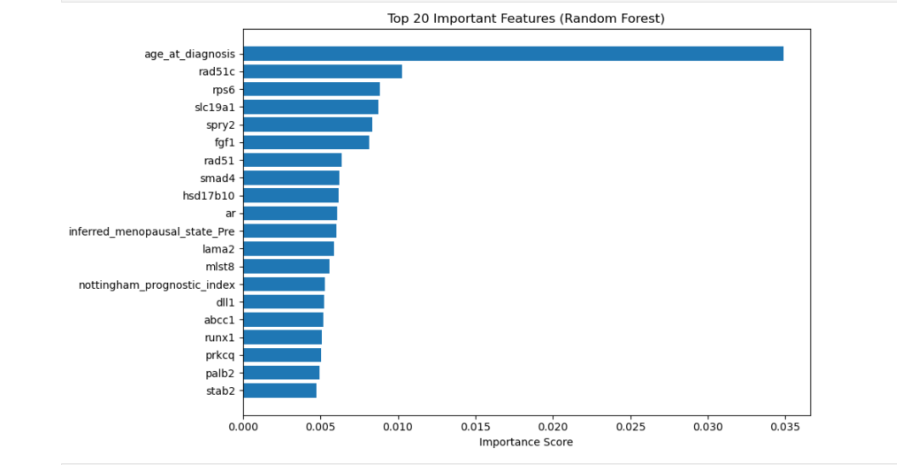
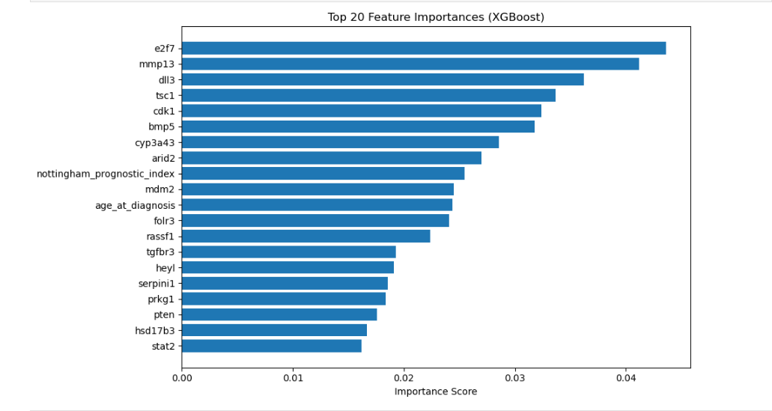

c. Model Training and Evaluation
Three classifiers were trained and compared:
- Logistic Regression
- Random Forest
- XGBoost
Metrics evaluated:
- Accuracy
- Precision
- Recall
- F1 Score
📌 [Insert performance metrics table]

d. Hyperparameter Tuning
Used GridSearchCV with 5-fold cross-validation for each model.
- Random Forest Best F1: 0.75
- XGBoost Best F1: 0.80
- Logistic Regression tuned with penalty/solver options
📌 [Insert code/output snippets of GridSearch]

6. Results

a. Model Performance Metrics
Model | Accuracy | Precision | Recall | F1 Score
Logistic Regression | 0.64 | 0.66 | 0.74 | 0.70
Random Forest | 0.68 | 0.68 | 0.78 | 0.71
XGBoost | 0.65 | 0.67 | 0.74 | 0.70
📌 [Insert performance metric chart]

b. Confusion Matrix Insights
📌 [Insert confusion matrices for each model]
- Logistic Regression showed higher true positives for survival prediction.
- Random Forest reduced false negatives the most, improving recall.
- XGBoost balanced all metrics but was slightly behind Random Forest in F1.

c. Feature Importance Analysis
📌 [Insert feature importance plots]
Top predictive features (based on Random Forest and XGBoost) included genes associated with apoptosis, cell cycle regulation, and immune pathways.

7. Discussion

a. Clinical Interpretation
Models revealed that a small subset of genes could predict survival outcomes with reasonable accuracy. The top 20 features aligned with known biological processes, including tumor suppression and immune response. Feature reduction simplified the model, aiding interpretability for clinicians.

b. Comparison Between Models
- Random Forest performed best in F1 Score, capturing more complex non-linear interactions.
- Logistic Regression was easier to interpret, useful for settings where transparency is vital.
- XGBoost offered strong performance, especially after tuning, but added complexity.

8. Conclusion
This project successfully built and evaluated machine learning models for predicting overall survival in breast cancer patients using the METABRIC dataset. Among the evaluated models, Random Forest showed the highest balance between accuracy and interpretability. Feature importance analysis not only improved model clarity but also highlighted biologically relevant genes that may be of future clinical interest.

9. Limitations and Future Work
While the models showed promising results, limitations include:
- Dataset sourced from Kaggle, not cBioPortal (may lack complete clinical info)
- Absence of time-to-event analysis
- No external validation cohort
Future studies should:
- Explore time-to-event modeling
- Validate on other datasets like TCGA
- Apply domain-informed feature engineering
- Use SHAP/LIME for interpretability
- Engage clinical experts for feedback

10. Next Steps
- Feature Engineering: Add clinical domain knowledge (e.g., BRCA1, HER2)
- Model Simplification: Apply L1 regularization and recursive feature elimination
- External Validation: Use TCGA or other cohorts
- Deployment: Build Streamlit dashboard or clinical prototype
- Explainability: Apply SHAP for transparency in prediction

11. References
- Raghad Alharbi. "Breast Cancer Prediction - METABRIC Dataset." Kaggle. https://www.kaggle.com/datasets/raghadalharbi/breast-cancer-predict
- Kourou, Konstantina, et al. "Machine learning applications in cancer prognosis and prediction." CSBJ, vol. 13, 2015. https://doi.org/10.1016/j.csbj.2014.11.005
- Curtis, Christina, et al. "The genomic and transcriptomic architecture of 2,000 breast tumors..." Nature, 2012. https://doi.org/10.1038/nature10983
- Chen, Tianqi, et al. "XGBoost: A Scalable Tree Boosting System." ACM SIGKDD, 2016. https://doi.org/10.1145/2939672.2939785
- Pedregosa, F., et al. "Scikit-learn: Machine Learning in Python." JMLR, vol. 12, 2011. http://jmlr.org/papers/v12/pedregosa11a.html
- Esteva, A., et al. "Deep learning-enabled medical computer vision." Nature Medicine, 2019. https://doi.org/10.1038/s41591-018-0300-7
- Collins, G.S., et al. "TRIPOD: Transparent Reporting of a Multivariable Prediction Model..." Ann Intern Med, 2015. https://doi.org/10.7326/M14-0697

