**Installing & Configuring LEMP Stack on AWS EC2 (Ubuntu)**

**LEMP** stands for **Linux, Nginx, MySQL, PHP**, and it’s used for hosting dynamic websites. Below are the complete steps to install and configure it.

**STEP 1: Launch an EC2 Instance with Ubuntu**

1. **Log in to AWS Console** → Go to **EC2 Dashboard**.
2. Click **"Launch Instance"** and configure:
   * **Name**: Choose any name for your server.
   * **AMI (OS)**: Select **Ubuntu 22.04 LTS** (latest).
   * **Instance Type**: Choose t2.micro (Free Tier eligible).
   * **Key Pair**: Create a new key pair (or use an existing one).
   * **Security Group (VERY IMPORTANT)** → Allow these ports:
     + **SSH (22)** → To connect via terminal
     + **HTTP (80)** → For web traffic
     + **HTTPS (443)** → For secure web traffic
   * Click **Launch** and wait a few seconds.
3. **Copy the Public IPv4 Address** of your EC2 instance (you’ll use this later).

**Expected Output:**

* Instance launches successfully and appears in the EC2 console.

**2. Connecting to the EC2 Instance via SSH**

**Steps:**

1. Copy the **Public IP Address** of the instance.
2. Open a terminal and connect using SSH:

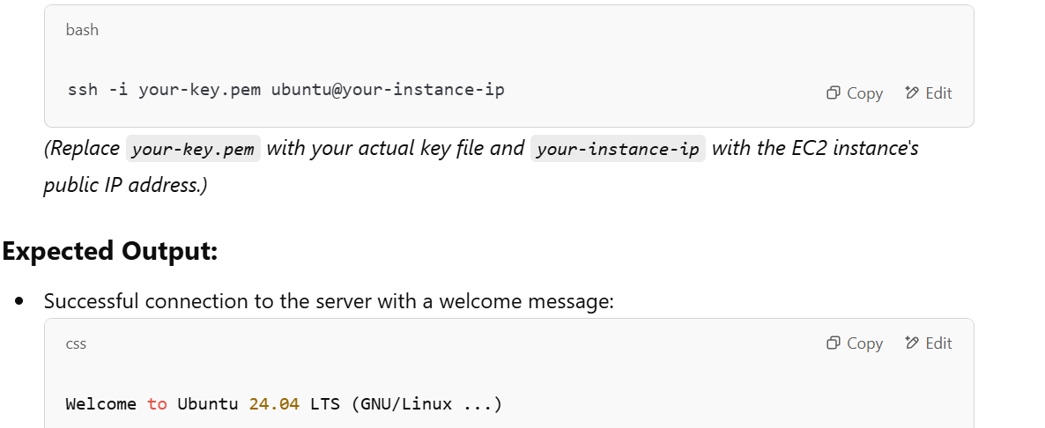

**Expected Output:**

* Successful connection to the server with a welcome message:

css

CopyEdit

Welcome to Ubuntu 24.04 LTS (GNU/Linux ...)

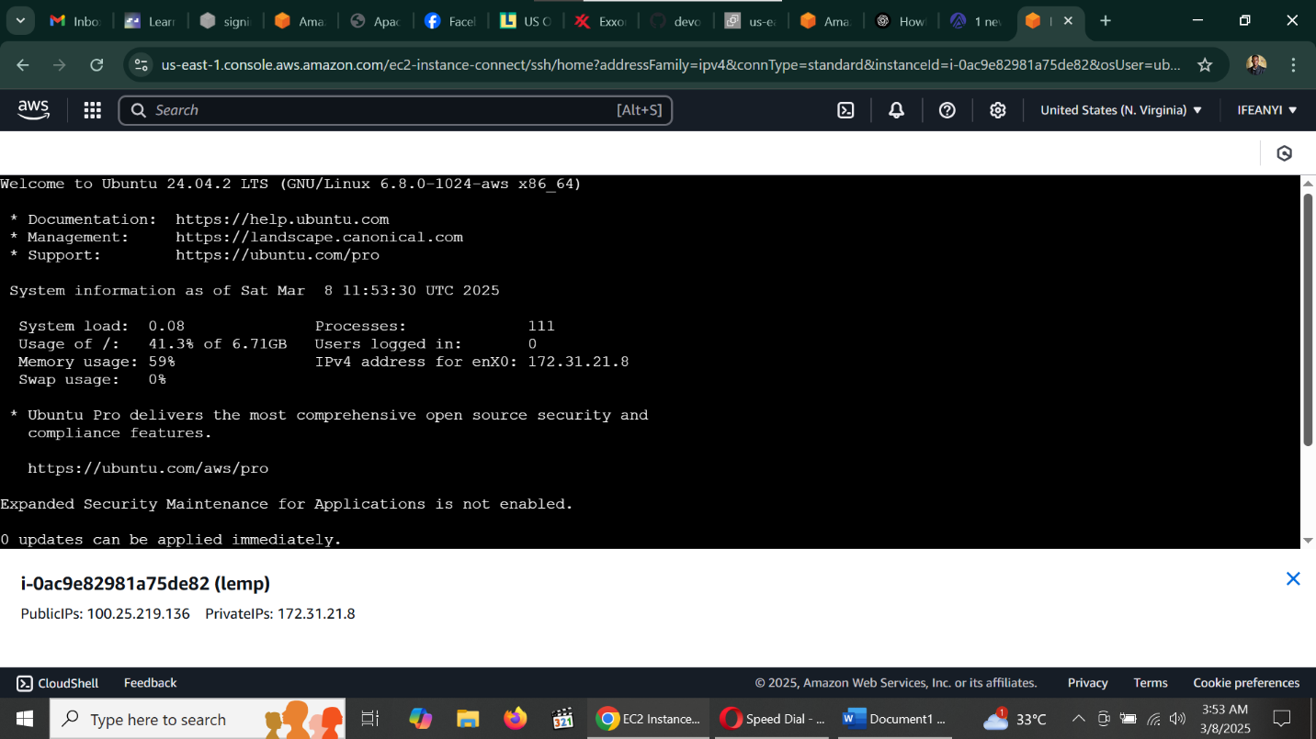

3. Updating the System Packages

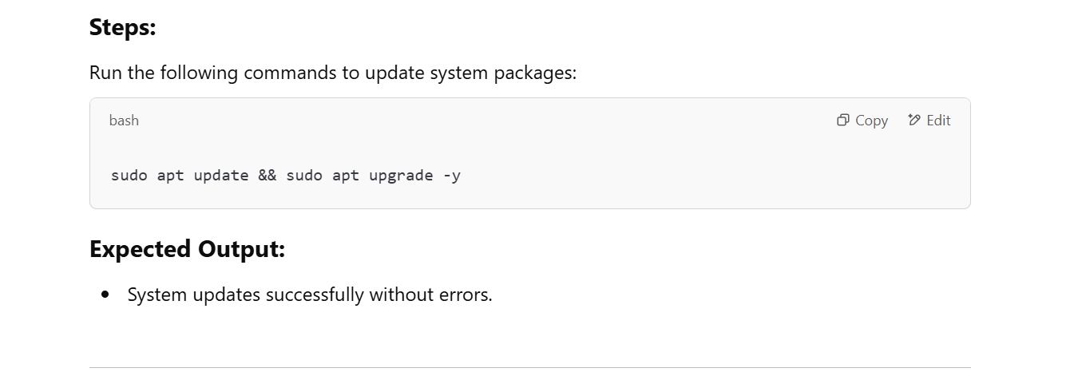

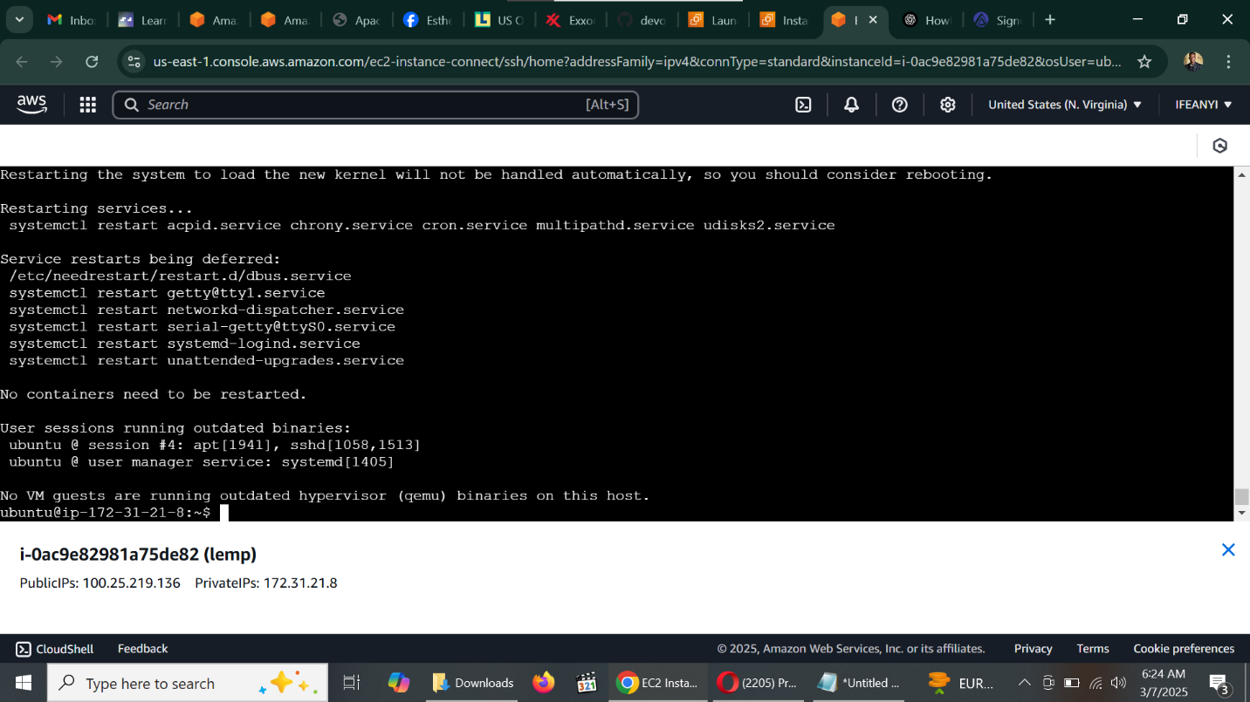

1. Installing Nginx

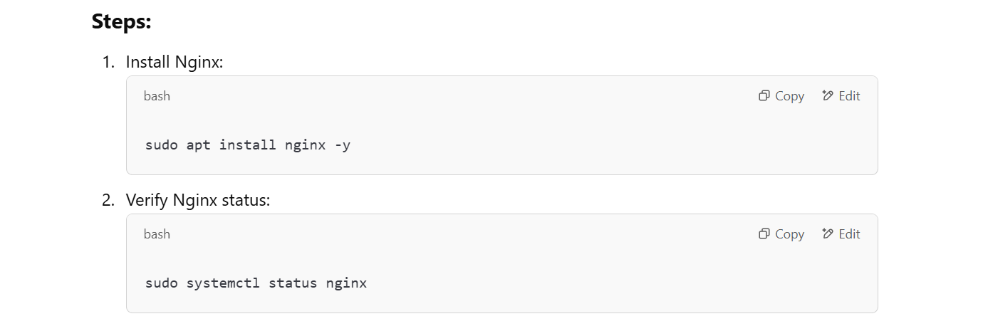

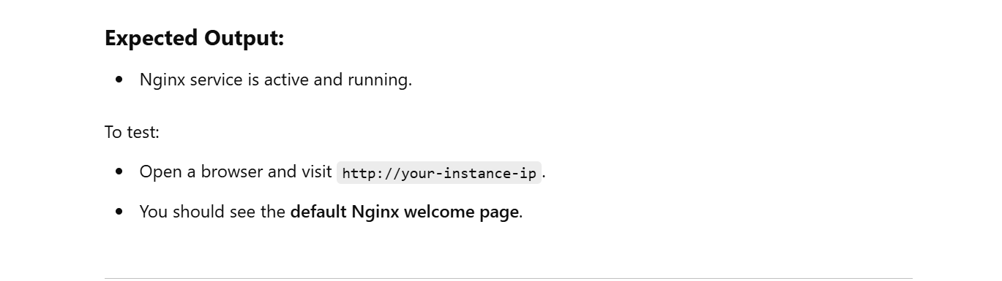

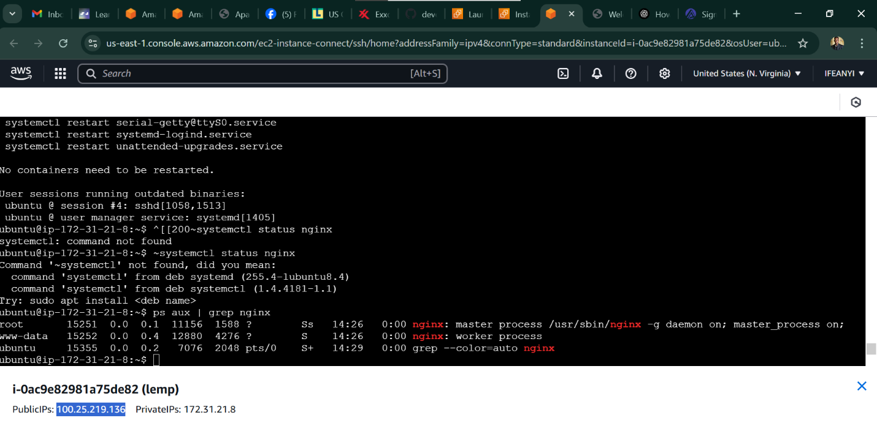

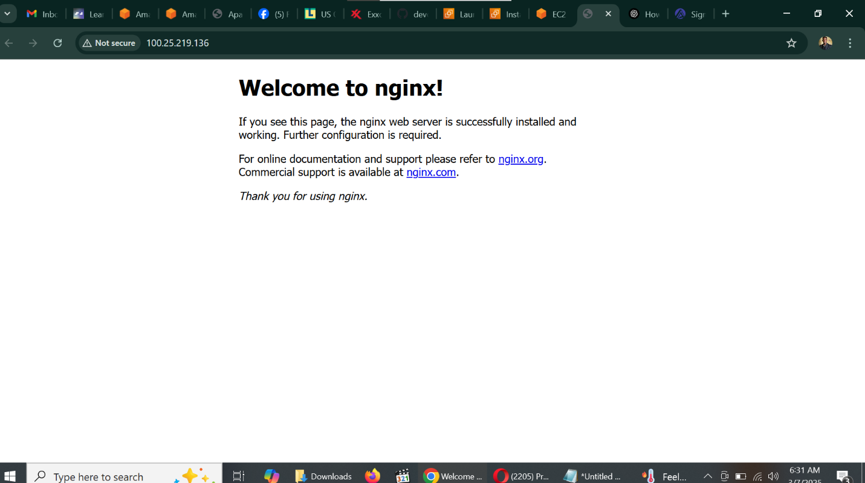

1. Installing MySQL

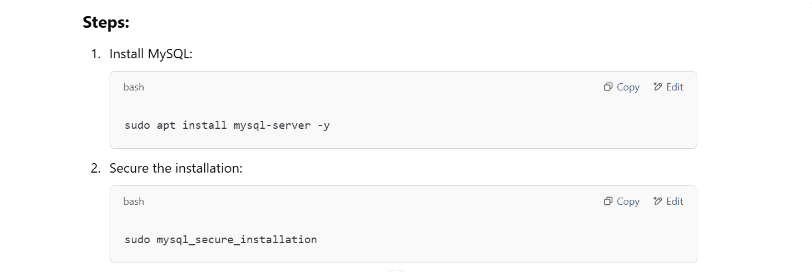

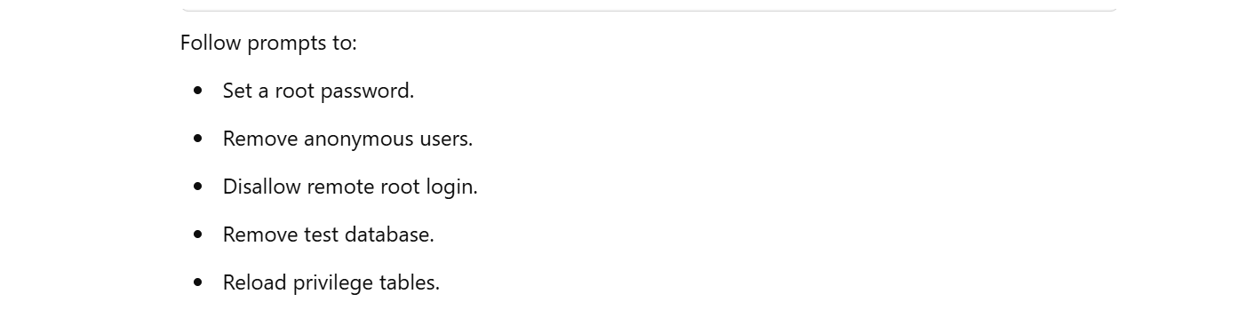

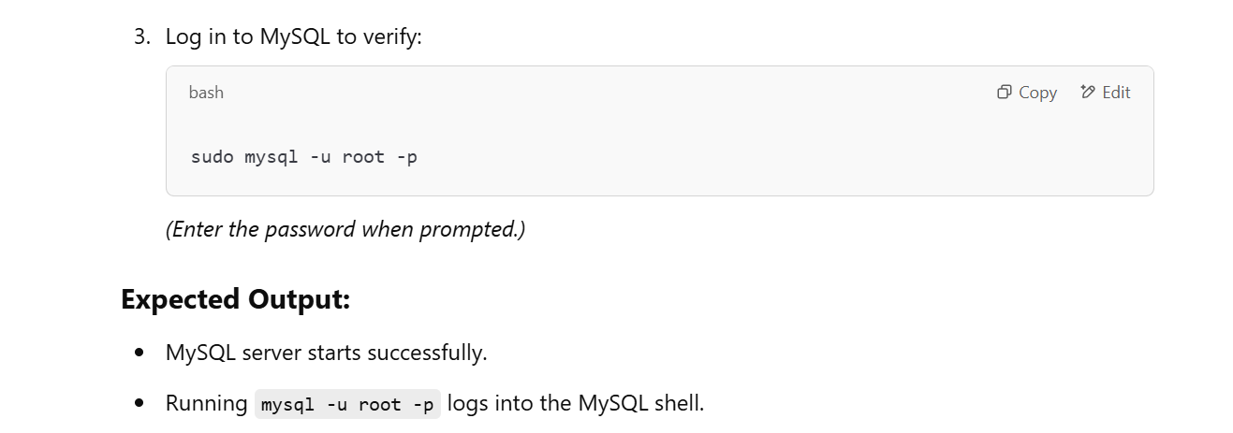

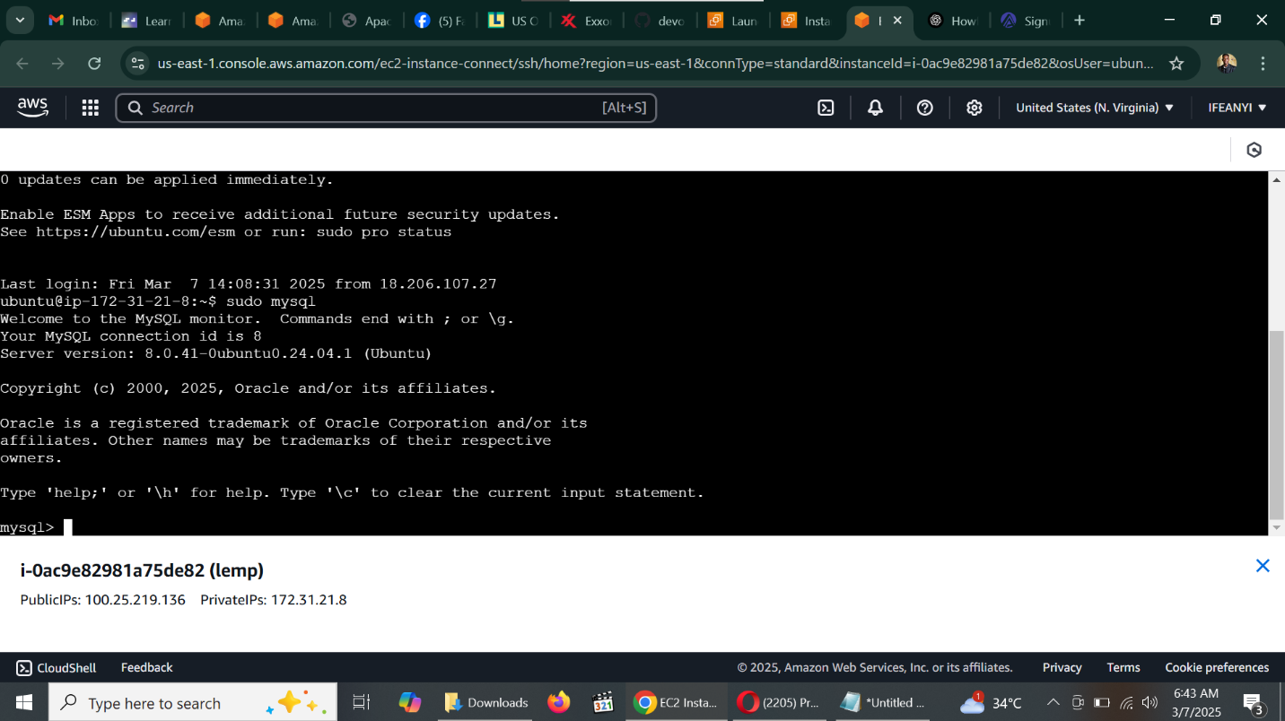

1. Installing PHP

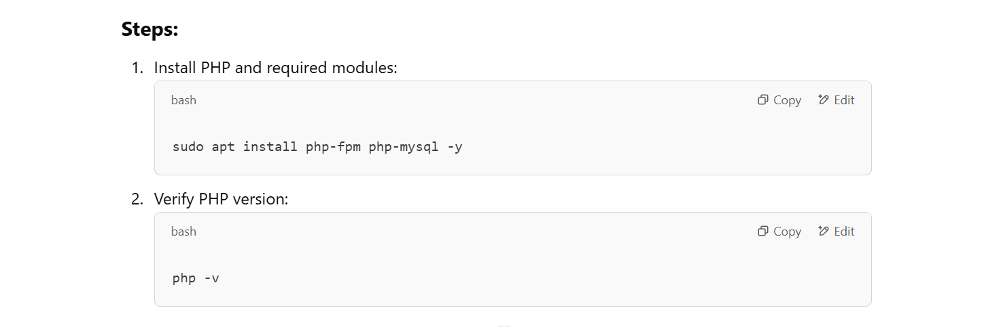

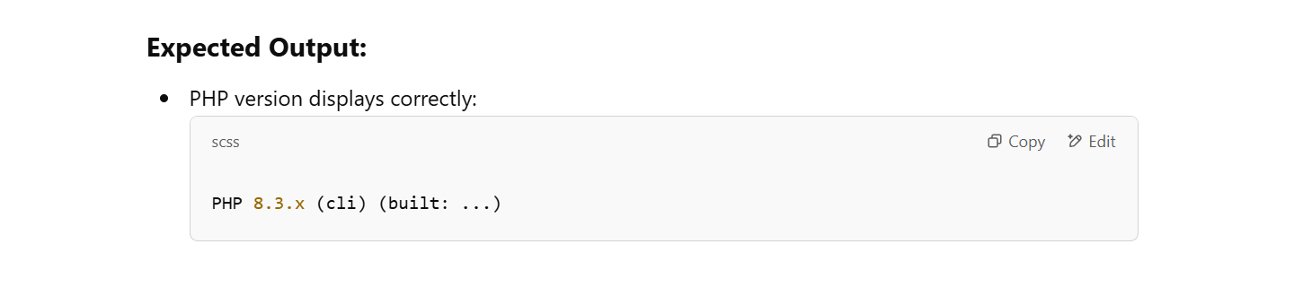

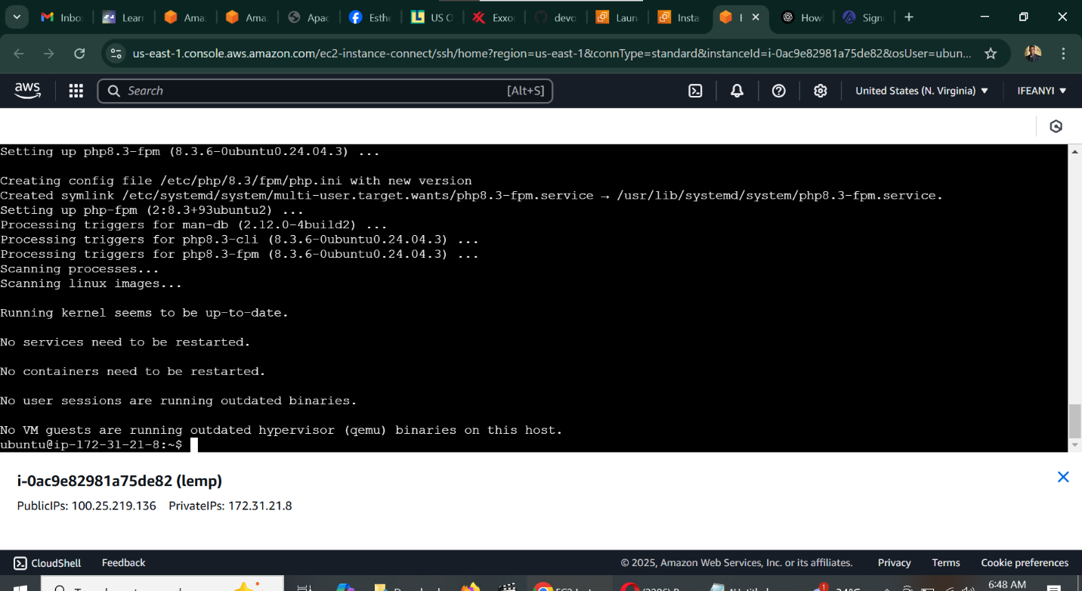

1. Configuring Nginx for PHP

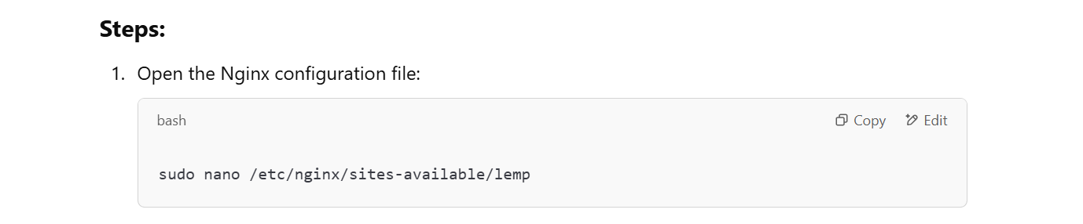

Paste the following configuration:

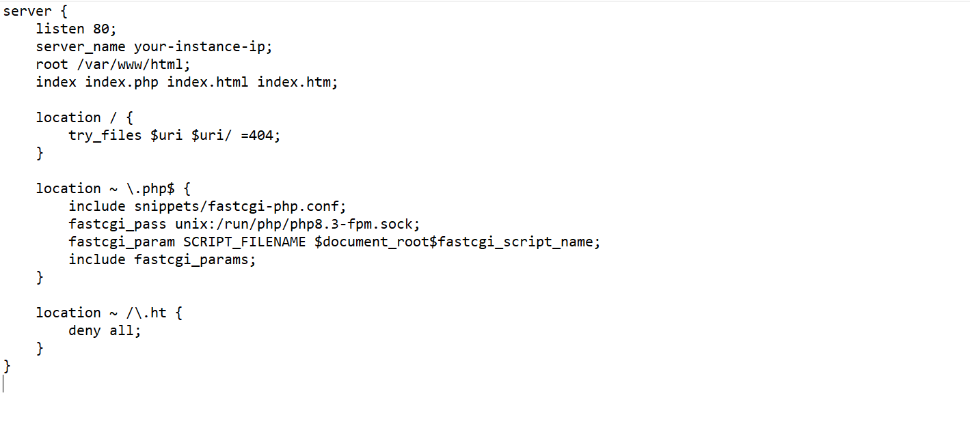

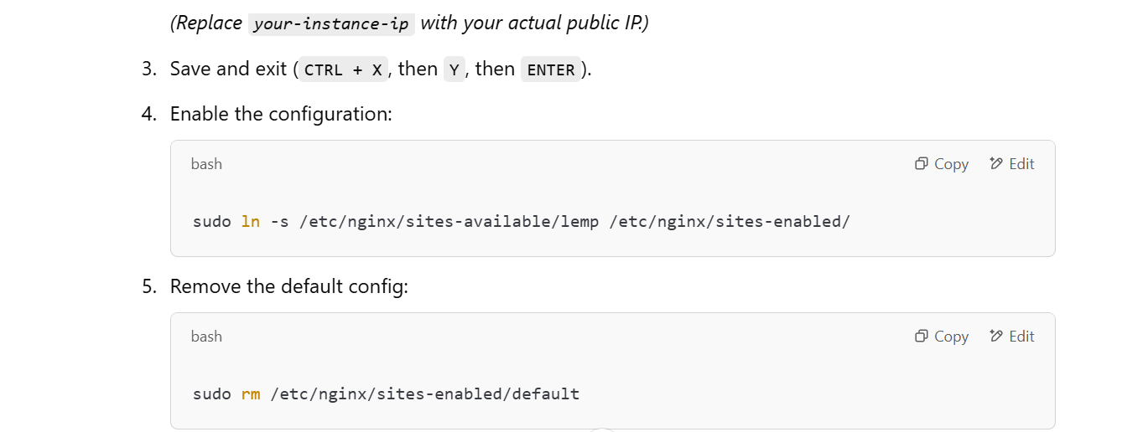

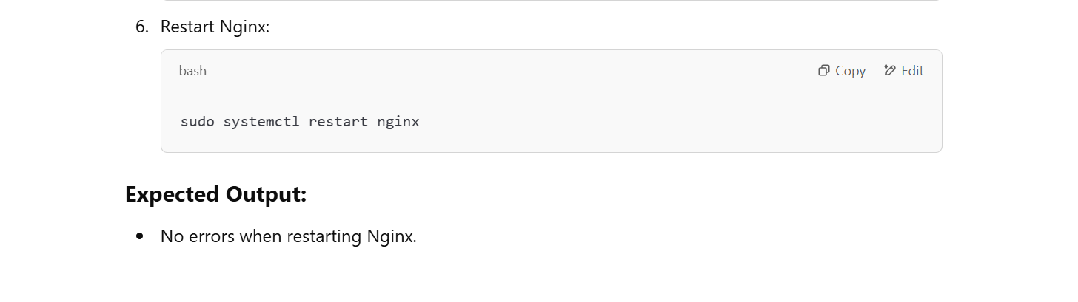

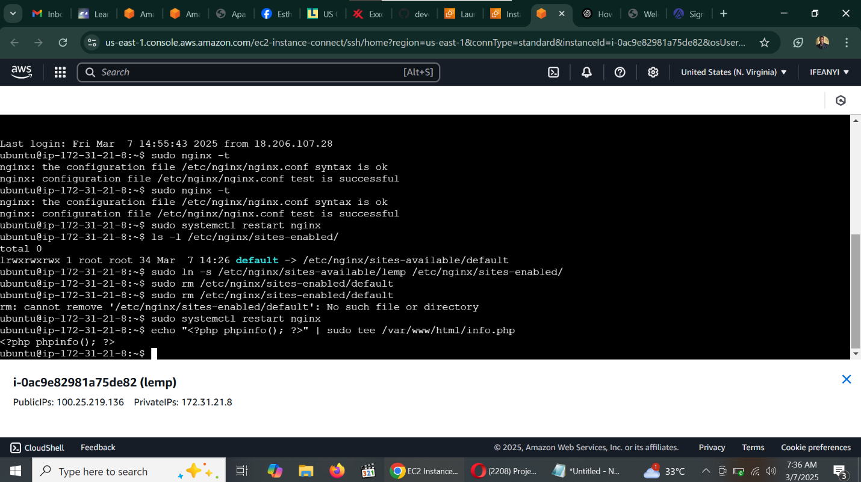

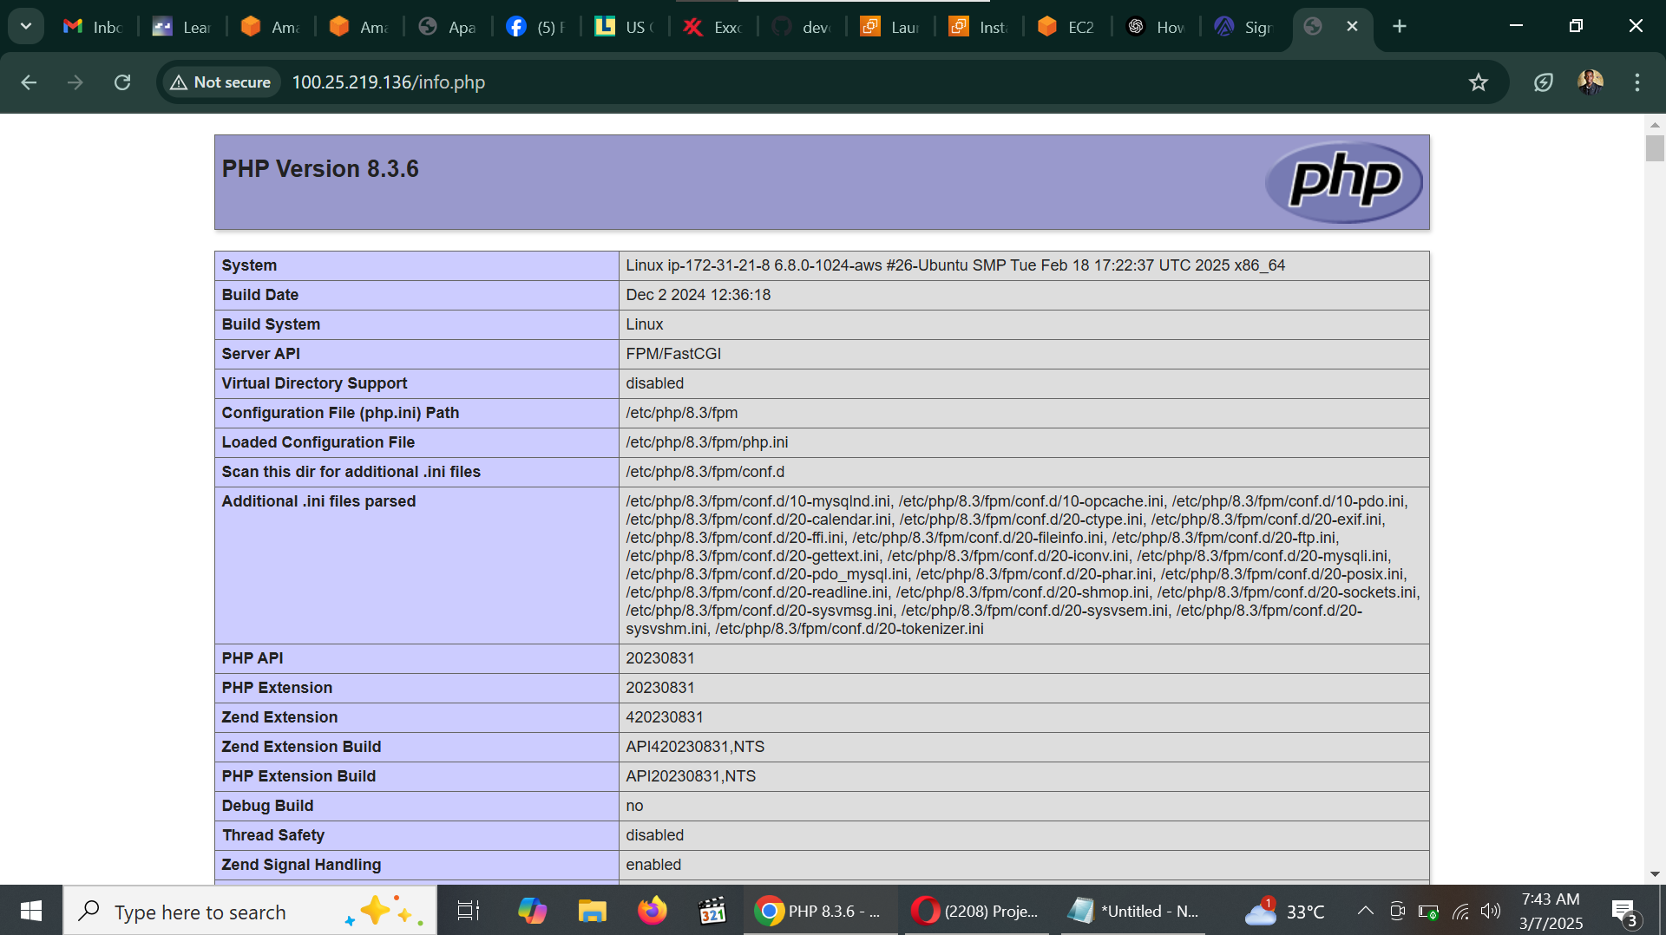

**Conclusion**

By following these steps, you have successfully set up a **LEMP stack** on an **AWS EC2 Ubuntu instance**, configured **Nginx**, enabled **PHP processing**, and secured **MySQL** for database management.

This setup provides a solid foundation for deploying web applications.