When setting up a web server on AWS, the first step is to launch an Ubuntu EC2 instance. This instance will act as the virtual machine where we install and configure Apache, a popular web server used for hosting websites.

In this guide, I'll walk you through the step-by-step process of:

1. **Launching an Ubuntu EC2 instance**
2. **Connecting to the instance via SSH**
3. **Installing and configuring Apache to serve web pages**
4. Launching an Ubuntu EC2 Instance on AWS

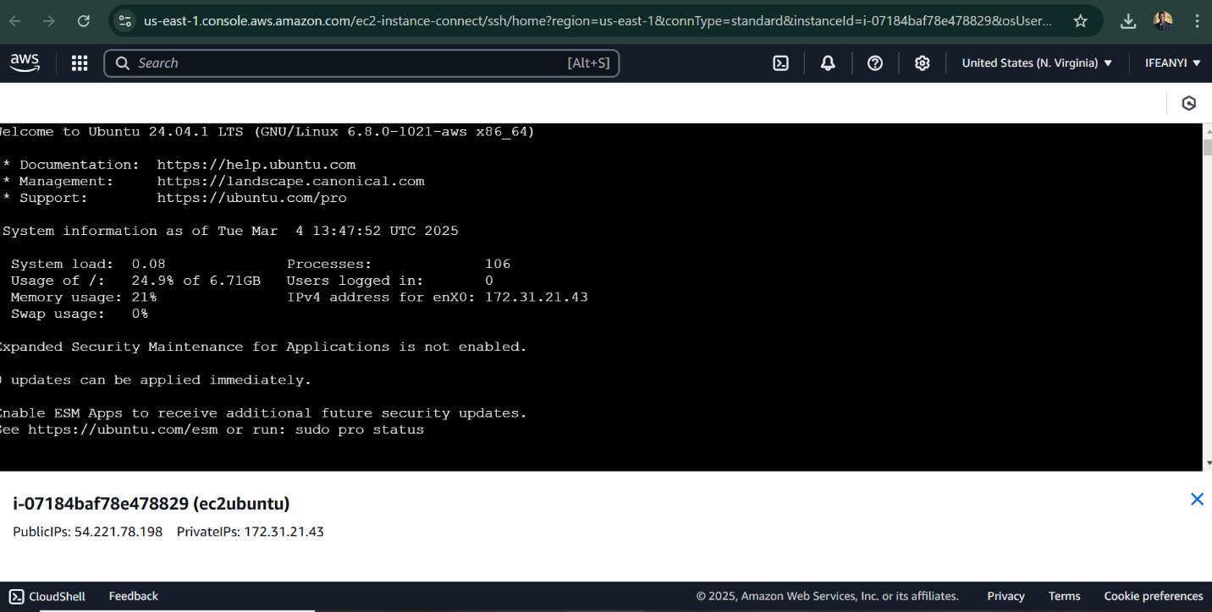

2: Connecting to the Instance via SSH

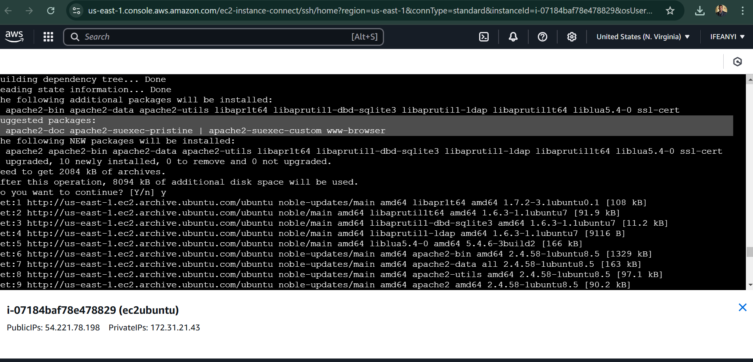

3: Installing and Configuring Apache on Ubuntu EC2

