SHG Hotel Booking Cancellations
An Analysis of Reservation Cancellations, Seasonality, and Lead Time
Project Report
Prepared by: Joseph Dolapo
Tool: Microsoft Excel (PivotTables, Formulas, Executive Insight Dashboard)
Date: October 2026

1. Executive Summary
This report documents the analysis of 119,390 hotel reservation records for the SHG hotel group, covering two properties — a City hotel and a Resort hotel — across bookings arriving between 2015 and 2017. The dataset records every booking's lead time, length of stay, distribution channel, customer type, country of origin, average daily rate (ADR), and whether the booking was ultimately cancelled, no-showed, or checked out.
The analysis was framed around a single, decision-ready question the business needed answered: why do cancellations spike so sharply in July and August, and what can be done about it. Unlike a general-purpose KPI dashboard, this project was built as a one-page executive insight dashboard — a format that leads with a single, specific business recommendation (“We need to overbook same-month reservations during July and August”) and supports it with just enough evidence to make the case, rather than presenting every possible metric.
The headline finding is that cancellations cost the hotel group approximately $1 million in lost revenue during the summer of 2016 alone. Investigation into booking lead time revealed that bookings made far in advance of arrival are both more likely to cancel and command a lower average daily rate than last-minute bookings — which is the basis for the overbooking recommendation detailed in this report.
Metric | Value
Total Bookings Analysed | 119,390
Overall Cancellation Rate | 37%
Properties Covered | 2 (City Hotel, Resort Hotel)
Date Range (Arrivals) | 2015 – 2017
Estimated Revenue Lost, Summer 2016 | ~$1,000,000
Cancellation Rate, Bookings Made 0–30 Days Before Arrival | 20%
Cancellation Rate, Bookings Made 30+ Days Before Arrival | 38%

2. Project Overview

2.1 Background
Hotel reservation systems record every booking made, whether or not the guest ultimately arrives. Over time, this produces a large transactional log of bookings, cancellations, and no-shows — valuable for operations, but not immediately useful for revenue management unless it is analysed for patterns. This project investigates one specific, high-value pattern: seasonal cancellation behaviour and what it costs the business, with a view to recommending a concrete operational change.

2.2 Project Objectives
Because this project was supplied with a finished dashboard and dataset but no separate task brief, the following four analytical objectives were reconstructed directly from the dashboard's own findings, so that the methodology behind each displayed figure could be properly documented:
- Examine how cancellation rate and average daily rate (ADR) move together across months and years, to identify when cancellations are most damaging
- Quantify the revenue lost to cancellations on a monthly basis, to size the financial impact of the summer cancellation spike
- Compare cancellation rate and ADR between bookings made within 30 days of arrival versus bookings made more than 30 days in advance
- Translate the findings into a concrete, actionable recommendation for revenue management during the July–August peak season

2.3 Technology and Tools
Component | Tool / Technique | Purpose
Data Source | Excel table of 119,390 hotel booking records | Raw booking-level transactional data
Data Preparation | Excel Tables, helper columns, date functions | Deriving month/year, lead-time buckets, and cancellation flags
Aggregation Engine | PivotTables | Summarising cancellation rate, ADR, and revenue loss by month and lead-time group
Visualisation | Combo charts (bar + line), waterfall-style stacked bar | Showing cancellation rate vs. ADR, and monthly revenue vs. revenue lost
Dashboard Layout | Single-slide executive insight format | Leading with a recommendation, supported by two focused evidence panels

3. Data Overview

3.1 Dataset Structure
The source dataset is a booking-level transactional table with one row per reservation. The table below shows a representative sample of the raw dataset as extracted into Excel.
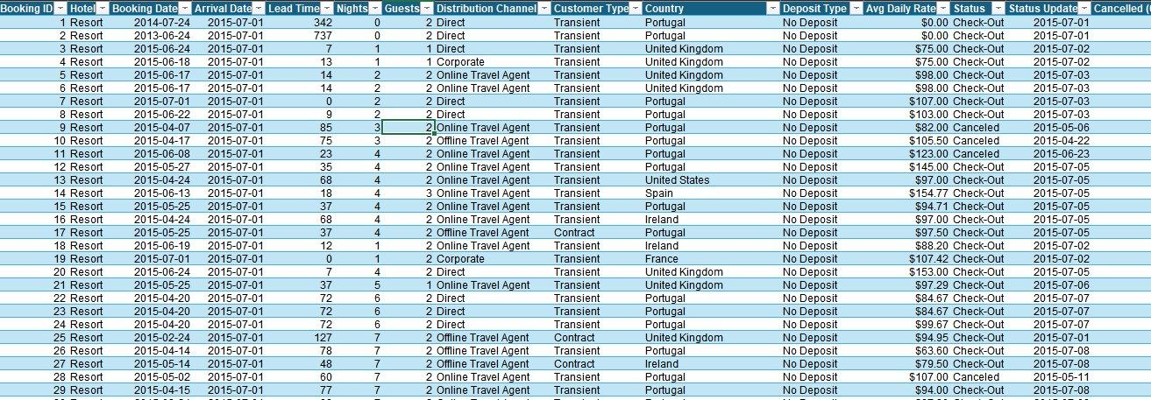
Figure 1 — Sample of the raw SHG booking dataset.

3.2 Data Characteristics
Field | Description
Booking ID | Unique identifier for each reservation
Hotel | Property the booking was made at — City or Resort
Booking Date / Arrival Date | The date the reservation was made, and the date the guest was due to arrive
Lead Time | Number of days between the booking date and the arrival date
Nights / Guests | Length of stay and number of guests on the reservation
Distribution Channel | How the booking was made — Direct, Corporate, Online Travel Agent, Offline Travel Agent
Customer Type | Transient, Transient-Party, Contract, or Group
Country | Guest's country of origin
Deposit Type | Whether a deposit was required to secure the booking
Avg Daily Rate (ADR) | The average nightly rate charged for the booking
Status / Status Update | Final outcome of the booking — Check-Out, Canceled, or No-Show — and the date that outcome was recorded
Cancelled (0/1) | Binary flag indicating whether the booking was ultimately cancelled
Revenue / Revenue Loss | Revenue realised from the booking, and revenue lost if the booking was cancelled

Across the full dataset, 79,330 bookings (66%) were for the City hotel and 40,060 (34%) for the Resort hotel. Of all bookings, 75,166 resulted in a completed check-out, 43,017 were cancelled, and 1,207 were no-shows — an overall cancellation rate of 37%. Online Travel Agents are by far the dominant distribution channel, responsible for 74,072 bookings (62% of the total), ahead of Offline Travel Agents, Direct bookings, and Corporate bookings.

3.3 Data Preparation Steps
- Converted the raw range into a formatted Excel Table so PivotTables could reference it directly
- Derived a Month and Year helper column from the Arrival Date field so bookings could be grouped by calendar month across the three-year span
- Derived a Lead-Time Bucket helper column (0–30 days vs. 30+ days) from the Lead Time field to support the booking-window comparison
- Verified the Cancelled (0/1) and Revenue Loss fields were consistent — every cancelled booking carries a non-zero revenue loss, and every checked-out booking carries zero revenue loss

4. Methodology
The analysis followed a consistent PivotTable-driven workflow for each question on the dashboard:
- Built a PivotTable grouping bookings by Month and Year, with Cancellation Rate (cancelled bookings ÷ total bookings) and Average Daily Rate as the Values, to produce the cancellation-rate-vs-ADR combo chart
- Built a second PivotTable summing Revenue and Revenue Loss by Month and Year, to produce the monthly revenue / revenue-loss waterfall-style chart
- Built a third PivotTable splitting bookings into the 0–30-day and 30+-day lead-time buckets (filtered to the July–August arrival window), calculating the count of cancellations, cancellation rate, and average ADR for each bucket
- Assembled the three resulting charts onto a single dashboard sheet, led by a headline recommendation banner rather than a neutral title, in keeping with the executive-insight dashboard format
This approach keeps the analysis fully traceable back to the raw booking table — every number on the dashboard can be reproduced by re-running the underlying PivotTables against the source data.

5. Task 1 — Cancellation Rate and ADR by Month
The first objective was to understand how cancellation rate and average daily rate move together across the calendar. A combo chart plots cancellation rate (bars) against ADR (line) for each month from July 2015 through August 2017.
Cancellation rate rises and falls in a clear seasonal rhythm, but critically, it rises fastest in the same months that ADR also spikes — July and August of each year. In the dashboard's own annotated figures, cancellation rate reaches 35% in August 2015, dips to a low of 13% in January 2016, climbs back to 34% in August 2016, falls again to 16% in January 2017, and reaches its highest point of 39% in August 2017. ADR follows a similar seasonal curve, climbing from roughly $90 in the low season to over $210 at the August 2017 peak.
This matters commercially because the months where the hotel group charges its highest rates are the same months where it is most likely to lose that revenue to a cancellation — turning the summer peak into the business's single largest point of revenue risk rather than its most reliable source of income.

6. Task 2 — Monthly Revenue Lost to Cancellations
The second objective was to size the financial impact in dollar terms, not just as a percentage. A second chart tracks monthly revenue (the upper, positive bars) against revenue lost to cancellations (the lower, negative bars) across the same period.
Revenue lost to cancellations grows every year in July and August, climbing from roughly $398k lost in July 2016 and peaking at approximately $593k lost in August 2016 — combining for an estimated $1 million in lost revenue across those two months in 2016 alone. This is the single figure that anchors the entire business case: it is not a marginal inefficiency, it is a seven-figure, recurring, predictable annual loss concentrated in exactly two months of the year.

7. Task 3 — Cancellation Rate and ADR by Booking Lead Time
The third objective was to understand whether the timing of the booking itself — how far in advance it was made — predicts cancellation risk. Summer (July–August) bookings were split into two groups: those made within 30 days of arrival, and those made more than 30 days before arrival.
Booking Window | Cancellation Rate | Average Daily Rate
0–30 days before arrival | 20% | $191
30+ days before arrival | 38% | $169

Of all summer cancellations, bookings made within 30 days of arrival accounted for only 175 cancellations against 859 for bookings made further in advance — meaning early, far-in-advance bookings make up roughly 83% of all summer cancellations, despite not being the majority of all summer bookings. Crucially, the pattern runs in the opposite direction from what might be assumed: bookings made closer to arrival are both less likely to cancel (20% vs. 38%) and command a higher average daily rate ($191 vs. $169) than bookings made far in advance.

8. Task 4 — Recommendation: Overbook Same-Month Summer Reservations
The fourth objective was to translate the first three findings into a specific, actionable recommendation — the headline message of the dashboard itself: “We need to overbook same-month reservations during July and August.”
Because far-in-advance summer bookings are both more likely to cancel and less profitable per night than last-minute bookings, the hotel group has a quantified opportunity to intentionally overbook rooms during July and August, anticipating that a predictable share of the far-in-advance bookings will cancel. The reasoning follows directly from the data:
- Replace the bookings made far in advance that are statistically likely to be cancelled (a 38% cancellation rate is high enough to plan around with confidence)
- With bookings made closer to arrival, which carry a lower cancellation risk (20%) and are less likely to leave a room unexpectedly vacant
- And can be sold at a higher average daily rate ($191 vs. $169), directly improving revenue per room even before accounting for the cancellation-recovery effect
Executed carefully, this strategy converts the roughly $1 million currently lost to summer cancellations each year into a mix of recovered occupancy and additional margin from higher-rate, lower-risk bookings — without materially increasing the hotel group's risk of a true walk-in “oversell” situation, given how reliably the cancellation pattern recurs year over year.

9. Dashboard Design
All three supporting analyses were consolidated onto a single executive-insight dashboard, led by the recommendation itself rather than a neutral chart title — a deliberate departure from the KPI-dashboard format used in other SHG-style reporting.
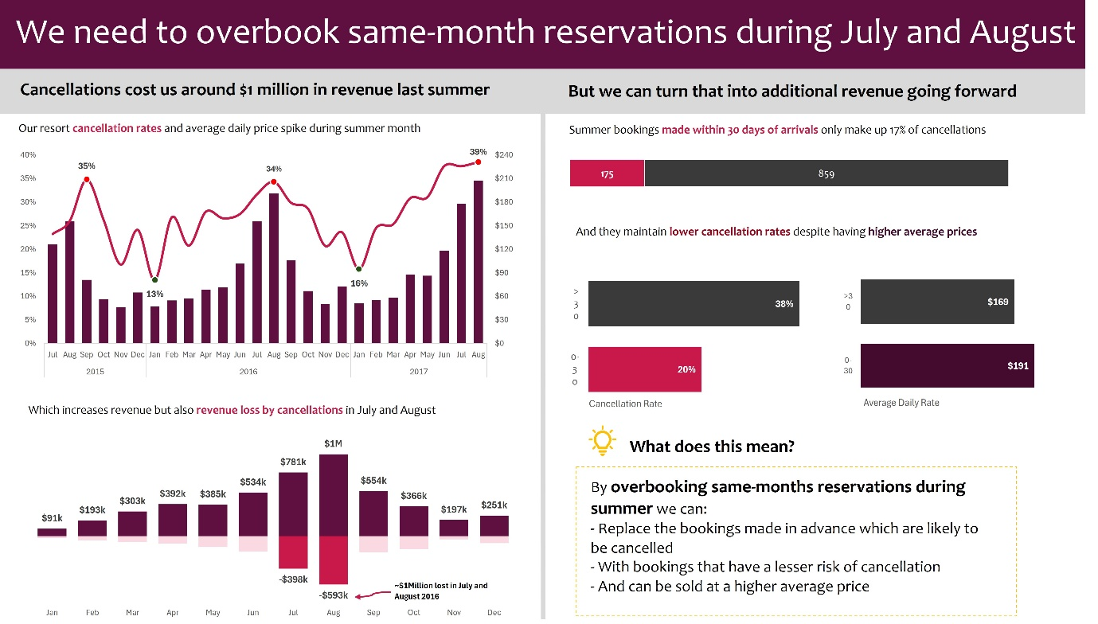
Figure 2 — The completed one-page executive insight dashboard.

9.1 Layout Logic
- Header banner: states the recommendation directly — “We need to overbook same-month reservations during July and August” — so the reader knows the conclusion before seeing any evidence
- Sub-header band: splits the page into “the problem” (cancellations cost ~$1 million last summer) on the left and “the opportunity” (how to turn that into revenue) on the right
- Left column: the cancellation-rate-vs-ADR combo chart, followed by the monthly revenue / revenue-loss chart — together proving the problem is real, seasonal, and large
- Right column: the lead-time cancellation comparison (bar counts, cancellation rate, and ADR by booking window), followed by a highlighted “What does this mean?” callout box spelling out the recommendation in plain language

9.2 Formatting Choices
- A deep maroon and dark grey palette, reserving bright magenta/pink exclusively for cancellation-related figures so the eye is drawn straight to the risk metric in every chart
- Data labels placed directly on every bar and line point, so the dashboard can be read without a legend
- A dashed-line annotation and arrow calling out the single most important number on the page — the ~$1 million lost in July and August 2016
- The recommendation callout box visually separated with a dashed gold border and a light-bulb icon, distinguishing “what the data shows” from “what we should do about it”

10. Key Insights and Findings
- Cancellation rate and average daily rate rise together, peaking in July and August of every year in the dataset — the hotel group's highest-revenue months are also its highest-risk months
- Cancellations in July and August 2016 alone cost the hotel group an estimated $1 million in lost revenue
- Bookings made more than 30 days before arrival are nearly twice as likely to cancel as bookings made within 30 days (38% vs. 20%)
- Despite being lower-risk, near-arrival bookings also command a higher average daily rate ($191 vs. $169) — there is no revenue trade-off in favouring them
- Far-in-advance bookings account for the large majority (roughly 83%) of all summer cancellations, making them a predictable, plannable source of recoverable inventory

11. Challenges and Resolutions
Challenge | Resolution
No separate task brief was supplied for this project — only the dataset and the finished dashboard | Reverse-engineered four analytical objectives directly from the dashboard's own charts and headline recommendation, so every displayed figure has a documented methodology behind it
Revenue Loss needed to be attributed to the correct month even though a booking's Booking Date and Arrival Date can fall in different months (and different years) | Aggregated monthly figures by Arrival Date rather than Booking Date, since the loss is realised against the month the room would have been occupied
Comparing lead-time groups required isolating the July–August arrival window specifically, not the full year, since the recommendation is seasonal | Filtered the lead-time PivotTable to arrivals in July and August only before splitting into the 0–30-day and 30+-day buckets

12. Repository Structure
SHG-Hotel-Cancellations-Dashboard/
├── README.md ← Project overview and documentation
├── SHG_Hotel_Cancellations_Report.docx ← Full written project report
├── SHG_Data.xlsx ← Excel workbook (data, PivotTables, dashboard)
└── images/
├── 01-dataset-screenshot.png ← Raw dataset sample
└── 02-dashboard-overview.png ← Final dashboard view

13. Conclusion
The SHG Hotel Booking Cancellations analysis shows the value of a dashboard built around a single, specific recommendation rather than a general overview of metrics. By tracing cancellation rate, ADR, and revenue loss across three years of booking data, and then narrowing in on booking lead time as the lever behind the pattern, the analysis converts a recurring ~$1 million annual revenue loss into a concrete, data-backed overbooking strategy for the hotel group's two highest-stakes months. The complete workbook, dataset, and supporting documentation are version-controlled in the accompanying GitHub repository for future reference and extension.
Author: Joseph Dolapo — SHG Hotel Booking Cancellations Project, October 2026.

