US International Travel Dashboard
An Analysis of US Outbound Passenger Travel (1990–2021)
Project Report
Prepared by: Joseph Dolapo
Tool: Microsoft Excel (PivotTables, Pivot Charts, Dashboard Design)
Date: October 2026

1. Executive Summary
This report documents the end-to-end development of the US International Travel Dashboard, an Excel-based analytical project exploring over three decades of US outbound passenger travel data. The dataset records monthly passenger counts between the United States and 32 years of destination countries worldwide, spanning January 1990 through 2021.
The objective of the project was to transform a flat, transaction-level dataset into a single, decision-ready dashboard that answers four core business questions: which countries Americans travel to most, how travel volume shifts across the days of the week, how travel volume shifts across the months of the year, and how travel patterns changed between the pandemic-disrupted years of 2020 and 2021. The result is a one-page Excel dashboard built entirely with native Excel tools — PivotTables, PivotCharts, and dashboard layout techniques — with no external add-ins required.
Across the full dataset, the analysis covers 46 total destinations, 4.1 billion recorded passengers, and 32 years of monthly data, with an average of 349 million passengers recorded per month-of-year bucket. Canada, Mexico, and the United Kingdom emerge as the United States' most consistently favoured long-run destinations, while Mexico dominates short-term travel in both 2020 and 2021, reflecting its accessibility during a period of heavy international travel restrictions.

2. Project Overview

2.1 Background
International travel data is typically captured and published in a flat, transactional format — one row per country, per month, per year — which is accurate for record-keeping but unusable for decision-making in its raw form. A travel analyst, airline planner, or tourism board reviewing this data needs answers to specific questions quickly: where are travellers going, when are they travelling, and how has that behaviour shifted over time. This project builds the analytical layer that turns the raw record into those answers.

2.2 Project Objectives
The brief for this dashboard specified four analytical tasks to be addressed on a single dashboard view:
- Identify the most-travelled US destinations
- Analyse passenger travel trends by day of the week
- Analyse passenger travel trends by month of the year
- Compare US travel destinations across the years 2020 and 2021
In addition to answering these four questions, the dashboard was required to be a single-page view — a format commonly used in business reporting so that an executive or stakeholder can absorb the full picture without scrolling or switching sheets.

2.3 Technology and Tools
Component | Tool / Technique | Purpose
Data Source | Flat CSV / Excel table (Country, Month, Total Passengers) | Raw monthly passenger counts by destination country
Data Preparation | Excel Tables, Filters, Sorting | Structuring the raw data for reliable PivotTable aggregation
Aggregation Engine | PivotTables | Summarising passengers by country, weekday, month, and year
Visualisation | PivotCharts (bar, line, donut) | Representing trends and rankings visually on the dashboard
Dashboard Layout | Cell merging, shape formatting, icons, text boxes | Assembling a single branded one-page report
Interactivity | Slicers / filter buttons | Allowing the dashboard to be filtered where needed

3. Data Overview

3.1 Dataset Structure
The source dataset is a simple three-column table: Country, Month, and Total Passengers. Each row represents the number of passengers that travelled between the United States and a given country within a given month. The table below shows a representative sample of the raw dataset as extracted into Excel.
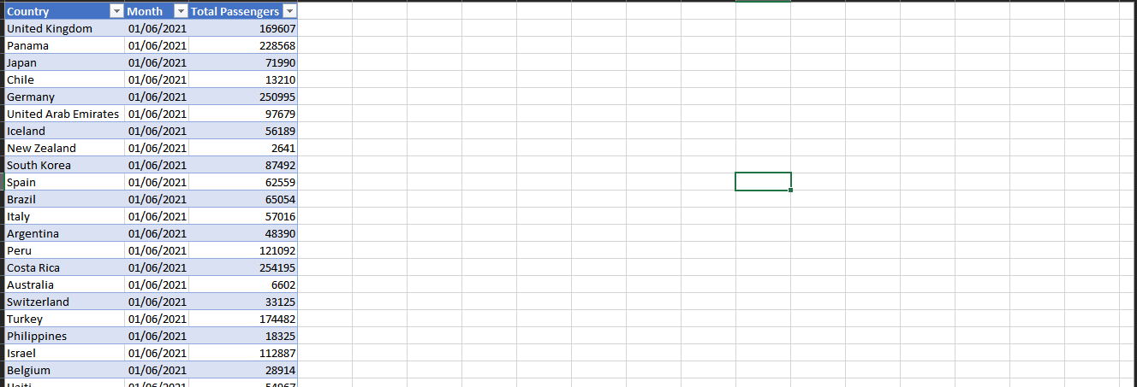
Figure 1 — Sample of the raw dataset used in the analysis (Country, Month, Total Passengers).

3.2 Data Characteristics
Field | Description
Country | The destination (or origin) country for the recorded passenger movement
Month | The calendar month the passenger count was recorded for, formatted as a date (DD/MM/YYYY)
Total Passengers | The total number of passengers recorded travelling that month for that country

The dataset spans 32 years of records across 46 distinct destination countries, accumulating to a total of 4.1 billion recorded passengers over the full period. This scale of data is well suited to PivotTable aggregation, which allows the entire history to be summarised instantly by country, by weekday, by month, or by year without manual calculation.

3.3 Data Preparation Steps
- Converted the raw range into a formatted Excel Table so new rows and refreshes are automatically picked up by PivotTables
- Verified the Month column was stored as a true date value (not text) so day-of-week and month-name groupings could be derived correctly
- Checked for and removed duplicate country/month combinations to avoid double-counting in aggregations
- Standardised country name spelling so that the same destination was never split across two labels in the PivotTable

4. Methodology
Each of the four analytical tasks was answered using a dedicated PivotTable and PivotChart pair, all of which feed into a single consolidated dashboard sheet. The general workflow for each task followed the same pattern:
- Build a PivotTable from the source table, placing the relevant dimension (country, weekday, or month) in the Rows area and Total Passengers in the Values area, summarised by SUM
- For day-of-week and month analysis, derive a helper column on the source data using WEEKDAY() and TEXT(month,"mmm") (or an equivalent formula) so the PivotTable could group correctly by weekday name and month name rather than by raw date
- Sort the PivotTable results (largest to smallest for rankings; chronological order for trend views)
- Insert a PivotChart linked to each PivotTable — horizontal bar charts for rankings, line charts for trends over time, and a donut chart for proportional breakdowns
- Copy/link the finished PivotCharts onto a single dashboard sheet, then format, align, and label them consistently
This PivotTable-driven approach keeps the dashboard fully dynamic: if the underlying dataset is refreshed with new monthly figures, every chart on the dashboard updates with a single “Refresh All” action, with no manual rebuilding required.

5. Task 1 — Most-Travelled US Destinations
The first task was to identify which countries Americans travel to most. A PivotTable was built with Country in the Rows area and Total Passengers (summed across all years) in the Values area, then sorted largest to smallest and filtered to the top 10 results.
Rank | Destination | Total Passengers (All Years)
1 | Canada | 601M
2 | Mexico | 524M
3 | United Kingdom | 473M
4 | Japan | 360M
5 | Germany | 244M
6 | France | 172M
7 | Netherlands | 125M
8 | Dominican Republic | 120M
9 | South Korea | 108M
10 | Brazil | 90M

Canada is the single most-travelled destination for US passengers across the full 32-year history, with 601 million recorded passengers — a reflection of the two countries' shared border, strong trade relationship, and dense air and land travel corridors. Mexico follows closely at 524 million, while the United Kingdom is the leading overseas (non-North American) destination at 473 million. Together, these three countries account for a disproportionately large share of all US outbound travel relative to the other 43 destinations in the dataset.

6. Task 2 — Passenger Trends by Weekday
The second task examined how total passenger volume varies by day of the week. A helper column derived each record's weekday using the WEEKDAY() function, and a PivotTable aggregated Total Passengers by weekday name, visualised as a line chart.
Day | Total Passengers
Monday | 588M
Tuesday | 585M
Wednesday | 606M
Thursday | 601M
Sunday | 614M

Passenger volume is relatively stable across the working week, dipping slightly to its lowest point on Tuesday (585M) before climbing back up through Wednesday and Thursday. Volume is highest at the Sunday end of the week (614M), consistent with Sunday being a common day for return travel and the start of new international itineraries. The overall spread between the lowest and highest weekday is narrow — under 5% — indicating that, unlike many short-haul domestic travel patterns, international travel volume is not heavily concentrated on any single day.

7. Task 3 — Passenger Trends by Month
The third task examined seasonality — how passenger volume rises and falls across the twelve months of the year. A PivotTable grouped Total Passengers by month name (derived from the Month date field) and in calendar order, visualised as a line chart with an overall average reference line.
Month | Total Passengers
January | 340M
February | 354M
March | 336M
April | 351M
May | 382M
July | 410M
August | 408M
September | 332M
October | 331M
November | 309M
December | 341M

The monthly trend shows a clear seasonal pattern typical of international leisure travel: volume climbs steadily from the start of the year, peaking in the Northern Hemisphere summer months of July (410M) and August (408M) — the traditional peak holiday season — before falling away sharply through the autumn to a low point in November (309M). December shows a modest recovery (341M) as winter holiday travel resumes. The average passenger volume across all months sits at 349M, giving a clear benchmark against which any given month's performance can be judged on the dashboard.

8. Task 4 — US Travel Destinations in 2020 vs 2021
The final task compared travel destination patterns specifically across 2020 and 2021 — the two years most affected by international travel restrictions during the global pandemic. A PivotTable filtered the dataset to each year in turn, ranked destinations by Total Passengers, and isolated the top three for comparison.

8.1 Year 2020
Rank | Destination | Passengers (2020) | Share of Total (25M)
1 | Mexico | 14M | 56%
2 | Canada | 7M | 28%
3 | United Kingdom | 4M | 16%

8.2 Year 2021
Rank | Destination | Passengers (2021) | Share of Total (17M)
1 | Mexico | 12M | 71%
2 | Dominican Republic | 3M | 18%
3 | Colombia | 1M | 6%

In 2020, Mexico, Canada, and the United Kingdom together accounted for 43% of all US outbound travel, with Mexico alone taking the largest single share at 14 million passengers. By 2021, the destination mix had narrowed sharply: Mexico, the Dominican Republic, and Colombia together made up over 56% of total travel, with Mexico's share growing even larger in relative terms. This shift reflects how, during a period of shifting international entry restrictions, Americans gravitated toward destinations with the fewest barriers to entry — Mexico and Caribbean/Latin American destinations in particular — while traditional overseas destinations such as the United Kingdom dropped out of the top three entirely in 2021. Total travel volume also fell between the two years, from 25 million passengers in 2020 to 17 million in 2021, underscoring how constrained international travel remained even as the destination mix adapted.

9. Dashboard Design
All four analyses were consolidated onto a single dashboard sheet titled “USA's favourite Travel Destination by Number of Passengers,” designed to be read top-to-bottom, left-to-right in under a minute.
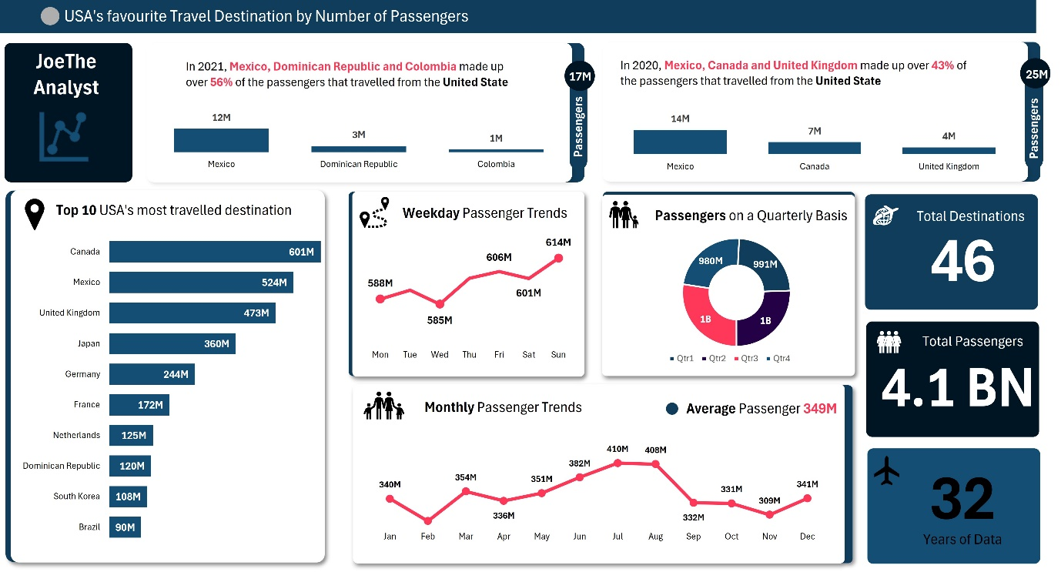
Figure 2 — The completed one-page US International Travel Dashboard.

9.1 Layout Logic
- Header band: dashboard title and branding bar across the top for immediate context
- Top row: side-by-side 2021 vs 2020 “top 3 destinations” comparison cards, directly answering Task 4
- Left panel: Top 10 most-travelled destinations as a horizontal bar chart, directly answering Task 1
- Centre panels: Weekday Passenger Trends (line chart) and Passengers on a Quarterly Basis (donut chart), directly answering Task 2 and supplementing the time-based analysis
- Bottom-centre panel: Monthly Passenger Trends (line chart) with an average reference value, directly answering Task 3
- Right-hand KPI column: three headline statistics — Total Destinations (46), Total Passengers (4.1BN), and Years of Data (32) — giving the dashboard immediate scale and credibility

9.2 Formatting Choices
- A consistent navy-and-white colour palette throughout, with red used sparingly to highlight the most important percentage figures
- Icons (location pin, people, plane, calendar) used next to each panel title to aid quick visual scanning
- Data labels placed directly on bars and line points so the dashboard can be read without hovering or cross-referencing a legend
- KPI tiles on the right-hand side styled as large, bold numbers to draw the eye to the dashboard's headline scale

10. Key Insights and Findings
- Canada, Mexico, and the United Kingdom are the United States' three most consistently travelled destinations over the full 32-year history, together far outweighing any other single country.
- International travel volume is remarkably stable across the days of the week, with only a narrow ~5% spread between the lowest day (Tuesday) and the highest (Sunday).
- Travel follows a clear seasonal curve, peaking in July and August and bottoming out in November — a pattern consistent with Northern Hemisphere summer holiday travel.
- The pandemic years sharply concentrated US travel around fewer, more accessible destinations: Mexico's share of total US outbound travel grew from 56% of the top-3 in 2020 to 71% of the top-3 in 2021.
- Total outbound travel volume nearly halved between 2020 (25M passengers in the top 3) and 2021 (17M), reflecting the continued impact of international travel restrictions even as destination preferences shifted.

11. Challenges and Resolutions
Challenge | Resolution
Raw Month field needed to support both weekday and month-name grouping, which PivotTables cannot derive automatically from a single date field | Added helper columns using WEEKDAY() and TEXT() formulas on the source table so the PivotTable could group cleanly by weekday name and by calendar month
Comparing 2020 vs 2021 required two independent top-3 rankings rather than one combined view | Built two separate filtered PivotTables (one per year) rather than a single PivotTable with a year slicer, so both top-3 lists could be displayed side-by-side permanently on the dashboard
Fitting six distinct chart types onto a single one-page dashboard without it feeling cluttered | Standardised chart sizing, spacing, and colour palette across all panels, and reserved the right-hand column exclusively for headline KPI numbers rather than another chart

12. Repository Structure
The following folder structure is used for the GitHub repository for this project:
US-Travel-Dashboard/
├── README.md ← Project overview and documentation
├── images/
│ ├── 01-dataset-screenshot.png ← Raw dataset sample
│ └── 02-dashboard-overview.png ← Final dashboard view
└── US_Travel_Dashboard.xlsx ← The full Excel workbook (data, PivotTables, dashboard)

13. Conclusion
The US International Travel Dashboard demonstrates that a single, well-structured Excel workbook — using nothing more than PivotTables, PivotCharts, and disciplined dashboard layout — can turn three decades of raw monthly travel records into a one-page report that answers every question asked of it. The dashboard confirms Canada, Mexico, and the United Kingdom as the United States' long-run favourite destinations, reveals a stable weekday travel pattern with a mild weekend peak, surfaces a clear July/August seasonal peak in travel demand, and captures how dramatically the pandemic years concentrated US travel around a small handful of accessible destinations.
Beyond its specific findings, the project is a template for how flat operational data — of the kind produced by almost any organisation — can be made immediately useful to decision-makers without requiring a dedicated BI platform. The complete workbook, dataset, and supporting documentation are version-controlled in the accompanying GitHub repository for future reference and extension.
Author: Joseph Dolapo — US International Travel Dashboard Project, October 2026.

