An Internship Report
Of
AI & Data Science Internship at XYlofy AI
Submitted
To
School of Computer Science and Engineering
IILM University, Greater Noida, U.P.
In partial fulfilment of the requirement of degree of
B.Tech (Computer Science and Engineering – AI & ML)

By
Roll Number of Student: 25SCS1003004378
Name of Student: UPMANYU RAJ
Email: upmanyu.25scs1003004378@iilm.edu
Batch: 2025-2029

CANDIDATE'S DECLARATION
I, Upmanyu Raj, do hereby declare that the internship report titled “AI & Data Science Internship at XYlofy AI” has been completed by me to fulfil the requirement for the award of the degree of Bachelor of Technology in Computer Science and Engineering (AI & ML). All the references have been quoted and I have not taken as such any material from any other source. I affirm that this report is my own and has not been submitted to any other institute for any degree/diploma requirement, and further I shall be solely responsible for any kind of copyright violation in this regard.
Signature: _______________________
Student Name: UPMANYU RAJ
Roll No.: 25SCS1003004378

ACKNOWLEDGEMENT
I am using this opportunity to express my gratitude to everyone who supported me throughout the Internship Program. I am thankful for their aspiring guidance, invaluably constructive criticism, and friendly advice during this work. I am sincerely grateful to them for sharing their truthful and illuminating views on a number of issues related to this work.
I would like to thank Mr. Pritam Gupta, Founder & CEO, and the entire team at XYlofy AI for providing me the opportunity and the structured platform to learn and gain hands-on, project-based exposure in the domain of Artificial Intelligence and Data Science. I am also thankful to my institute, IILM University, Greater Noida, and the faculty of the School of Computer Science and Engineering for their continuous support and encouragement.
I express my gratitude to my parents for their blessings.
Signature: _______________________
Student Name: UPMANYU RAJ
Roll No.: 25SCS1003004378

TABLE OF CONTENTS
1. Candidate's Declaration i
2. Acknowledgement ii
3. Internship Offer Letter & Certificate -
4. Project Description 1
4.1 Introduction 1
4.2 Organization Profile 2
4.3 Problem Statement 2
4.4 Project Objectives 3
4.5 Scope of the Project 3
4.6 Technologies and Tools Used 4
4.7 System Architecture 4
4.8 Methodology (Week-wise Plan) 5
4.9 Project 1 — House Price Prediction 6
4.10 Project 2 — Sales Forecasting & Demand Intelligence System 7
4.11 Expected Outcomes / Learnings 8
4.12 Certificate of Completion and Communication Proof 9
5. Bibliography / References 10

3. INTERNSHIP OFFER LETTER & CERTIFICATE
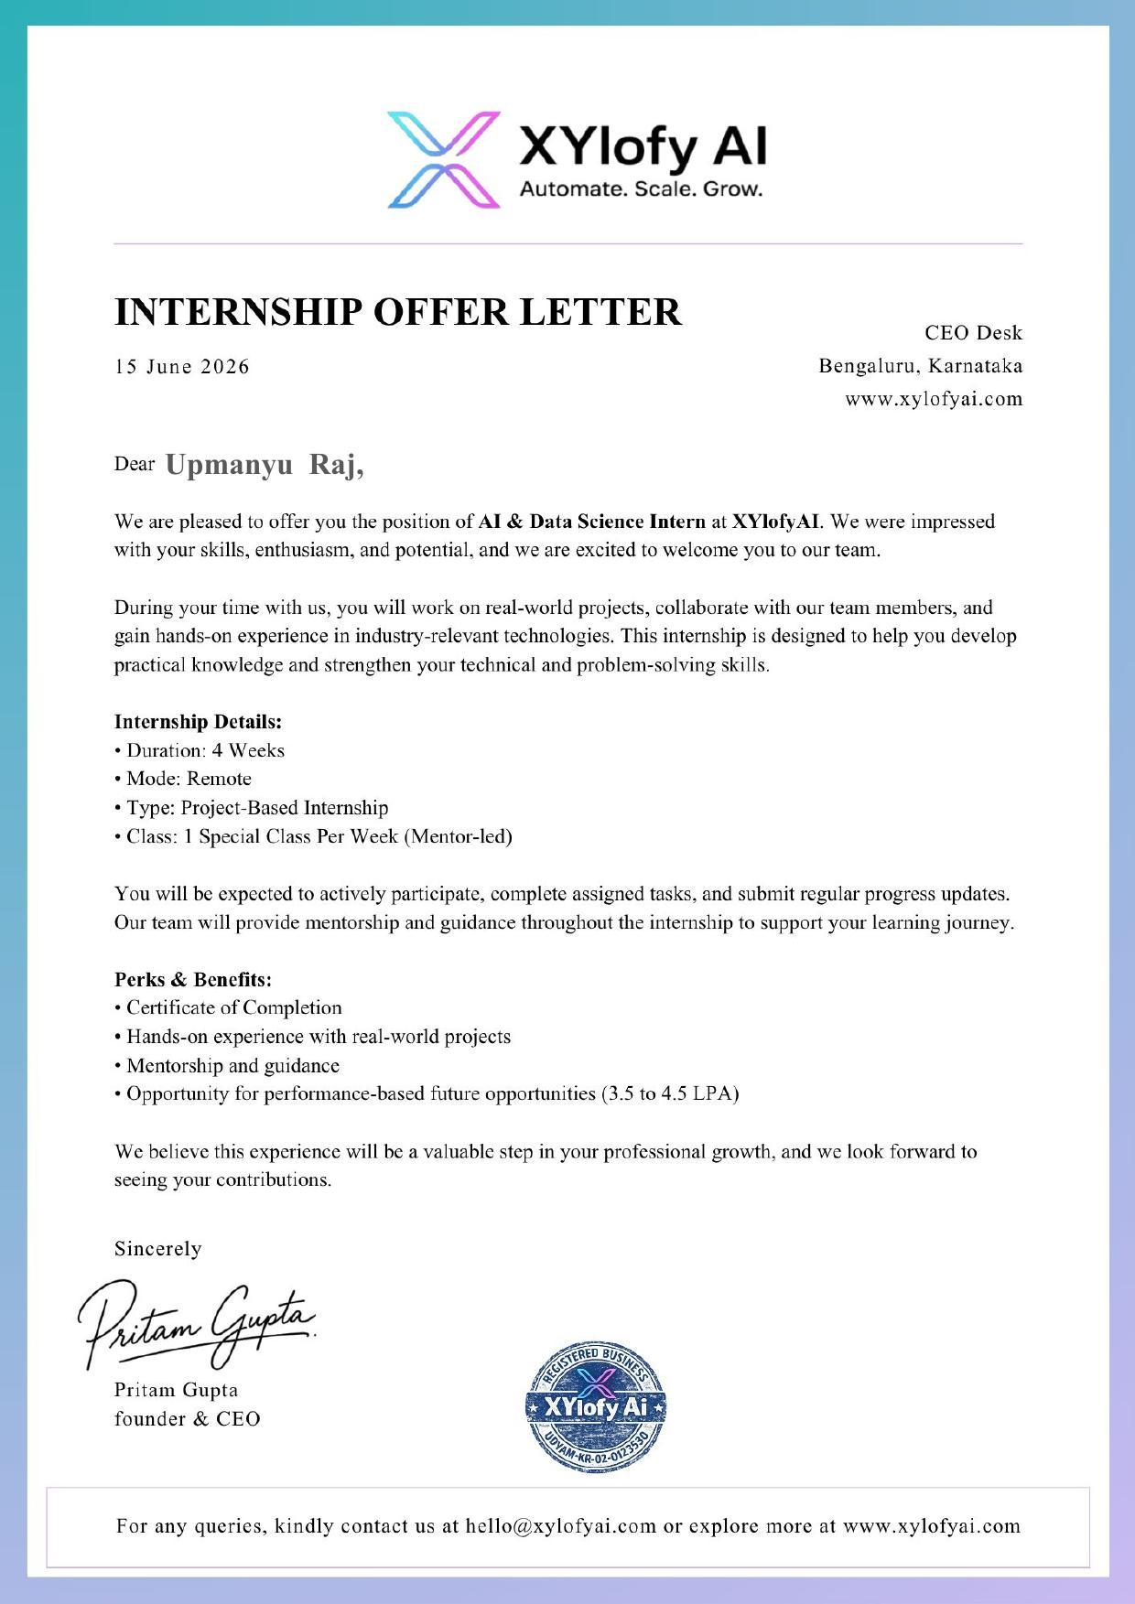

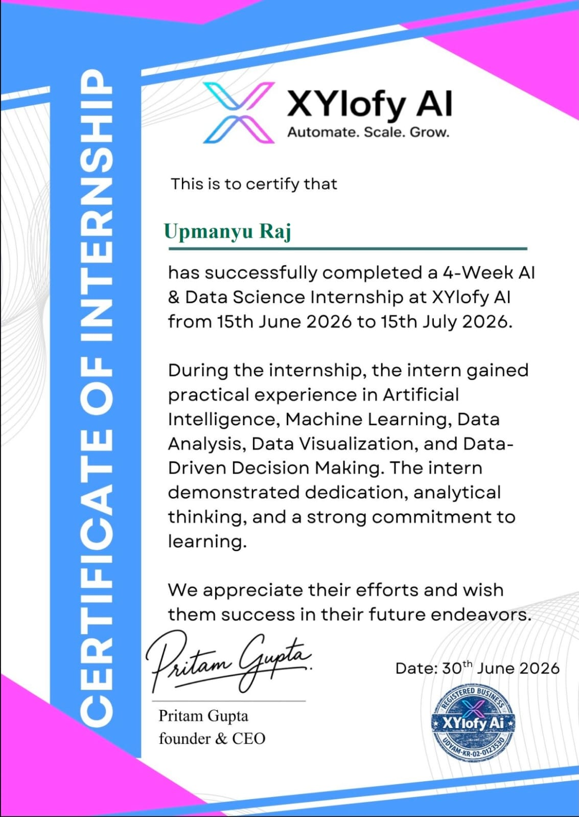

4. PROJECT DESCRIPTION

4.1 Introduction
This report presents a detailed account of the 4-week AI & Data Science Internship undertaken at XYlofy AI, Bengaluru, Karnataka, as part of the requirement of the Bachelor of Technology (Computer Science and Engineering, AI & ML specialization) programme at IILM University, Greater Noida. The internship was carried out remotely from 15th June 2026 to 15th July 2026 under the mentorship of Mr. Pritam Gupta, Founder & CEO, XYlofy AI.
The internship was a project-based, mentor-led programme with one special mentoring class held every week. The primary aim of the internship was to build a strong practical foundation in Artificial Intelligence, Machine Learning, Data Analysis, Data Visualization, and Data-Driven Decision Making, and to apply these concepts to real-world, end-to-end data science projects. Over the course of the internship, two major projects were undertaken: a House Price Prediction system built using regression analysis, and an end-to-end Sales Forecasting & Demand Intelligence System combining time-series forecasting, anomaly detection, customer/product segmentation, and an interactive dashboard.
On successful completion of all assigned tasks and the mentor-led evaluation, a Certificate of Internship was awarded by XYlofy AI, recognizing the intern's dedication, analytical thinking, and strong commitment to learning.

4.2 Organization Profile
XYlofy AI is a Bengaluru-based, registered AI and automation solutions company operating under the tagline “Automate. Scale. Grow.” The organization focuses on building practical, industry-relevant AI, Machine Learning, and Data Science solutions, and runs a structured, project-based virtual internship programme for engineering students to help them gain hands-on experience with real-world datasets and tools. The internship programme is led by Mr. Pritam Gupta, Founder & CEO of XYlofy AI, with weekly mentor-led sessions to guide interns through each stage of their projects.

4.3 Problem Statement
Although a large number of engineering students learn the theoretical foundations of machine learning and statistics during their academic coursework, very few get structured, hands-on exposure to building complete, end-to-end data science solutions — from raw, messy data to a deployable, decision-support application. Concepts such as regression modelling, time-series forecasting, anomaly detection, and customer/product segmentation are often understood only at a theoretical level, with little practice in applying them to real business datasets or presenting the results through an interactive dashboard. The problem addressed by this internship was to practically learn and apply the complete data-science workflow — from data cleaning and exploratory analysis, to model building and evaluation, to communicating insights through visual reports and a live dashboard — using two real datasets: a housing dataset for price prediction, and a retail sales dataset for demand forecasting.

4.4 Project Objectives
- To strengthen Python programming skills for data analysis using NumPy and Pandas.
- To perform exploratory data analysis (EDA) and data visualization using Matplotlib and Seaborn.
- To understand and apply regression techniques for predictive modelling, using house price prediction as a case study.
- To identify the key features that most strongly influence a target variable using correlation analysis and feature-importance techniques.
- To learn and apply time-series forecasting techniques (SARIMA, Prophet, XGBoost) to real retail sales data.
- To detect anomalies in sales data using statistical (Z-score) and machine-learning (Isolation Forest) methods.
- To segment products by demand behaviour using K-Means clustering.
- To build and deploy an interactive, multi-page Streamlit dashboard to present forecasts, anomalies, and segments to a business audience.
- To communicate technical findings through executive-style summary reports.

4.5 Scope of the Project
The scope of this internship spans the complete data-science workflow applied across two independent projects. The first project, House Price Prediction, covers data cleaning, exploratory data analysis, correlation analysis, regression modelling, and evaluation of prediction accuracy against actual values. The second project, the Sales Forecasting & Demand Intelligence System, covers data pipeline development, multi-model time-series forecasting, anomaly detection, K-Means-based demand segmentation, and deployment of the results through an interactive Streamlit dashboard, along with an executive summary report. The internship was carried out in a remote, project-based, mentor-guided environment, and the projects were developed and tested in a personal development/notebook environment rather than an organizational production system.

4.6 Technologies and Tools Used
- Programming Language: Python
- Data Handling & Analysis: NumPy, Pandas
- Data Visualization: Matplotlib, Seaborn
- Machine Learning: Scikit-learn (Regression, Isolation Forest, K-Means Clustering)
- Time-Series Forecasting: SARIMA (Statsmodels), Prophet, XGBoost
- Application/Dashboard Layer: Streamlit
- Development Environment: Jupyter Notebook (analysis.ipynb), Google Colab
- Version Control & Hosting: Git, GitHub
- Report Generation: Python-based report scripts (make_report.py), Microsoft Word / PDF

4.7 System Architecture
The general architecture followed during the internship for both projects can be summarized in the following layers:
- Data Layer: Raw datasets (Housing.csv for price prediction; train.csv and vgsales.csv for sales forecasting) form the foundational input.
- Processing Layer: Data cleaning, feature engineering, and exploratory analysis are performed using Pandas and NumPy.
- Modelling Layer: Regression models (for house price prediction) and forecasting/clustering/anomaly-detection models — SARIMA, Prophet, XGBoost, Isolation Forest, K-Means — (for the sales project) form the core intelligence layer.
- Pipeline Layer: An automated pipeline script (pipeline.py) regenerates charts and machine-readable result artifacts from the source data.
- Presentation Layer: Charts (correlation heatmaps, feature-importance plots, forecast plots) and an interactive multi-page Streamlit dashboard (app.py) present the results to end users.
- Reporting Layer: Executive-style summary reports (summary.docx / summary.pdf) communicate key findings in a business-friendly format.

4.8 Methodology (Week-wise Plan)
The internship followed a structured, week-wise, mentor-led methodology, combining conceptual learning with hands-on project work, as summarized in the table below.
Week | Module | Description
1 | Python & Data Foundations | Refreshed Python for data analysis; worked with NumPy and Pandas for data handling, cleaning, and manipulation.
1 | Exploratory Data Analysis | Practiced exploratory data analysis (EDA) and data visualization using Matplotlib and Seaborn to uncover patterns and relationships in raw datasets.
2 | Machine Learning Foundations | Studied core machine-learning concepts and regression techniques; built and evaluated a supervised learning model.
2 | House Price Prediction Project | Applied EDA, correlation analysis, and a regression model to the Housing dataset to predict house prices; identified the price distribution, feature correlations, and the most influential features driving price.
3 | Time-Series Forecasting | Learned time-series analysis and forecasting techniques, including SARIMA, Prophet, and XGBoost-based forecasting, and how to evaluate forecast accuracy using MAE, RMSE, and MAPE.
3 | Sales Forecasting – Data Pipeline | Built a data pipeline (pipeline.py) on the Superstore sales dataset to clean data, engineer features, and generate forecasting artifacts and charts.
4 | Anomaly Detection & Segmentation | Implemented anomaly detection using Isolation Forest and Z-score methods, and applied K-Means clustering to segment products by demand behaviour.
4 | Dashboard Development & Deployment | Built an interactive multi-page Streamlit dashboard (app.py) to present the forecasts, anomalies, and demand segments, and prepared an executive summary report of the findings.
Note: This was an unpaid, project-based internship with performance-based future opportunities offered by the organization.

4.9 Project 1 — House Price Prediction
Repository: github.com/ifeelxraj/house-price-prediction
This project applies exploratory data analysis and regression modelling to a housing dataset (Housing.csv) to predict house prices from property features. The complete workflow — data loading, cleaning, exploratory visualization, model training, and evaluation — is documented in analysis.ipynb, with a written executive summary provided in summary.docx.

Key Tasks Performed
- Loaded and cleaned the housing dataset, handling missing values and inconsistent feature formats.
- Performed exploratory data analysis to understand the distribution of house prices (chart1_price_distribution.png).
- Built a correlation heatmap to identify relationships between numerical features and the sale price (chart2_correlation_heatmap.png).
- Trained a regression model to predict house prices from the available features.
- Evaluated model performance by comparing actual versus predicted prices (chart3_actual_vs_predicted.png).
- Identified and ranked the features that most strongly influence house price using a feature-importance analysis (chart4_feature_importance.png).

Key Outcome
The analysis identified the property attributes most strongly correlated with sale price and produced a regression model whose predictions closely tracked actual prices on the evaluation data, demonstrating a practical, end-to-end application of the regression workflow — from raw data to an interpretable, evaluated model.

4.10 Project 2 — Sales Forecasting & Demand Intelligence System
Repository: github.com/ifeelxraj/SalesForecasting_UpmanyuRaj
This project is an end-to-end system that forecasts product demand, detects sales anomalies, segments products by demand behaviour, and serves all of these results through an interactive, multi-page Streamlit dashboard. It was built on a retail Superstore sales dataset (train.csv), with a supplementary video-game sales dataset (vgsales.csv) used for merging exercises. The complete, executed analysis covering all assigned tasks is documented in analysis.ipynb, with an automated pipeline (pipeline.py) that regenerates all charts and result artifacts, and a two-page executive business report (summary.pdf).

Key Tasks Performed
- Built a data-cleaning and feature-engineering pipeline on the Superstore sales dataset.
- Trained and compared multiple time-series forecasting models — SARIMA, Prophet, and XGBoost — to forecast future monthly sales.
- Selected SARIMA as the best-performing forecasting model, based on the lowest MAE/RMSE on a held-out three-month test period (~20% MAPE), and generated a three-month sales forecast with 95% confidence intervals.
- Analyzed seasonality patterns and confirmed that September, November, and December consistently rank among the top three months for sales across all four years in the dataset.
- Studied the sales outlook across five business segments, identifying the segment with the strongest relative (least-declining) outlook for the upcoming quarter.
- Implemented anomaly detection using two complementary methods — Isolation Forest and Z-score — to flag unusual weekly sales patterns.
- Applied K-Means clustering to group products into four demand segments (High-Volume Stable, Low-Volume Volatile, Growing, and Declining), using an annualised CAGR-based growth feature.
- Built a four-page interactive Streamlit dashboard (app.py) to present the forecasts, anomalies, and demand segments to a business audience.
- Authored a two-page executive summary report (summary.pdf) translating the technical findings into business recommendations.

Key Outcome
The project delivered a working, end-to-end demand-intelligence system: a validated three-month sales forecast, a clear picture of seasonal demand patterns, an anomaly-flagging mechanism using two independent methods, and a four-segment view of product demand behaviour — all accessible through a live, interactive dashboard rather than a static notebook.

4.11 Expected Outcomes / Learnings
- Strengthened ability to clean, explore, and visualize real-world datasets using Pandas, NumPy, Matplotlib, and Seaborn.
- Practical understanding of building and evaluating regression models for predictive tasks such as house price prediction.
- Hands-on experience comparing multiple time-series forecasting models (SARIMA, Prophet, XGBoost) and selecting the best model using standard error metrics.
- Applied understanding of anomaly detection techniques (Isolation Forest, Z-score) and unsupervised clustering (K-Means) for business segmentation problems.
- Skill to build and deploy an interactive data application using Streamlit.
- Ability to communicate technical analysis to a non-technical audience through executive-style summary reports.
- Successful completion of a mentor-led, project-based internship, resulting in a Certificate of Internship from XYlofy AI.

4.12 Certificate of Completion and Communication Proof
The Internship Offer Letter and the Certificate of Internship issued by XYlofy AI, confirming successful completion of the 4-week AI & Data Science Internship, are attached in Chapter 3 of this report. Both projects developed during the internship — House Price Prediction and the Sales Forecasting & Demand Intelligence System — are publicly available on GitHub at the repository links cited in the References section below, serving as further proof of work completed.
The official offer-letter communication e-mail received from XYlofy AI is attached below as further communication proof.
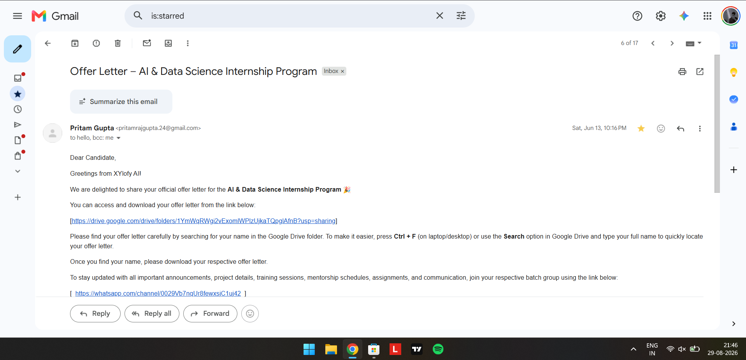

5. BIBLIOGRAPHY / REFERENCES
- XYlofy AI, “Internship Offer Letter,” 15 June 2026.
- XYlofy AI, “Certificate of Internship,” issued to Upmanyu Raj, 30 June 2026.
- Upmanyu Raj, House Price Prediction, GitHub repository: github.com/ifeelxraj/house-price-prediction
- Upmanyu Raj, Sales Forecasting & Demand Intelligence System, GitHub repository: github.com/ifeelxraj/SalesForecasting_UpmanyuRaj
- Pandas Documentation, pandas.pydata.org
- Scikit-learn Documentation, scikit-learn.org
- Statsmodels SARIMA Documentation, statsmodels.org
- Streamlit Documentation, streamlit.io

