Name: Jonathan Ifegunni
Section:
Laboratory Exercise 6

DIGITAL FILTER STRUCTURES
6.1 REALIZATION OF FIR TRANSFER FUNCTIONS
Project 6.1 Cascade Realization
A copy of Program P6_1 is given below:
% Program P6_1A
% Conversion of a rational transfer function
% to its factored form.
% MODIFIED to make the numerator and denominator coefficient vectors
% the same length for calling tf2zp.
num = input('Numerator coefficient vector = ');
den = input('Denominator coefficient vector = ');
[b,a] = eqtflength(num,den); % make lengths equal
[z,p,k] = tf2zp(b,a);
sos = zp2sos(z,p,k)

Answers:
Q6.1 By running Program P6_1 with num = [2 10 23 34 31 16 4] and den = [1] we arrive at the following second-order factors:
The block-diagram of the cascade realization obtained from these factors is given below:
H1(z) is a ___________-phase transfer function.
Q6.2 By running Program P6_1 with num = [6 31 74 102 74 31 6] and den = [1] we arrive at the following second-order factors:

sos =
6.0000 15.0000 6.0000 1.0000 0 0
1.0000 2.0000 3.0000 1.0000 0 0
1.0000 0.6667 0.3333 1.0000 0 0
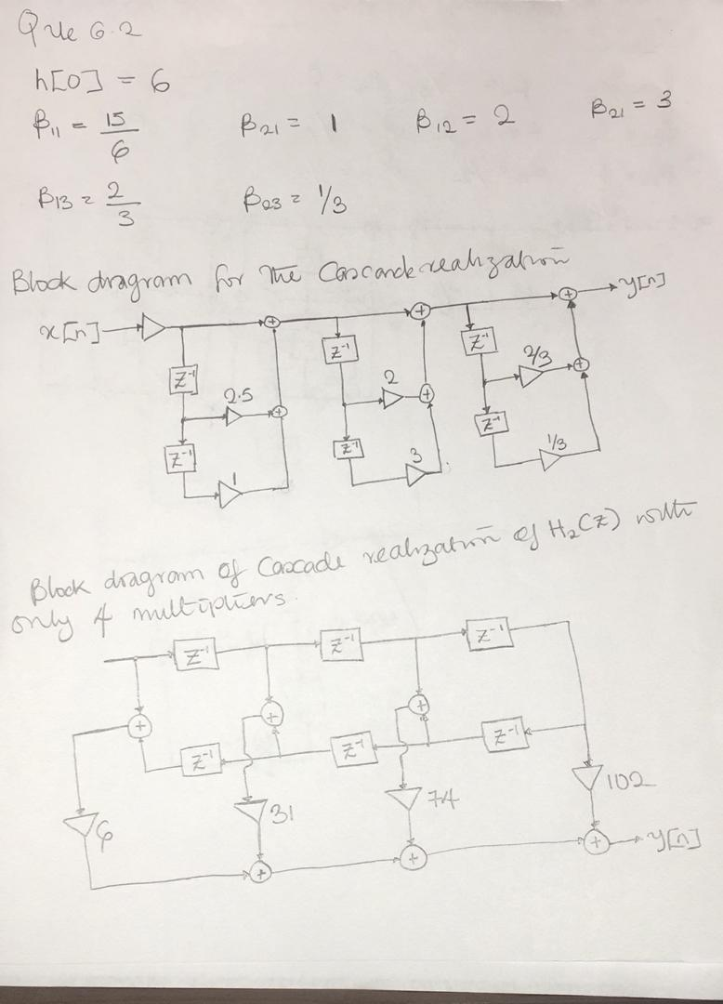
The block-diagram of the cascade realization obtained from these factors is given below:
H2(z) is a ___Type I linear____-phase transfer function.
The block-diagram of the cascade realization of H2(z) with only 4 multipliers is shown below:
6.2 REALIZATION OF IIR TRANSFER FUNCTIONS
Project 6.2 Cascade Realization
Answers:
Q6.3 By running Program P6_1 with num = [3 8 12 7 2 –2] and den = [16 24 24 14 5 1] we arrive at the following second-order factors:
sos =

0.1875 -0.0625 0 1.0000 0.5000 0
1.0000 2.0000 2.0000 1.0000 0.5000 0.2500
1.0000 1.0000 1.0000 1.0000 0.5000 0.5000
The block-diagram of the cascade realization obtained from these factors is given below:
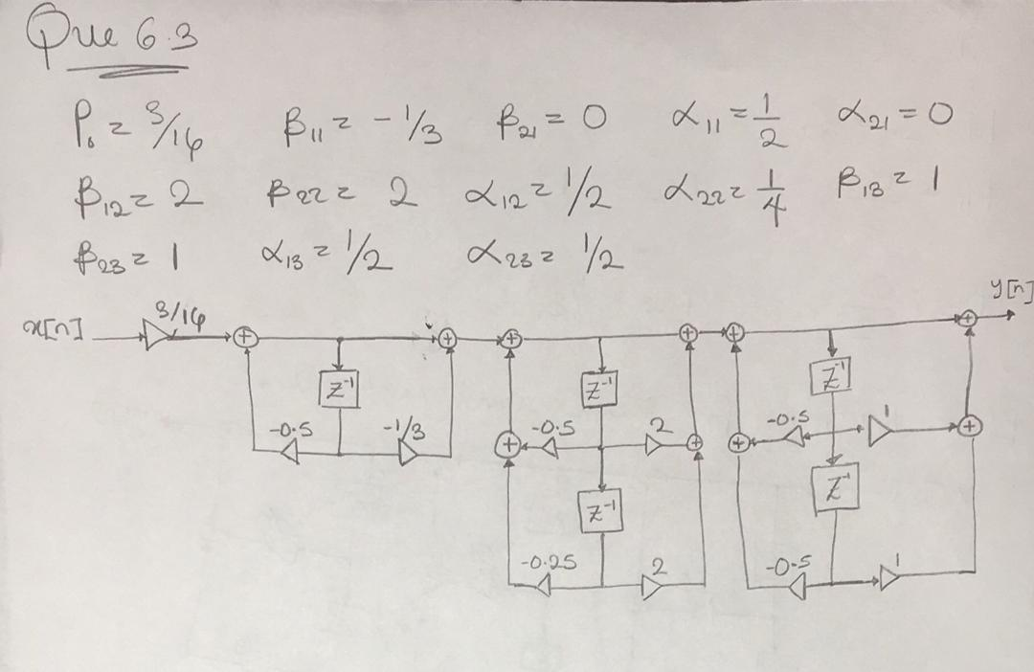

Q6.4 By running Program P6_1 with num = [2 10 23 34 31 16 4] and den = [36 78 87 59 26 7 1] we arrive at the following second-order factors:
The block-diagram of the cascade realization obtained from these factors is given below:
A copy of Program P6_2 is given below:

% Program P6_2
% Parallel Form Realizations of an IIR Transfer
num = input('Numerator coefficient vector = ');
den = input('Denominator coefficient vector = ');
[r1,p1,k1] = residuez(num,den);
[r2,p2,k2] = residue(num,den);
disp('Parallel Form I')
disp('Residues are');disp(r1);
disp('Poles are at');disp(p1);
disp('Constant value');disp(k1);
disp('Parallel Form II')
disp('Residues are');disp(r2);
disp('Poles are at');disp(p2);
disp('Constant value');disp(k2);

Project 6.3 Parallel Realization
Answers:
Q6.5 By running Program P6_2 with num = [3 8 12 7 2 –2] and den = [16 24 24 14 5 5] we arrive at the partial-fraction expansion of H1(z) in z–1 given by:
Parallel Form I
Residues are
-0.0006 + 0.0069i
-0.0006 - 0.0069i
0.1612 + 0.0000i
0.2138 - 0.2683i
0.2138 + 0.2683i

Poles are at
-0.4686 + 0.8626i
-0.4686 - 0.8626i
-0.9290 + 0.0000i
0.1831 + 0.5617i
0.1831 - 0.5617i

Constant value
-0.4000

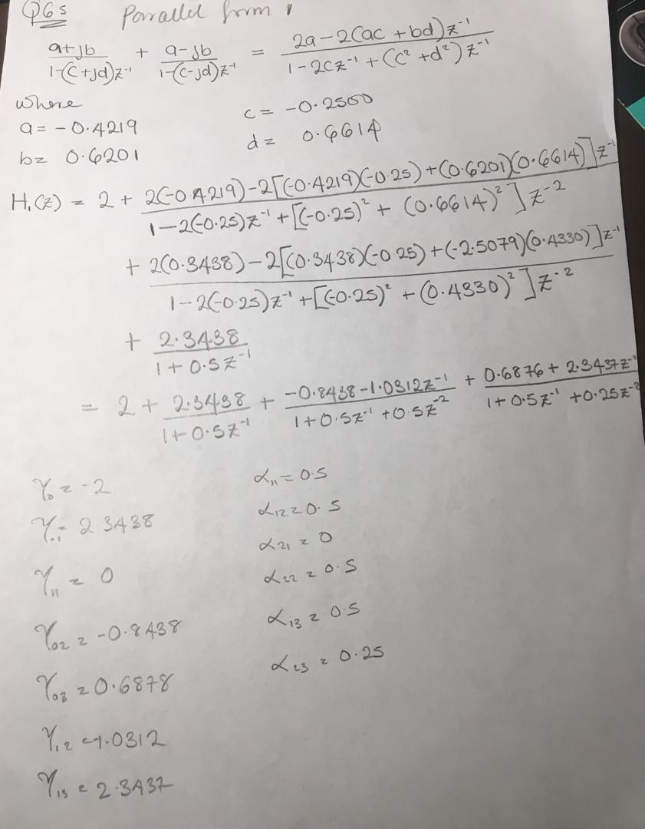

Parallel Form II
Residues are
-0.0056 - 0.0037i
-0.0056 + 0.0037i
-0.1497 + 0.0000i
0.1899 + 0.0710i
0.1899 - 0.0710i

Poles are at
-0.4686 + 0.8626i
-0.4686 - 0.8626i
-0.9290 + 0.0000i
0.1831 + 0.5617i
0.1831 - 0.5617i

Constant value
0.1875

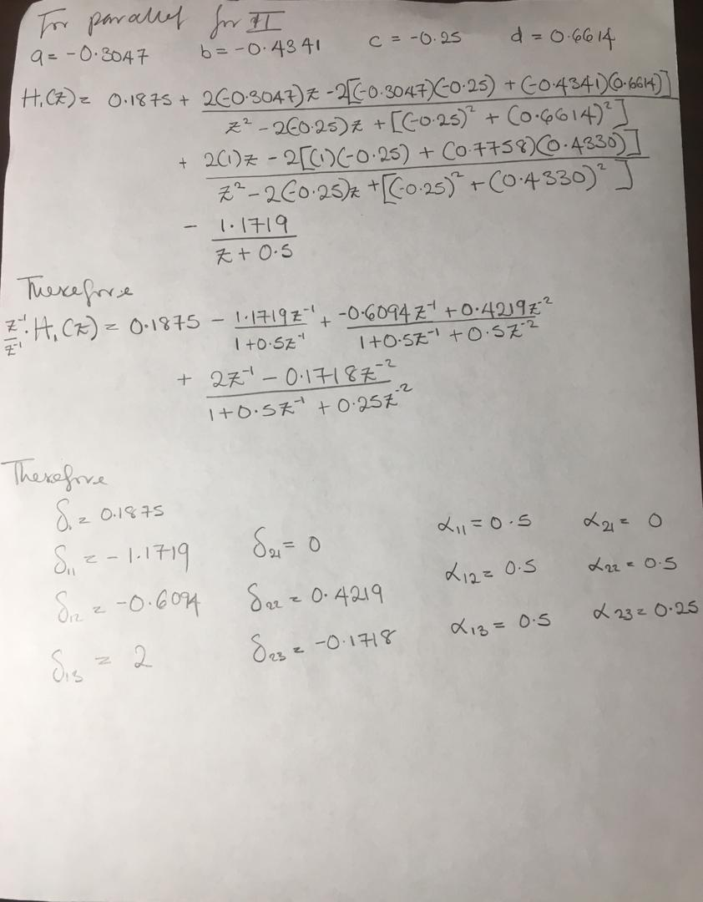

and the partial-fraction expansion of H1(z) in z given by:
The block-diagram of the parallel-form I realization of H1(z) is thus as indicated below:
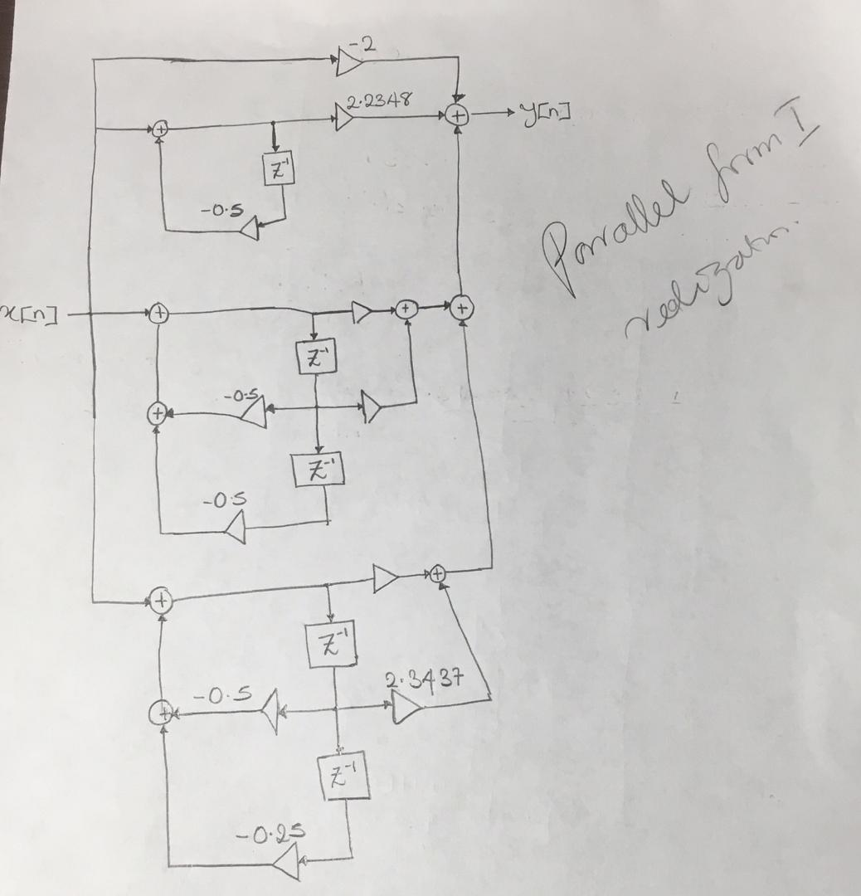

The block-diagram of the parallel-form II realization of H1(z) is thus as indicated below:

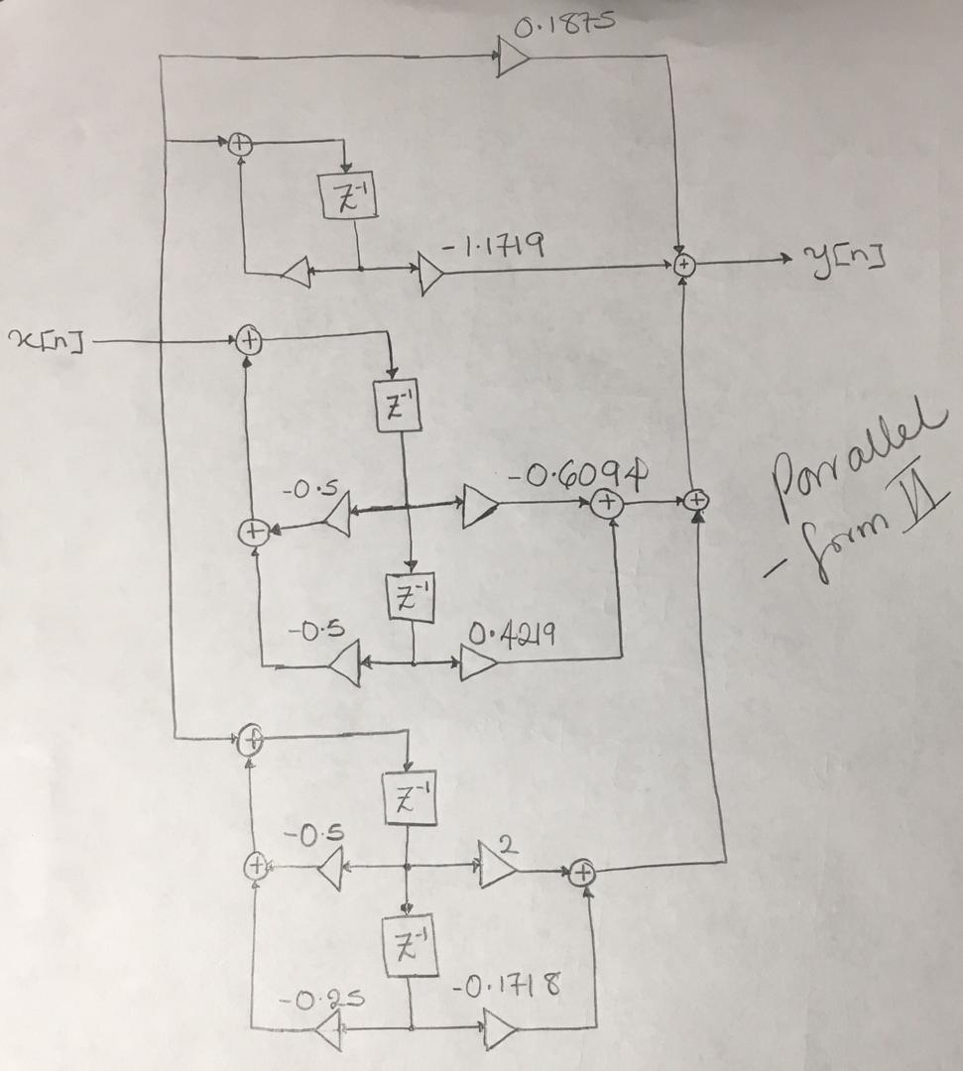

Q6.6 By running Program P6_2 with num = [2 10 23 34 31 16 4] and den = [36 78 87 59 26 7 1] we arrive at the partial-fraction expansion of H2(z) in z–1 given by:
and the partial-fraction expansion of H2(z) in z given by:
The block-diagram of the parallel-form I realization of H2(z) is thus as indicated below:
The block-diagram of the parallel-form II realization of H2(z) is thus as indicated below:
Project 6.4 Realization of an Allpass Transfer function
Answers:
Q6.7 Using Program P4_4 we arrive at the following values of {ki} for A5(z):
k(5) = 0.0625 k(4) = 0.2196 k(3) = 0.4811
k(2) = 0.6837 k(1) = 0.6246
The block-diagram of the cascaded lattice realization of A5 (z) is thus as shown below:
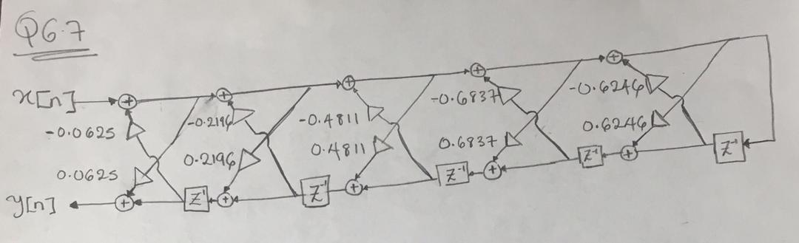
From the values of {ki} we conclude that the transfer function A5(z) is - STABLE
Q6.8 Using Program P4_4 we arrive at the following values of {ki} for A6(z):
k(6) = 0.0278 k(5) = 0.1344 k(4) = 0.3717 k(3) = 0.5922
k(2) = 0.7711 k(1) = 0.8109
The block-diagram of the cascaded lattice realization of A6 (z) is thus as shown below.

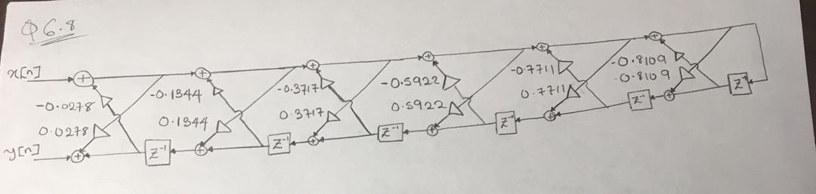
From the values of {ki} we conclude that the transfer function A6(z) is - STABLE
Q6.9 Using zp2sos we obtain the following factors of A5(z):
From the above factors we arrive at the decomposition of A5(z) into its low-order allpass factors as:
The block-diagram of the canonic cascade realization of A5(z) using Type 1 and 2 allpass sections is thus as indicated below:
The total number of multipliers in the final structure is ___________.
Q6.10 Using zp2sos we obtain the following factors of A6(z):
From the above factors we arrive at the decomposition of A6(z) into its low-order allpass factors as:
The block-diagram of the canonic cascade realization of A6(z) using Type 2 allpass sections is thus as indicated below:
The total number of multipliers in the final structure is ___________.
Project 6.5 Cascaded Lattice Realization of an IIR Transfer function
A copy of Program P6_3 is given below:
< Insert program code here. Copy from m-file(s) and paste. >
Answers:
Q6.11 Using Program P6_3 we arrive at the lattice parameters and the feed-forward multiplier coefficients of the Gray-Markel realization of the causal IIR transfer function H1(z) of Q6.3 as given below:

Lattice parameters are
0.624596860890131 0.683737827429193 0.481119423483979 0.219607843137255 0.062500000000000

Feedforward multipliers are
Columns 1 through 5

-0.125000000000000 0.312500000000000 0.160539215686274 0.184300471408489 -0.090851695086766

Column 6

-0.019821006235218

From these parameters we obtain the block-diagram of the corresponding Gray-Markel structure as given below:

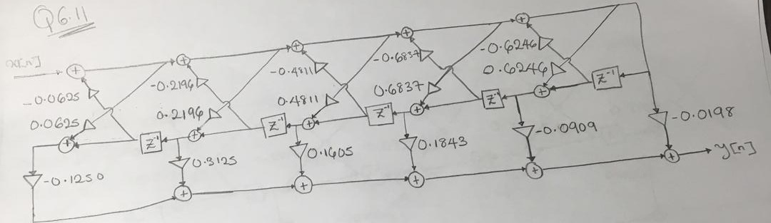

From the lattice parameters obtained using Program P6_3 we conclude that the transfer function H1(z) is - STABLE
Q6.12 Using Program P6_3 we arrive at the lattice parameters and the feed-forward multiplier coefficients of the Gray-Markel realization of the causal IIR transfer function H2(z) of Q6.4 as given below:
Lattice parameters are
Columns 1 through 4
0.81093584641352 0.77112772506402 0.59215187769984 0.37169052478550
Columns 5 through 6
0.13436293436293 0.02777777777778
Feedforward multipliers are
Columns 1 through 4
0.11111111111111 0.20370370370370 0.15199485199485 -0.04739265773254
Columns 5 through 7
-0.01456452038379 0.02345313662512 -0.01112037033486
From these parameters we obtain the block-diagram of the corresponding Gray-Markel structure as given below:

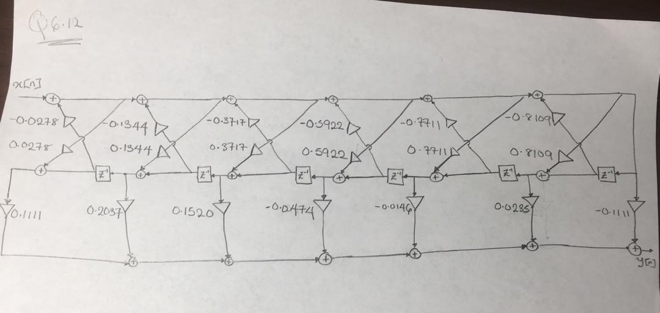
From the lattice parameters obtained using Program P6_3 we conclude that the transfer function H2(z) is – Stable

Q6.13 The MATLAB program to develop the Gray-Markel realization of a causal IIR transfer function using the function tf2latc is given below:
< Insert program code here. Copy from m-file(s) and paste. >
Using this program we arrive at the lattice parameters and the feed-forward multiplier coefficients (vectors k and alpha) of the Gray-Markel realization of the transfer function H1(z) of Q6.3 as given below:
The parameters obtained using this program are __________ as that obtained in Q6.11.
Using the function latc2tf we obtain the following transfer function from the vectors k and alpha:
The transfer function obtained is _________ as H1(z) of Q6.3.
Q6.14 Using this program we arrive at the lattice parameters and the feed-forward multiplier coefficients (vectors k and alpha) of the Gray-Markel realization of the transfer function H2(z) of Q6.4 as given below:
The parameters obtained using this program are __________ as that obtained in Q6.12.
Using the function latc2tf we obtain the following transfer function from the vectors k and alpha:
The transfer function obtained is _________ as H2(z) of Q6.4.
Project 6.6 Parallel Allpass Realization of an IIR Transfer function
Answers:
Q6.15 Using zplane we obtain the pole-zero plot of G(z) as shown below:
< Insert MATLAB figure(s) here. Copy from figure window(s) and paste. >
Next using roots we obtain the pole locations of G(z) as given below:
Making use of the pole-alteration property we thus arrive at the two allpass sections A0(z) and A1(z) as given below:
The power-complementary transfer function H(z) is therefore given by
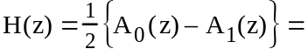
The order of A0(z) is -
The order of A1(z) is -
The block-diagram of a 3-multiplier realization of G(z) and H(z) using Type 1 and Type 2 allpass structures is as indicated below:
Q6.16 Using zplane we obtain the pole-zero plot of G(z) as shown below:
< Insert MATLAB figure(s) here. Copy from figure window(s) and paste. >
Next using roots we obtain the pole locations of G(z) as given below:
Making use of the pole-alteration property we thus arrive at the two allpass sections A0(z) and A1(z) as given below:
The power-complementary transfer function H(z) is therefore given by
The order of A0(z) is -
The order of A1(z) is -
The block-diagram of a 5-multiplier realization of G(z) and H(z) using Type 1 and Type 2 allpass structures is as indicated below:

Date: 12/4/18 Signature: Jonathan Ifegunni

