**Problem: The overturning circulation driven by a cone plume is extremely weak. E.g., case 4 (ambient melt + plume) below is almost the same as case 3 (melt only).**

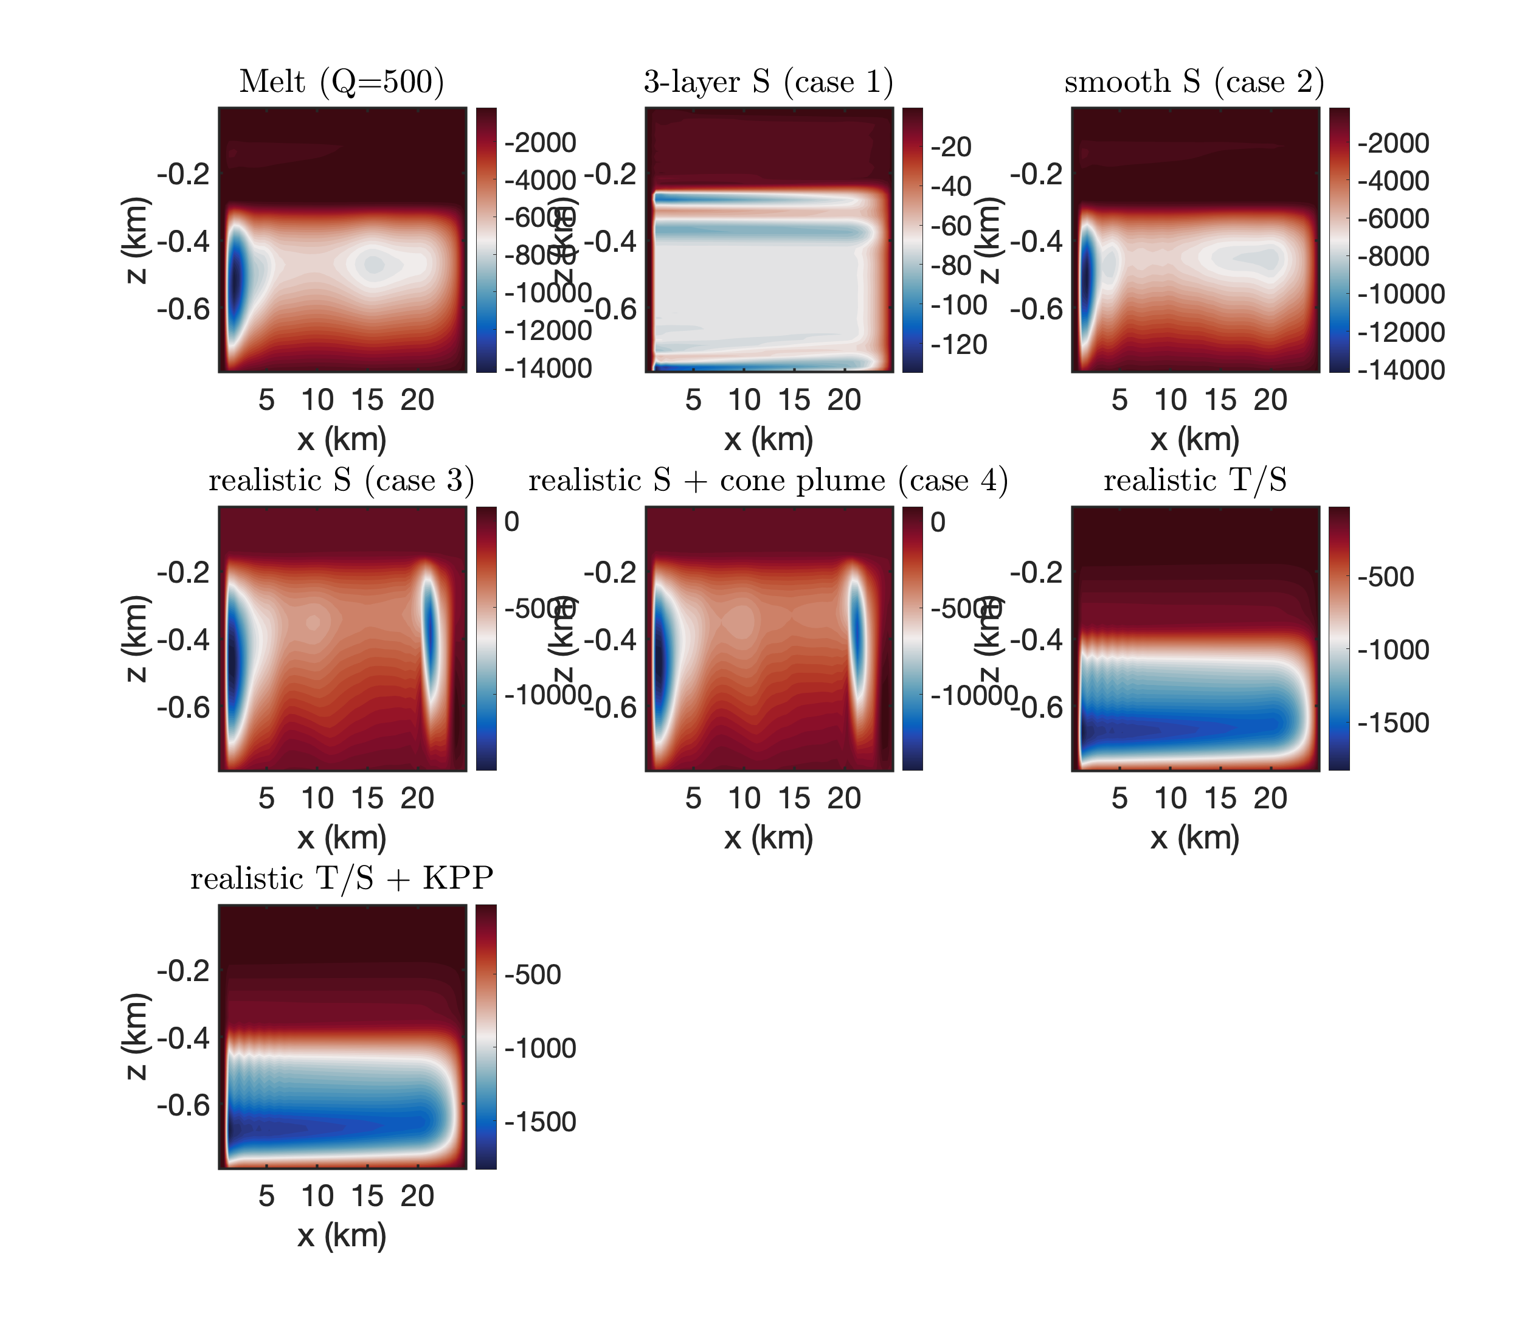

(1) **Summarize the equations used in iceplume package**

(Cowton et al. 2015: [https:// agupubs.onlinelibrary.wiley.com/doi/full/10.1002/2014JC010324).\](https://agupubs.onlinelibrary.wiley.com/doi/full/10.1002/2014JC010324).\)

See github: <https://github.com/zhazorken/MITgcm_FJ/tree/master/iceplume>

**When a cone plume is initialized:**

**In iceplume_plume_model.F, line 394:**

**In iceplume_calc.F, line 271:**

volFlux(k)=pi*(rProfPlume(k)**2)*wProfPlume(k)/2.

A couple of corrections:

*C - even if plume is still buoyant, it cannot flow through the fjord surface*

volFlux(1) = 0.D0

*C - the initial volume flux is equal to runoff*

volflux(iceDepthK) = Q_sg

*C Calculate volume flux differential to give entrainment / extrainment*

*C First clear volfluxdiff*

DO K = 1,Nr

volfluxdiff(K) = 0.D0

ENDDO

DO k=1,iceDepthK-1

volFluxDiff(k) = volFlux(k+1) - volFlux(k)

ENDDO

**In iceplume_calc.F, line 593:**

temp_AddMass3D(I,J,K,bi,bj) = ! convert to potential temp

& SW_PTMP(sProfPlume(k),tProfPlume(k),prProf(k),0. _d 0)

salt_AddMass3D(I,J,K,bi,bj) = sProf(k)

addMass(I,j,k,bi,bj) = volFLuxDiff(k)*1000

(2) **What we should expect in a plume parameterization?**