https://dev.to/leandronsp/resolvendo-problema-de-performance-no-postgresql-com-cte-468d

Query Original
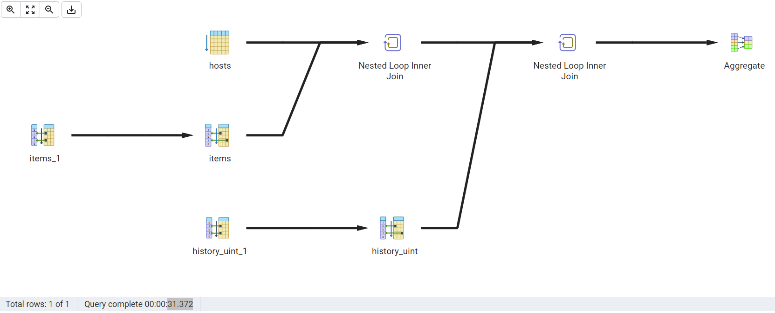
Query Reformulada
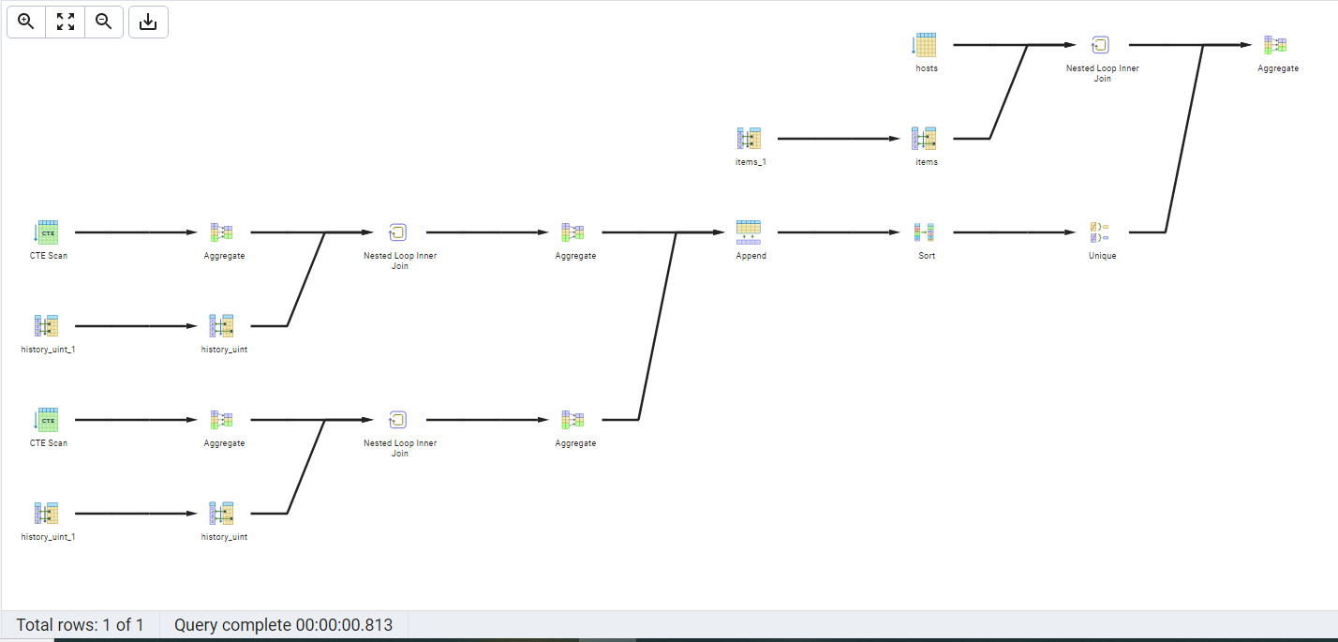

/*select max(hi.value) - min(hi.value) as quantidade,
max(hi.value) as contador_maximo, min(hi.value) as contador_minimo
from hosts h
inner join items it on (h.hostid = it.hostid)
inner join history_uint hi on (it.itemid = hi.itemid)
where h.host = 'Reprografia-Samsung-K7500LX'
and it.name = 'Contador_Pagina_Impressa'
and hi.value > 0
and cast(to_timestamp(hi.clock) AT TIME ZONE 'BRST' as date) between '2022-06-01' and '2022-06-30'*/

with
host_idx as (
select h.hostid, h.host, it.itemid, it.name from hosts h
inner join items it on (h.hostid = it.hostid)
where h.host = 'Reprografia-Samsung-K7500LX' and
it.name = 'Contador_Pagina_Impressa'
),
history_minimo as (

select min(hi.value) as contador from history_uint hi
where hi.itemid in ( select host_idx.itemid from host_idx) and
cast(to_timestamp(hi.clock) AT TIME ZONE 'BRST' as date) = '2022-06-01'
),
history_maximo as (
select max(hi.value) as contador from history_uint hi
where hi.itemid in ( select host_idx.itemid from host_idx) and
cast(to_timestamp(hi.clock) AT TIME ZONE 'BRST' as date) = '2022-06-30'
),
uniao as ( select * from history_minimo
union
select * from history_maximo
)

select min(contador) as minimo, max(contador) as maximo, max(contador) - min(contador) as quantidade from uniao

==========================

select min(quantidade) as contador_minimo, max(quantidade) as contador_maximo, max(quantidade) - min(quantidade) as quantidade from (select hi.value as quantidade
from hosts h
inner join items it on (h.hostid = it.hostid)
inner join history_uint hi on (it.itemid = hi.itemid)
where h.host = 'Reprografia-Samsung-K7500LX'
and it.name = 'Contador_Pagina_Impressa'
and hi.value > 0
and cast(to_timestamp(hi.clock) AT TIME ZONE 'BRST' as date) = '2022-06-01'
union
select hi.value as quantidade
from hosts h
inner join items it on (h.hostid = it.hostid)
inner join history_uint hi on (it.itemid = hi.itemid)
where h.host = 'Reprografia-Samsung-K7500LX'
and it.name = 'Contador_Pagina_Impressa'
and hi.value > 0
and cast(to_timestamp(hi.clock) AT TIME ZONE 'BRST' as date) = '2022-06-30') as teste

with
host_idx as (
select h.hostid, h.host, it.itemid, it.name from hosts h
inner join items it on (h.hostid = it.hostid)
where h.host = 'ADM-Samsung-SL-M4080FX-02' and
it.name = 'Contador_Pagina_Impressa'
),

historico as ( select min(hi.value), max(hi.value)
from history_uint hi, host_idx
where hi.itemid = host_idx.itemid
and
( cast(to_timestamp(hi.clock) AT TIME ZONE 'BRST' as date) = '2022-06-01' or
cast(to_timestamp(hi.clock) AT TIME ZONE 'BRST' as date) = '2022-06-30')
)

select * from historico

