**Questions:**

1. **Write a Python program that reads the file created as demonstrated into a dictionary taking ‘name’ as the key and a list consisting of ‘dept’ and ‘cgpa’ as the value for each line. Make changes in some ‘cgpa’ and then write back the whole file.**
2. **Implement in generic ways (as multi-modular and interactive systems) the Greedy Best-First and A* search algorithms in Prolog and in Python.**

**Solution to the question no 1**

The demonstrated Python code:

dict={}

f1=open('stdfile.py', "r")

for l in f1:

name, dept, cgpa =l.split("\t")

dict[name] = [dept,float(cgpa)]

print(name+'\t'+dept+'\t'+str(cgpa))

f1.close

num=int(input("How many records you want to change:"))

for i in range(num):

name = input("Enter the name were you want to change the cgpa:")

cgpa = float(input("New cgpa is:"))

dict[name][1]= cgpa

f1=open('stdfile.py', "w")

for name in dict:

dept=dict[name][0]

cgpa=dict[name][1]

std=name+"\t"+dept+"\t"+str(cgpa)

print(std, end="\n", file=f1)

f1.close

print("\nUpdate:")

f1=open('stdfile.py', "r")

for l in f1:

name, dept, cgpa =l.split("\t")

dict[name] = [dept,float(cgpa)]

print(name, dept, float(cgpa), end="\n")

f1.close

A sample of input and output is as below:

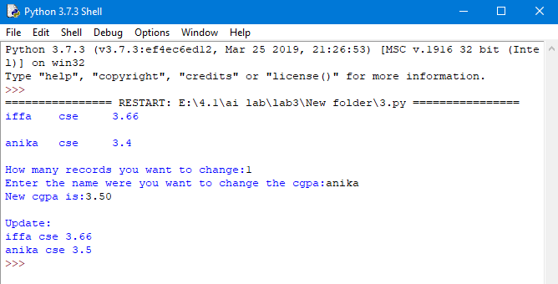

**Solution to the question no 2**

The demonstrated Prolog code is below:

% Including data files

:-use_module(inputGraph).

% Declaration of dynamic data

:-dynamic(t_node/2).

:-dynamic(pq/1).

:-dynamic(pp/1).

% Search begins

search:-write('Enter start node:'),read(S),h_fn(S,HV),

assert(t_node(S, 'nil')),assert(pq([node(S,HV)])),

assert(pp([])),generate,find_path_length(L), display_result(L).

% Generating the solution

generate:-pq([H|_]),H=node(N,_),N=g, add_to_pp(g),!.

generate:-pq([H|_]),H=node(N,_),update_with(N), generate.

% Adding a node to possible path

add_to_pp(N):-pp(Lst), append(Lst,[N],Lst1), retract(pp(_)),

assert(pp(Lst1)).

% Updating data according to selected node.

update_with(N):-update_pq_tr(N), update_pp(N).

% Updating Priority Queue and Tree

update_pq_tr(N):-pq(Lst), delete_1st_element(Lst,Lst1), retract(pq(_)),

assert(pq(Lst1)), add_children(N).

delete_1st_element(Lst,Lst1):-Lst = [_|Lst1].

add_children(N):- neighbor(N,X,_), not(t_node(X,_)),insrt_to_pq(X),

assert(t_node(X,N)),fail.

add_children(_).

% Inserting node to Priority Queue

insrt_to_pq(X):- pq(Lst), h_fn(X,V), insert12pq(node(X,V),Lst,Lst1),

retract(pq(_)), assert(pq(Lst1)).

insert12pq(El,[], [El]):-!.

insert12pq(El, L1, L2):-L1=[H|_], El=node(_,V1), H=node(_,V2),

not(V1 > V2), L2 = [El|L1], !.

insert12pq(El, L1, L2):-L1=[H|T], insert12pq(El, T, Lx), L2 = [H|Lx].

% Updating Possible Path

update_pp(N):- retract(pp(_)), assert(pp([])), renew_pp(N).

renew_pp(N):-t_node(N,nil), pp(X), append([N],X,X1),

retract(pp(_)), assert(pp(X1)), !.

renew_pp(N):- pp(X), append([N],X,X1), retract(pp(_)), assert(pp(X1)),

t_node(N,N1), renew_pp(N1).

% Finding 'shortest' path length

find_path_length(L):-pp(Lst),path_sum(Lst,L).

path_sum(Lst,0):- Lst=[g|_],!.

path_sum(Lst,L):-Lst=[N|T],T=[N1|_], neighbor(N,N1,D), path_sum(T,L1),L is L1+D.

% Displaying 'shortest' path and its length

display_result(L):- pp(Lst), write('Solution:'), write(Lst),nl,

write('Length:'), write(L).

% List dynamic data

list_records:-listing(t_node), listing(pq), listing(pp).

% Save file with modified records in place of old ones.

save_records:-tell('gbfs_db.pl'), listing(t_node), listing(pq), listing(pp),told.

%Clear the database

clr_db:-retractall(t_node(_,_)), retractall(pp(_)), retractall(pq(_)).

% Arrange a menu of actions

start:- repeat,

write('\n1. Clear database'),

write('\n2. Execute GBFS'),

write('\n3. Display database'),

write('\n4. Save database'),

write('\n5. Exit'),

write('\n\nEnter your choice: '),

read(N), N >0, N < 6,

do(N), N=5,!.

do(1):-clr_db.

do(2):-search.

do(3):-list_records.

do(4):-save_records.

do(5):-abort.

A sample of input and output is as below:

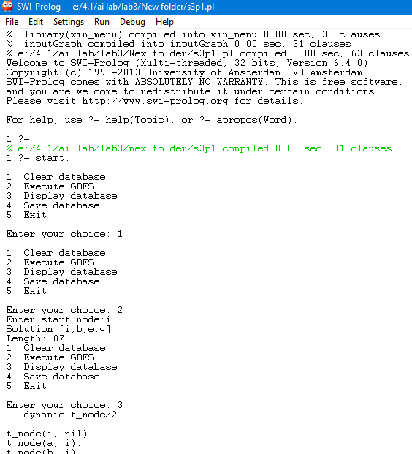

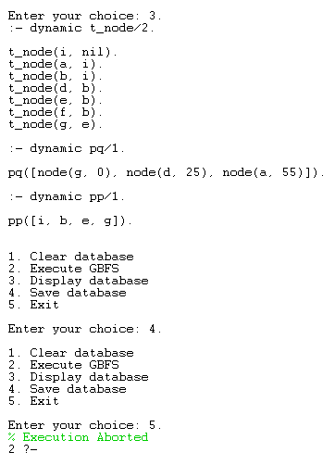

The demonstrated Python code is below:

from collections import defaultdict

def dfs(source,dest,visited,path):

visited[source]= True

path.append(source)

if source == dest:

total =0

print(path)

l = len(path)

for i in range(l-1):

total += graph[path[i]][path[i+1]]

print(total)

else:

for i in graph[source]:

if visited[i] == False:

dfs(i,dest,visited,path)

path.pop()

visited[source]=False

graph = defaultdict(dict)

graph[0][1]=35

graph[0][2]=45

graph[1][3]=22

graph[1][4]=32

graph[2][4]=28

graph[2][5]=36

graph[2][6]=27

graph[4][7]=30

graph[3][4]=31

graph[3][7]=47

graph[4][7]=30

graph[5][7]=26

source = int(input("Source: "))

dest = int(input("Destination: "))

visited = [False]*8

path=[]

dfs(source,dest, visited, path)

A sample of input and output is as below:

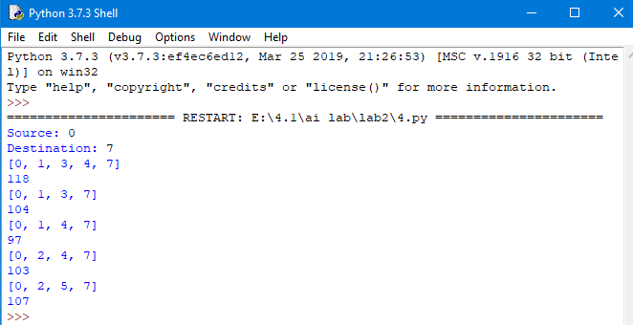

**Solution to the question no 2 (A*)**

% Including data files

:-use_module(inputGraph).

% Declaration of dynamic data

:-dynamic(t_node/4).

:-dynamic(t_indx/1).

:-dynamic(pq/1).

:-dynamic(pp/1).

% Search begins

search:-write('Enter start node:'),read(S),h_fn(S,HV),

assert(t_node(S,0,nil,HV)),assert(pq([node(S,0,'nil',HV)])),assert(t_n_indx(1)),

assert(pp([])),generate,find_path_length(L), display_result(L).

% Generating the solution

generate:-pq([H|_]),H=node(N,_,_,_),N=g, add_to_pp(g),!.

generate:-pq([H|_]), H=node(N,I,_,_), update_with(N,I),generate.

% Adding a node to possible path

add_to_pp(N):-pp(Lst), append(Lst,[N],Lst1), retract(pp(_)),

assert(pp(Lst1)).

% Updating data according to selected node.

update_with(N,I):-update_pq_tr(N,I), update_pp(N,I).

% Updating Priority Queue and Tree

update_pq_tr(N,I):-pq(Lst), delete_1st_element(Lst,Lst1), retract(pq(_)),

assert(pq(Lst1)), add_children(N,I).

delete_1st_element(Lst,Lst1):-Lst = [_|Lst1].

add_children(N,I):- neighbor(N,X,D), t_n_indx(I1), t_node(_,I,_,V),

h_fn(N,V1), h_fn(X,V2), FNV is V+D-V1+V2,

insrt_to_pq(X,I1,I,FNV), assert(t_node(X,I1,I,FNV)),

incr_indx, fail.

add_children(_,_).

incr_indx:- t_n_indx(X), Y is X+1, retract(t_n_indx(X)), assert(t_n_indx(Y)).

% Inserting node to Priority Queue

insrt_to_pq(X,I1,I,FNV):- pq(Lst), insert12pq(node(X,I1,I,FNV),Lst,Lst1),

retract(pq(_)), assert(pq(Lst1)).

insert12pq(El,[], [El]):-!.

insert12pq(El, L1, L2):-L1=[H|_], El=node(_,_,_,V1), H=node(_,_,_,V2),

not(V1 > V2), L2 = [El|L1], !.

insert12pq(El, L1, L2):-L1=[H|T], insert12pq(El, T, Lx), L2 = [H|Lx].

% Updating Possible Path

update_pp(N,I):- retract(pp(_)), assert(pp([])), renew_pp(N,I).

renew_pp(N,I):-t_node(N,I,nil,_), pp(X), append([N],X,X1),

retract(pp(_)), assert(pp(X1)), !.

renew_pp(N,I):- pp(X), append([N],X,X1), retract(pp(_)), assert(pp(X1)),

t_node(N,I,I1,_),t_node(N1,I1,_,_), renew_pp(N1,I1).

% Finding 'shortest' path length

find_path_length(L):-pp(Lst),path_sum(Lst,L).

path_sum(Lst,0):- Lst=[g|_],!.

path_sum(Lst,L):-Lst=[N|T],T=[N1|_], neighbor(N,N1,D), path_sum(T,L1),L is L1+D.

% Displaying 'shortest' path and its length

display_result(L):- pp(Lst), write('Solution:'), write(Lst),nl,

write('Length:'), write(L).

% List dynamic data

list_records:-listing(t_node), listing(pq), listing(pp).

% Save file with modified records in place of old ones.

save_records:-tell('astars_db.pl'), listing(t_node), listing(pq), listing(pp),told.

%Clear the database

clr_db:-retractall(t_node(_,_,_,_)),retractall(t_n_indx(_)), retractall(pp(_)), retractall(pq(_)).

% Arrange a menu of actions

start:- repeat,

write('\n1. Clear database'),

write('\n2. Execute GBFS'),

write('\n3. Display database'),

write('\n4. Save database'),

write('\n5. Exit'),

write('\n\nEnter your choice: '),

read(N), N >0, N < 6,

do(N), N=5,!.

do(1):-clr_db.

do(2):-search.

do(3):-list_records.

do(4):-save_records.

do(5):-abort.

A sample of input and output is as below:

