**Question:**

**1. Implement Linear Regression and k-Nearest Neighbor Classifier without using Scikit-learn.**

**Solution to Linear Regression**

The demonstrated Python code:

# Import the necessary libraries

import matplotlib.pyplot as plot

import pandas

import numpy as np

def getAlpha():

global xTrain,yTrain,xMean,yMean

n = 0

for i in range(len(xTrain)):

n = n + (xTrain[i] - xMean) * (yTrain[i] - yMean)

dn = 0

for i in range(len(xTrain)):

dn = dn + pow((xTrain[i] - xMean),2)

return n/dn

def meanAbsoluteError():

global yTest, pred

n = 0

for i in range(len(yTest)):

nom = n + abs(yTest[i] - pred[i])

return n/len(yTest)

def meanSquaredError():

global yTest, pred

n = 0

for i in range(len(yTest)):

n = n + pow((yTest[i] - pred[i]),2)

return n/len(yTest)

# Import the dataset

dataset = pandas.read_csv('salaryData.csv')

x = dataset['YearsExperience'].values

y = dataset['Salary'].values

# Reshape x y

X = x.reshape(len(x),1)

Y = y.reshape(len(y),1)

# Spliting dataset

xTrain, yTrain, xTest, yTest, pred = ([] for i in range(5))

for i in range(int(len(X)*1/3)):

xTrain.append(X[i])

yTrain.append(Y[i])

for i in range(int(len(X)*1/3), len(X)):

xTest.append(X[i])

yTest.append(Y[i])

# Calculation of mean values and alpha, beta

xMean = np.mean(xTrain)

yMean = np.mean(yTrain)

alpha = getAlpha()

beta = yMean - alpha*xMean

# Prediction on Training data

for i in range(len(xTest)):

pred.append( alpha* xTest[i] + beta)

print(np.asarray(pred).shape)

df = pandas.DataFrame({'Actual': np.asarray(yTest).flatten(), 'Predicted': np.asarray(pred).flatten()})

print(df)

df1 = df

df1.plot(kind='bar')

plot.show()

print('Mean Absolute Error:', meanAbsoluteError())

print('Mean Squared Error:', meanSquaredError())

print('Root Mean Squared Error:', np.sqrt(meanSquaredError()))

A sample of input and output is as below:

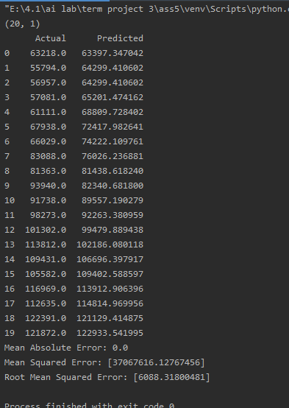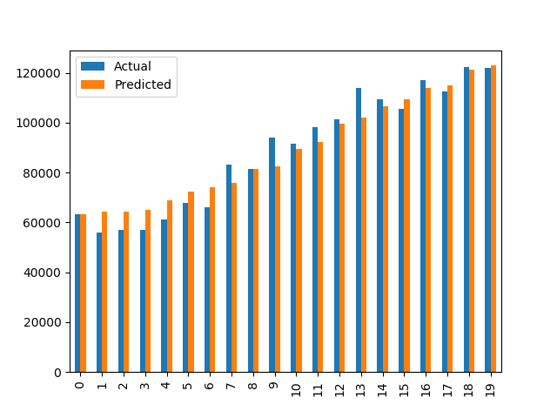

"E:\4.1\ai lab\term project 3\ass5\venv\Scripts\python.exe" "E:/4.1/ai lab/term project 3/ass5/regressionAssignment.py"

(20, 1)

Actual Predicted

0 63218.0 63397.347042

1 55794.0 64299.410602

2 56957.0 64299.410602

3 57081.0 65201.474162

4 61111.0 68809.728402

5 67938.0 72417.982641

6 66029.0 74222.109761

7 83088.0 76026.236881

8 81363.0 81438.618240

9 93940.0 82340.681800

10 91738.0 89557.190279

11 98273.0 92263.380959

12 101302.0 99479.889438

13 113812.0 102186.080118

14 109431.0 106696.397917

15 105582.0 109402.588597

16 116969.0 113912.906396

17 112635.0 114814.969956

18 122391.0 121129.414875

19 121872.0 122933.541995

Mean Absolute Error: 0.0

Mean Squared Error: [37067616.12767456]

Root Mean Squared Error: [6088.31800481]

**Solution to K nearest neighbor**

The demonstrated Python code:

# Import the necessary libraries

import matplotlib.pyplot as plot

import pandas

import numpy as np

def getAlpha():

global xTrain,yTrain,xMean,yMean

n = 0

for i in range(len(xTrain)):

n = n + (xTrain[i] - xMean) * (yTrain[i] - yMean)

dn = 0

for i in range(len(xTrain)):

dn = dn + pow((xTrain[i] - xMean),2)

return n/dn

def meanAbsoluteError():

global yTest, pred

n = 0

for i in range(len(yTest)):

nom = n + abs(yTest[i] - pred[i])

return n/len(yTest)

def meanSquaredError():

global yTest, pred

n = 0

for i in range(len(yTest)):

n = n + pow((yTest[i] - pred[i]),2)

return n/len(yTest)

# Import the dataset

dataset = pandas.read_csv('salaryData.csv')

# Differentiate attribute and target columns

x = dataset['YearsExperience'].values

y = dataset['Salary'].values

# Reshaping

X = x.reshape(len(x),1)

Y = y.reshape(len(y),1)

# Spliting dataset into test and training data

xTrain, yTrain, xTest, yTest, pred = ([] for i in range(5))

for i in range(int(len(X)*1/3)):

xTrain.append(X[i])

yTrain.append(Y[i])

for i in range(int(len(X)*1/3), len(X)):

xTest.append(X[i])

yTest.append(Y[i])

# Calculating the mean values and alpha, beta

xMean = np.mean(xTrain)

yMean = np.mean(yTrain)

alpha = getAlpha()

beta = yMean - alpha*xMean

# Prediction on Training data

for i in range(len(xTest)):

pred.append( alpha* xTest[i] + beta)

print(np.asarray(pred).shape)

df = pandas.DataFrame({'Actual': np.asarray(yTest).flatten(), 'Predicted': np.asarray(pred).flatten()})

print(df)

df1 = df

df1.plot(kind='bar')

plot.show()

print('Mean Absolute Error:', meanAbsoluteError())

print('Mean Squared Error:', meanSquaredError())

print('Root Mean Squared Error:', np.sqrt(meanSquaredError()))

A sample of input and output is as below:

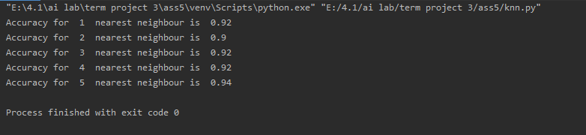

"E:\4.1\ai lab\term project 3\ass5\venv\Scripts\python.exe" "E:/4.1/ai lab/term project 3/ass5/knn.py"

Accuracy for 1 nearest neighbour is 0.92

Accuracy for 2 nearest neighbour is 0.9

Accuracy for 3 nearest neighbour is 0.92

Accuracy for 4 nearest neighbour is 0.92

Accuracy for 5 nearest neighbour is 0.94