Discussion Based Forum

With eShopping

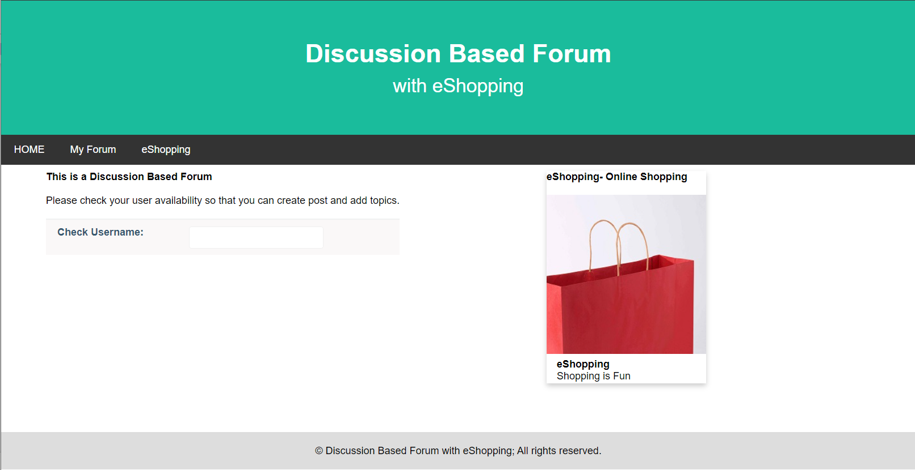

Picture: Snapshot of Index.php

**Exporting Database**

**Database Name:** Discussion-Forum

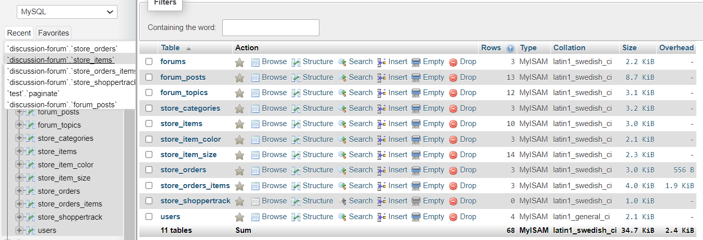

Step-1: Go to ‘Export’ tab

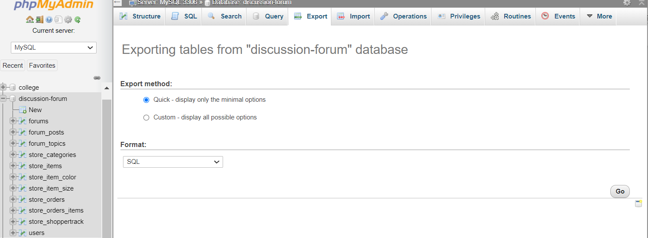

Step-2: Save and Download Discussion-Forum.sql

