PROJECT: Analysis, Design and Development of a Banking System
1. Requirement Analysis
Banking System Case Study

Functional Requirements with Stories for Each:

No: | Functional Requirement | User Story
1 | Card Ejector | As a customer I need a place where I can insert my card into the ATM machine for getting the Service so that Card Ejector will use for this purpose.
2 | Cash Dispenser | As a Customer I need a place where I can get my money from the ATM Machine so that Cash dispenser will use for this purpose.
3 | keyboard | As a customer I need a place where I can enter my password or amount range so that keyboard will use for entry the input toward ATM machine.
4 | Card Validation | As a manager I want when the customer inserts the card then ATM will check first card is valid or not so card validation will use for this purpose.
5 | Pin Validation | As a manager I want when the customer inserts the card and enter him secret password then check pin will valid or not so that Pin validation will use for this purpose.
6 | Server | As a manager I want a server where I can store all the customer data about their account information or card information so that Server will use to store the data of the customer
7 | Bio-metric verification | As a manger when a new customer will come for getting the services then first store bio-metric information for the security of the customer and store all the information on the server
8 | Magnetic chip reader | As a manager I need magnetic chip reader in the ATM machine because all the information of customer store on the ATM Card magnetic chip. In order to take that information, we need magnetic chip reader. Magnetic chip reader will use for this purpose.
9 | Account Type | As a customer I need when I insert my card and then pin then ATM should ask me what is your account type. Whether it is saving or current or other
10 | Current Account | As a manger I need to know what are the service for the customer in this account type. If the account type is current, we need to keep his money just not give him the interest for the money.
11 | Saving Account | As a manger I need to know what are the service for the customer in this account type. If the account type is saving, we need to increase his money by specific interest.
12 | Withdraw Amount | As a customer I need to withdraw my money from the atm machine after entered the card and pin validation and account types. So, withdraw module will use for this purpose
13 | Query Amount | As a customer I need that I just want Query our account and how much balance in it not interesting in Withdraw amount So Query Module will use for this purpose.
14 | Print slip | As a customer I need slip of my account after the transaction. Slip contains the information about the transaction date, money and account detail
15 | Transfer Funds | As a customer I need to transfer my amount into the other account. Transfer module will use for this purpose.
16 | Fingerprint | As a customer I need a fingerprint if I am not able to remember the password so the Fingerprint will use as a pin for this purpose.
17 | Card Eject | As a customer I need if the transaction taking too much time from the normal routine, I need button for eject the card to terminate all the instruction

2. Architectural Design

Tests:
- Card Ejector:
Input:
Card
Test:
- It should eject card properly.
- It should not hold card inside it.
- It should be of same size as that of card.

- Card Despenser:
Input:
Money.
Tests:
- It should not be empty with money.
- On transaction it should give correct amount of money to the customer.

- Keyboard:
Input:
Buttons
Test:
- Buttons should be working smooth.

- Card validation:
Input:
Card
Test:
- Card should be entered correct, if not the it should give error and deny the acceptance of the card.
- After several incorrect card insertion, it should block the user’s card and should not allow further to insert it.

- Pin validation:
Input:
Card.
Test:
- The user should enter the correct pin.
- On incorrect pin number, it should give error.
- Pin number should only be 4 digits.
- On several tries, if user fails to give correct pin number, its card should get blocked.

- Biometric Validation:
Input:
User’s Fingerprint.
Test:
- User should give fingerprints of both of his/her thumbs.

- Account Type:
Input:
Card, pin.
Test:
- It should display all types of accounts to the user.
- When user enters his/her choice, it should return the valid information regarding his/her query.

- Withdraw Account:
Input:
Valid card, valid pin.
Test:
- It should give appropriate information about the user account.
- It should display how much amount the customer wants to withdraw.
- On entering the amount, it should return the same amount back to the customer.

- Query Account:
Input:
Card, Pin.
Test:
- It should display the amount that the user has left in his/her account.
- If there is no money left, it should return that balance =0.

- Print slips:
Input:
Amount withdraws.
Test:
- There should be papers present inside atm machine for printing.
- Printer inside it should be working fine.
- There should be cartilage for printing paper.
- It should print the details of transaction as soon as the atm has given out the money to the user.

- Transfer Funds:
Input:
Card.
Test:
- It should have all the information of the user’s account and the account he/she wants to transfer to funds in.
- If anything is entered wrong, it should give error and should not proceed the transaction/transfer.

- Finger Print:
Input:
Sensor, finger of the user.
Test:
- The sensor should be working fine.
- User must have registered his/her fingerprint prior to use to the bank.
- If the sensor does not recognize the fingerprint, it should not proceed further towards transaction.
- On successful attempt, it should proceed further and ask user to enter his/her choice.

Use case of ATM Machine

- Use case of Validate PIN

Name Validate Pin
Summary | System validates customer PIN
Dependency | None
Actor | ATM customer
Preconditions | ATM is idle, display a welcome Message
Flow of event | Activity Diagram
Alternatives | - If the system determines that the card date has expired, the card is confiscated.  - If the system determines that the card has been reported lost or stolen, the  card is confiscated.  - If the customer-entered PIN does not match the PIN number for this card, the system re-prompts for PIN.  - If the customer enters the incorrect PIN three times, the system confiscates the card.  - If the customer enters Cancel, the system cancels the transaction and ejects  the card
Post Condition Customer Pin has been validated

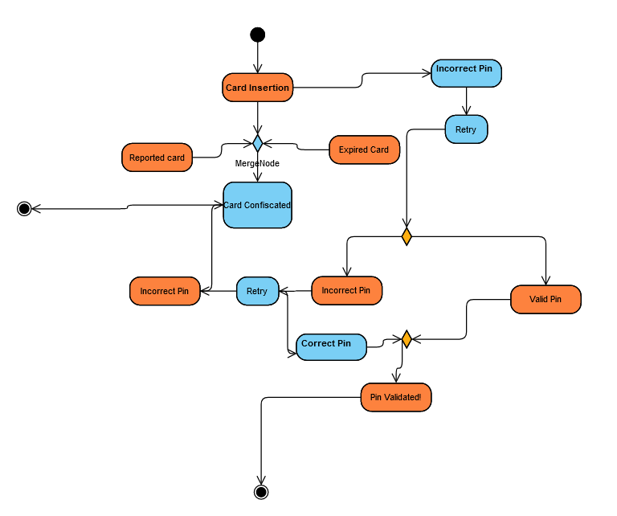

- Use case of Deposit

Name Deposit
Summary | System accommodates the Deposit Service
Dependency | None
Actor | ATM customer
Preconditions | If the customer pin is valid
Flow of event | Activity Diagram
Alternatives | - If customer currency is fake then cancel the transaction  •
Post Condition Deposit status updated

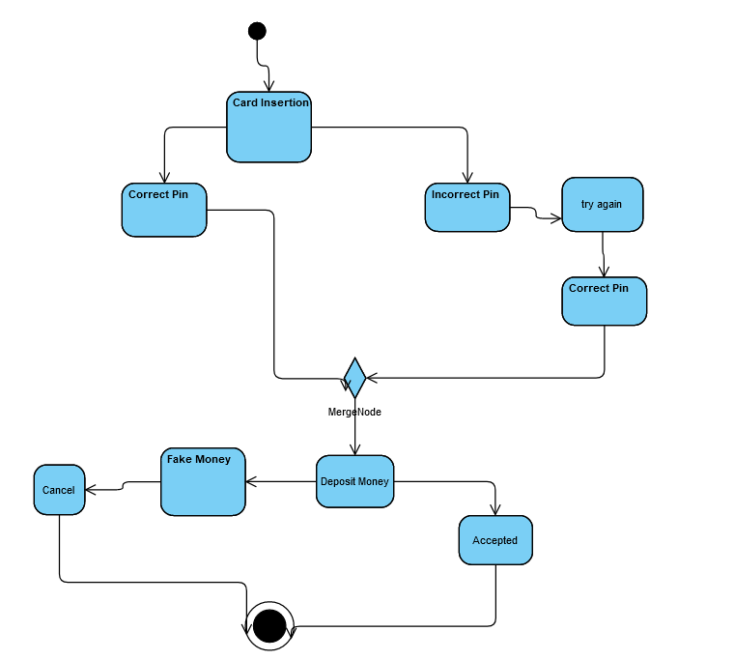

- Use case of Withdrawal

Name Withdrawal
Summary | System accommodates the withdrawal service
Dependency | ATM contain specific amount
Actor | ATM customer
Preconditions | If the customer pin is valid, Required amount should in ATM
Flow of event | Activity Diagram
Alternatives | - If the customer entered amount value does not contain his account, then ATM machine should change his withdrawal  •
Post Condition withdrawal status updated

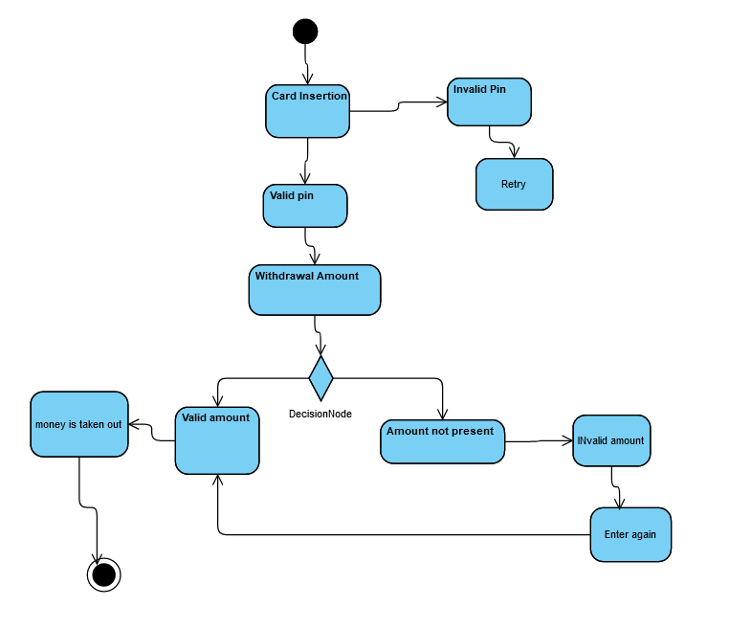

- Use case of Inquiry Account

Name Inquiry Account
Summary | System accommodates the Inquiry account
Dependency | None
Actor | ATM customer
Preconditions | If the customer pin is valid, if ATM detected correctly.
Flow of event | Activity Diagram
Alternatives | - If Customer Pin is not valid then cancel this operation.  - If the customer completes this operation, then ATM should ask from the user at the end for printing the slip.  •
Post Condition Inquiry status updated

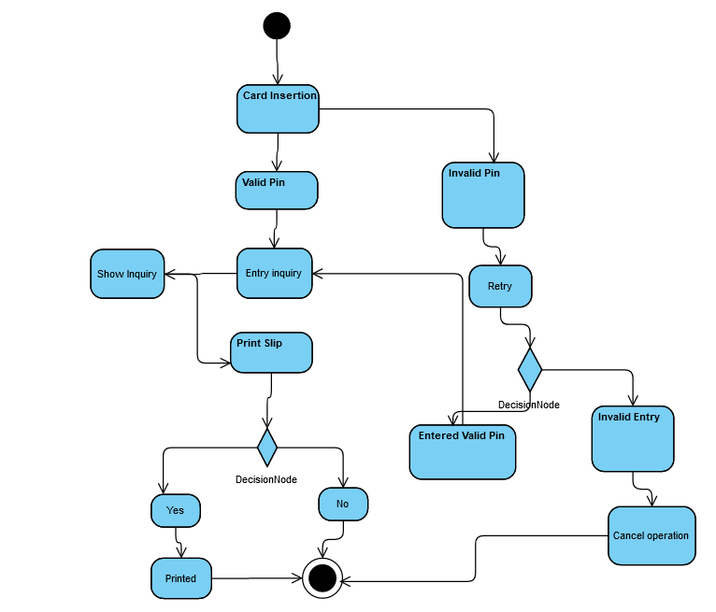

- Use case of Check Balance

Name Check Balance
Summary | System accommodates the Balance Check Service
Dependency | None
Actor | ATM customer
Preconditions | If the customer pin is valid, if ATM detected correctly.
Flow of event | Activity Diagram
Alternatives | - If the customer entered amount value does not contain his account, then ATM machine should change his withdrawal  •
Post Condition Balance check status updated

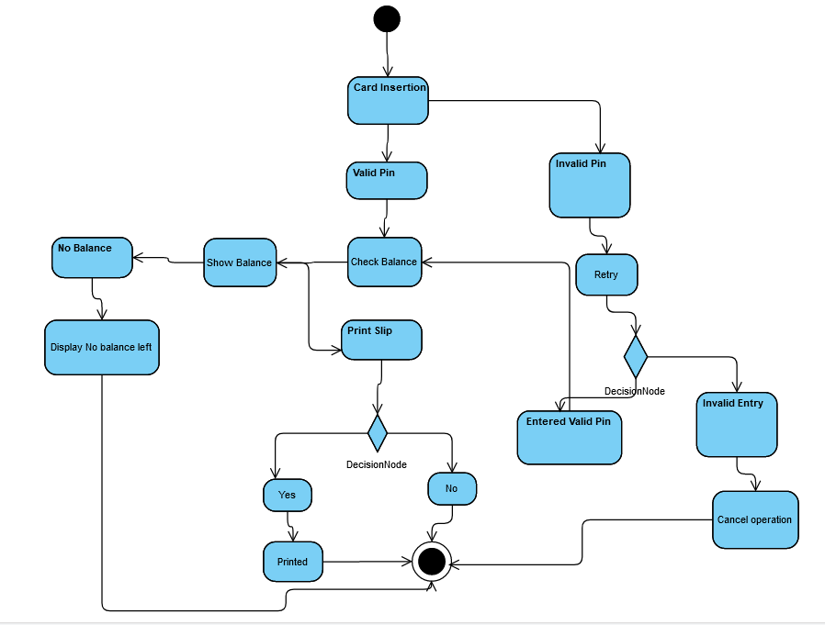

- Use case of Transfer Funds

Name Transfer funds
Summary | System accommodates the Transfer funds Service
Dependency | None
Actor | ATM customer
Preconditions | Balance status greater then transfer amount
Flow of event | Activity Diagram
Alternatives | •  •
Post Condition Balance check status updated

- 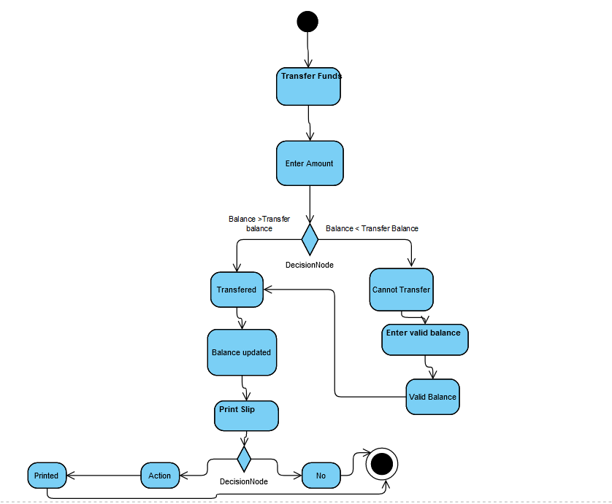Use case of Print Receipt

Name Print Receipt
Summary | System accommodates the Print Receipt Service
Dependency | None
Actor | ATM customer
Preconditions | If the customer is valid
Flow of event | Activity Diagram
Alternatives | - if ATM will not print receipt, then ATM will display all the information on the screen.  - If the ATM is not in idle condition, then ATM should kick out the card :)
Post Condition Print Receipt status updated

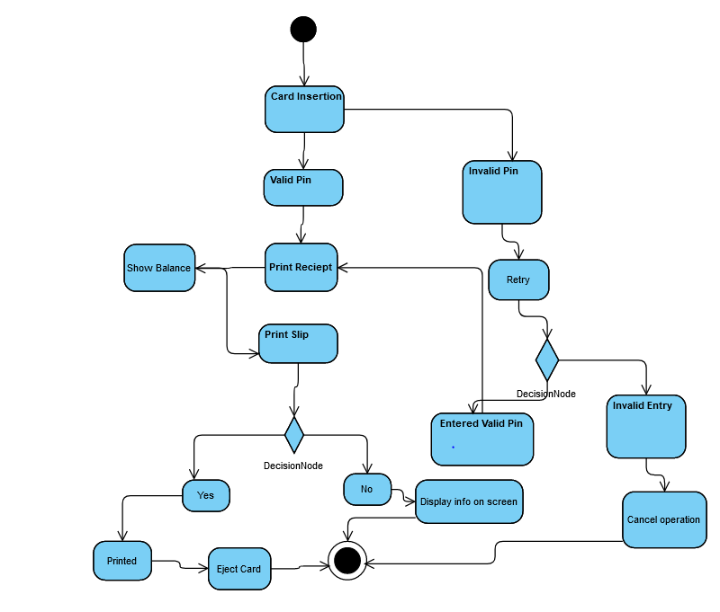

- Use case of Stolen ATM Card

Name Stolen ATM Card
Summary | System catches the Stolen ATM Card
Dependency | None
Actor | ATM Machine Actor
Preconditions | If the Card is reported
Flow of event | Activity Diagram
Alternatives | - if the card Is reported on bank due to loss or stolen then ATM should block the card under the machine
Post Condition Card block status updated

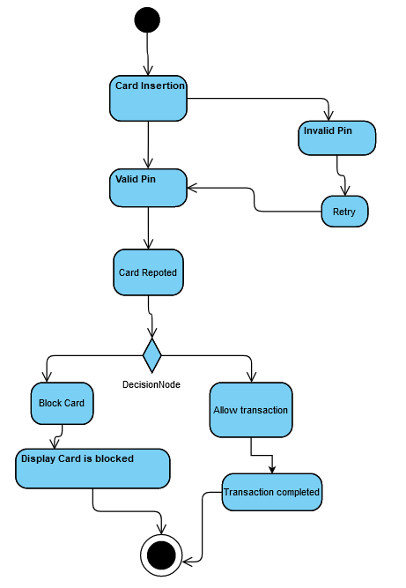

- Use case of Updates Transaction

Name Updates Transaction
Summary | Bank will update user by email or Message
Dependency | None
Actor | Bank Actor
Preconditions | If some transaction has done
Flow of event | Activity Diagram
Alternatives | - if customer has done some operation with ATM Machine, then Bank should update the customer using email or message.
Post Condition Updates Status updated

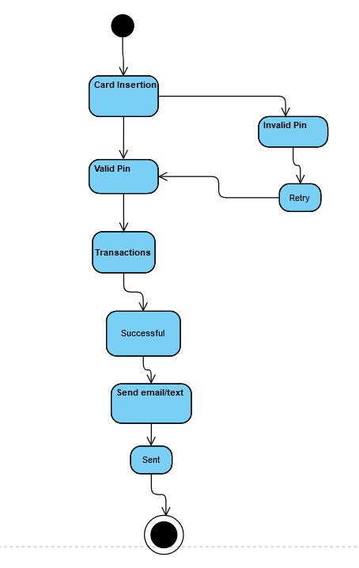
- Use case of ATM Help

Name ATM Help
Summary | Help the user that how to use the ATM Machine
Dependency | None
Actor | Customer Actor
Preconditions | None
Flow of event | Activity Diagram
Alternatives | •
Post Condition Updates Status updated

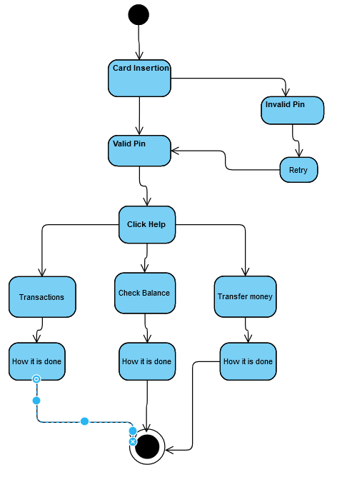

Swim line Diagram:
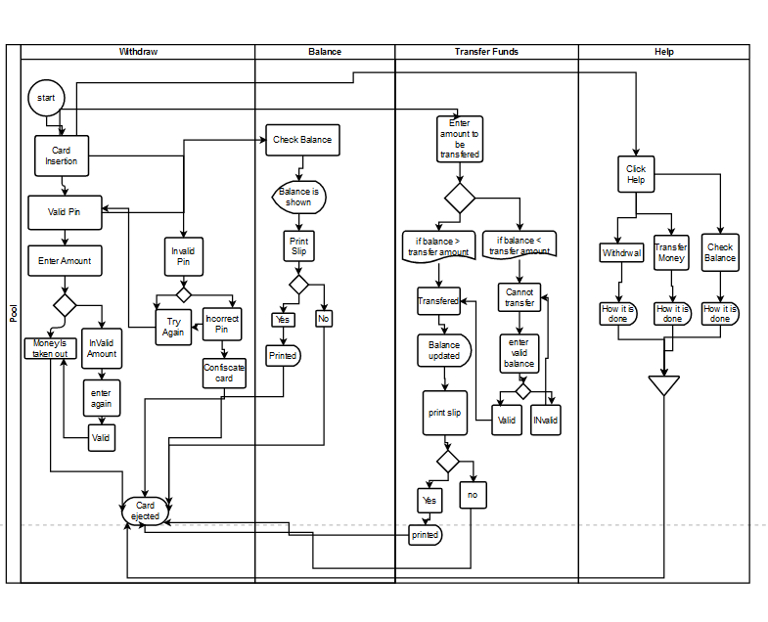

Architecture Evaluation by Qualitative Method

I will evaluate our model by Qualitative method using ATAM which is stand for Architecture Trade
off Analysis Method.

ATAM:

Pre -requisite
The prerequisite of the our Architecture which is Actually Sensitivity point and trade off point. The senstitvity point in our architecture are Server(Database) because our all information and pins validation password are stored on the store if the server is down then all other component will not work and second is Fingerprint Biometric . If the Fingerprint device is not working well then system will not allow the user to get the services. Validation is the third component which is our also main component who are actually validate all actions and checking whole process is working is right or not.

Function Driver
The main function Driver Component are
- Verify the Credentials
- Transaction
- User information
- SMS Alert
- Check user Account information(related to amount)

Now we evaluate the architecture using Scenario base
Quality Attributes | Stimulus (Scenario) | System response
availability | If the system is Down | If the system is not available due to server down or Cash is not present on the ATM Machine then may be system will be off but once the conditions are satisfied the System will not off unless there is weakened or Government Polices.
availability | If the Server is Down | Normally Server will never down let suppose if the Server will down then for that we have two type of server local server and global server  if the local server Is down then all the functionality performed by Global server
Reliability | If the services are not performing well | If some function are not performing well then System alert Message will send to Administration and set it soon but for the current he closed that’s the functionality.
Modifiability | What you will you if the system need updates in the future. | That will easy for us because we are using micro services plus layered architecture if some component need updates then updates will come from the Server and update that component
Modifiability | How will you update the app | Now we are not going to develop app but we will see when we do this.
Availability | What you will do if you have million of request at the server bots base | If request are huge then definitely there are some bots then for that we will use the recaptcha to detect the bots.

Quantitative Analysis

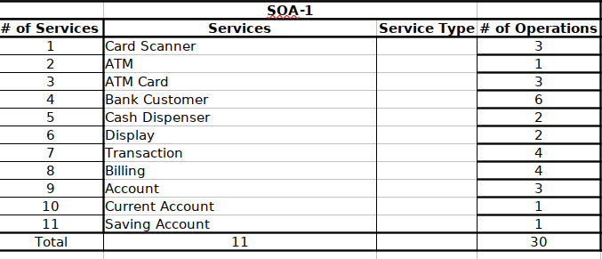

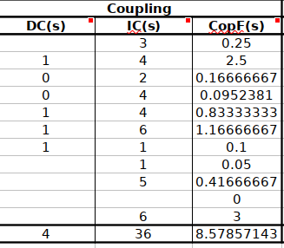

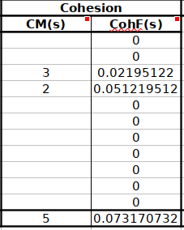
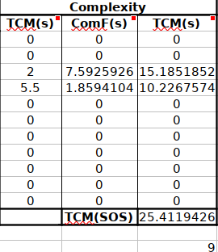

fef

Our complexity Analysis is 25 percent which is not good we will reduce the coupling by eliminate the some condition. We added the some more functionality in our architecture that is running commercial on the atm Machine when no one of using it. That’s why complexity of the of the Architecture is 25 which is not too bad.

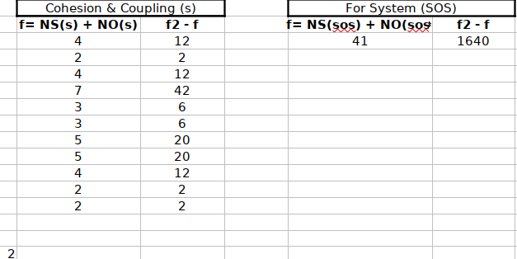
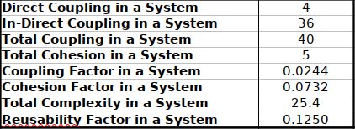

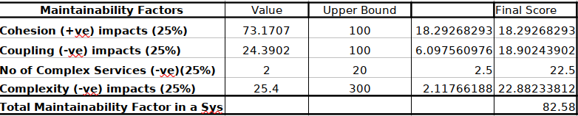

3. Detail Design

We determined the classes from each component of the architecture and then ignore the
un-relevent information from our the system. Then created the Class Diagram.
