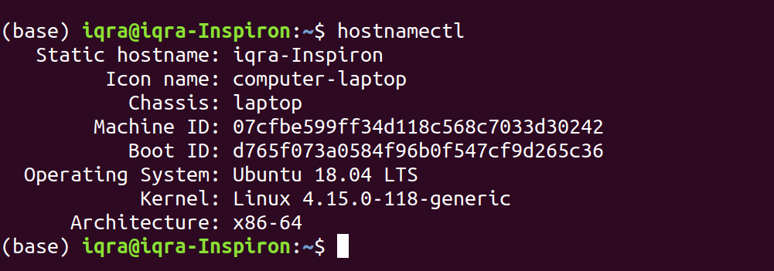
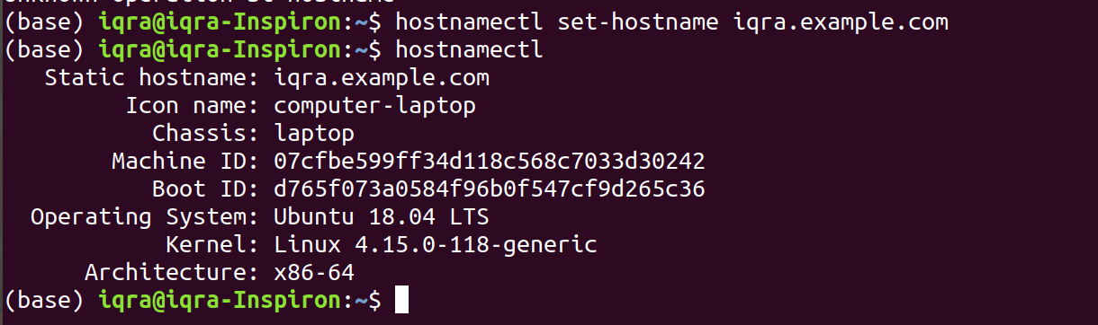
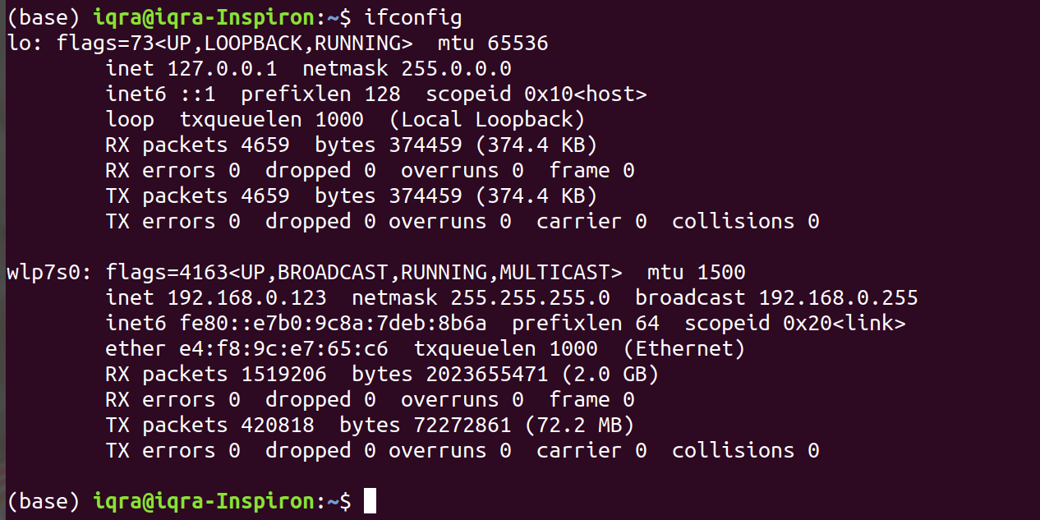

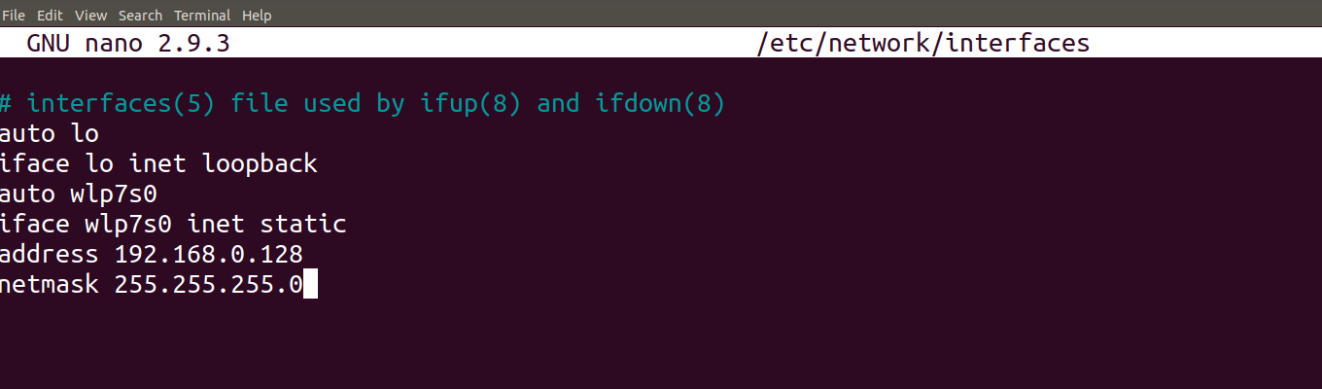
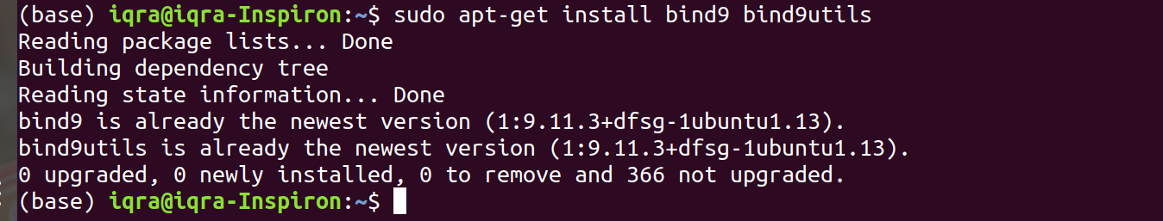
Main Configuration file of this DNS server
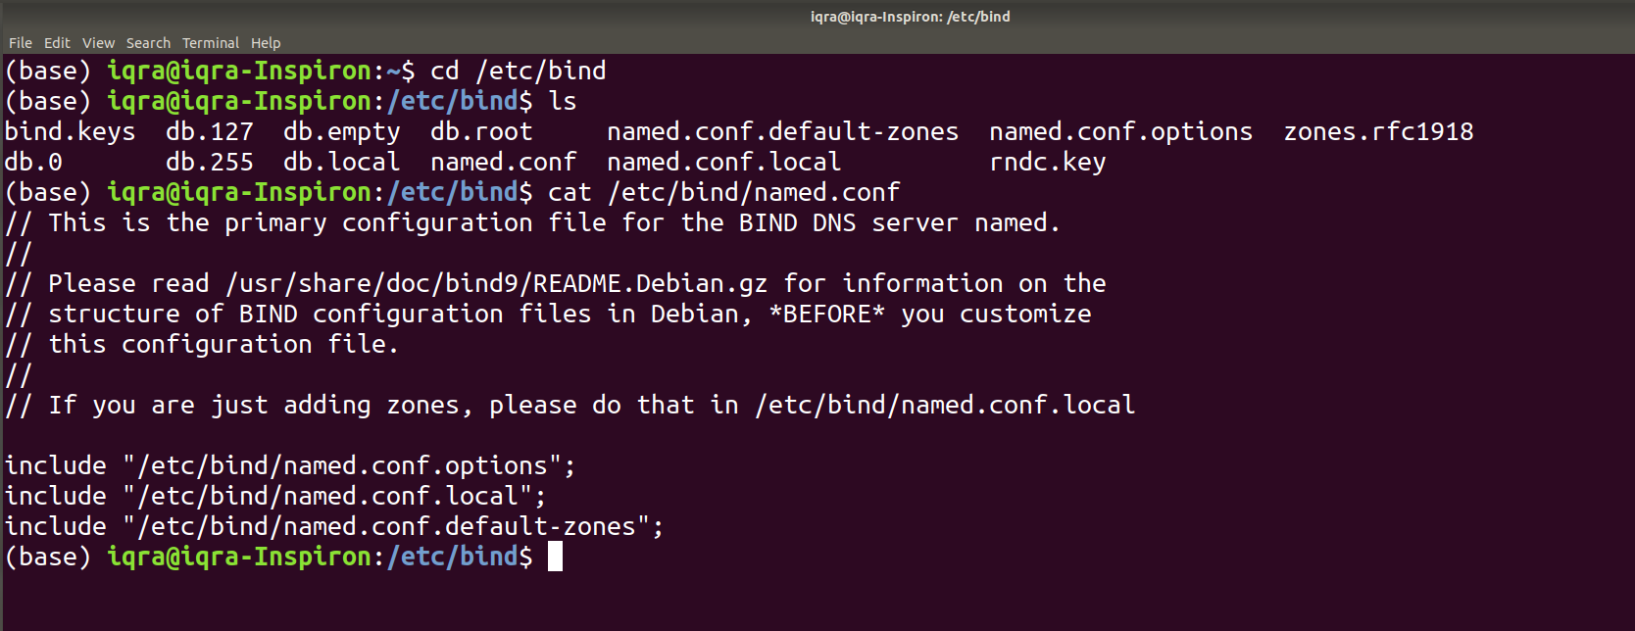
here we will create zones, you will have to give the domain name for which you are creating the domain name server. Like: “example.com”
IN means Internet
type is master because we are creating master DNS server.
File for forward zone
must exist in etc/bind
In reverse zone give ip in reverse order no need to give host
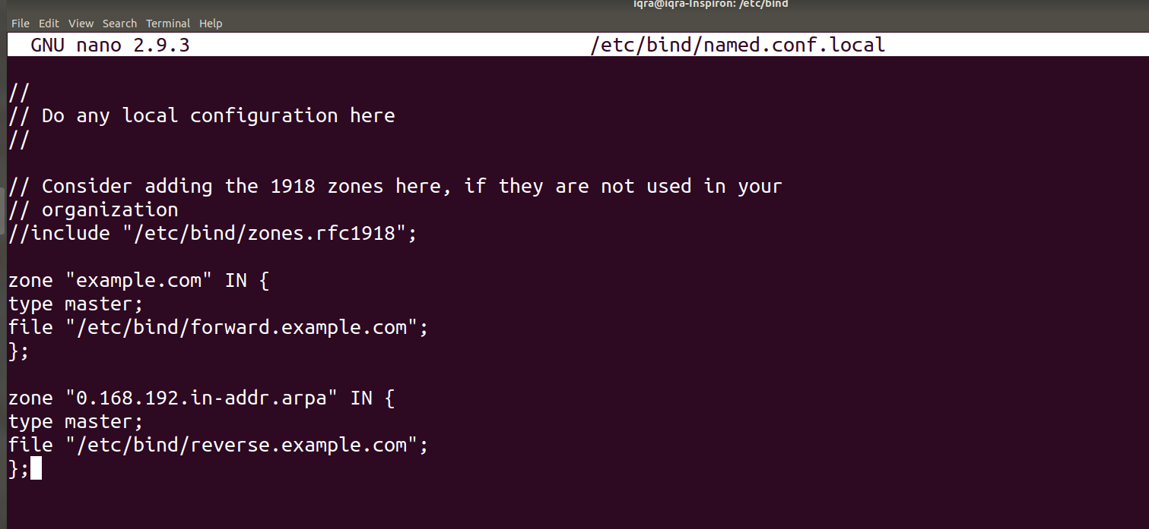

we will copy files db.local because we need similar configuration
SOA=start of authority
after hostname place dot(.)
NS= NameServer
A is for Ipv4 Address
AAAA is for Ipv6 Address
given different names to same server

