DHCP (Dynamic Host Configuration Protocol)
The ability to network devices quickly and easily is critical in a hyper-connected world, and although it has been around for decades, DHCP remains an essential method to ensure that devices are able to join networks and are configured correctly.
DHCP greatly reduces the errors that are made when IP addresses are assigned manually, and can stretch IP addresses by limiting how long a device can keep an individual IP address.

DHCP definition
DHCP stands for dynamic host configuration protocol and is a network protocol used on IP networks where a DHCP server automatically assigns an IP address and other information to each host on the network so they can communicate efficiently with other endpoints.
In addition to the IP address, DHCP also assigns the subnet mask, default gateway address, domain name server (DNS) address and other pertinent configuration parameters. Request for comments (RFC) 2131 and 2132 define DHCP as an Internet Engineering Task Force (IETF)- defined standard based on the BOOTP protocol.

DHCP simplifies IP address management
The primary reason DHCP is needed is to simplify the management of IP addresses on networks. No two hosts can have the same IP address, and configuring them manually will likely lead to errors. Even on small networks manually assigning IP addresses can be confusing, particularly with mobile devices that require IP addresses on a non-permanent basis. Also, most users aren’t technically proficient enough to locate the IP address information on a computer and assign it. Automating this process makes life easier for users and the network administrator.

1)sudo apt-get update
2)sudo apt-get install isc-dhcp-server
3)ifconfig
Note your NIC name, IP,NetMask,Broadcastip
4)sudo nano /etc/default/isc-dhcp-server
give the name of your NIC in INTERFACESv4
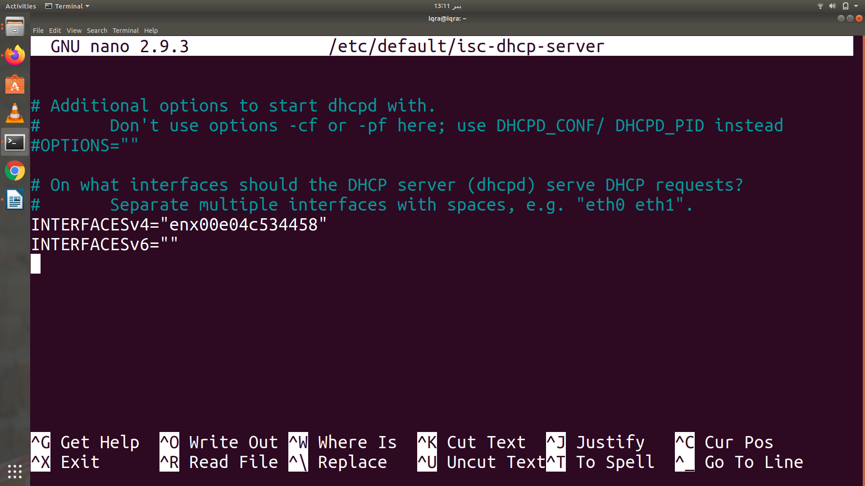

5)cd /etc/dhcp/
6) ls
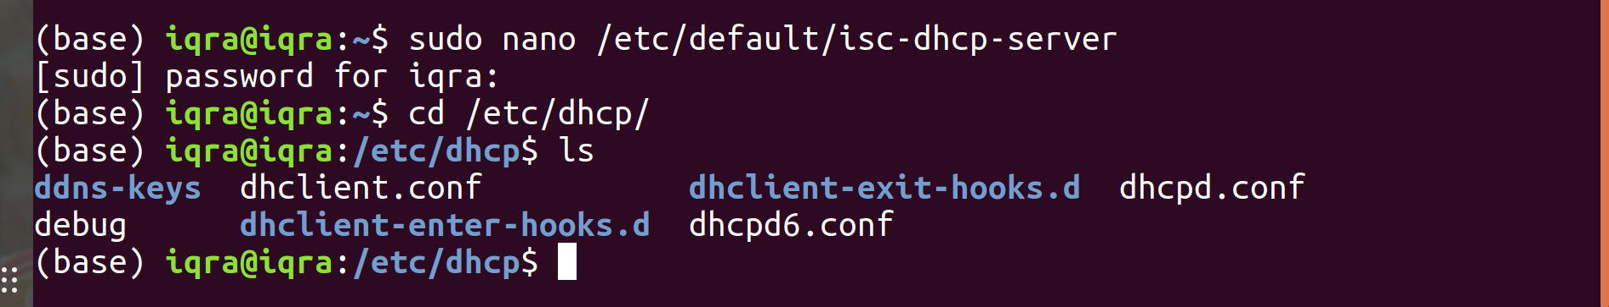

7)sudo nano /etc/dhcp/dhcpd.conf
uncomment authoritative
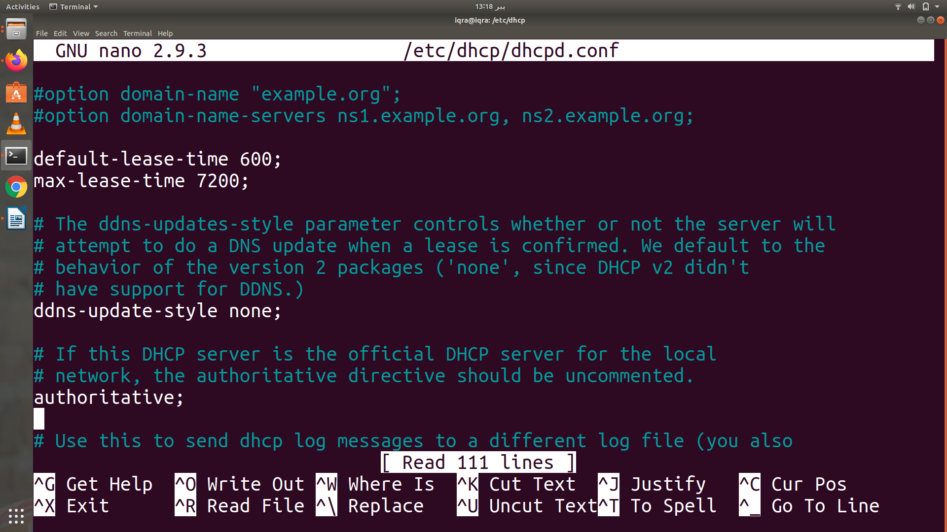

give the subnet, netmask, range of ip’s

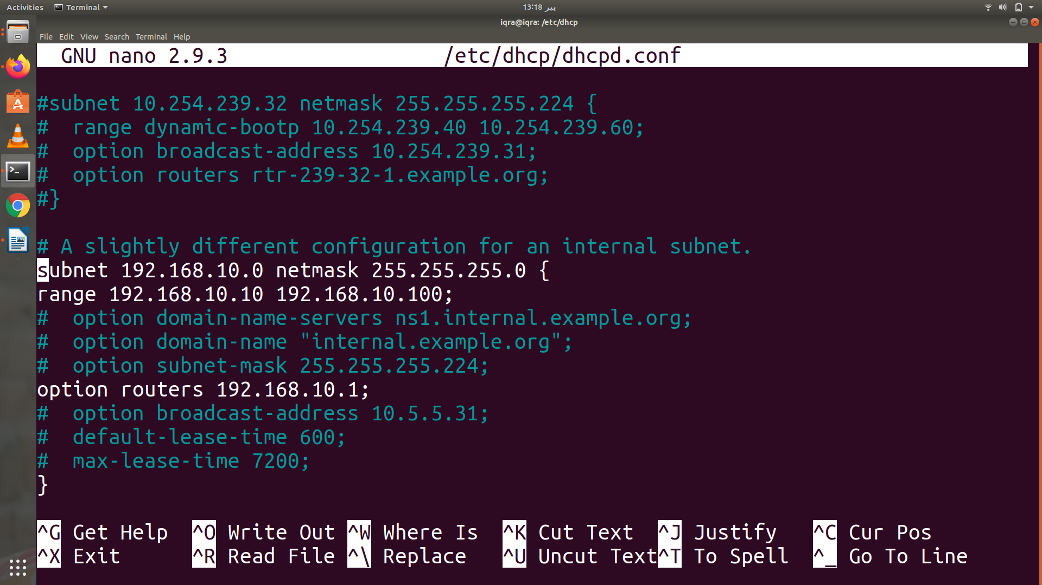

8)sudo systemctl start isc-dhcp-server
9)sudo systemctl status isc-dhcp-server
10)sudo systemctl enable isc-dhcp-server
After that check if firewall is enabled or not
11) sudo ufw status
if it is active then enter command,
12)sudo ufw allow in on “name of your NIC” from any port 68 to any port 67 udp
(it will allow communication to your nic through these ports)
To check how many devices are connected to your DHCP and what IP is assigned to them and what is their MAC address and what is their lease-time
13) dhcp-lease-list

Youtube Tutorial Link: https://youtu.be/j3wsYskgdAs

