Torrent
Working:
in order to understand the how the torrent working we need to understand two term. But we need to know how the normal IDM Download the file from the websites. For example we are downloading some video from websites obviously they are on the Some Server . When you click on the Download link then transferring of file is start from the server in your Computer. In this way When you have high traffic on your websites then may be your server become Down which is horrible for your websites and your client. In order to keep in mind the services of clients we use Torrent.
But the Downloading criteria is different here.
Torrent:
As I mentioned there are two terms in order to inhale the concept of torrent. One of these is Seeder and leecher. Seeder is defined as who are uploading the file and leecher are who are downloading the file from torrent.

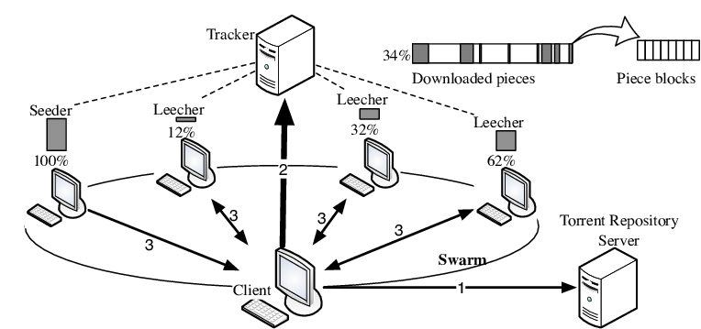
When you start the torrent downloading as shown in diagram. File is transferring from server to the client and keep the track where where is file is downloading . When other user come on the websites and start downloading then for him there are two source of Downloading one of the Server and other is seeder who are already started the Downloading. As you see in the diagram the source of file more then one . In this way Downloading is fast and keep the rate high of Websites. Number of seeder is directly proportional to the Downloading speed .

