Dining Philosophers Problem

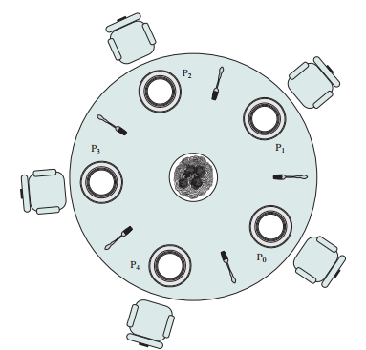
Problems:
The problem faced on the dinning table is that when philosopher p1 take fork from left side and then right side then its oky because in this time only philosopher want to take meal but the problem become when more then philosopher want to take meals at the same time . For example philosopher p took fork f1 from left side and then took f2 from right side in this moment philosopher p2 come and want to take meal but there is no spoon for him .in this way the Race Condition is occoured.
Solution:
We are going to solve this problem using binary semaphore. Philosopher has must have two work
think and eat. We used Array of semaphore number of fork(spoon). [S0,S1,S2,S3,S4]. In this way we will remove the race condition.
Sudo Code:
Void philosopher(void)
{
while(True)
{
Thinking();
wait(table_fork(Si)
wait(table_fork(S(i+1)mod N)

Eat() ; //critical section

signal(put_fork(i));
signal(put_fork(i+1)mod N);
}
}

Case 1:
if p0 has come to eat:
then it will take s0, s1
In such moment if p1 has come to eat
then it will take s1,s2 but s1 has already down then p1 have to wait for the S1

Case 2 :
if p0 has come to eat :
then it it will take s0,s1 ( in wait call s0 , s1 become down until finish the task
in such moment if p2 has come to eat
then it will take s2 and s3 .He can take it because s2 and s3 already up!

Calling Table
Philosopher | Semaphore s0 | Semaphore s1
P0 | S0 | S1
p1 | S1 | S2
p2 | S2 | S3
p3 | S3 | S4
p4 | S4 | S0

Is There any Deadlock in Dining philosopher?
Yes , There is deadlock if all the philosopher take only left spoon and they are not able to get right spoon due to high priority processes like if all the s0,s1,s2,s3 , s4 all semaphore become down then no one can enter in the critical section (eat()) that would become deadlock state.

Implementation:

