Smart Cache
Cache memory lie between the main memory and CPU. Cache memory has Fast Speed greater then main memory or register. Cache has different level and has different speed depend upon the level.
In order to understand the why we need cache and how much its important’s lets take into the deep dive. When the CPU processing the data then core of process takes data again and again from the main memory which is really costing . For resolving this issue we created the middle men which is memory are called cache. Cache has job to keep the data which is coming and outing again and again. For the next time when the process need that data they will take out from the cache instead of
the main memory. When the processor get the data in the cache then we called it Hit and when the processor did not get the data in the cache then we called it miss the data. Cache has Three level depending upon distance from the cpu.
Level of Cache:
- Level one Cache
level one cache also called the l1. L1 has most fastest cache because it too near from the CPU . L1 is not shared with other process’s and not shared with other thread . Its limited in the size and less in size as compared to other cache.
- Level 2 Cache
  - Level 2 cache also called L2.L2 is less fast from the L1 .its share able between the thread .
  - Greater in size from the L1
- Level 3 Cache
  - level 3 cache near to the main memory . Also called Smart Cache because it’s share able between the core .
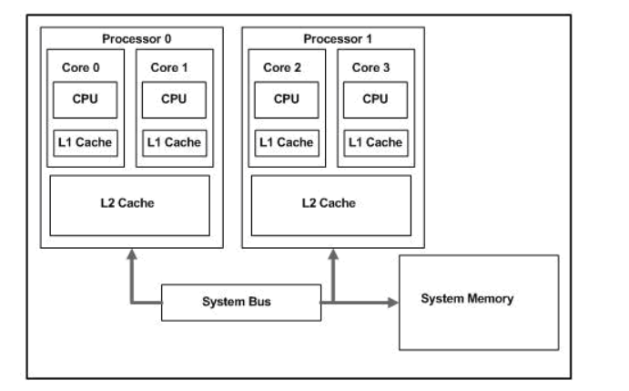

When processor 0 is doing some working during working his L1 and L2 cache has fulled and processor 1 has cache completely free because p1 is not working at the same time then in this way we are wasting our cache memory . In order to reduce this we introduces the l2 which is share able between the threads not he process’s. In this way to achieve some higher speed not the perfection. In order to get more speed we introduced one more layer which l3 is also callled Smart Cache.

Function and working:

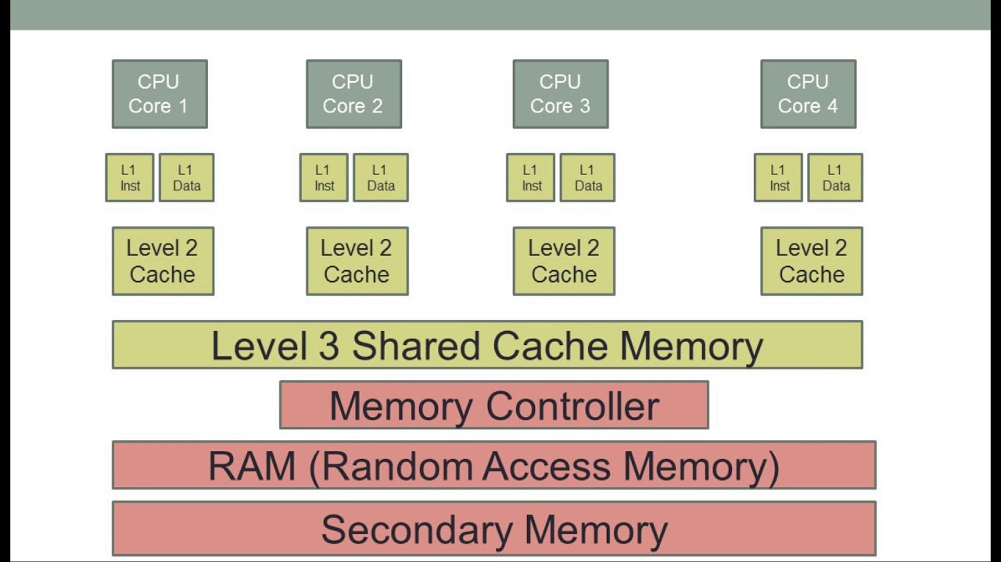
In the above diagram you can look the third layer which is share able memory also called smart memory. Which is the reason to get high speed . The idea behind the Smart memory is get the maximum speed. The Core who is working more then this will take more cache memory memory.
For example c1 is working 50 percent the c1 will take 50 percent of the cache memory and if c2 is working 20 percent the c2 will take 20 percent of the cache memory and c3 will take 10 percent of the memory and c4 will take 10 percent of the cache memory . In this way we utilized all the Cache memory that’s why called Smart Cache

