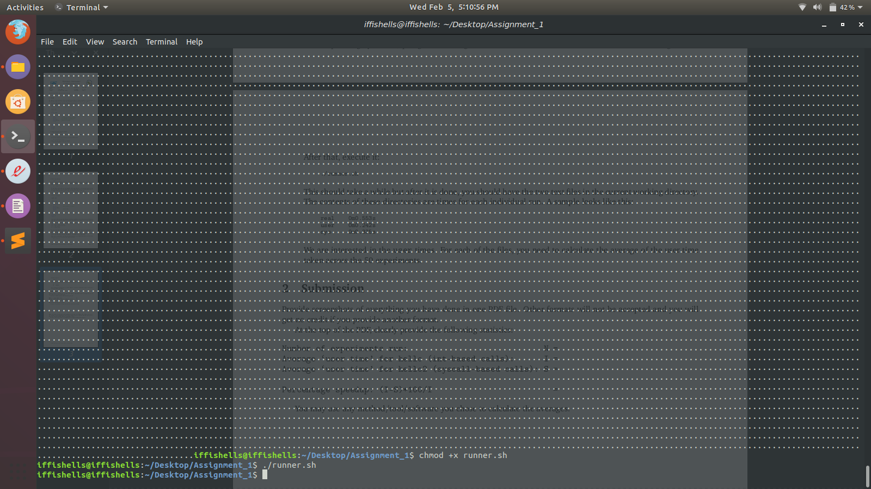
Number of experiments run: N =50
Average ‘user time’ for hello (int-based calls): I = 0.15576

Average ‘user time’ for hello2 (syscall-based calls): S =0.11647999999999997

Percentage speedup: (I-S)*100/I = 25.21828454031846

Output of the code :
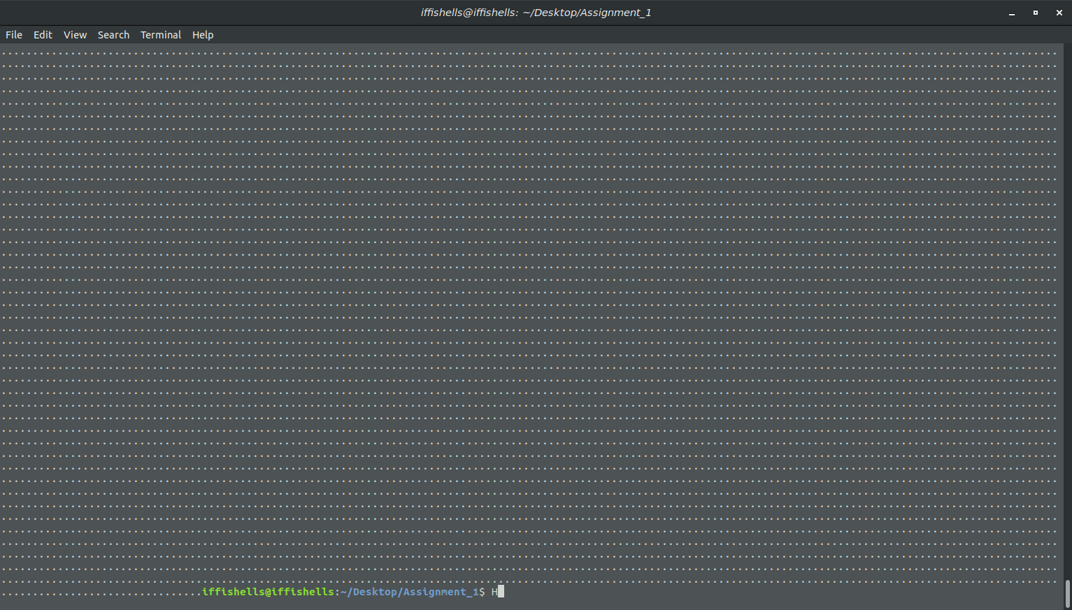

Executing command :
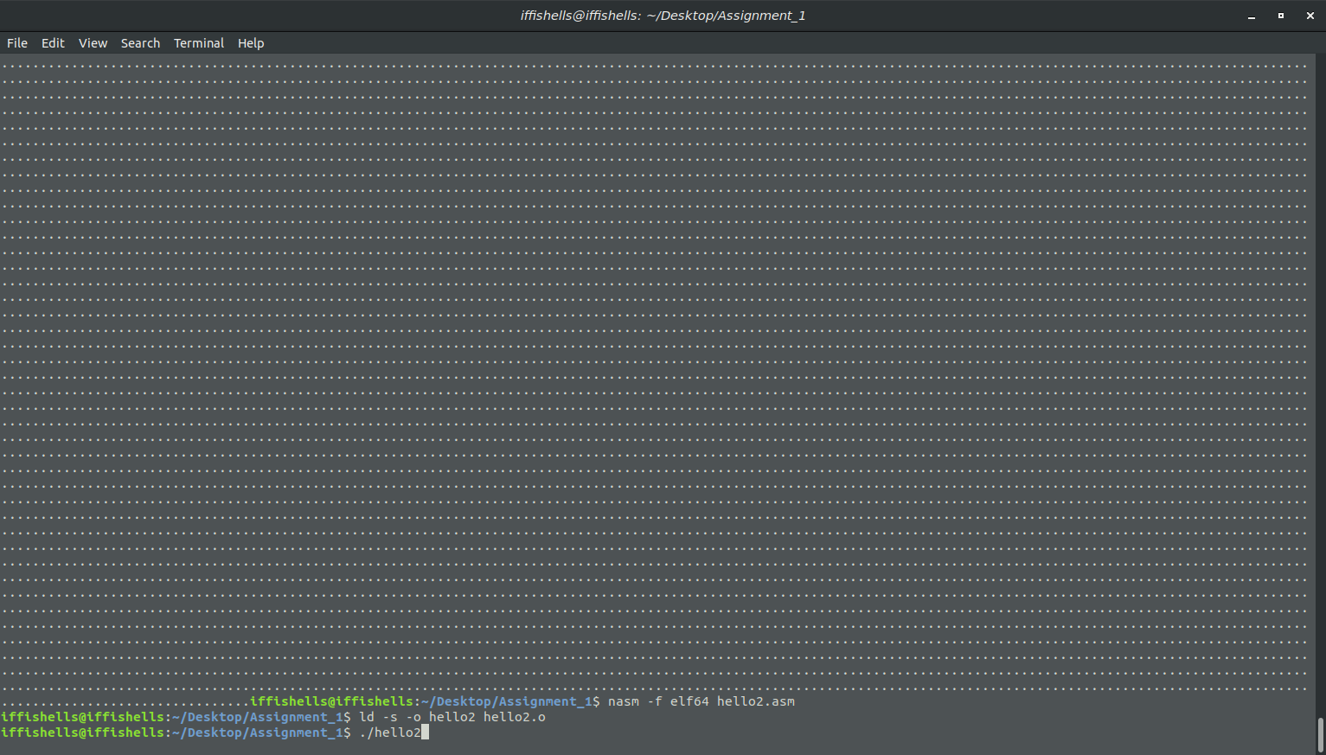

code to Extract data from file
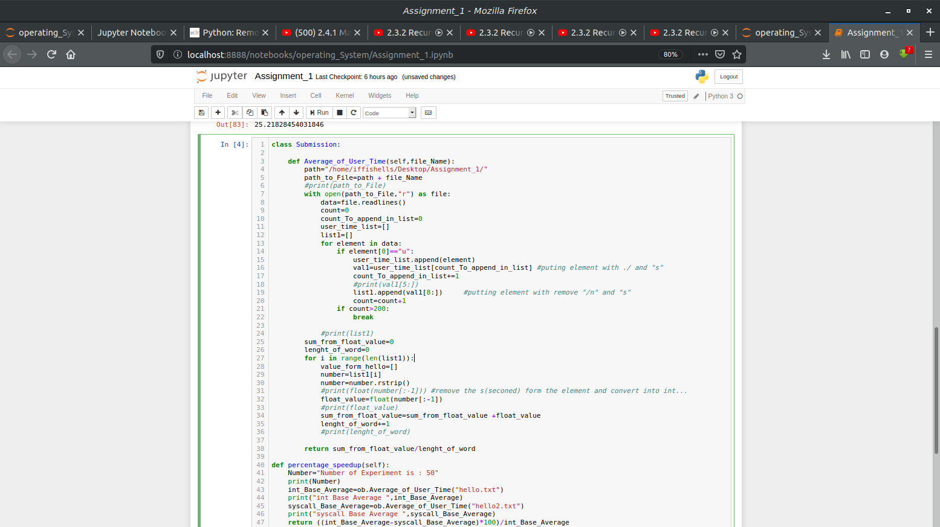

showing output
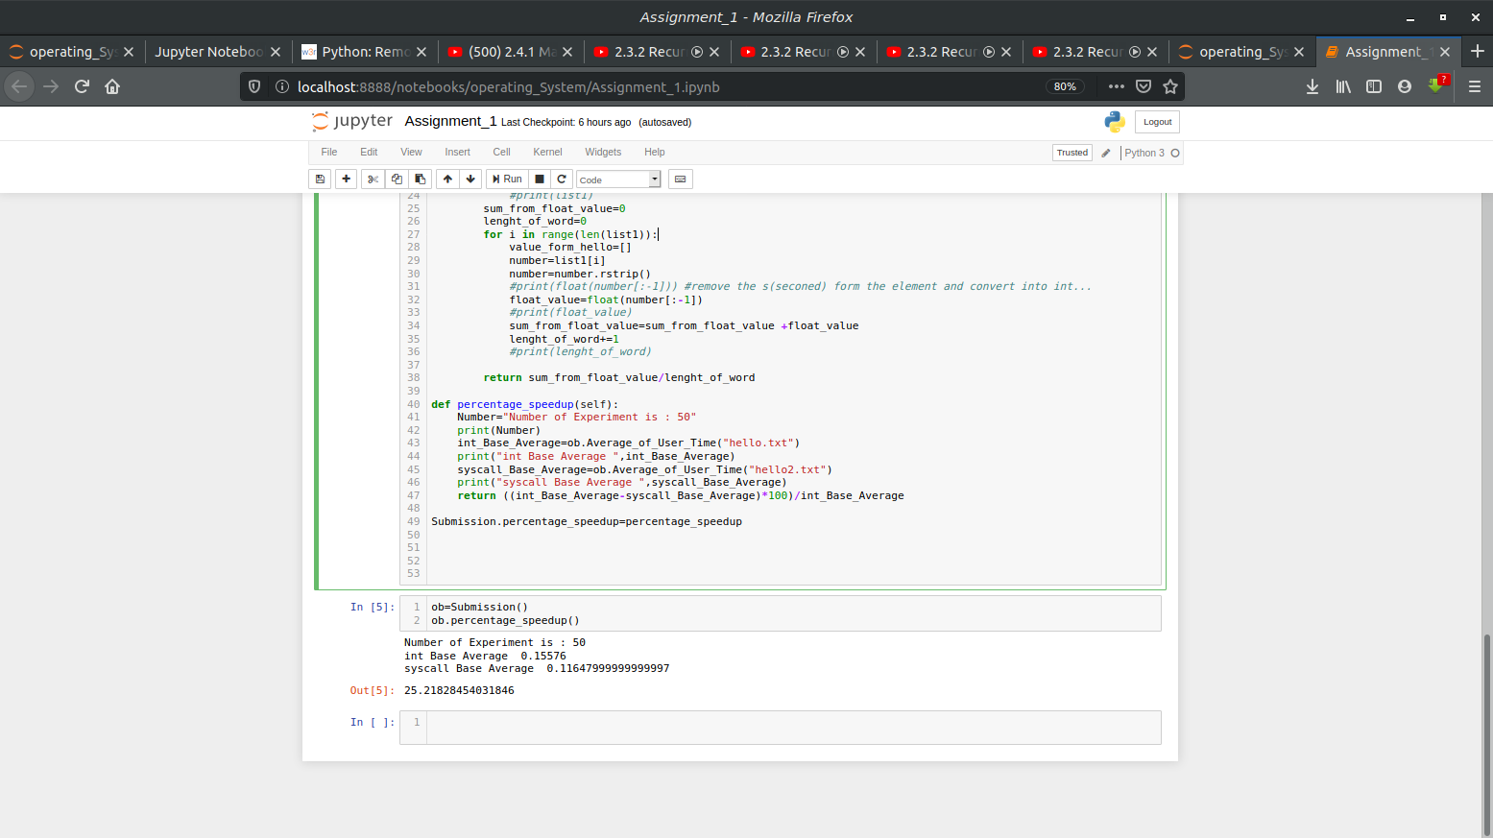
show user time
