**Installation commands –**

**Install Jenkins** - https://www.jenkins.io/doc/tutorials/tutorial-for-installing-jenkins-on-AWS/

sudo yum update –y

sudo wget -O /etc/yum.repos.d/jenkins.repo \

https://pkg.jenkins.io/redhat-stable/jenkins.repo

sudo rpm --import https://pkg.jenkins.io/redhat-stable/jenkins.io-2023.key

sudo yum upgrade

sudo yum install java-17-amazon-corretto -y

sudo yum install jenkins -y

sudo systemctl enable jenkins

sudo systemctl start jenkins

sudo systemctl status Jenkins

**Install Maven**

sudo yum install -y maven

**Install Git**

sudo yum install -y git

**Install Docker**

sudo dnf install docker -y

sudo systemctl enable --now docker

sudo usermod -aG docker $USER

newgrp docker

sudo usermod -aG docker Jenkins

**Restart Jenkins**

sudo systemctl restart Jenkins

**Install Kubectl**

curl -LO "https://dl.k8s.io/release/$(curl -Ls https://dl.k8s.io/release/stable.txt)/bin/linux/amd64/kubectl"

chmod +x kubectl

sudo mv kubectl /usr/local/bin/

kubectl version --client

**Install Minikube**

curl -LO https://storage.googleapis.com/minikube/releases/latest/minikube-linux-amd64

sudo install minikube-linux-amd64 /usr/local/bin/minikube

minikube version

minikube start

minikube status

chmod 655 .kube/config

chmod 755 /home/ec2-user

chmod 644 /home/ec2-user/.minikube/profiles/minikube/client.key

**Create tomcat directory and change its ownership**

sudo mkdir -p /usr/local/tomcat/webapps

sudo chown jenkins:jenkins -R /usr/local/tomcat

**Prometheus and Grafana**

HELM Chart:::

Helm is a pkg manager for kubernetes

which help to automatically create manifest files for any kubernetes objects in the form of HELM Charts

HELM Chart for prometheus

Eg.: Kubernetes Dashboard installation using HELM

Install HELM https://helm.sh/docs/intro/install/

- Goto https://github.com/helm/helm/releases

- right click on Linux amd64 and copy link address.

on kubernetes master node install Helm

###############################################################################################

# Prometheus & Grafana on Kubernetes using Helm

helm repo add prometheus-community https://prometheus-community.github.io/helm-charts

helm search repo prometheus-community

helm search repo prometheus-community/kube-prometheus-stack

helm search repo prometheus-community/kube-prometheus-stack --versions

helm install prometheus prometheus-community/kube-prometheus-stack --version 45.7.1 --namespace monitoring --create-namespace

kubectl get pods -n monitoring

kubectl get pods --all-namespaces

kubectl get svc

kubectl get svc -n monitoring

//kubectl port-forward svc/prometheus-operated -n monitoring 9090:9090

//kubectl edit svc prometheus-operated

kubectl get svc -n monitoring

//kubectl edit svc prometheus-operated -n monitoring

kubectl edit svc prometheus-kube-prometheus-prometheus -n monitoring

#goto type: key && Change ClusterIP to NodePort & save the file

#30000 - 32767

#Now check the service, it should show you, NortPort with Nodeport IP

kubectl get svc -n monitoring

kubectl edit svc prometheus-grafana -n monitoring

#goto type: key && Change ClusterIP to NodePort & save the file

#30000 - 32767

#Now check the service, it should show you, NortPort with Nodeport IP

kubectl get svc -n monitoring

kubectl get secret -n monitoring prometheus-grafana -o jsonpath="{.data.admin-password}" | base64 --decode

Take the public_ip address fo kubernetes master node.

Eg>: https://<k_master_public_ip_address:<NodePort>/

**Public Repository**

**[iffyes/igp2-mar25: Purdue GitHub IGP March 25 repository](https://github.com/iffyes/igp2-mar25/tree/main)**

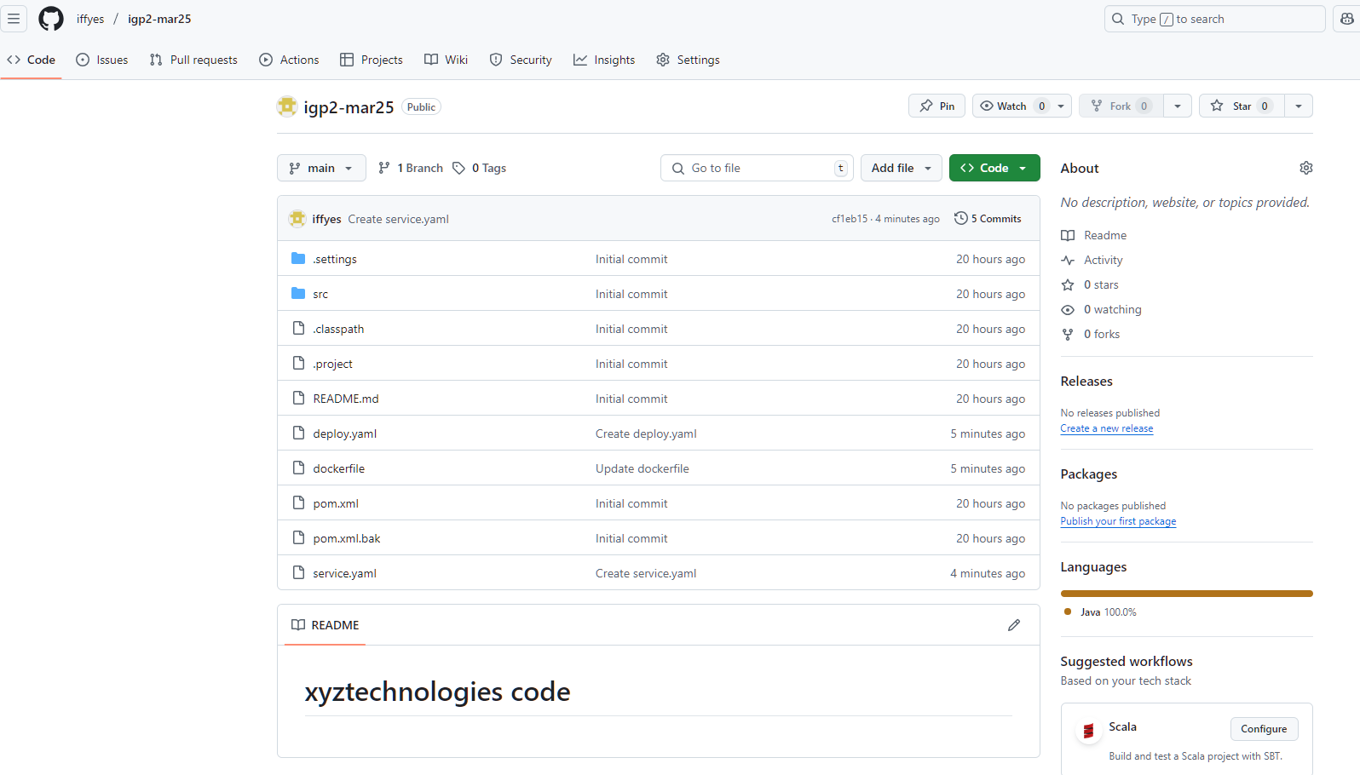

**Create Jenkins job**

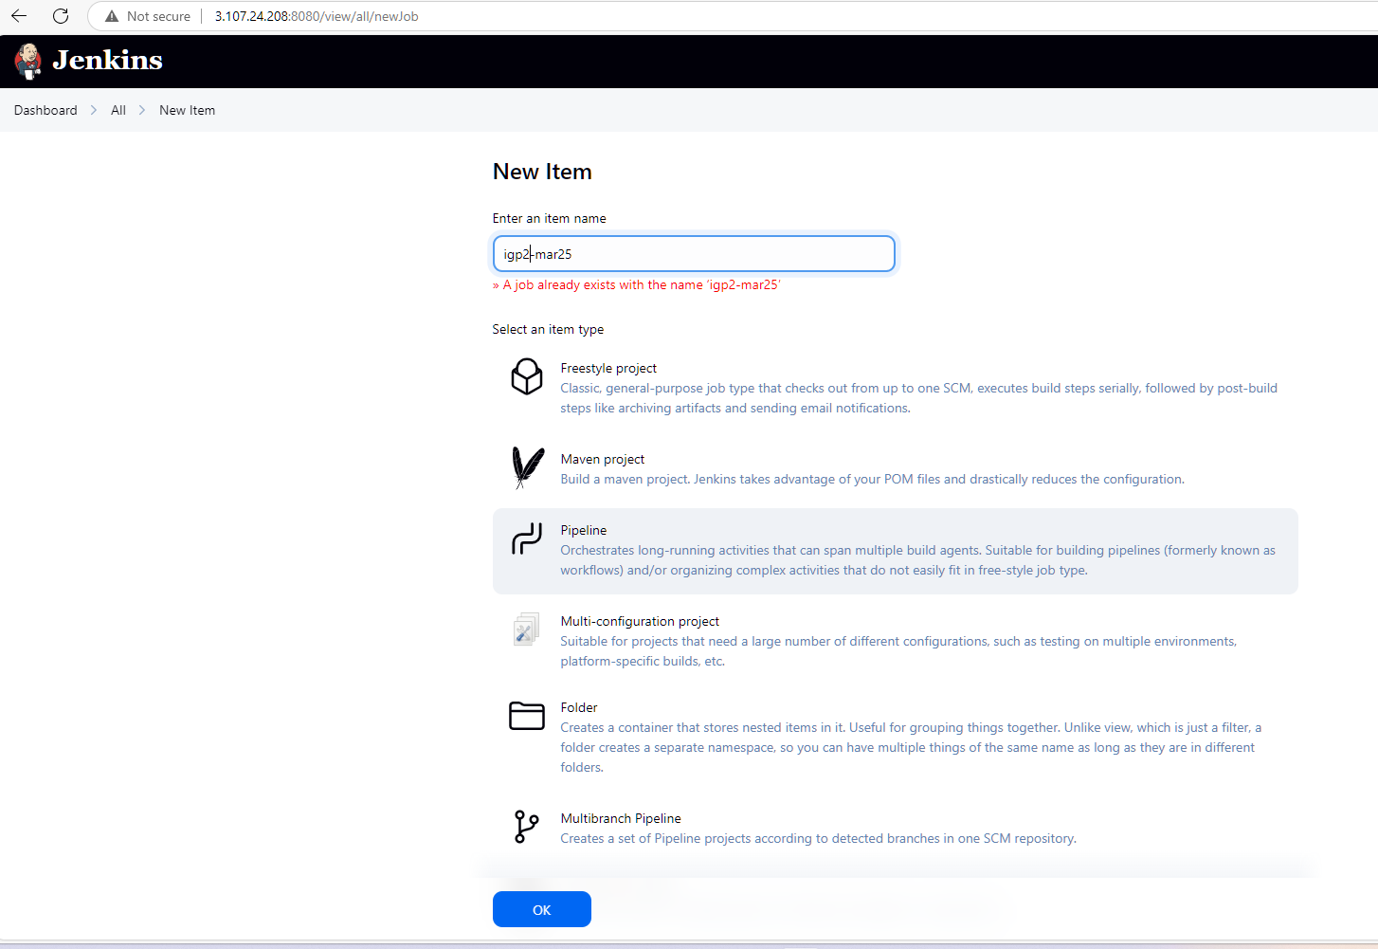

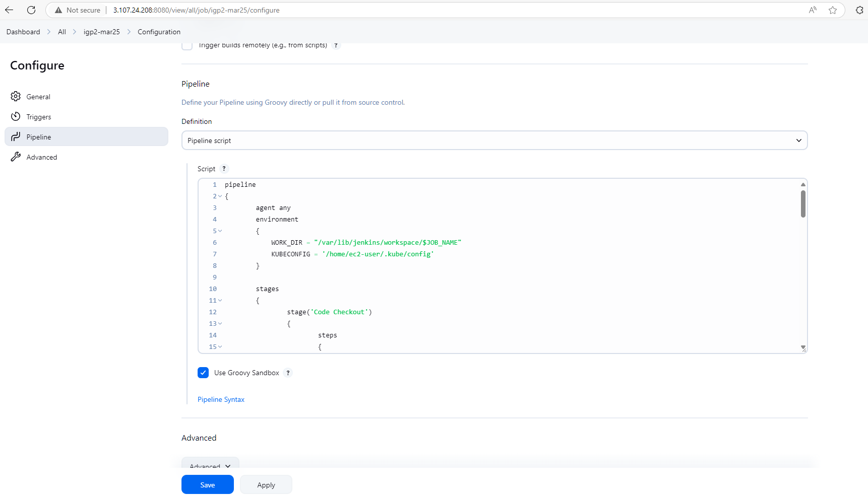

**Success Jenkins Job**

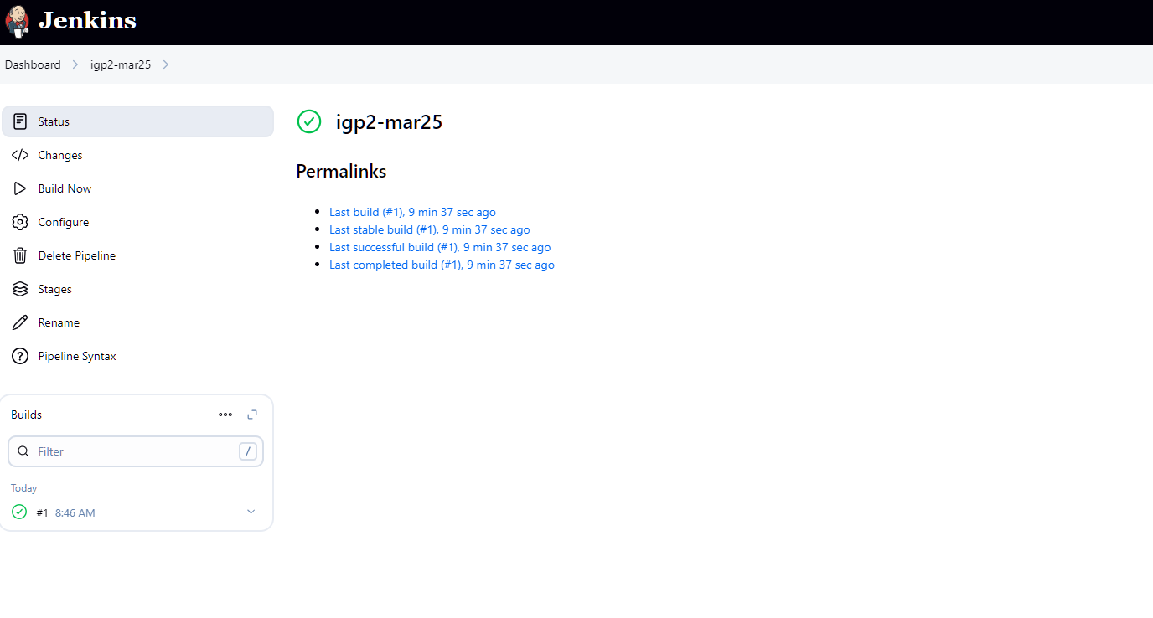

**XYZ Tech Deployment on Kubernetes**

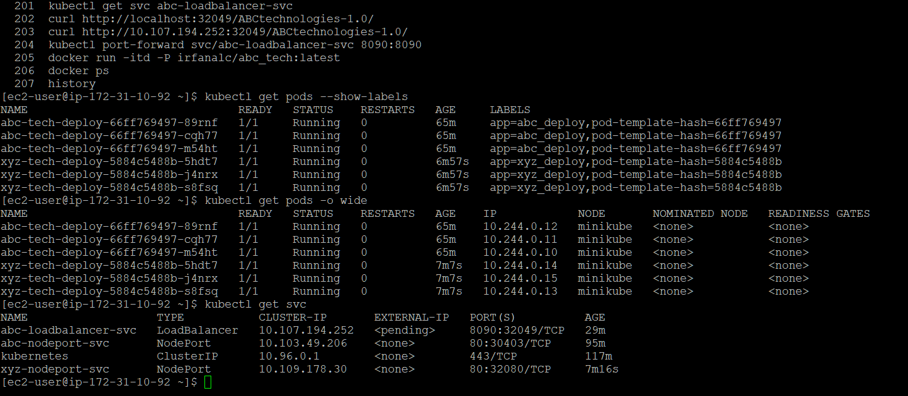

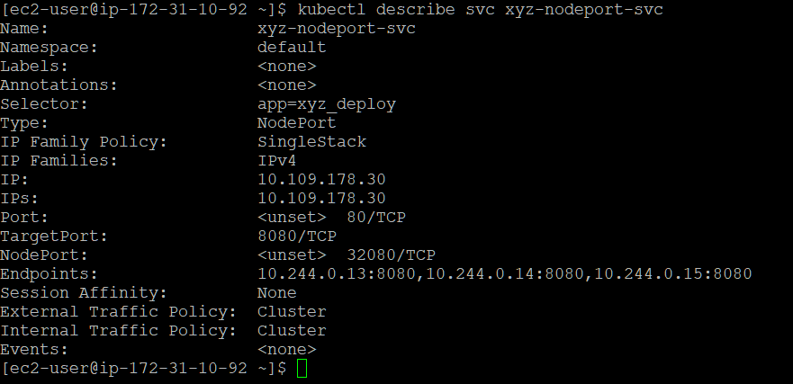

**Running Application**

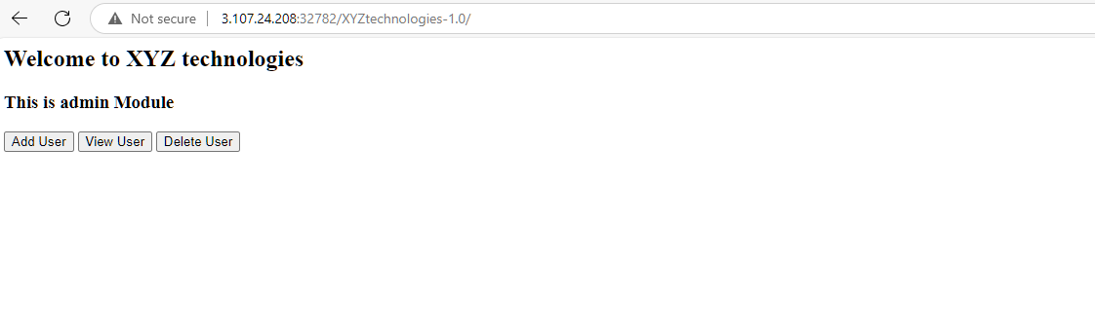

**Docker Hub**

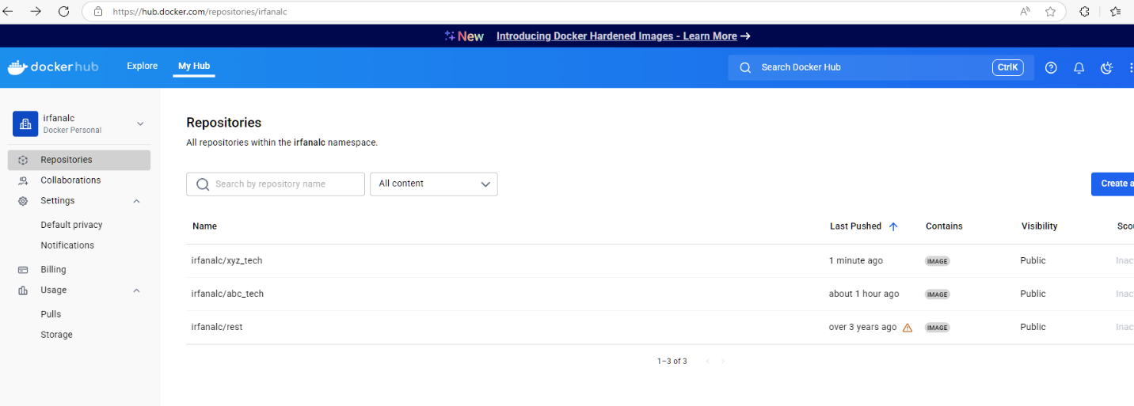

**Prometheus and Grafana Running**

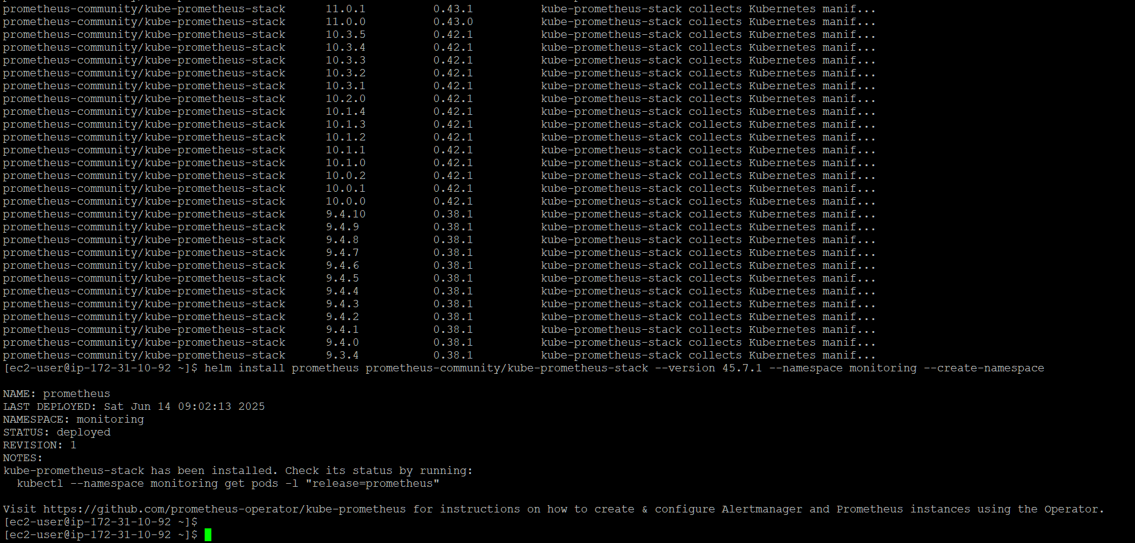

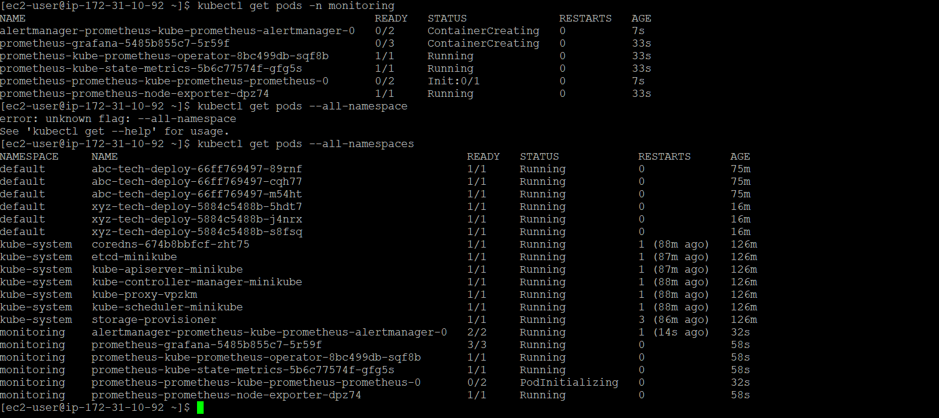

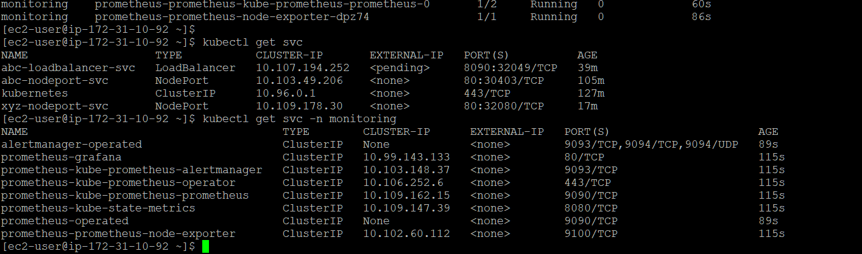

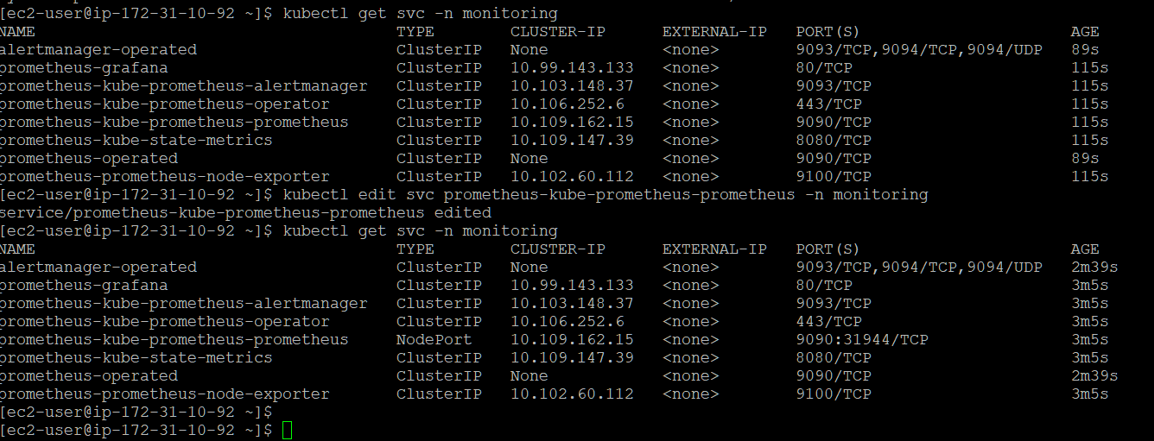

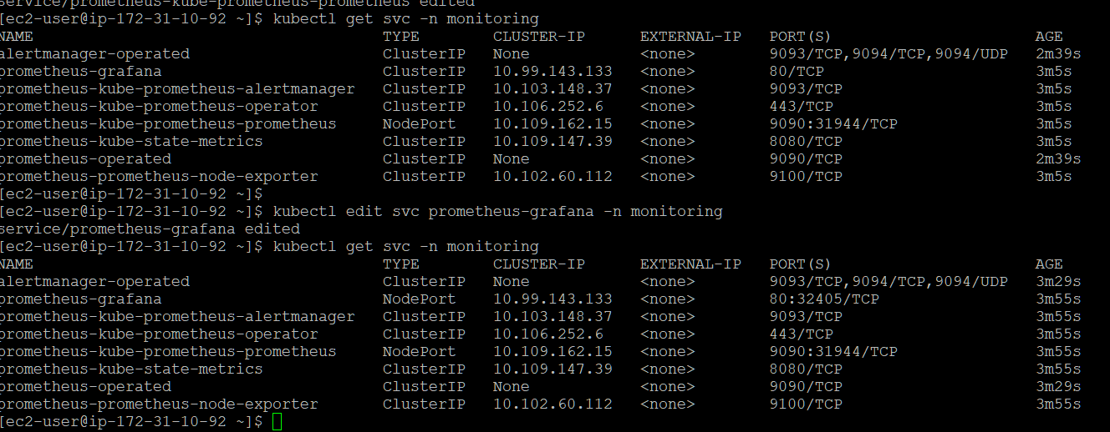

**Prometheus GUI and queries**

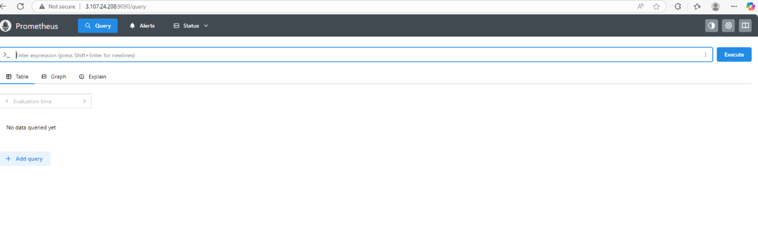

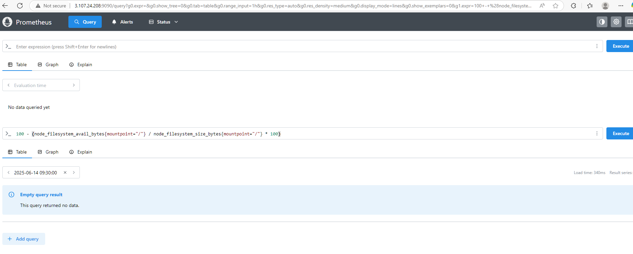

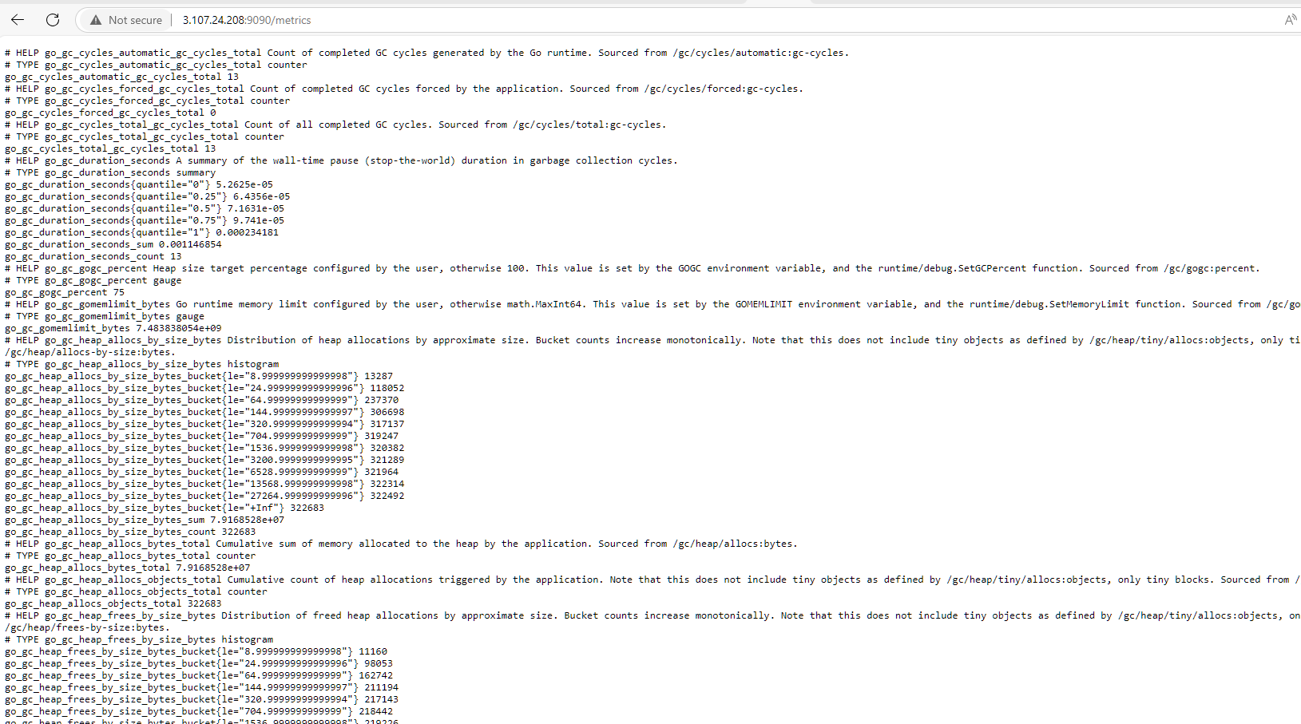

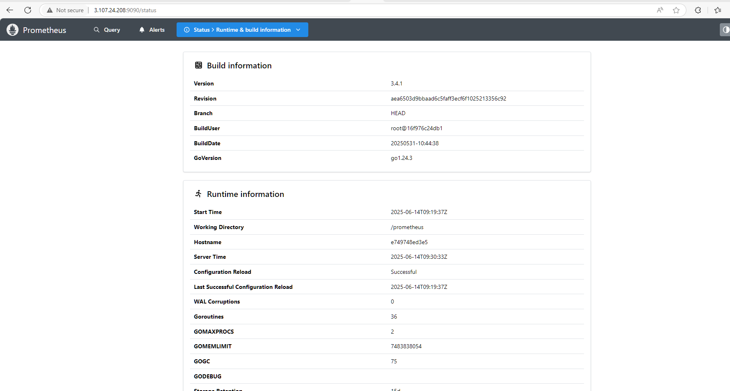

**Grafana GUI**

