NUMBER 1: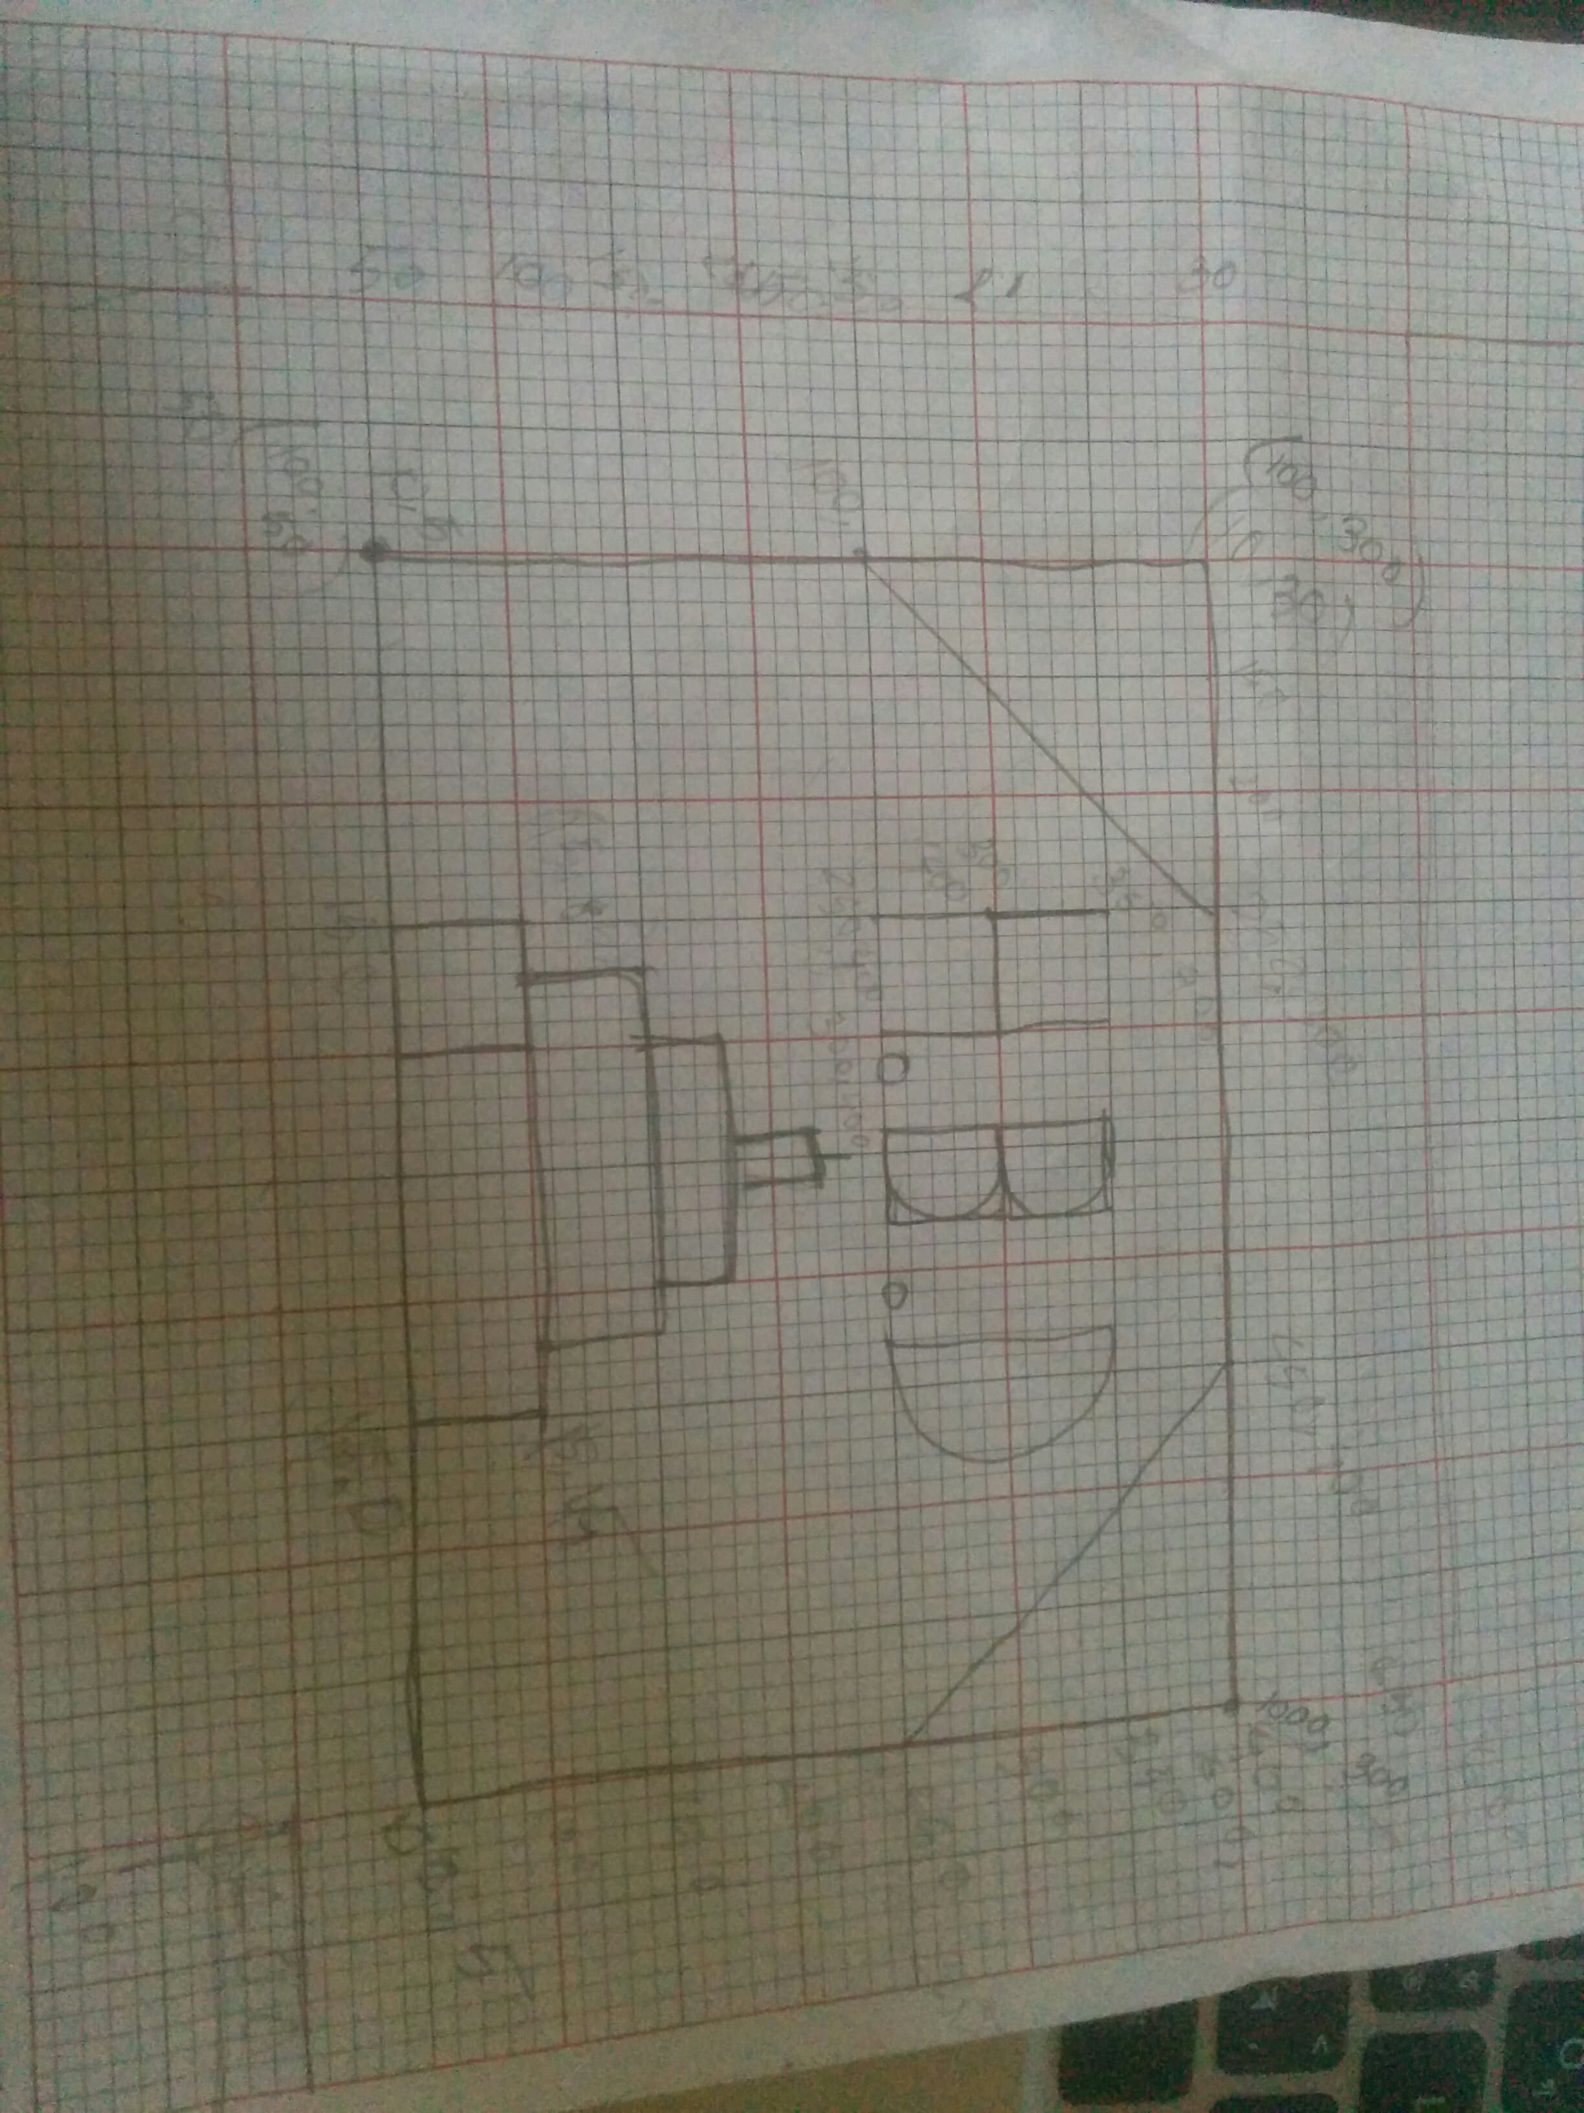

#include<windows.h>

#include <GL/glut.h>

void init(void)

{

glClearColor(1.0, 1.0, 1.0, .0); // Set display window colour to white

glMatrixMode(GL_PROJECTION); // Set projection parameters

gluOrtho2D(0.0, 500.0, 0.0, 500.0);

}

void draw();

int main(int argc, char* argv[])

{

glutInit(&argc, argv);

glutInitDisplayMode(GLUT_SINGLE|GLUT_RGB);

glutInitWindowPosition(10, 10);

glutInitWindowSize(600, 600);

glutCreateWindow("Ghor Bari");

// init

glClearColor(0.1, 0.1, 0.1, 0.1);

glMatrixMode(GL_PROJECTION);

gluOrtho2D(0.0, 600, 0.0, 600);

glutDisplayFunc(draw); // Send graphics to display window

glutMainLoop(); // Display everything and wait

return 0;

}

void draw(){

glClear(GL_COLOR_BUFFER_BIT);

glColor3f(0.5f, 0.0f, 1.0f);

glPointSize(10.0);

// left side square

glColor3f(1.0, .5, 0.0);

glBegin(GL_QUADS);

glVertex2d(100, 50);

glVertex2d(100, 400);

glVertex2d(600, 400);

glVertex2d(600, 50);

glEnd();

glColor3f(0.0, 1.0, 0.0);

glBegin(GL_TRIANGLES);

glVertex2i(100, 250);

glVertex2i(100, 400);

glVertex2i(250, 400);

glEnd();

glColor3f(0.0, 1.0, 0.0);

glBegin(GL_TRIANGLES);

glVertex2i(450, 400);

glVertex2i(600, 400);

glVertex2i(600, 250);

glEnd();

glColor3f(1.0, .5, 1.0);

glBegin(GL_QUADS);

glVertex2d(250, 50);

glVertex2d(250, 100);

glVertex2d(450, 100);

glVertex2d(450, 50);

glEnd();

glColor3f(1.0, .5, 1.0);

glBegin(GL_QUADS);

glVertex2d(280, 100);

glVertex2d(280, 150);

glVertex2d(420, 150);

glVertex2d(420, 100);

glColor3f(1.0, .5, 1.0);

glBegin(GL_QUADS);

glVertex2d(320, 150);

glVertex2d(320, 200);

glVertex2d(380, 200);

glVertex2d(380, 150);

glColor3f(1.0, .5, 1.0);

glColor3f(1.0, 1.5, 1.0);

glBegin(GL_QUADS);

glVertex2d(345, 200);

glVertex2d(345, 250);

glVertex2d(355, 250);

glVertex2d(355, 200);

glEnd();

glColor3f(1.0, 1.5, 1.0);

glBegin(GL_LINES);

glVertex2i(250, 300);

glVertex2i(250, 400);

glEnd();

glColor3f(1.0, 1.5, 1.0);

glBegin(GL_LINES);

glVertex2i(300, 300);

glVertex2i(300, 400);

glEnd();

glColor3f(1.0, 1.5, 1.0);

glBegin(GL_LINES);

glVertex2i(250, 350);

glVertex2i(300, 350);

glEnd();

glColor3f(1.0, 1.5, 1.0);

glBegin(GL_LINES);

glVertex2i(350, 300);

glVertex2i(350, 400);

glEnd();

glColor3f(1.0, 1.5, 1.0);

glBegin(GL_QUADS);

glVertex2d(350, 400);

glVertex2d(380, 400);

glVertex2d(380, 350);

glVertex2d(350, 350);

glEnd();

glColor3f(1.0, 1.5, 1.0);

glBegin(GL_QUADS);

glVertex2d(350, 348);

glVertex2d(380, 348);

glVertex2d(380, 300);

glVertex2d(350, 300);

glEnd();

glColor3f(1.0, 1.5, 1.0);

glBegin(GL_QUADS);

glVertex2d(400, 400);

glVertex2d(450, 400);

glVertex2d(450, 300);

glVertex2d(400, 300);

glEnd();

glFlush();

}

