**RFID Based Automated Door System.**

**by**

|  |  |
| --- | --- |
| Name | ID |
| Musavvir Al Jami | 163-15-8274 |
| Anup Paul | 163-15-8324 |
| Iffat Firozy | 163-15-8432 |
| Sharmin Akter | 163-15-8436 |
| Al Amin Ripon | 163-15-8370 |
| Sadia Akter | 161-15-986 |
| Joy Biswas | 152-15-5856 |
| Jahid Hasan | 152-15-5588 |

**Course Code: CSE423  
Course Title: Embedded System  
Sec: A.**

**Submitted to -**

**Mosharraf Hossain Khan**

Senior Lecturer

Department of CSE, DIU.



**DAFFODIL INTERNATIONAL UNIVERSITY**

**Dhaka, Bangladesh**

**11 april, 2020**

**Introduction:** Our project is RFID Based Automated Door system. RFID stands for Radio-Frequency Identification (RFID). It’s a non-contact technology that’s broadly used in many industries for tasks such as personnel tracking, access control, supply chain management, books tracking in libraries, tollgate systems and so on. So, the basic working process of RFID based automated door system is whenever a person stands on the sensored area in front of the door, the door will open automatically and will close after a certain time which we are going provide in the sketch.

**Elements/Components:** The components we will need to make a RFID based automated door system are:

* Jumper Wires.
* MFRC522 RFID Module
* Servo Motor
* LCD Display
* Arduino Board
* Breadboard
* Proximity Sensor CNY70

**Circuit Diagram**:

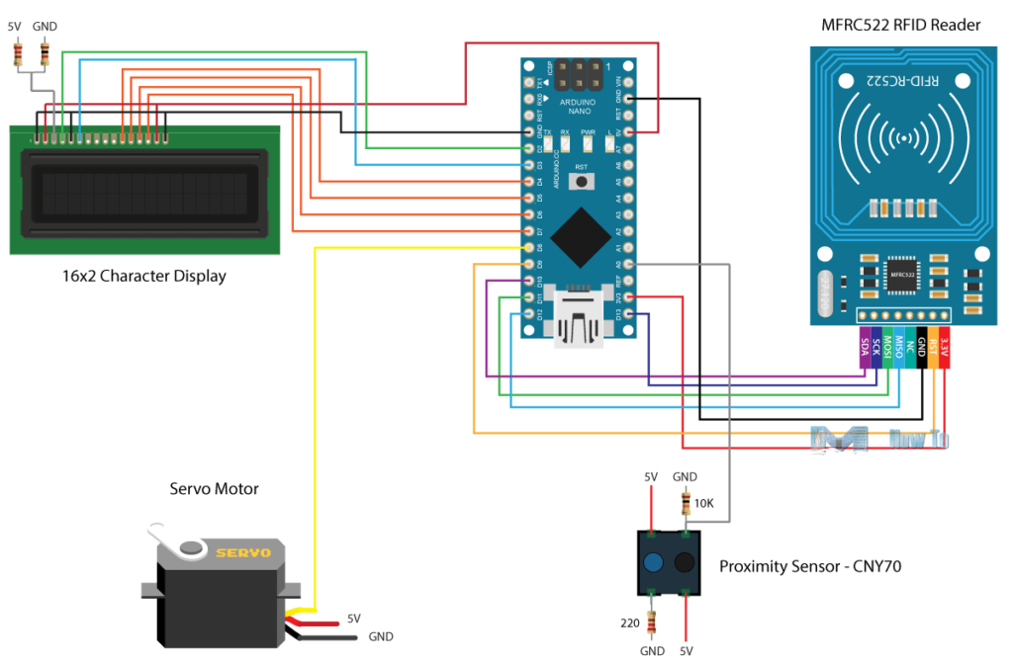

**Sketch:**

1. #include <SPI.h>
2. #include <MFRC522.h>
3. #include <LiquidCrystal.h>
4. #include <Servo.h>
5. #define RST_PIN 9
6. #define SS_PIN 10
7. byte readCard[4];
8. **char**\* myTags[100] = {};
9. **int** tagsCount = 0;
10. String tagID = "";
11. boolean successRead = **false**;
12. boolean correctTag = **false**;
13. **int** proximitySensor;
14. boolean doorOpened = **false**;
15. // Create instances
16. MFRC522 mfrc522(SS_PIN, RST_PIN);
17. LiquidCrystal lcd(2, 3, 4, 5, 6, 7); //Parameters: (rs, enable, d4, d5, d6, d7)
18. Servo myServo; // Servo motor
19. **void** setup() {
20. // Initiating
21. SPI.begin(); // SPI bus
22. mfrc522.PCD_Init(); // MFRC522
23. lcd.begin(16, 2); // LCD screen
24. myServo.attach(8); // Servo motor
25. myServo.write(10); // Initial lock position of the servo motor
26. // Prints the initial message
27. lcd.print("-No Master Tag!-");
28. lcd.setCursor(0, 1);
29. lcd.print(" SCAN NOW");
30. // Waits until a master card is scanned
31. **while** (!successRead) {
32. successRead = getID();
33. **if** ( successRead == **true**) {
34. myTags[tagsCount] = strdup(tagID.c_str()); // Sets the master tag into position 0 in the array
35. lcd.clear();
36. lcd.setCursor(0, 0);
37. lcd.print("Master Tag Set!");
38. tagsCount++;
39. }
40. }
41. successRead = **false**;
42. printNormalModeMessage();
43. }
44. **void** loop() {
45. **int** proximitySensor = analogRead(A0);
46. // If door is closed...
47. **if** (proximitySensor > 200) {
48. **if** ( ! mfrc522.PICC_IsNewCardPresent()) { //If a new PICC placed to RFID reader continue
49. **return**;
50. }
51. **if** ( ! mfrc522.PICC_ReadCardSerial()) { //Since a PICC placed get Serial and continue
52. **return**;
53. }
54. tagID = "";
55. // The MIFARE PICCs that we use have 4 byte UID
56. **for** ( uint8_t i = 0; i < 4; i++) { //
57. readCard[i] = mfrc522.uid.uidByte[i];
58. tagID.concat(String(mfrc522.uid.uidByte[i], HEX)); // Adds the 4 bytes in a single String variable
59. }
60. tagID.toUpperCase();
61. mfrc522.PICC_HaltA(); // Stop reading
62. correctTag = **false**;
63. // Checks whether the scanned tag is the master tag
64. **if** (tagID == myTags[0]) {
65. lcd.clear();
66. lcd.print("Program mode:");
67. lcd.setCursor(0, 1);
68. lcd.print("Add/Remove Tag");
69. **while** (!successRead) {
70. successRead = getID();
71. **if** ( successRead == **true**) {
72. **for** (**int** i = 0; i < 100; i++) {
73. **if** (tagID == myTags[i]) {
74. myTags[i] = "";
75. lcd.clear();
76. lcd.setCursor(0, 0);
77. lcd.print(" Tag Removed!");
78. printNormalModeMessage();
79. **return**;
80. }
81. }
82. myTags[tagsCount] = strdup(tagID.c_str());
83. lcd.clear();
84. lcd.setCursor(0, 0);
85. lcd.print(" Tag Added!");
86. printNormalModeMessage();
87. tagsCount++;
88. **return**;
89. }
90. }
91. }
92. successRead = **false**;
93. // Checks whether the scanned tag is authorized
94. **for** (**int** i = 0; i < 100; i++) {
95. **if** (tagID == myTags[i]) {
96. lcd.clear();
97. lcd.setCursor(0, 0);
98. lcd.print(" Access Granted!");
99. myServo.write(170); // Unlocks the door
100. printNormalModeMessage();
101. correctTag = **true**;
102. }
103. }
104. **if** (correctTag == **false**) {
105. lcd.clear();
106. lcd.setCursor(0, 0);
107. lcd.print(" Access Denied!");
108. printNormalModeMessage();
109. }
110. }
111. // If door is open...
112. **else** {
113. lcd.clear();
114. lcd.setCursor(0, 0);
115. lcd.print(" Door Opened!");
116. **while** (!doorOpened) {
117. proximitySensor = analogRead(A0);
118. **if** (proximitySensor > 200) {
119. doorOpened = **true**;
120. }
121. }
122. doorOpened = **false**;
123. delay(500);
124. myServo.write(10); // Locks the door
125. printNormalModeMessage();
126. }
127. }
128. uint8_t getID() {
129. // Getting ready for Reading PICCs
130. **if** ( ! mfrc522.PICC_IsNewCardPresent()) { //If a new PICC placed to RFID reader continue
131. **return** 0;
132. }
133. **if** ( ! mfrc522.PICC_ReadCardSerial()) { //Since a PICC placed get Serial and continue
134. **return** 0;
135. }
136. tagID = "";
137. **for** ( uint8_t i = 0; i < 4; i++) { // The MIFARE PICCs that we use have 4 byte UID
138. readCard[i] = mfrc522.uid.uidByte[i];
139. tagID.concat(String(mfrc522.uid.uidByte[i], HEX)); // Adds the 4 bytes in a single String variable
140. }
141. tagID.toUpperCase();
142. mfrc522.PICC_HaltA(); // Stop reading
143. **return** 1;
144. }
145. **void** printNormalModeMessage() {
146. delay(1500);
147. lcd.clear();
148. lcd.print("-Access Control-");
149. lcd.setCursor(0, 1);
150. lcd.print(" Scan Your Tag!");
151. }

**How it works:** An RFID system consists of two main components, a transponder or a tag which is located on the object that we want to be identified, and a transceiver or a reader. The RFID reader consist of a radio frequency module, a control unit and an antenna coil which generates high frequency electromagnetic field. On the other hand, the tag is usually a passive component, which consist of just an antenna and an electronic microchip, so when it gets near the electromagnetic field of the transceiver, due to induction, a voltage is generated in its antenna coil and this voltage serves as power for the microchip.

Now as the tag is powered it can extract the transmitted message from the reader, and for sending message back to the reader, it uses a technique called load manipulation. Switching on and off a load at the antenna of the tag will affect the power consumption of the reader’s antenna which can be measured as voltage drop. This changes in the voltage will be captured as ones and zeros and that’s the way the data is transferred from the tag to the reader.

**Conclusion:** The RFID based automatic door system helps us to secure our rooms, it doesn’t need any manual locking, so every time one gets in or out of the room they don’t need to worry about the door or the lock and without the tag one cannot into