DriverPass System Design Document
CS 255 - System Analysis and Design
Isela Flores
Southern New Hampshire University

UML Diagrams
The following UML diagrams illustrate the complete system design for the DriverPass platform. Each diagram provides a different perspective on how the system will function and how its components interact to meet the client's business requirements.

UML Use Case Diagram
The use case diagram below shows all system actors and their interactions with the DriverPass system. This includes customers (students), secretary staff, driving instructors, IT officers, the business owner, and the DMV system integration. The diagram illustrates the complete range of functionality available to each user role, including account registration, lesson booking, practice test access, administrative functions, and business reporting capabilities.
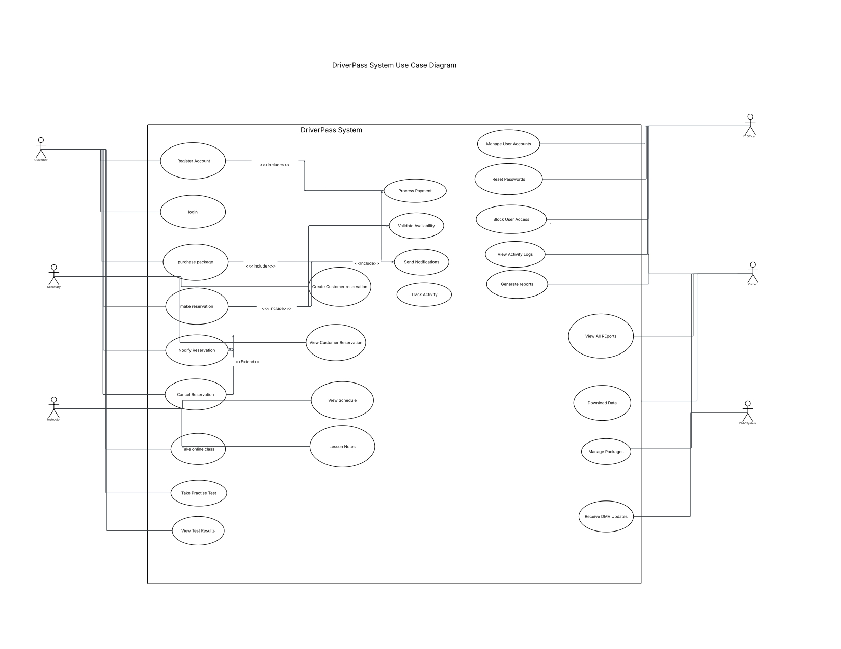
The use case diagram demonstrates how we addressed your need for role-based access control. Each actor can only perform the functions relevant to their role, ensuring security and simplifying the user experience. The integration with the DMV system ensures your practice test content remains current with actual testing requirements, directly supporting your goal of improving student pass rates.

UML Activity Diagrams

Activity Diagram 1: Make Reservation
This activity diagram details the complete workflow when a customer makes a reservation for a driving lesson. The diagram shows the step-by-step process across four participants: the customer, the system, the database, and the notification service. This workflow addresses your requirement to eliminate scheduling conflicts and reduce manual coordination by your staff.
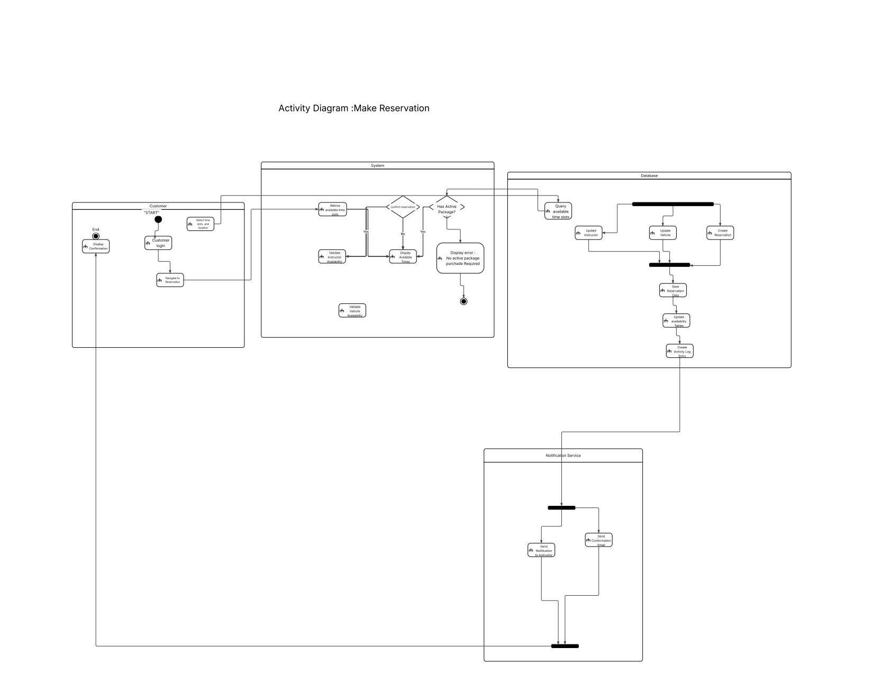
The reservation process includes automatic package validation, real-time availability checking for both instructors and vehicles, confirmation steps to prevent accidental bookings, and automated notifications to all parties. This workflow eliminates the phone tag and manual calendar coordination you mentioned as a pain point in your current process.

Activity Diagram 2: Take Online Practice Test
This activity diagram illustrates the workflow when a student takes an online practice test. The process includes package access validation, test selection, question-by-question progression with answer tracking, automatic scoring, and results storage. This directly supports your primary business goal of helping students pass their driving exams through better preparation.
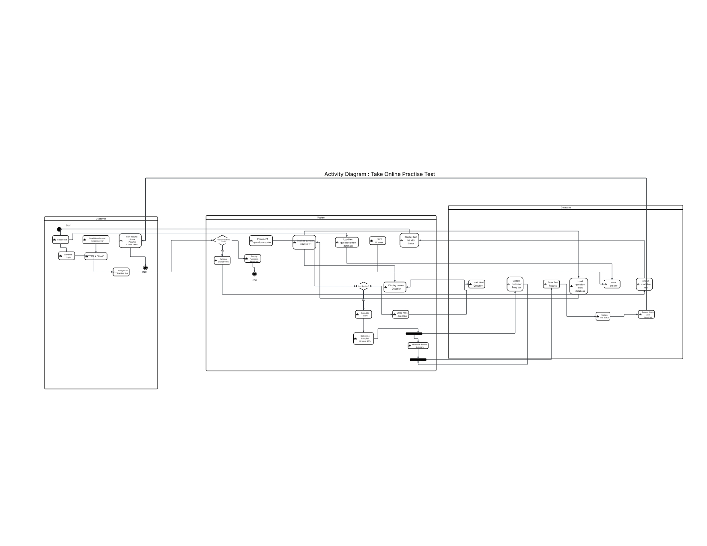
The test-taking workflow ensures students can only access practice tests if they have an active package with online access included. The system automatically scores tests, tracks progress over time, and provides immediate feedback. This gives your students the comprehensive preparation tools that set DriverPass apart from competitors offering only in-car training.

UML Sequence Diagram
The sequence diagram below shows the detailed message exchanges between system components during the reservation creation process. This diagram illustrates how the customer interface, reservation controller, authentication service, database, and notification service communicate to complete a booking. Each numbered message represents a specific interaction, showing both the requests sent and the responses returned.
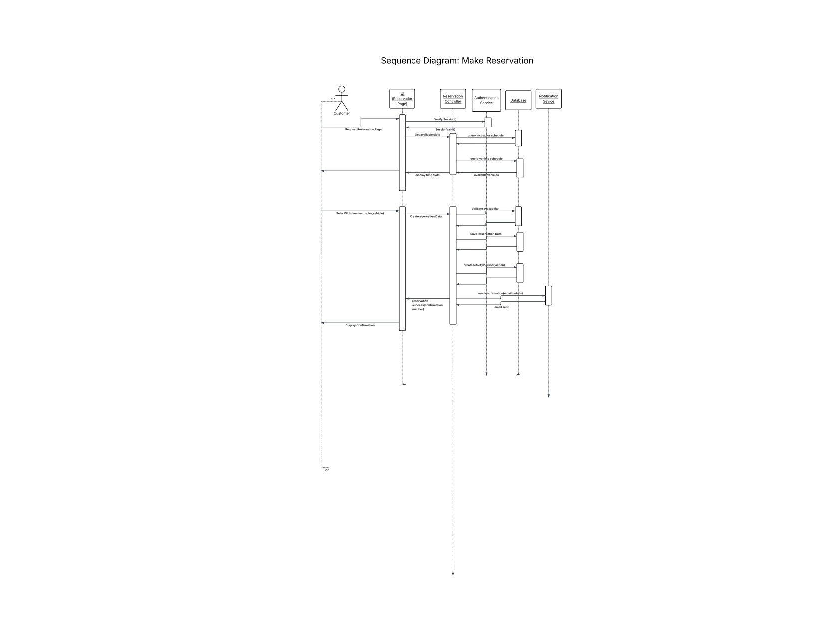
This sequence demonstrates the system's layered approach to processing reservations. The system first verifies the customer's login session, retrieves available time slots by querying instructor and vehicle schedules, validates the selected slot is still available before confirming, saves the reservation with automatic activity logging, and triggers notifications to all relevant parties. This coordinated interaction ensures data consistency and eliminates the possibility of double-booking.

UML Class Diagram
The class diagram represents the system's data structure and the relationships between different entities. This diagram shows all the major classes needed to support the DriverPass system, including user types, packages, reservations, vehicles, online tests, payments, and activity logs. Each class includes its attributes (data fields) and methods (functions it can perform).
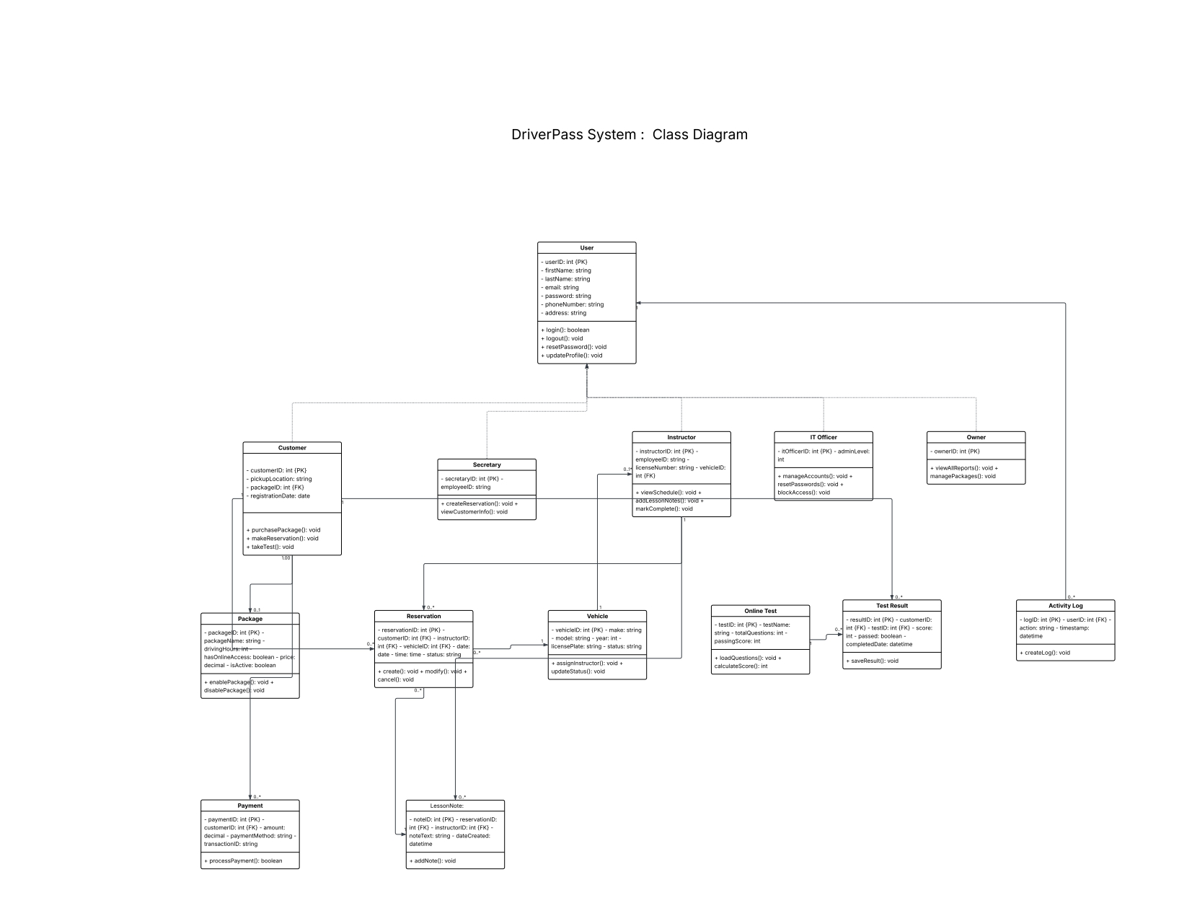
The class structure supports your business model with flexible user roles, customizable training packages, comprehensive reservation tracking, and complete activity logging. The User class serves as a parent for Customer, Secretary, Instructor, IT Officer, and Owner, allowing each role to inherit common authentication functionality while maintaining role-specific capabilities. The relationships between classes ensure referential integrity - for example, a reservation must reference a valid customer, instructor, and vehicle, preventing orphaned data that could cause operational problems.

Technical Requirements
Based on the system design illustrated in the UML diagrams above, the following technical requirements specify the hardware, software, and infrastructure needed to build and operate the DriverPass system successfully.

Software Requirements
Web Application Framework: The system requires a modern web framework such as React or Vue.js for the front-end user interface, paired with a back-end framework like Node.js with Express or Python with Django. These frameworks provide the structure needed to build responsive, scalable web applications that work across different devices and browsers.
Database Management System: A relational database such as PostgreSQL or MySQL will store all system data including user accounts, reservations, test results, and activity logs. The database must support transactions to ensure data consistency during operations like booking confirmations where multiple tables update simultaneously. A caching layer using Redis will improve performance for frequently accessed data like available time slots.
Cloud Platform: The system will be hosted on a cloud platform such as Amazon Web Services (AWS), Google Cloud Platform (GCP), or Microsoft Azure. Cloud hosting provides the scalability to handle varying user loads, automatic backup capabilities, and the high availability guarantee of 99.9% uptime. The cloud platform will include load balancing to distribute traffic across multiple servers and auto-scaling to add resources during peak usage periods.
Security Infrastructure: SSL/TLS certificates will encrypt all data transmission between users and servers. Authentication will be implemented using OAuth 2.0 or JSON Web Tokens (JWT) to secure user sessions. A Web Application Firewall (WAF) will protect against common security threats. Payment processing will integrate with a PCI DSS compliant gateway such as Stripe or PayPal, ensuring credit card data never touches your servers. Password storage will use bcrypt hashing with salt, making stored credentials unreadable even if the database is compromised. Two-factor authentication will be available as an optional security enhancement.
Email and Notification Services: Integration with SendGrid, Amazon SES, or similar email services will handle automated confirmation messages and notifications. SMS notifications can be added through Twilio for time-sensitive reminders about upcoming lessons. Push notifications can be implemented for users who access the system through mobile devices.
Reporting and Data Export: The system will use libraries like Apache POI for Excel export functionality and PDF generation libraries to create downloadable reports. A business intelligence dashboard will provide visual analytics showing key metrics like booking trends, popular time slots, and student progress statistics.

Hardware Requirements
Client-Side Requirements: Users need a device with a modern web browser (Chrome, Firefox, Safari, or Edge) and internet connectivity. The system supports desktop computers, laptops, tablets, and smartphones. Minimum screen resolution of 1024x768 ensures proper display of all interface elements. A stable internet connection with at least 5 Mbps download speed provides smooth performance.
Server Infrastructure: The cloud deployment will utilize 2-4 virtual machines for the web application servers, each with 4-8 virtual CPUs and 16-32 GB of RAM to handle concurrent user sessions and background processing tasks. A managed database service will provide dedicated resources with automatic scaling and backup capabilities. Load balancers will distribute incoming traffic across application servers. Storage requirements include at least 500GB for initial deployment with automatic expansion as data grows. This includes space for user data, test questions, lesson history, and seven years of activity logs for compliance.
Network Requirements: The hosting environment requires high-speed network connectivity with at least 1 Gbps bandwidth. Redundant internet service providers ensure continuous operation if one connection fails. Content Delivery Network (CDN) integration will cache static assets like images and stylesheets at edge locations closer to users, reducing page load times globally.
Backup and Disaster Recovery: Automated daily backups will be stored in geographically separate data centers. The backup system will support point-in-time recovery, allowing restoration to any moment over the past 30 days. This protects against both catastrophic failures and gradual data corruption.
Monitoring and Maintenance: Server monitoring tools like New Relic, Datadog, or AWS CloudWatch will track system performance, alert on errors, and provide insights for optimization. Uptime monitoring services will immediately notify administrators of any service interruptions. Error tracking services like Sentry will capture application crashes and exceptions for debugging.

Integration Requirements
DMV System Integration: The system will connect to Department of Motor Vehicles APIs or data feeds to receive updates about test content, rule changes, and regulation updates. This integration may use REST APIs, webhooks, or scheduled data imports depending on the DMV's available systems. The integration ensures your practice test questions and content remain synchronized with current DMV testing standards.
Payment Gateway Integration: Integration with Stripe, PayPal, or similar payment processors will handle secure credit card transactions when students purchase training packages. The integration will support one-time payments, refunds, and transaction history tracking while keeping sensitive payment data off your servers to minimize PCI compliance requirements.

Compliance and Security Requirements
Data Privacy Compliance: The system must comply with GDPR (General Data Protection Regulation) for any European users, CCPA (California Consumer Privacy Act) for California residents, and other relevant data privacy laws. This includes providing mechanisms for users to view, export, and delete their personal data upon request.
Accessibility Standards: The system will conform to WCAG 2.1 Level AA accessibility guidelines, ensuring compatibility with screen readers, keyboard navigation, and other assistive technologies. This expands your potential customer base and meets legal accessibility requirements.
Data Retention: Activity logs and transaction records will be retained for seven years as required by business record regulations. User data for deleted accounts will be anonymized while preserving transaction history. Regular automated purging will remove old temporary data while preserving required records.

Development and Deployment Requirements
Version Control: Git will be used for source code management with a repository hosted on GitHub, GitLab, or similar platform. This enables multiple developers to collaborate, tracks all code changes, and supports rollback if problems are discovered after deployment.
CI/CD Pipeline: Continuous Integration and Continuous Deployment tools will automate testing and deployment processes. Every code change will trigger automated tests before deployment, reducing the risk of bugs reaching production. The deployment pipeline will support multiple environments including development, staging, and production.
Containerization: Docker containers will package the application and its dependencies, ensuring consistent behavior across development, testing, and production environments. Kubernetes or similar orchestration tools can manage container deployment and scaling in production.
Testing Infrastructure: The development process will include unit testing frameworks, integration testing environments, and user acceptance testing tools. Automated browser testing will verify functionality across different devices and browsers before each release.

Conclusion
This system design addresses all the requirements identified during the DriverPass interview. The architecture supports your business goals of improving student pass rates through comprehensive practice test access, reducing administrative overhead through automated scheduling and notifications, and providing business intelligence through robust reporting capabilities. The technical infrastructure ensures reliability, security, and scalability to grow with your business. The design balances powerful functionality with ease of use, ensuring both your students and staff can accomplish their tasks efficiently.
The modular design allows for future enhancements as your business evolves. Additional features like video training modules, multiple location support, or advanced analytics can be integrated without requiring fundamental system redesign. The cloud-based architecture scales automatically to handle growth in your customer base without requiring hardware purchases or capacity planning.

